Attention Military Service Members, Veterans, and Family Members:
(Including Guard and Reservist, Veterans/Family Members and Caregivers)

American Legion Post 32 and 260
in conjunction with
Piedmont Area Veterans Council and Community Resources

Will host a Claims Clinic/informational Meeting on August 16, 2021
From 11:00 AM – 1:00 PM at
Sheldon’s Restaurant
1450 Four Locust Hwy, Keysville, VA 23947

NO registration necessary!
Attendees will receive an individual
Comprehensive review of benefits/
Resources to include VA Claims Assistance.
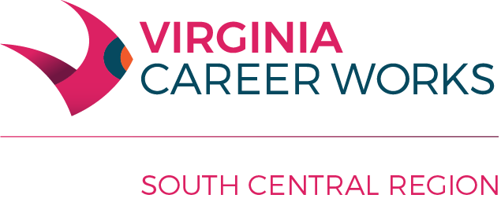

Equal Opportunity Employer/Program

Auxiliary aids and services are available upon request to individuals with disabilities
This flyer and the Adult and Dislocated Worker programs described are 100% supported by a federal U.S. Department of Labor Employment and Training Administration Workforce Innovation and Opportunity Act (WIOA) award of $589,731.00 (AA-34799- 20-55-A-51) made to Charlotte County on behalf of the South Central Workforce Development Area by the pass-through entity, the Virginia Community College System. No costs of this program are financed by nongovernmental sources.

