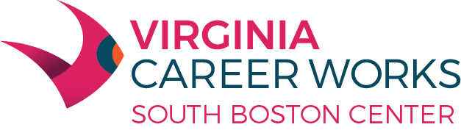

**We are happy to host a**

**Resume Writing Workshop**

**June 29, 2022 2pm-3pm**

**Are you ready for employers to be blown away by your resume?**

**Join us at 2506 Houghton Avenue on June 29th from 2pm-3pm and learn how your resume will set up apart from your competition.**

**No Registration Required!**

**Questions? Call us at**

**(434) 572-8064 VA Relay 711**

**Virginia Career Works—South Boston Center**

**2506 Houghton Ave. South Boston, VA 24592**

**Equal Opportunity Employer/Program**

**Auxiliary aids and services are available upon request to**

**individuals with disabilities**