LAKE COUNTRY HIRING EVENT
Join us at “The Dogwood” at 313 Franklin Street to market your skills to local employers looking to hire local talent!
September 9, 2021
10:00am to 2:00pm

*** EMPLOYERS ***
TO REGISTER PLEASE CONTACT:

Terra Napier
By phone at (434) 542-5871 or by email at tnapier@vcwsouthcentral.com
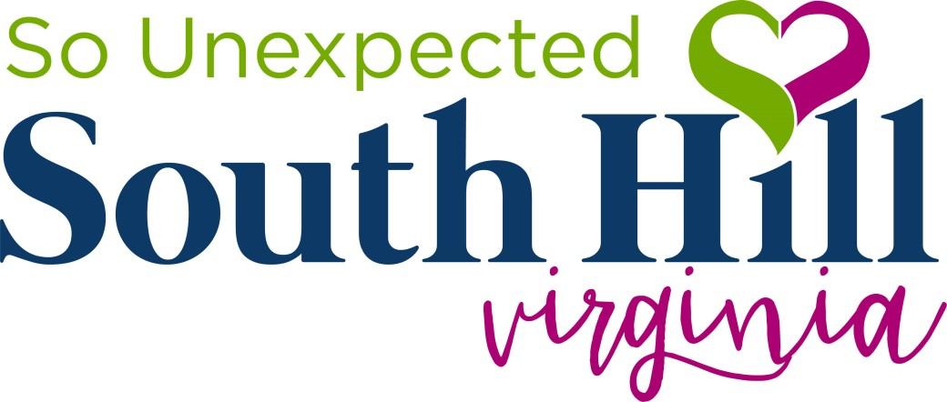
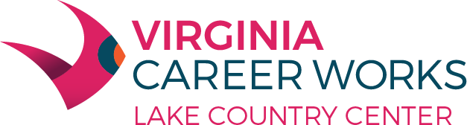

Equal Opportunity Employer/Program

Auxiliary aids and services are available upon request to individuals with disabilities
This flyer and the Adult and Dislocated Worker programs described are 100% supported by a federal U.S. Department of Labor Employment and Training Administration Workforce Innovation and Opportunity Act (WIOA) award of $589,731.00 (AA-34799- 20-55-A-51 ) made to Charlotte County on behalf of the South Central Workforce Development Area by the pass-through entity, the Virginia Community College System. No costs of this program are financed by nongovernmental sources.

