South Central Workforce Development Board

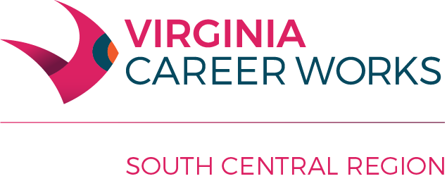

Thursday, July 18, 2024

Heartland Park

200 Heartland Drive, Keysville, VA 23947

9:00 a.m.

**Members Present:** Amelia- Faustine Dye; Brunswick- None; Buckingham-Stephanie Coleman; Charlotte- Gary Walker; Cumberland- Liz Jamerson; Halifax- Mike Dolianitis, Catherine Howard, Elizabeth Smith; Lunenburg- Trisha Currin; Mecklenburg- Donnie Williams; Nottoway- None; Prince Edward- Asha Moses, Margaret Taylor-Collins, Sherri McGuire (Alt- Dana Knott)

**Members Absent:** Eric Napier, Buffy Allgood, Tina Wood, Mark Webb, Jeremy Satterfield

| **Topic** | **Issues** | **Action** | **Follow Up** |
| --- | --- | --- | --- |
| I. Welcome/Call to Order/Roll Call  II. Public Input  III. SCWDB Minutes: July 20, 2023  IV. Information Only: CLEO Minutes: April 26, 2024  V. Committee Reports  VI. Other/Adjourn | None  None  The minutes were reviewed.  The CLEO minutes were reviewed.  A. Youth Committee-Addison Gills/Terra Napier reviewed the Youth Committee report. Youth year reports were reviewed along with program performance for PY 2023.  B. Strategic Planning- Donnie Williams/Terra Napier reviewed the Strategic Planning Committee Report.  C. Policy/Oversight Committee- Terra Napier reviewed the committee report. Reviewed One-Stop 3rd Quarter report. Reviewed PY 2023 3rd Quarter Performance Report.  D. Employment Enhancement Committee- Terra Napier reviewed the report. The board reviewed Business Solutions Teams reports along with Microsoft Hiring Event information.  E. Executive Committee-Donnie Williams reviewed the committee report and updates on expenditures, programs, grants, and performance. The committee reviewed PY 2024-2025 Allocations for Virginia and South Central Region for all programs, the MOU, and AJC Center Certification Process. The committee recommended the PY 2024-2025 Budget to be approved. Donnie Williams asked for volunteers for the Center Certification Team. Reviewed the upcoming calendar of meetings.  None | Donnie Williams-Vice-Chair called the meeting to order and the Executive Director called roll. A quorum was present.  None  Mike Dolianitis made a motion to approved the minutes from the April 18, 2024 meeting. Liz Jamerson seconded the motion and it was approved.  None  None  None  None    None  Liz Jamerson made a motion to approve the PY 2024-2025 budget. Faustine Dye seconded the motion and it was approved.  Asha Moses made a motion to recommend Margaret Collins, Faustine Dye and Dana Knott for the AJC Center Certification Team. Liz Jamerson seconded the motion and it was approved.  Margaret Collins made a motion to approve the MOU/IFA. Liz Jamerson seconded the motion and it was approved.  None | None  None  None  None  None  None  None  None  Forwarded to CLEOs for approval.  Forward to CLEOs for approval.  Forward to CLEOs for approval.  The next meeting will be Thursday, October 17, 2024 at 9:00 AM location TBD. |