HEARTLAND
HIRING EVENT
Join us to market your skills to local employers looking to hire local talent!
June 9, 2022
10:00am to 2:00pm
Location:
Farmville-Prince Edward Community Library
Wilck’s Lake Public Area
1303 W 3rd St, Farmville, VA 23901

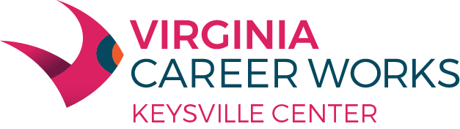

Equal Opportunity Employer/Program

Auxiliary aids and services are available upon request to individuals with disabilities

This flyer and the Adult and Dislocated Worker programs described are 100% supported by a federal U.S. Department of Labor Employment and Training Administration Workforce Innovation and Opportunity Act (WIOA) award of $589,731.00 (AA-34799- 20-55-A-51) made to Charlotte County on behalf of the South Central Workforce Development Area by the pass-through entity, the Virginia Community College System. No costs of this program are financed by nongovernmental sources.

