COVID-19 Update
Friday, April 17, 2020

Virginia Daily Key Statistics - (please note that the VDH and VHHA numbers may vary slightly due to reporting times.)
Virginia’s Daily COVID-19 Statistics - Virginia Department of Health: http://www.vdh.virginia.gov/coronavirus/ (This page is updated daily before 10 AM. Numbers are preliminary and close out at 5 PM the day before posting. Case counts reflect what has been reported to VDH by healthcare providers and laboratories.)
Number of People Tested: 48,997
Total Cases: 7,491
Total Hospitalizations: 1,221
Total Deaths: 231

COVID in Virginia’s Hospitals Dashboard: https://www.vhha.com/communications/virginia-hospital-covid-19-data-dashboard/

Emerging surge models for Virginia
Predicting the peak of COVID 19 infections and the number of healthcare workers needed to serve them has led to a number of predictive models that often convey conflicting information. Nevertheless, here are a few leading scenarios for Virginia.

Virginia COVID-19 projections assuming full social distancing through May 2020:
https://covid19.healthdata.org/united-states-of-america/virginia
Source: The Institute for Health Metrics and Evaluation (IHME) is an independent global health research center at the University of Washington

Press Release: Governor Northam, University of Virginia Biocomplexity Institute, RAND Corporation Present Infectious Disease Modeling on Impact of COVID-19 Mitigations in Virginia

Modeling suggests social distancing efforts have slowed the spread of the virus in the Commonwealth. Full text: https://www.governor.virginia.gov/newsroom/all-releases/2020/april/headline-856112-en.html

Unemployment Data
VEC Report for the Week: https://www.vec.virginia.gov/node/11845
For the filing week ending April 11, the figure for seasonally unadjusted initial claims in Virginia was 104,619. This brings the most recent four-week (March 21, March 28, April 4, and April 11) total of weekly initial claims filings to 410,762, which is only 67,000 fewer than the average of all initial claims filed during the last three economic recessions. The latest claims figure was a decrease of 42,750 claimants from the previous week. The 29% decrease indicates that initial claims volumes may have peaked during the April 4 filing week, following its dizzying ascent in late March.

More than 100k Virginians filed for unemployment last week: https://www.virginiabusiness.com/article/more-than-100k-virginians-filed-for-unemployment-last-week/

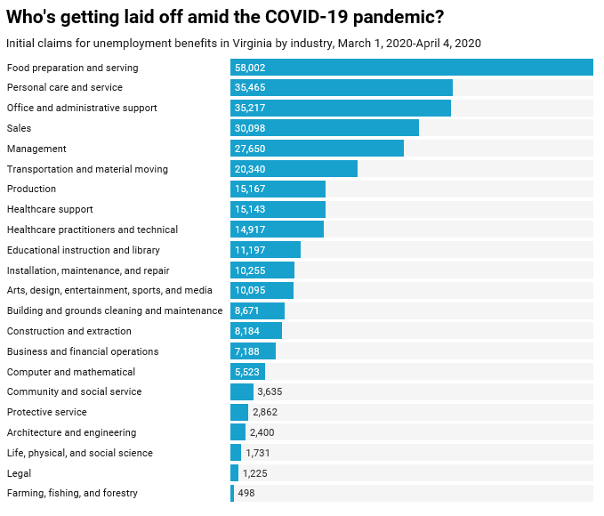
Source: Virginia Mercury and Virginia Employment Commission

Support for Businesses
- Virginia State Resources: https://www.virginia.gov/coronavirus/support-for-businesses/#854620
- Support for affected workers: https://www.virginia.gov/coronavirus/employment-and-financial-support/#855804
- F.A.Q. on Coronavirus Relief for Small Businesses, Freelancers https://www.nytimes.com/article/small-business-loans-stimulus-grants-freelancers-coronavirus.html
- The Paycheck Protection Program (PPP), a provision of the CARES Act, offers forgivable low-interest loans to small businesses facing uncertainty during the COVID-19 emergency, so businesses can retain workers, maintain payroll, and cover certain other existing overhead costs. https://www.sba.gov/funding-programs/loans/coronavirus-relief-options/paycheck-protection-program-ppp
  - Update: "The SBA is currently unable to accept new applications for the Paycheck Protection Program based on available appropriations funding," a Small Business Administration spokesperson said in an emailed statement Thursday 4/16. "Similarly, we are unable to enroll new PPP lenders at this time."
  - Small Business Emergency Relief Program Hits $349 Billion Cap In Less Than 2 Weeks: https://www.npr.org/sections/coronavirus-live-updates/2020/04/16/835958069/small-business-emergency-relief-program-hits-349-billion-cap-in-less-than-2-week

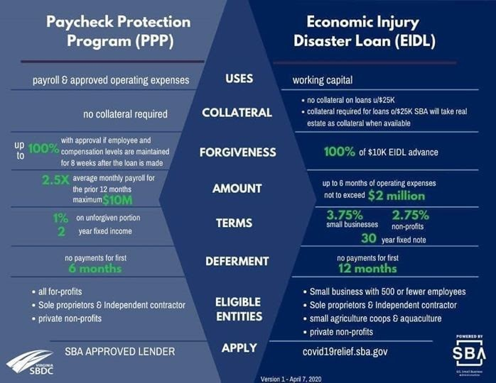
WARN notices
Due to severe restrictions aimed at curbing the spread of coronavirus (COVID-19), some businesses are being forced to significantly reduce staff, and many will likely close altogether for at least some period of time.
The federal WARN Act requires covered employers to provide 60 days’ advanced notice before terminating or laying off employees in connection with a plant closing or mass layoff. However, there are three exceptions to the 60 days’ notice requirement and two of these exceptions—for unforeseeable business circumstances and for faltering businesses—are likely to apply during the crisis that is unfolding from COVID-19.
**Businesses with fewer than 100 employees are not covered under the WARN Act and do not have to file WARN letters with the state. Therefore this is not a comprehensive reflection of business closures in Virginia.
http://www.vec.virginia.gov/warn-notices
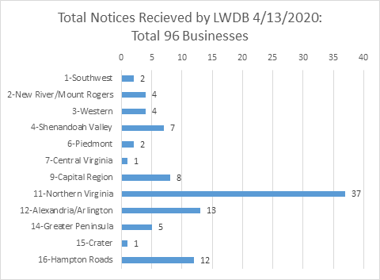
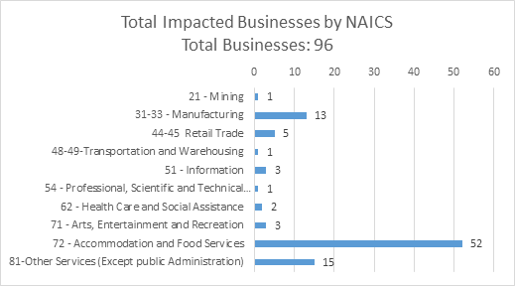

The above graphics do not represent all layoffs that have occured in the Commonwealth of Virginia, only the businesses that have filed official notices with the Commonwealth or who have sought assistance from the workforce system.

Virginia news:
- Virginia Mercury: https://www.virginiamercury.com/

National news:
- Sign up for The New York Times Morning Briefing: https://www.nytimes.com/series/us-morning-briefing
- The Daily podcast: https://www.nytimes.com/column/the-daily

