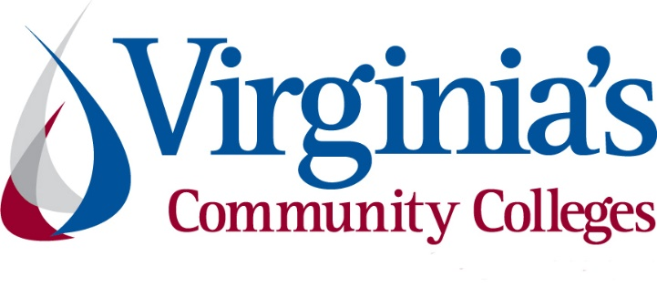
COVID-19 Update
Thursday, April 30, 2020

Virginia Daily Key Statistics - (please note that the VDH and VHHA numbers may vary slightly due to reporting times.)
Virginia’s Daily COVID-19 Statistics - Virginia Department of Health: http://www.vdh.virginia.gov/coronavirus/ (This page is updated daily before 10 AM. Numbers are preliminary and close out at 5 PM the day before posting. Case counts reflect what has been reported to VDH by healthcare providers and laboratories.)
Number of People Tested: 90,843 (26,325 or 40.8% increase from last week)
Total Cases: 15,846 (4,848 or 44.1% increase from last week)
Total Hospitalizations: 2,322 (569 or 32.5% increase from last week)
Total Deaths: 552 (180 or 48.4% increase from last week)
COVID in Virginia’s Hospitals Dashboard: https://www.vhha.com/communications/virginia-hospital-covid-19-data-dashboard/
Governor’s Blueprint for Easing Public Restrictions
April 24 - Governor Ralph Northam today presented the “Forward Virginia” blueprint, which will help guide the Commonwealth on when to safely begin easing public health restrictions. The blueprint includes a phased approach that is grounded in the federal Centers for Disease Control and Prevention guidelines and has specific goals to contain the spread of the virus through increased testing, personal protective equipment and supplies, and medical capacity.
The Forward Virginia blueprint includes the following priorities:
- Testing and Tracing
- Personal Protective Equipment
- Hospital Capacity and Staff
News Release: https://www.governor.virginia.gov/newsroom/all-releases/2020/april/headline-856337-en.html
Presentation: https://www.governor.virginia.gov/media/governorvirginiagov/governor-of-virginia/pdf/Slide-Deck-4-24-2020-.pdf
COVID 19 Testing in Virginia
April 27 - The governor said there's been a 41% increase in testing statewide over the last week, with the commonwealth reaching about 4,000 tests administered a day over the last two days, which meets a key criteria of the governor's blueprint announced on Friday.
He said the Department of Health is prioritizing testing in public housing, prisons, and long-term care facilities to try and focus on people in some of the most vulnerable populations.
https://www.whsv.com/content/news/Gov-Northam-set-to-address-Virginia-as-COVID-19-cases-rise-past-13000-569981751.html
Support for Virginians

Pandemic Unemployment Assistance (PUA) for Non-traditional Workers
The federal CARES Act includes a temporary program called Pandemic Unemployment Assistance (PUA), which allows individuals who are not traditionally eligible for unemployment insurance, like independent contractors and gig workers, to receive benefits. More than 50,000 Virginians have successfully filed claims through this program since we launched PUA last week, and these individuals should begin receiving their benefits next week.

https://www.vec.virginia.gov/html/pua.html

Governor Northam Signs Executive Order Giving Flexibility to Medicaid Providers
April 23 - Governor Ralph Northam today made it easier for Medicaid recipients to access medical care amid the current public health crisis, by signing Executive Order Fifty-Eight. This order is a companion to the COVID-19 relief package approved yesterday by the General Assembly and will give the Department of Medical Assistance Services (DMAS) to flexibility to make critical services more accessible to people who need them as a result of the pandemic.
https://www.governor.virginia.gov/newsroom/all-releases/2020/april/headline-856310-en.html

Liability Protections for Healthcare Workers
April 28 - Governor Ralph Northam today signed Executive Order Sixty, which reinforces certain existing statutory liability protections for Virginia healthcare workers. Due to COVID-19, public and private healthcare providers are operating with limited resources and may be forced to serve patients outside of conventional standards of care.
https://www.governor.virginia.gov/newsroom/all-releases/2020/april/headline-856370-en.html

VDSS Releases “One-Stop” App
The Virginia Department of Social Services (VDSS) just launched a mobile app and website designed to be a “one-stop” resource for benefits and information during the coronavirus outbreak. The new COVID-19 Virginia Resources website and app include information about food assistance, child care, health care and other benefits.
https://www.wavy.com/10-on-your-side/virginia-dept-of-social-services-launches-covid-19-app-and-website/

Elective Surgeries in Virginia

Governor Ralph Northam announced that hospitals and dentists will be allowed to resume non-emergency procedures as of midnight Thursday, April 30.

In March, elective medical procedures were banned under Public Health Order Number 2, signed by Governor Northam and State Health Commissioner M. Norman Oliver. This was done to preserve personal protective equipment during the COVID-19 pandemic, and to allow hospitals to focus resources on COVID patients.

Governor Northam said non-emergency procedures can resume because social distancing and other measures have slowed the spread of the COVID virus. Thanks to the efforts of all Virginians, hospitals have not been overwhelmed with a surge in patients. The administration is working closely with hospitals and dental practices to ensure they resume operations safely, use necessary PPE, follow all CDC guidelines, and take all measures to protect the health of employees and patients

https://www.wtvr.com/news/coronavirus/non-emergency-surgeries-to-resume-in-virginia

Governor’s News Release: https://www.governor.virginia.gov/newsroom/all-releases/2020/april/headline-856308-en.html
Unemployment Data
VEC Report for the Week: https://www.vec.virginia.gov/node/11884
For the filing week ending April 25, the figure for seasonally unadjusted initial claims in Virginia was 72,488. The latest claims figure was a decrease of 10,241 claimants from the previous week. Though the 12.4% decline indicates that the volume of initial claims has retreated from its recent peak, it may not return to pre-pandemic levels for some time.
For the most recent filing week, continued weeks claimed totaled 341,295 up nearly 15% from the previous week and 322,665 higher than the 18,630 continued claims from the comparable week last year. The continued claims total mainly comprised those recent initial claimants who continued to file for unemployment insurance benefits during the COVID-19 pandemic. That total is more than ten percent of private sector payroll employment in the Commonwealth.
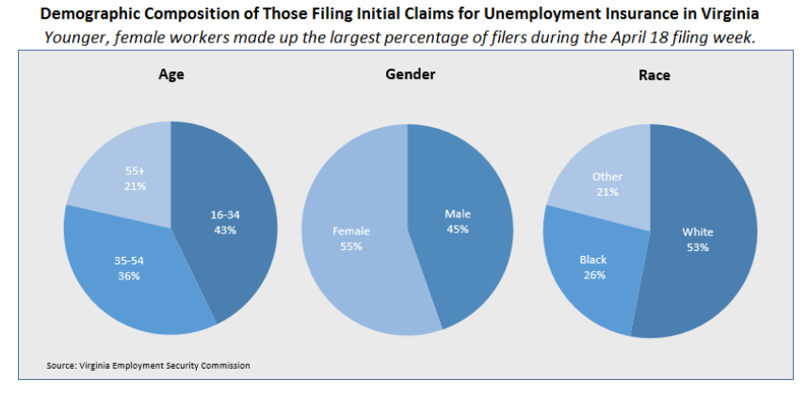
For additional information on who is claiming unemployment insurance in Virginia, access the VEC’s U.I. claims data dashboard (https://www.vec.virginia.gov/ui-claims-dashboard) that is updated the following Monday after the weekly claims press release.

Support for Higher Education

Governor Northam Announces Expansion of Payment Relief for Student Loan Borrowers
The federal CARES Act provided much-needed relief for students with federal loans, including the suspension of monthly payments, interest, and involuntary collection activity until September 30, 2020. However, millions of student loan borrowers with loans made by private lenders and federal loans not owned by the U.S. Government were left out.

Under this initiative, Virginians with commercially-owned Federal Family Education Loan (FFEL) loans, Perkins loans, or privately held student loans who are struggling to make their payments due to the ongoing COVID-19 pandemic will be eligible for expanded relief. Borrowers in need of assistance must immediately contact their student loan servicer to identify the options that are appropriate to their circumstances. Relief options include:

- Providing a minimum of 90 days of forbearance
- Waiving late payment fees
- Ensuring that no borrower is subject to negative credit reporting
- Ceasing debt collection lawsuits for 90 days
- Working with borrower to enroll them in other borrower assistance programs, such as income-based repayment
Full press release: https://www.governor.virginia.gov/newsroom/all-releases/2020/april/headline-856375-en.html

Support for Workers and Businesses
- Virginia State Resources: https://www.virginia.gov/coronavirus/support-for-businesses/#854620

- FAQs from Workers Regarding Covid-19:
English:https://www.governor.virginia.gov/media/governorvirginiagov/governor-of-virginia/pdf/Frequently-Asked-Questions-from-Workers-Regarding-COVID-19.pdf
Spanish:https://www.governor.virginia.gov/media/governorvirginiagov/governor-of-virginia/pdf/Las-Preguntas-Mas-Frecuentes-para-los-Empleados-Sobre-COVID-19.pdf
- Support for affected workers: https://www.virginia.gov/coronavirus/employment-and-financial-support/#855804

- F.A.Q. on Coronavirus Relief for Small Businesses, Freelancers https://www.nytimes.com/article/small-business-loans-stimulus-grants-freelancers-coronavirus.html

- The Paycheck Protection Program (PPP), a provision of the CARES Act, offers forgivable low-interest loans to small businesses facing uncertainty during the COVID-19 emergency, so businesses can retain workers, maintain payroll, and cover certain other existing overhead costs. https://www.sba.gov/funding-programs/loans/coronavirus-relief-options/paycheck-protection-program-ppp
  - Update: President Donald Trump signed a $484 billion coronavirus relief package into law Friday, April 24 . The legislation includes:
- $310 billion in new funds for the Paycheck Protection Program, which provides small business loans that can be forgiven if used for wages, benefits, rent and utilities. $60 billion is set aside for small lenders.
- $60 billion for Small Business Administration disaster assistance loans and grants.
- $75 billion in grants to hospitals dealing with a flood of patients.
- $25 billion to bolster coronavirus testing, a key part of efforts to reopen the economy.
- Small Business Association (SBA) resumed the Paycheck Protection Program on April 27.
WARN notices
Due to severe restrictions aimed at curbing the spread of coronavirus (COVID-19), some businesses are being forced to significantly reduce staff, and many will likely close altogether for at least some period of time.
The federal WARN Act requires covered employers to provide 60 days’ advanced notice before terminating or laying off employees in connection with a plant closing or mass layoff. However, there are three exceptions to the 60 days’ notice requirement and two of these exceptions—for unforeseeable business circumstances and for faltering businesses—are likely to apply during the crisis that is unfolding from COVID-19.
**Businesses with fewer than 100 employees are not covered under the WARN Act and do not have to file WARN letters with the state. Therefore, this is not a comprehensive reflection of business closures in Virginia.
http://www.vec.virginia.gov/warn-notices
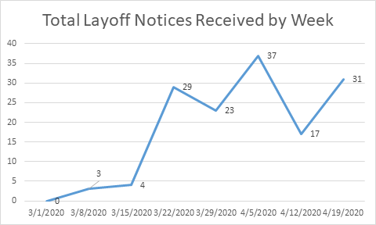

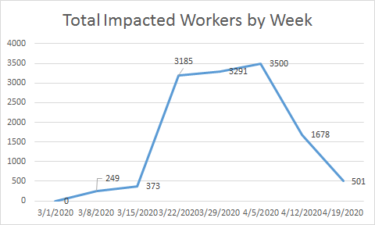
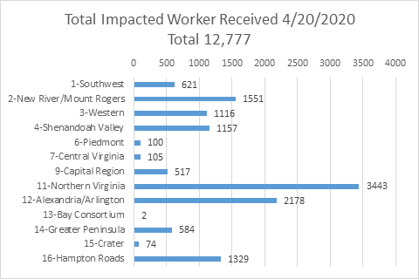
The above graphics do not represent all layoffs that have occurred in the Commonwealth of Virginia, only the businesses that have filed official notices with the Commonwealth or who have sought assistance from the workforce system.

Virginia news:
- Virginia Mercury: https://www.virginiamercury.com/
National news:
- Sign up for The New York Times Morning Briefing: https://www.nytimes.com/series/us-morning-briefing
The Daily podcast: https://www.nytimes.com/column/the-daily

