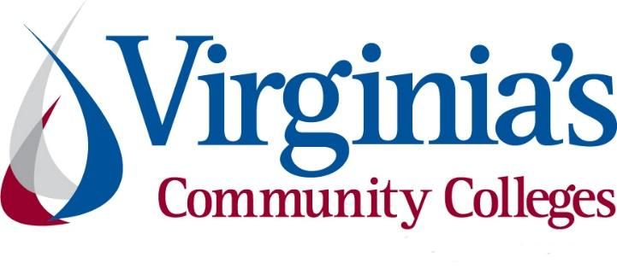
COVID-19 Update
Thursday, July 16, 2020
Virginia Daily Key Statistics
(Please note that the VDH and VHHA numbers may vary slightly due to reporting times.)
Virginia’s Daily COVID-19 Statistics-Virginia Department of Health: http://www.vdh.virginia.gov/coronavirus/ (This page is updated daily before 10 AM. Numbers are preliminary and close out at 5 PM the day before posting. Case counts reflect what has been reported to VDH by healthcare providers and laboratories.)
Tests Administered (PCR): 858,312 (107,681 or 14.3% increase from last week)
Total Cases: (74,431) (6,443 or 9.4% increase from last week)
Total Hospitalizations: 7,020 (395 or 6.0% increase from last week)
Total Deaths: 2,007 (70 or 3.6% increase from last week)
COVID in Virginia’s Hospitals Dashboard: https://www.vhha.com/communications/virginia-hospital-covid-19-data-dashboard/

July 16 - COVID-19 hospitalizations increasing in Virginia

The number of people who have been discharged from a hospital after testing positive for coronavirus continues to increase. However, the hospitalization trends across the state are changing, with an increase in total hospitalizations reported over the last week.

As of Thursday, July 16, 9,644 people have been discharged following hospitalization for coronavirus. The state also reports that it currently has 3,462 beds available with only 21% of its ventilators in use.
https://www.msn.com/en-us/health/medical/covid-19-hospitalizations-increasing-in-virginia/ar-BB12eUO7

July 15 - Virginia's COVID-19 cases increase by 1,084; positivity rate at 7.2%

The Virginia Department of Health reported Wednesday that the statewide total for COVID-19 cases is 73,527 — an increase of 1,084 from the 72,443 reported Tuesday.

The 73,527 cases consist of 70,669 confirmed cases and 2,858 probable cases. There are 1,992 COVID-19 deaths in Virginia — 1,882 confirmed and 110 probable. That’s an increase of 15 from the 1,977 reported Tuesday.

Also, the region has 304 deaths attributed to the virus: 175 in Henrico, 63 in Chesterfield, 36 in Richmond and 30 in Hanover.
As the overall number of positive COVID-19 test results in Virginia grows, data from the VDH coronavirus dashboard shows the percentage of positive results from testing is still below 10%. Health experts suggest a positivity rate below 10% is an adequate number to allow state health officials to detect new cases and outbreaks.
https://richmond.com/news/virginia/virginias-covid-19-cases-increase-by-1-084-positivity-rate-at-7-2/article_d0b80d86-bb5e-5299-9b8a-18ac782dc1c8.html

July 15- Virginia July 15 COVID-19 update: 1,084 new cases reported in Va., nearly 500 in Hampton Roads

PORTSMOUTH, Va. (WAVY) — Virginia reported more than 1,000 new COVID-19 cases on Wednesday, its most in more than a month, with nearly 500 of those cases in the Hampton Roads region.
Norfolk reported a record 136 new cases with Virginia Beach adding 144. Chesapeake also added 62 new cases.
The region is now averaging more than 350 cases per day, about 5 times its previous high in daily cases from the beginning of the pandemic through late June. With the new cases, the percent of positive cases has also gone up, rising sharply in the three localities above and others.
https://www.wavy.com/news/health/coronavirus/virginia-july-15-covid-19-update-1084-new-cases-reported-in-va-nearly-500-in-hampton-roads/

July 13- Westmoreland virus cases jump almost 70% since July 1
Two recent outbreaks have caused the number of COVID-19 cases in Westmoreland County to surge by almost 70 percent since July 1.

The Northern Neck locality had been experiencing one of the slowest increases of virus-related cases in the region until late June, when numbers started to rise more dramatically, from 93 to 100, then to 104, 108, 116 cases.
https://fredericksburg.com/news/local/westmoreland-virus-cases-jump-almost-70-since-july-1/article_52b67d3a-2441-5e0a-8fb7-87fdb366c518.htm

July 14- Virginia Department of Health Expands COVID-19 Regional Data Reporting

(Richmond, Va.) — Today, the Virginia Department of Health (VDH) began providing the COVID-19 Key Measures for additional regions across the state: Central, Eastern, Northwest and Southwest. Previously, VDH only provided statewide and Northern Region key measures; data is now provided for all regions in the state. The new regional dashboards are available on the Key Measures webpage.

https://www.vdh.virginia.gov/news/2020-news-releases/5038-2/
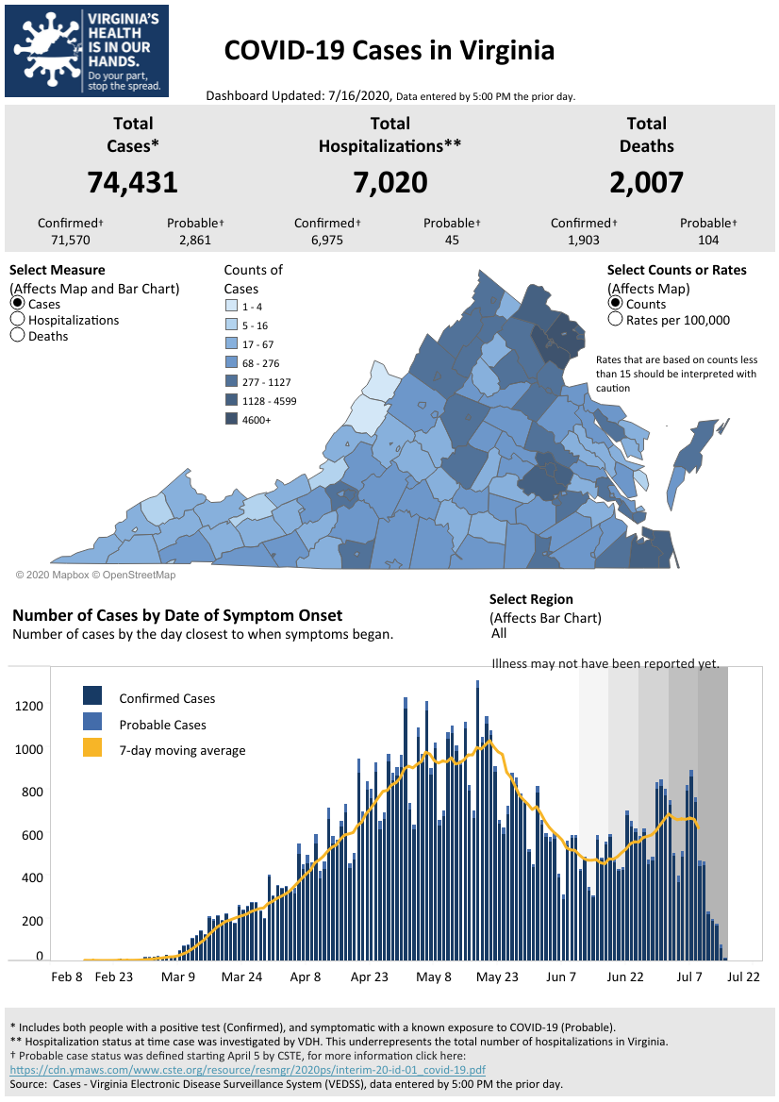
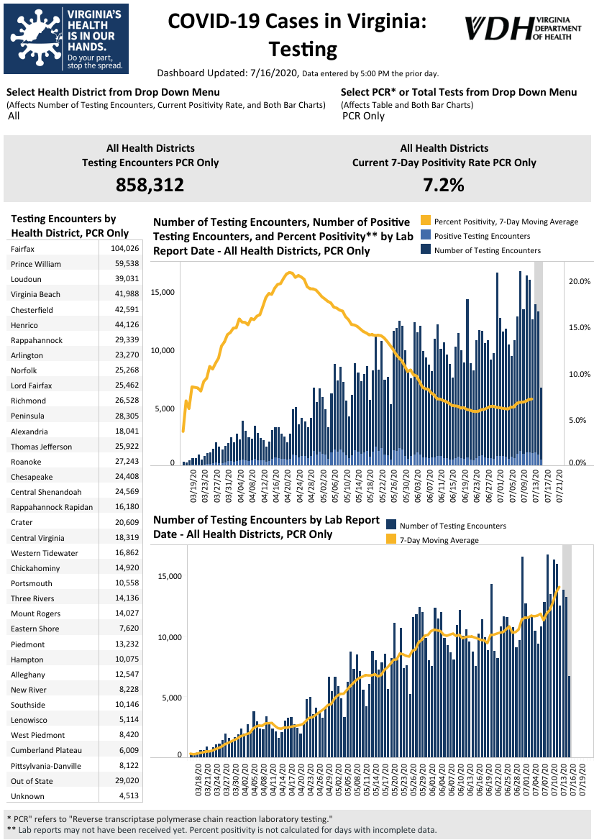
Graphs obtained from Virginia Department of Health: https://www.vdh.virginia.gov/coronavirus/

Support for Virginians
July 14 - Governor Increases Enforcement in COVID Hot Spots

Governor Northam stepped up enforcement of guidelines and restrictions as cases in the Hampton Roads area show a troubling increase.
According to local health officials, the rise in cases in the region is driven partly by people gathering in groups, often without wearing face coverings.
To increase enforcement of existing restrictions in restaurants and other places where people gather, Governor Northam is directing teams made up of members from the health departments, the Virginia ABC, the Department of Agriculture and Consumer Services, and other licensing agencies, to conduct unannounced visits to establishments as needed.
https://www.governor.virginia.gov/

July 16 - VDH launches online form to report COVID-19 violation

The Virginia Department of Health (VDH) launched an online system to report violations of face coverings and select phase 3 restrictions.

The complaints allow a person to list the type of establishment in violation, the name, address, and information pertaining to the violation.

VDH will review complaints and forward them to the respective local health department for further investigation.

Virginia is currently under a face covering/mask mandate, as ordered by Governor Ralph Northam.

https://www.nbc12.com/2020/07/16/vdh-launches-online-form-report-covid-violations/?fbclid=IwAR0pOYb0M82txuDlH-mZD-u_-wx683qvBDKu7XVUaRP-fNuSlmZXk4L9gdU

July 15 - Citing noncompliance, Northam steps up enforcement of state’s mask order

Virginia Gov. Ralph Northam is blaming the state’s recent rise in COVID-19 cases on noncompliance with his May mask order.

At a Tuesday news briefing — his first in three weeks — Northam announced that the state would be stepping up enforcement as a result, especially in the Hampton Roads region, where the number of daily new cases has averaged more than 300 over the last week.

“There is clearly substantial community spread,” Northam said. “A lot of that increase is driven by people socializing without wearing masks — especially young people.” In Virginia, cases among residents aged 25 to 29 have risen by 250 percent compared to early June.
https://www.virginiamercury.com/2020/07/14/citing-noncompliance-northam-steps-up-enforcement-of-states-mask-order/

July 5 - Evictions ramp up in Virginia as local courts decline governor’s request to continue moratorium
Courts around Virginia began working their way through a backlog of more than 12,000 eviction cases last week as a statewide moratorium expired, with many judges apparently declining a last-minute request from Gov. Ralph Northam to continue the stay at the local level.

“It’s a total patchwork,” said Christie Marra, the director of housing advocacy at the Virginia Poverty Law Center, which has asked Northam to use his executive authority to intervene more decisively. She said the current approach of leaving the decision to local courts is “absolutely not working.”
https://www.nbc12.com/2020/07/07/evictions-ramp-up-virginia-local-courts-decline-governors-request-continue-moratorium/
July 2 - After eviction freeze lifted, rent programs for tenants accessible
While the statewide freeze on evictions has expired, a new rent relief program has begun. Virginia is using $50 million of Coronavirus Aid, Relief, and Economic Security Act funds (CARES act) to help people facing evictions as a result of the coronavirus crisis, called the Virginia Rent and Mortgage Relief Program.
https://www.wric.com/news/virginia-news/after-eviction-freeze-lifted-rent-programs-for-tenants-accessible/

Support for Businesses

July 15- Virginia Adopts First-in-the-Nation Workplace Safety Standards for COVID-19 Pandemic
Governor Ralph Northam today announced the adoption of statewide emergency workplace safety standards in response to the novel coronavirus, or COVID-19. These first-in-the-nation safety rules will protect Virginia workers by mandating appropriate personal protective equipment, sanitation, social distancing, infectious disease preparedness and response plans, record keeping, training, and hazard communications in workplaces across the Commonwealth. The actions come in the absence of federal guidelines.

“Workers should not have to sacrifice their health and safety to earn a living, especially during an ongoing global pandemic,” said Governor Northam. “In the face of federal inaction, Virginia has stepped up to protect workers from COVID-19, creating the nation’s first enforceable workplace safety requirements. Keeping Virginians safe at work is not only a critical part of stopping the spread of this virus, it’s key to our economic recovery and it’s the right thing to do.”

https://www.governor.virginia.gov/newsroom/all-releases/2020/july/headline-859234-en.html

July 15- Labor groups warn of loophole in Virginia’s COVID-19 workplace safety rules
With a vote expected Wednesday on Virginia’s first-in-the-nation workplace pandemic safety regulations, employers and labor groups are at odds over a provision that would allow businesses to disregard the new rules if they instead follow all CDC guidelines for their industry.

Advocates for workers, including the AFL-CIO and Legal Aid Justice Center, called the language a loophole that will allow employers to skirt otherwise strict regulations that mandate social distancing, employee training and workplace hazard assessments.

https://www.virginiamercury.com/2020/07/15/labor-groups-warn-of-loophole-in-virginias-covid-19-workplace-safety-rules/

July 15 - Va. Adopts Nation's First COVID-19 Workplace Safety Mandate

Virginia on Wednesday became the first state to adopt an emergency workplace safety standard addressing the ongoing coronavirus pandemic, which Gov. Ralph Northam said is necessary to fill a gap created by federal inaction.

The state's infectious disease prevention benchmark mandates that workers be provided with personal protective equipment and sets parameters for businesses to sanitize their worksites, enforce social distancing protocols and have infectious disease response plans, according to Northam's office.

https://www.law360.com/employment/articles/1292428/va-adopts-nation-s-first-covid-19-workplace-safety-mandate?nl_pk=3917a1d6-0ff6-439d-9b09-7d12aa33cc66&utm_source=newsletter&utm_medium=email&utm_campaign=employment
July 16 - Norfolk Naval Shipyard Takes on Innovative Solutions During COVID-19 Pandemic
Innovative employees at Norfolk Naval Shipyard in Virginia came together to face the challenges of the COVID-19 pandemic head-on by using additive manufacturing to produce face shields.

In Mid-March, Naval Sea Systems Command reached out to innovation programs at its shipyards and other departments acto assess additive manufacturing capability to produce personal protective equipment so workers could safely maneuver through the current environment.

Simultaneously, requests began pouring in from individuals across the shipyard with a strong desire to assist in the development and production efforts.
https://www.defense.gov/Explore/Features/Story/Article/2274539/norfolk-naval-shipyard-takes-on-innovative-solutions-during-covid-19-pandemic/

PPE
July 9 - Primary care doctors in Virginia want more resources from state as demand for testing grows
Virginia, like the rest of the country, has spent months fighting supply shortages in an effort to build a comprehensive network of COVID-19 testing sites. But despite gradually increasing its numbers (the state averaged more than 11,000 tests per day over the last week), many primary care physicians are still reporting difficulties in sourcing the basic supplies that make in-office testing possible.
https://www.nbc12.com/2020/07/09/primary-care-doctors-virginia-want-more-resources-state-demand-testing-grows/
July 8 - CareFirst BlueCross BlueShield Establishes $5 Million Personal Protective Equipment Initiative for Coronavirus Relief
Today, CareFirst BlueCross BlueShield (CareFirst) announced its new initiative, “Care, delivered,” a $5 million public-private sector philanthropic endeavor that will distribute personal protective equipment (PPE) at no-cost to healthcare and social service organizations on the front lines of the pandemic. This initiative is part of CareFirst’s ongoing commitment to support the communities it serves as they navigate the complexities of this public health crisis.
https://individual.carefirst.com/individuals-families/news/2020/07/carefirst-bluecross-blueshield-establishes-5-mill/
Education
July 14- Trump Administration Abruptly Rescinds Controversial Rule on Foreign Students
In a surprise announcement, District Judge Allison D. Burroughs, U.S. District Court for the District of Massachusetts, announced a reversal of the government decision that was announced just last week regarding students in F-1 or M-1 nonimmigrant status. Foreign students will now be able to enter the United States and remain even if they are only taking online courses. The government agreed to resume the flexibility it had announced in March when COVID-19 forced most colleges and universities to go online.

https://www.natlawreview.com/article/trump-administration-abruptly-rescinds-controversial-rule-foreign-students

July 13- Northam: Classrooms won't reopen if Virginia can't remain in phase 3

Virginia Gov. Ralph Northam said Friday students will not be able to return to classrooms in the fall if the state is unable to stay within phase three of its Covid-19 reopening plan.
“I want as much as anybody to get our kids back in school, but if our numbers don’t stay where they are, if we aren’t able to stay in phase three, then we’re not going to be able to move forward with that,” Northam told Richmond’s NBC 12.

https://www.bizjournals.com/washington/news/2020/07/13/northam-state-must-remain-in-phase-3-for-schools.html

July 13- USDOL Announces Availability of $40 Million In Strengthening Community Colleges Training Grants

The U.S. Department of Labor announced the availability of $40 million in Strengthening Community Colleges Training Grants. The grants aim to address the skill development needs of employers and to support workers in gaining skills and transitioning quickly from unemployment to employment. The grants also build the capacity of community colleges to address challenges associated with the coronavirus health crisis, such as expanding online and technology-enabled learning, and migrating services to a virtual environment.

https://www.grants.gov/web/grants/view-opportunity.html?oppId=327958

July 13 - Virginia Ready Initiative Established

The Virginia Ready Initiative (VA Ready), a newly established nonprofit organization formed in response to the economic hardships created by COVID-19, recently announced details of its plan to help thousands of unemployed Virginians access the training needed to get back to work.

VA Ready and its partners - 20 of the Commonwealth's leading businesses - provide incentives for motivated, out-of-work Virginians to reskill for in-demand jobs in high-growth sectors. Further partnering with Virginia's 23 community colleges and their existing FastForward initiative, a state-sponsored workforce credential grant program, VA Ready marries Virginia's business needs with high-quality, short-term training programs offered by community colleges. Funded through philanthropic donations and company contributions, VA Ready recognizes and rewards student initiative to gain new skills.

https://www.prnewswire.com/news-releases/virginia-ready-initiative-incentivizes-retraining-to-get-virginians-back-to-work-301084980.html

Unemployment Data

RICHMOND—The Virginia Employment Commission (VEC) announced that the total number of initial claims filed from the first filing week of 2020 through the July 11, 2020 filing week surpassed one million initial claims.
For the filing week ending July 11, the figure for seasonally unadjusted initial claims in Virginia was 32,292. The latest claims figure was an increase of 467 claimants from the previous week. The weekly growth was an increase from the previous week, but well below the weekly peak in unemployment insurance claims reached during the April 4 filing week.
For the most recent filing week, continued weeks claimed totaled 372,070, down 6,537 from the previous week, but 351,316 higher than the 20,754 continued claims from the comparable week last year. The continued claims total is mainly comprised of those recent initial claimants who continued to file for unemployment insurance benefits during the COVID-19 pandemic. Continued claims during the July 11 filing week equaled 38% of all initial claims filed during the pandemic to this point. This percentage has leveled off in recent weeks.
For additional information on who is claiming unemployment insurance in Virginia, access the VEC’s U.I. claims data dashboard (https://www.vec.virginia.gov/ui-claims-dashboard) that is updated no later than the following Monday after the weekly claims press release.
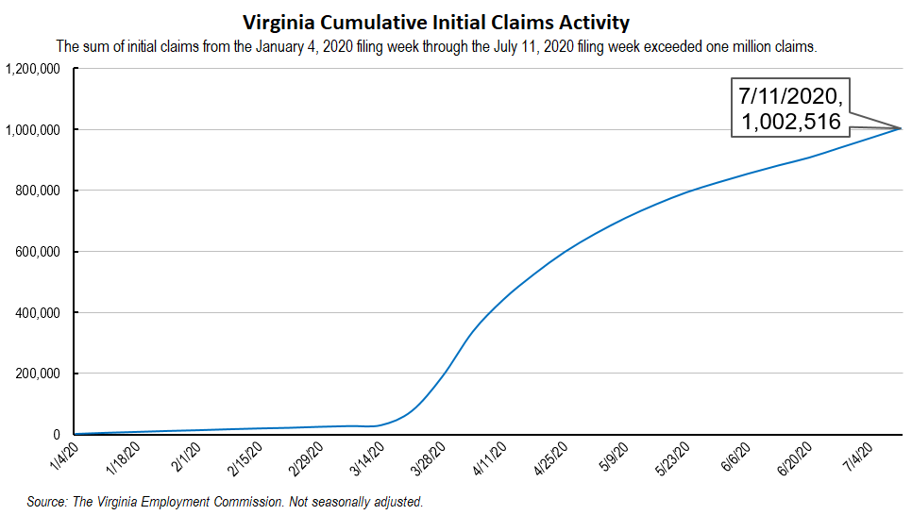
Nationwide, in the week ending July 11, the advance figure for seasonally adjusted initial claims was 1,300,000, a decrease of 10,000 from the previous week's revised level. The previous week's level was revised down by 4,000 from 1,314,000 to 1,310,000. The advance number of actual initial claims under state programs, unadjusted, totaled 1,503,892 in the week ending July 11, an increase of 108,811 (or 7.8 percent) from the previous week. There were 243,621 initial claims in the comparable week in 2019. Looking at preliminary data, most states reported increases while four states reported weekly increases greater than 10,000. These were in Florida (+62,467), Georgia (+31,176), California (+22,941), and Washington (+12,272). Virginia’s weekly change was the 15th largest increase among states.
https://www.vec.virginia.gov/UI-press-release
PDF of press release: https://www.vec.virginia.gov/sites/default/files/news-12031-Initial%20Claims%20Press%20Release%207%204%202020.pdf
For additional information on who is claiming unemployment insurance in Virginia, access the VEC’s U.I. claims data dashboard (https://www.vec.virginia.gov/ui-claims-dashboard) that is updated the following Monday after the weekly claims press release.

July 15- Labor groups warn of loophole in Virginia’s COVID-19 workplace safety rules
With a vote expected Wednesday on Virginia’s first-in-the-nation workplace pandemic safety regulations, employers and labor groups are at odds over a provision that would allow businesses to disregard the new rules if they instead follow all CDC guidelines for their industry.
Advocates for workers, including the AFL-CIO and Legal Aid Justice Center, called the language a loophole that will allow employers to skirt otherwise strict regulations that mandate social distancing, employee training and workplace hazard assessments.
https://www.virginiamercury.com/2020/07/15/labor-groups-warn-of-loophole-in-virginias-covid-19-workplace-safety-rules/
Virginia Economy
July 9 - Virginia Issues Year-End Revenue Report
Governor Ralph Northam today announced that Virginia ended fiscal year 2020 with a deficit of approximately $236.5 million in general fund revenue collections. While the shortfall was expected due to the impacts of COVID-19 on the state’s economy and budget, it is smaller than anticipated, and overall, revenues increased 2.0 percent over fiscal year 2019.
News Release: https://www.governor.virginia.gov/newsroom/all-releases/2020/july/headline-859135-en.html
Other Resources
- Virginia State Resources: https://www.virginia.gov/coronavirus/support-for-businesses/#854620
- FAQs from Workers Regarding Covid-19:
English: https://www.governor.virginia.gov/media/governorvirginiagov/governor-of-virginia/pdf/Frequently-Asked-Questions-from-Workers-Regarding-COVID-19.pdf
Spanish:https://www.governor.virginia.gov/media/governorvirginiagov/governor-of-virginia/pdf/Las-Preguntas-Mas-Frecuentes-para-los-Empleados-Sobre-COVID-19.pdf
- Support for affected workers: https://www.virginia.gov/coronavirus/employment-and-financial-support/#855804
- F.A.Q. on Coronavirus Relief for Small Businesses, Freelancers https://www.nytimes.com/article/small-business-loans-stimulus-grants-freelancers-coronavirus.html
- The Paycheck Protection Program (PPP), a provision of the CARES Act, offers forgivable low-interest loans to small businesses facing uncertainty during the COVID-19 emergency, so businesses can retain workers, maintain payroll, and cover certain other existing overhead costs. https://www.sba.gov/funding-programs/loans/coronavirus-relief-options/paycheck-protection-program-ppp
- COVID 19 Testing Information and Locations: https://www.vdh.virginia.gov/coronavirus/covid-19-testing/

WARN Notices
WARN Notices due to COVID-19 have significantly dropped off in Virginia starting in mid-June 2020. While no single factor can be attributed to this fact, the slow down does not mean that businesses have stopped laying off; many large businesses that were covered by the WARN Act up to this point have likely already felt the pandemic’s impact and reported accordingly. As any new spikes in WARN activity as a result of COVID-19 are reported the charts in this section will be updated accordingly.
http://www.vec.virginia.gov/warn-notices

Virginia News
Virginia Mercury: https://www.virginiamercury.com/

National News
Sign up for The New York Times Morning Briefing: https://www.nytimes.com/series/us-morning-briefing
The Daily podcast: https://www.nytimes.com/column/the-daily

