COVID-19 Update
Thursday, November 19, 2020
Virginia Daily Key Statistics

(Please note that the VDH and VHHA numbers may vary slightly due to reporting times.)
Virginia’s Daily COVID-19 Statistics-Virginia Department of Health: http://www.vdh.virginia.gov/coronavirus/ (This page is updated daily before 10 AM. Numbers are preliminary and close out at 5 PM the day before posting. Case counts reflect what has been reported to VDH by healthcare providers and laboratories.)
Tests Administered (PCR): 3,007,461 (153,664 or 5.4% increase from last week)
Total Cases: 210,787 (12,760 or 6.4% increase from last week)
Total Hospitalizations: 13,815 (476 or 3.6% increase from last week)
Total Deaths: 3,896 (138 or 3.7% increase from last week)
Current 7-Day Positivity Rate: 7.1% (Last Week: 6.5%)
https://www.vdh.virginia.gov/coronavirus/covid-19-in-virginia/

November 18 - U.S. surpasses 250,000 coronavirus deaths as virus mortality rate surges

The United States has recorded a quarter-million Covid-19 deaths, the latest NBC News numbers showed Wednesday, and the death rate has been accelerating in recent weeks as cases have been surging across the country.

https://www.nbcnews.com/news/us-news/u-s-surpasses-250-000-coronavirus-deaths-virus-mortality-rate-n1248109

Virginia and National Developments
November 18 - Northam signs revised budget, adds to COVID-19 relief support

Previous funding allocations under the CARES Act were finalized Wednesday when Governor Ralph Northam signed Virginia’s revised biennial budget, House Bill 5005.

Following the August 18 General Assembly special session, this new spending plan will protect what Northam calls key priorities, preserve the state’s financial options and address challenges from the COVID-19 pandemic.

https://www.wdbj7.com/2020/11/19/northam-signs-revised-budget-adds-to-covid-19-relief-support/

November 18 - VEC says Extended Benefits Program will end on Saturday

The Virginia Employment Commission announced that the U.S. Department of Labor has told them that the Extended Benefits Program in Virginia will end on Nov. 21.

This program entitled claimants 50% of the total amount they received on their claim for regular unemployment benefits.

https://www.wric.com/news/virginia-news/vec-ending-extended-benefits-program/

November 18 - 'This year, staying home is an act of love:' Northam addresses COVID-19 ahead of holidays

Governor Ralph Northam addressed the Commonwealth about COVID-19 at a press conference on Wednesday afternoon.

Northam's press conferences come after new mitigation measures were put into effect at midnight on Sunday. Northam announced the new measures, including a new limit on gathering sizes and an expansion of the statewide mask mandate.

https://wset.com/news/local/this-year-staying-home-is-an-act-of-love-northam-addresses-covid-19-ahead-of-holidays

November 18 - Pandemic triggers ‘enormous’ spike in drug overdose deaths

Since the start of the COVID-19 pandemic, fatal drug overdoses have exploded in Virginia, and health officials are predicting “the worst year on record by far” for such deaths in the commonwealth.

https://www.virginiamercury.com/2020/11/18/pandemic-triggers-enormous-spike-in-drug-overdose-deaths/

November 13 - Governor Northam Announces New Statewide Measures to Contain COVID-19

As COVID-19 surges in states across the country, Governor Ralph Northam today announced new actions to mitigate the spread of the virus in Virginia. While the Commonwealth’s case count per capita and positivity rate remain comparatively low, all five health regions are experiencing increases in new COVID-19 cases, positive tests, and hospitalizations.

https://www.governor.virginia.gov/newsroom/all-releases/2020/november/headline-861342-en.html

PPE, Testing, Treatment, & Vaccines

November 19 - Covid testing strained again as U.S. heads into holidays

With coronavirus cases surging and families hoping to gather safely for Thanksgiving, long lines to get tested have reappeared across the U.S. — a reminder that the nation’s strained testing system remains unable to keep pace with the virus.

NBC News

November 18 - Early Data Show Moderna’s Coronavirus Vaccine Is 94.5% Effective

The drugmaker Moderna announced on Monday that its coronavirus vaccine was 94.5 percent effective, joining Pfizer as a front-runner in the global race to contain a raging pandemic that has killed 1.2 million people worldwide.

New York Times

November 18 - Pfizer: COVID-19 shot 95% effective, seeking clearance soon

Pfizer said Wednesday that new test results show its coronavirus vaccine is 95% effective, is safe and also protects older people most at risk of dying — the last data needed to seek emergency use of limited shot supplies as the catastrophic outbreak worsens across the globe.

WRIC

November 17 - FDA authorizes first at-home Covid-19 test that gives users results quickly

The Food and Drug Administration has authorized the first Covid-19 test designed for users to take and develop at home for results within an hour.

The agency announced the emergency use authorization for the Lucira COVID-19 All-In-One Test Kit on Tuesday night.

NBC News

Virginia and U.S. Economy
November 17 - Federal Reserve Chair Jerome Powell says surge in virus cases threatens U.S. economy
Federal Reserve Chair Jerome Powell said Tuesday that the nationwide surge in confirmed coronavirus could slow the economy in the months ahead by discouraging consumers from spending.

“We’re seeing states begin to impose some activity restrictions,” Powell said in an online discussion with the Bay Area Council, a San Francisco-based business group. “The concern is that people will lose confidence in efforts to control the pandemic, and … we’re seeing signs of that already.”

https://www.pbs.org/newshour/economy/federal-reserve-chair-jerome-powell-says-surge-in-virus-cases-threatens-u-s-economy

Education
November 19 - Who's Up, Who's Down and Why
Community college enrollments are suffering. Badly. Nationally, they are down 9.5 percent, according to the latest report from the National Student Clearinghouse Research Center. Community college freshman enrollment is down by 19 percent. Enrollment of underrepresented minorities has taken an especially hard hit -- it's down by nearly 30 percent.

https://www.insidehighered.com/news/2020/11/19/community-college-enrollments-down-nationally-not-everywhere

November 19 - Faculty Pandemic Stress Is Now Chronic

COVID-19-related changes to teaching and dealing with students' mental health continue to weigh on professors, with implications for their own mental health.

https://www.insidehighered.com/news/2020/11/19/faculty-pandemic-stress-now-chronic

November 18 - Pandemic Lessons From Community Colleges

The ongoing COVID-19 pandemic has taken its toll on nearly all postsecondary institutions that contend with challenges around enrollment declines, reopening plans, pivoting to virtual learning, integrating added student supports, shifts in skill demands and more. As we continue treading uncertain waters, I cannot emphasize enough how important it is that we watch and learn from community colleges. They serve widely diverse populations, who are among the most resilient at realizing their hopes and dreams. And just like their students, community colleges are sites of agile adaptation and innovation, perpetually responsive to emerging societal needs. Amid times of crisis, community colleges are once again rising to the occasion.

https://www.insidehighered.com/views/2020/11/18/what-community-colleges-can-teach-higher-ed-about-supporting-students-during-and
November 17 - When Career Advancement Feels Impossible

More than half -- 52 percent -- of Americans say it is difficult for them to get a good job or that their opportunities to advance at work are limited, according to new survey data from the Strada Education Network, a research and advocacy organization focused on the link between education and employment.

https://www.insidehighered.com/news/2020/11/17/survey-many-americans-feel-powerless-over-ability-advance-professionally

November 17 - A strategy to ensure equity, retention amid Covid

As colleges continue online instruction for spring 2021, it is important for student services, success and support professionals to consider the impact on students, their success and outcomes. Now more than ever, it is important to anticipate student needs, reach out and connect them to services and supports and engage them in the life of the college, and with key personnel who can guide them through their educational journey.

https://www.ccdaily.com/2020/11/a-strategy-to-ensure-equity-retention-amid-covid/

Unemployment Data
November 19 - Virginia’s Unemployment Insurance Weekly Claims for Week Ending November 14th
Seasonally unadjusted weekly initial unemployment insurance claims rose by 11.9% from the previous filing week as continued claims fell by 7.4% during that period
The Virginia Employment Commission (VEC) announced that the number of continued claims filed during the November 7 filing week remained below 100,000 continuing recent trends, according to figures released today.

For the filing week ending November 14, the figure for seasonally unadjusted initial claims in Virginia was 11,088. The latest claims figure was an increase of 1,179 claimants from the previous week and rose to its highest level in nearly a month.

For the most recent filing week, continued weeks claimed totaled 85,129, which was a 7.4% decrease from the previous week, but 67,529 higher than the 17,600 continued claims from the comparable week last year. Over half of claims were in the accommodation/food service, health care, administrative support, and retail trade industries. The continued claims total is mainly comprised of those recent initial claimants who continued to file for unemployment insurance benefits during the COVID-19 pandemic.

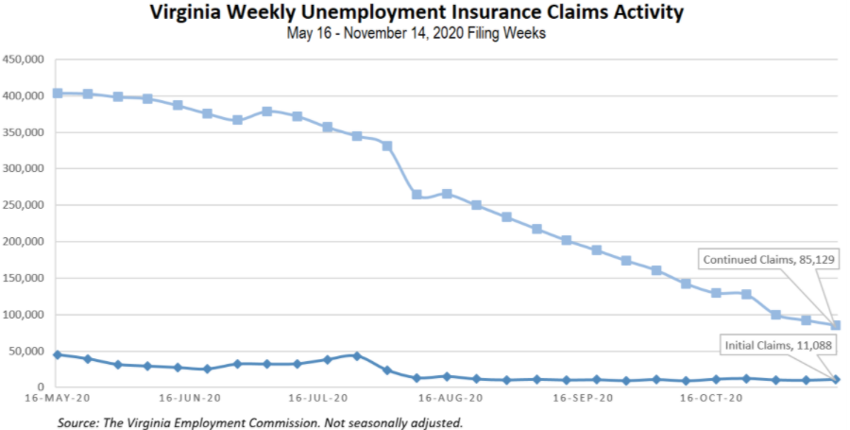
Nationwide, in the week ending November 7, the advance figure for seasonally adjusted initial claims was 742,000, an increase of 31,000 from the previous week's revised level. The previous week's level was revised up by 2,000 from 709,000 to 711,000. The advance number of actual initial claims under state programs, unadjusted, totaled 743,460 in the week ending November 14, an increase of 18,344 (or 2.5 percent) from the previous week. There were 227,892 initial claims in the comparable week in 2019. Looking at preliminary data, most states reported decreases on a seasonally unadjusted basis. Illinois’s preliminary weekly change (-20,632) was the largest decrease among states. Florida’s preliminary weekly change (-9,865) was the second largest decrease. Others included New Jersey (-8,689), Washington (-8,516), Georgia (-4716), and Tennessee (-1,545). Virginia’s preliminary weekly change (+4,180) was the fourth largest increase.
https://www.vec.virginia.gov/UI-press-release
For additional information on who is claiming unemployment insurance in Virginia, access the VEC’s U.I. claims data dashboard (https://www.vec.virginia.gov/ui-claims-dashboard) that is updated the following Monday after the weekly claims press release.
November 19 - US jobless claims rise to 742,000; millions to lose aid
The number of Americans seeking unemployment aid rose last week to 742,000, the first increase in five weeks and a sign that the resurgent viral outbreak is likely slowing the economy and forcing more companies to cut jobs.
https://apnews.com/article/pandemics-jobless-claims-unemployment-coronavirus-pandemic-united-states-a9abee07cc3eb7246e7e3c8603430a49
November 19 - Initial jobless claims rise as extended benefits come to an end; U.S. Labor Department will cut off 13 extra weeks of unemployment pay
As the U.S. Department of Labor notified the Virginia Employment Commission that the state’s extended benefits program would end on Nov. 21, more than 11,000 Virginians filed initial jobless claims and more than 85,000 filed continued claims.
https://www.virginiabusiness.com/article/initial-jobless-claims-rise-as-extended-benefits-come-to-an-end/

Other Resources
- Virginia State Resources: https://www.virginia.gov/coronavirus/
- COVID 19 Testing Information and Locations: https://www.vdh.virginia.gov/coronavirus/covid-19-testing/

