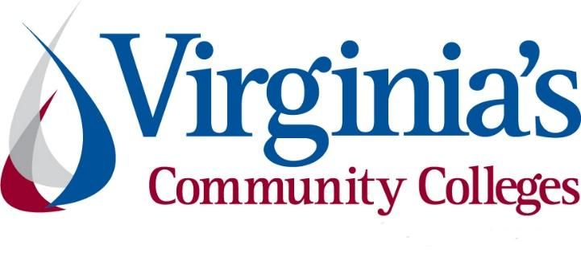
COVID-19 Update
Thursday, November 5, 2020
Virginia Daily Key Statistics
(Please note that the VDH and VHHA numbers may vary slightly due to reporting times.)
Virginia’s Daily COVID-19 Statistics-Virginia Department of Health: http://www.vdh.virginia.gov/coronavirus/ (This page is updated daily before 10 AM. Numbers are preliminary and close out at 5 PM the day before posting. Case counts reflect what has been reported to VDH by healthcare providers and laboratories.)
Increases are computed based on figures from Wednesday, October 28.
Tests Administered (PCR): 2,563,313 (155,893 or 6.1% increase from last week)
Total Cases: 176,754 (10,448 or 5.9% increase from last week)
Total Hospitalizations: 12,384 (481 or 3.9% increase from last week)
Total Deaths: 3,616 (72 or 2.0% increase from last week)
Current 7-Day Positivity Rate: 5.8% (Last Week: 5.1%)
https://www.vdh.virginia.gov/coronavirus/covid-19-in-virginia/
November 3 - Community transmission of COVID-19 continues to rise in Northern Virginia, state

The level of community transmission of the COVID-19 virus continues to increase in Northern Virginia and throughout the state, according to new reports from the Virginia Department of Health on Tuesday.

While Northern Virginia remains in the moderate range of community transmission for the third successive week, according to the health department's weekly analysis, it is moving closer toward the high end of the range. Meanwhile, three Virginia regions - Central, near Southwest and far Southwest - are now experiencing substantial community transmission.

Inside NOVA
November 4 - A Dreadful New Peak for the American Pandemic

The United States reported 103,087 cases of COVID-19 on Wednesday, the highest single-day total on record, according to the COVID Tracking Project at The Atlantic. It marks the first time that the country—or any country in the world, for that matter—has documented more than 100,000 new cases in one day.

https://www.theatlantic.com/health/archive/2020/11/100000-coronavirus-cases/616999/

November 4 - Health Director: COVID-19 Metrics Show Stronger Action is Needed in Southwest Virginia

COVID-19 cases in the Roanoke region have gone up dramatically over the past two weeks.
Health officials say the data shows people need to take stronger action to get the virus under control.

https://www.wvtf.org/post/health-director-covid-19-metrics-show-stronger-action-needed-southwest-virginia#stream/0

Virginia and National Developments

November 4 – VA Ready expands to include underemployed Virginians

The Virginia Ready Initiative (VA Ready), launched this summer to reskill unemployed Virginians hit hard by the COVID-19 pandemic, is now also open to Virginians who are underemployed, furloughed, working reduced hours, or working part-time to support themselves and their families.

https://www.timesvirginian.com/news/article_e1990db2-1ae5-11eb-b822-dfdd7f46f9f2.html

November 2 - Governor Northam Announces Over $9 Million in GO Virginia Grants to Spur Economic Recovery, Support Long-Term Growth

Governor Ralph Northam today announced two allocations of Growth and Opportunity for Virginia (GO Virginia) grants, totaling more than $9 million.
The first allocation of more than $7.8 million will support 11 regional projects and two statewide projects. The funding will help advance innovative workforce development initiatives designed to expand employment in the technology and maritime sectors and grow Virginia’s portfolio of business-ready sites. The grant awards will leverage an additional $15 million in non-state resources to support ongoing recovery and economic diversification efforts throughout Virginia.

https://www.governor.virginia.gov/newsroom/all-releases/2020/november/headline-861174-en.html

November 2 - Re-Employing Virginians (REV) funding available to retrain workers suffering from COVID-19-related job losses

“If you have lost your job, or seen a reduction in your hours and paycheck, Virginia’s community colleges want to help you,” said Glenn DuBois, Chancellor of the Virginia Community College System.

The new Re-Employing Virginians (REV) initiative will provide scholarships to eligible individuals to enroll in a workforce or community college program in five essential industries: health care, information technology, skilled trades, public safety, and early childhood education.

https://royalexaminer.com/re-employing-virginians-rev-funding-available-to-retrain-workers-suffering-from-covid-19-related-job-losses/
October 30 - Governor Northam Directs $30 Million to Support Workforce Training for Unemployed Virginians
Governor Ralph Northam today announced that Virginia is allocating $30 million in federal Coronavirus Aid, Relief, and Economic Security (CARES) Act dollars to help Virginians whose employment has been impacted by the COVID-19 crisis pursue workforce training in a high-demand field. The new Re-Employing Virginians (REV) initiative will provide scholarships to eligible individuals to enroll in a workforce or community college program in five essential industries, including health care, information technology, skilled trades, public safety, and early childhood education.
https://www.governor.virginia.gov/newsroom/all-releases/2020/october/headline-861136-en.html
October 28 - Governor Northam Invites Small Businesses and Nonprofits to Apply for Up to $100,000 from Rebuild VA Grant Fund
Governor Ralph Northam today announced that Rebuild VA, a grant program to help small businesses and nonprofit organizations affected by the COVID-19 pandemic, will expand eligibility criteria and increase the amount of grant money businesses receive.
Rebuild VA launched in August with $70 million from the federal Coronavirus Aid, Relief, and Economic Security (CARES) Act. Governor Northam is directing an additional $30 million to support the expansion of the program. Businesses with less than $10 million in gross revenue or fewer than 250 employees will be eligible under the new criteria, and the maximum grant award will increase from $10,000 to $100,000.
https://www.governor.virginia.gov/newsroom/all-releases/2020/october/headline-861101-en.html
October 28 - Northam sends $116 million to higher education, as new partnership focuses on work force opportunities
Virginia colleges and universities are getting a one-time boost of $116 million in federal aid to cope with the fallout from the COVID-19 pandemic, while partnering with the Virginia Chamber to create opportunities for students as interns or apprentices ultimately to fill jobs critical to rebuilding the state’s economy.
Bristol Herald Courier
October 26 - There’s Been a Concerning Lack of Progress for Communities of Color During the COVID-19 Crisis
Since March, more than 8.3 million American have contracted COVID-19, and more than 222,000 Americans have died. The economy lost more than 22 million jobs in March and April and has gained only half those jobs back since then.
Data show we’re experiencing a “K-shaped recovery.” This means higher-income households have essentially fully recovered, while lower-income families continue to suffer. And throughout the pandemic and its recovery, people of color have been disproportionately harmed by the “most unequal recession in modern US history.”
https://www.urban.org/urban-wire/theres-been-concerning-lack-progress-communities-color-during-covid-19-crisis

PPE, Testing, Treatment, & Vaccines
November 2 - Why HBCUs are taking an active role in COVID-19 testing and vaccine efforts
Officials say their schools are well-equipped to address the pandemic for their communities in light of a history of abuses by the medical establishment.
James Hildreth, president of Meharry Medical College, hopes the coronavirus vaccine under investigation by his historically Black institution in Nashville will help bring an end to a virus that is disproportionately killing Black Americans.
https://www.educationdive.com/news/why-hbcus-are-taking-an-active-role-in-covid-19-testing-and-vaccine-efforts/588257/
October 28 - Feds issue coverage plan for COVID-19 vaccine and treatments
Federal health officials Wednesday issued insurance coverage rules designed to deliver on the promise that every American will have access to free COVID-19 vaccines when they are approved.

WTVR

Virginia and U.S. Economy
November 4 - Race, Risk, and Workforce Equity in the Coronavirus Economy

Over a span of less than three months, the COVID-19 pandemic has radically upended the lives and livelihoods of millions of workers and their families. More than 42 million workers have filed for unemployment insurance, and economists have estimated that 100,000 small businesses have permanently closed. But while the pain has been widespread, it has not been equally shared: workers of color and immigrant workers, especially women, are being hardest hit by the loss of jobs and income and are disproportionately employed in the lowest-wage, essential jobs that place them at risk of contracting the virus.

https://www.policylink.org/our-work/economy/national-equity-atlas/COVID-workforce
November 3 - Six SWVA projects receive ARC funding

More than $3.9 million in funding will go toward recovery health programs, broadband infrastructure expansion, workforce development, natural gas line improvements and rural tourism and job growth efforts in Southwest Virginia, Gov. Ralph Northam announced Monday.
The funding will be disbursed through six Appalachian Regional Commission’s (ARC) Partnership for Opportunity and Workforce and Economic Revitalization (POWER) Initiative grants.

Virginia Business

November 1 - Virginia Women, Others Leave Workforce Amid Pandemic
…
Experts are calling it the first female recession. For the first time, women are falling behind in the U.S. job market after decades of progress.

https://www.usnews.com/news/best-states/virginia/articles/2020-11-01/virginia-women-others-leave-workforce-amid-pandemic

Education
November 3 - You want systemic change? Community colleges have some tools to consider

In the outcry for racial justice following the brutal killings of Ahmaud Arbery, Breonna Taylor, George Floyd and Jacob Blake, the country is propelled to move from grief to action. The action made visible in the streets is now reverberating in organizations, businesses and all the systems and structures of our society – education, healthcare, housing and finance. The persistent, pervasive demand for dismantling the systemic racism woven deeply into the fabric of our nation has a new sense of urgency.

https://www.ccdaily.com/2020/11/you-want-systemic-change-community-colleges-have-some-tools-to-consider/

November 3 - 4 Reasons Why Every Course Should Be Designed as an Online Course

Now is the time to plan for the post-pandemic university. Too early, you say? Still in the midst of managing the low-density university amid surging COVID-19 cases?

Inside Higher Ed
November 3 - Higher ed must promote ‘wide’ learning, racial equity, in preparing students for the work of the future

When people ask what kind of learning we need to offer students in this age of smart machines, I start with a one-word answer: wide.

https://www.luminafoundation.org/news-and-views/higher-ed-must-promote-wide-learning-racial-equity-in-preparing-students-for-the-work-of-the-future/

November 2 - The alarming rise in for-profit college enrollment

The coronavirus pandemic has altered higher education in previously unimaginable ways. Much of the news coverage has focused on debates over campus closures and the decline in enrollment in public and nonprofit institutions. What has not received enough attention is the simultaneous increase in enrollment in for-profit institutions.

https://www.brookings.edu/blog/brown-center-chalkboard/2020/11/02/the-alarming-rise-in-for-profit-college-enrollment/

October 28 - Tapping Local Support To Strengthen Community Colleges

Community colleges are inherently more local in mission and impact than most four-year colleges. They respond to local labor market needs, and their graduates tend to stay close by, contributing to their region as workers, civic leaders, and parents raising the next generation.1 This vital local role filled by community colleges, though often taken for granted, could point to part of the solution for the chronic underfunding of these institutions.

Center for American Progress
October 28 - ‘Hung out to dry’: School boards, not the state, are deciding how to reopen, sparking fierce local debates
A little over a week after Gov. Ralph Northam announced plans for a phased reopening of Virginia’s K-12 schools, Virginia Beach Superintendent Aaron Spence wrote a frustrated email to a top official at the state’s Department of Education.
https://www.virginiamercury.com/2020/10/28/hung-out-to-dry-school-boards-not-the-state-are-deciding-how-to-reopen-sparking-fierce-local-debates/
October 28 - Report: Students With Disabilities Face More Pandemic Hardships
Students with disabilities are more likely to experience financial hardships, mental health challenges and food and housing insecurity as a result of the coronavirus pandemic, according to a recent survey report published by the Student Experience in the Research University, or SERU, Consortium.
https://www.insidehighered.com/quicktakes/2020/10/28/report-students-disabilities-face-more-pandemic-hardships

October 28 - Working students need more support
Community college students with jobs have much more difficulty taking the courses they need and generally being engaged in college, according to a new report from the Center for Community College Student Engagement (CCCSE). The report urges colleges to better meet working students’ needs by providing support services, helping them with scheduling and promoting ways for working students to develop stronger connections with faculty and staff.
https://www.ccdaily.com/2020/10/working-students-need-more-support/
October 21 - Americans Back Federal Help for Student Loan Borrowers Amid Pandemic, Economic Uncertainty
Most Americans have concerns about borrowers’ ability to repay student loans—and the impact that can have more broadly on the nation’s economy—but they agree that taking out loans for higher education is reasonable, given the benefits of a college degree.

https://www.pewtrusts.org/en/research-and-analysis/articles/2020/10/21/americans-back-federal-help-for-student-loan-borrowers-amid-pandemic-economic-uncertainty

Unemployment Data
November 5 - Virginia’s Unemployment Insurance Weekly Claims for Week Ending October 31st
Seasonally unadjusted weekly initial unemployment insurance claims fell by 16.2% from the previous filing week as continued claims fell by 21.9% during that period
The Virginia Employment Commission (VEC) announced that the number of continued claims filed during the October 31 filing week was three quarters lower than its May 16 filing week peak, according to figures released today.

For the filing week ending October 31, the figure for seasonally unadjusted initial claims in Virginia was 10,350. The latest claims figure was a decrease of 2,002 claimants from the previous week and fell to its lowest level in a month.

For the most recent filing week, continued weeks claimed totaled 99,711, which was a 21.9% decrease from the previous week, but 82,426 higher than the 17,285 continued claims from the comparable week last year. This was the largest percentage drop since the May 16 filing week peak and indicated an acceleration of its recent declining trend. The continued claims total is mainly comprised of those recent initial claimants who continued to file for unemployment insurance benefits during the COVID-19 pandemic.

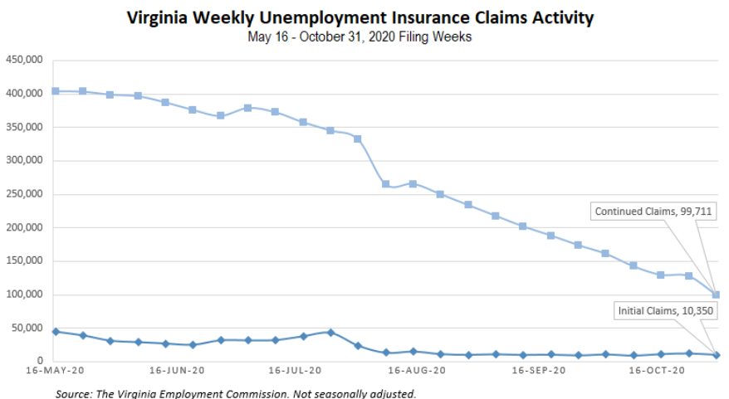
Nationwide, in the week ending October 31, the advance figure for seasonally adjusted initial claims was 751,000, a decrease of 7,000 from the previous week's revised level. The previous week's level was revised up by 7,000 from 751,000 to 758,000. The advance number of actual initial claims under state programs, unadjusted, totaled 738,166 in the week ending October 31, a decrease of 543 (or -0.1 percent) from the previous week. There were 205,625 initial claims in the comparable week in 2019. Looking at preliminary data, most states reported decreases on a seasonally unadjusted basis. Massachusetts’ preliminary weekly change (-9,055) was the largest decrease among states. Georgia’s preliminary weekly change (-7,057) was the second largest decrease. Others included New York (-6,208), Michigan (-5,220), Florida (-4,840), and New Jersey (-3,299). Virginia’s preliminary weekly change (+543) was the thirteenth largest increase while Illinois (+23,200) reported the largest weekly increase in filings.
https://www.vec.virginia.gov/UI-press-release
For additional information on who is claiming unemployment insurance in Virginia, access the VEC’s U.I. claims data dashboard (https://www.vec.virginia.gov/ui-claims-dashboard) that is updated the following Monday after the weekly claims press release.
November 5 - Initial jobless claims drop 16.2% last week; Continued claims three-quarters lower than May peak
The number of initial jobless claims in Virginia dropped by 16.2% last week, the Virginia Employment Commission reported Thursday, and the number of continued claims was three-quarters lower than its May 16 filing week peak.
https://www.virginiabusiness.com/article/initial-jobless-claims-drop-16-2-last-week/

October 29 - Jobless claims fall to 751,000, but new coronavirus infections threaten recovery
The number of Americans seeking unemployment benefits fell last week to 751,000, the lowest since March but a figure that remains historically high and indicates the viral pandemic is still forcing many employers to cut jobs.

https://www.wtvr.com/news/national/us-jobless-claims-aid-fall-to-751-000-as-coronavirus-resurges?fbclid=IwAR2AkPc9Y4w9mr8alyl36N98pRR8q-xJdPFPNnRLAmG-7uA6Iij4e_MoH7w
Other Resources
- Virginia State Resources: https://www.virginia.gov/coronavirus/support-for-businesses/#854620
- FAQs from Workers Regarding Covid-19:
English:https://www.governor.virginia.gov/media/governorvirginiagov/governor-of-virginia/pdf/Frequently-Asked-Questions-from-Workers-Regarding-COVID-19.pdf
Spanish:https://www.governor.virginia.gov/media/governorvirginiagov/governor-of-virginia/pdf/Las-Preguntas-Mas-Frecuentes-para-los-Empleados-Sobre-COVID-19.pdf
- Support for affected workers: https://www.virginia.gov/coronavirus/employment-and-financial-support/#855804
- F.A.Q. on Coronavirus Relief for Small Businesses, Freelancers https://www.nytimes.com/article/small-business-loans-stimulus-grants-freelancers-coronavirus.html
- The Paycheck Protection Program (PPP), a provision of the CARES Act, offers forgivable low-interest loans to small businesses facing uncertainty during the COVID-19 emergency, so businesses can retain workers, maintain payroll, and cover certain other existing overhead costs. https://www.sba.gov/funding-programs/loans/coronavirus-relief-options/paycheck-protection-program-ppp
- COVID 19 Testing Information and Locations: https://www.vdh.virginia.gov/coronavirus/covid-19-testing/

WARN Notices
WARN Notices due to COVID-19 have significantly dropped off in Virginia starting in mid-June 2020. While no single factor can be attributed to this fact, the slow down does not mean that businesses have stopped laying off; many large businesses that were covered by the WARN Act up to this point have likely already felt the pandemic’s impact and reported accordingly. As any new spikes in WARN activity as a result of COVID-19 are reported the charts in this section will be updated accordingly.
http://www.vec.virginia.gov/warn-notices

