COVID-19 Update
Thursday, October 22, 2020
Virginia Daily Key Statistics
(Please note that the VDH and VHHA numbers may vary slightly due to reporting times.)
Virginia’s Daily COVID-19 Statistics-Virginia Department of Health: http://www.vdh.virginia.gov/coronavirus/ (This page is updated daily before 10 AM. Numbers are preliminary and close out at 5 PM the day before posting. Case counts reflect what has been reported to VDH by healthcare providers and laboratories.)
Tests Administered (PCR): 2,431,736 (104,934 or 4.5% increase from last week)
Total Cases: 170,104 (7,163 or 4.4% increase from last week)
Total Hospitalizations: 12,073 (369 or 3.2% increase from last week)
Total Deaths: 3,524 (136 or 4% increase from last week)
Current 7-Day Positivity Rate: 5% (Last Week: 4.7%)
https://www.vdh.virginia.gov/coronavirus/covid-19-in-virginia/
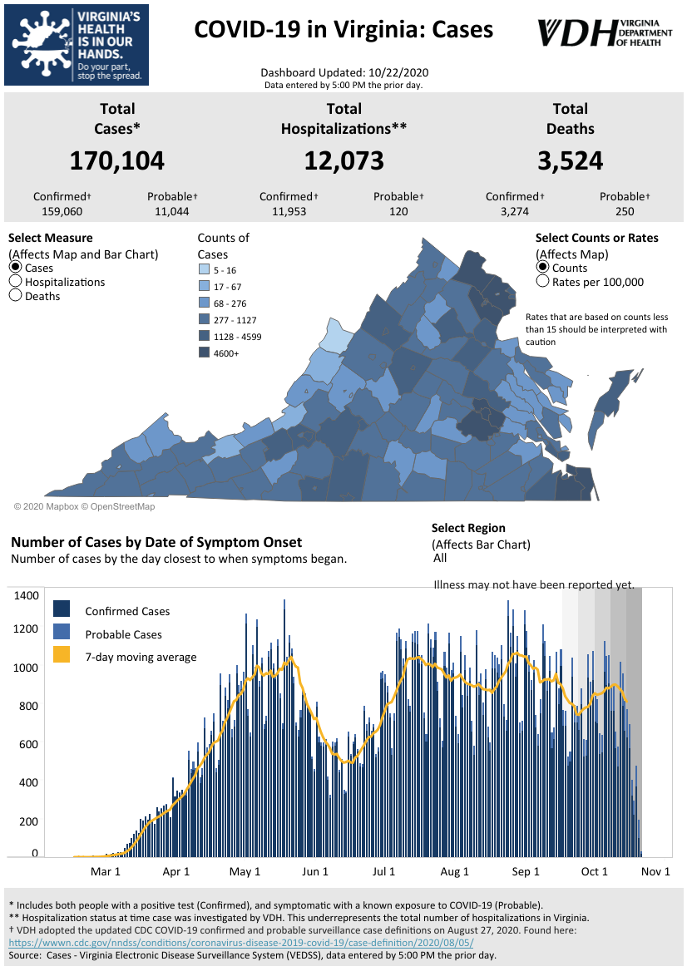
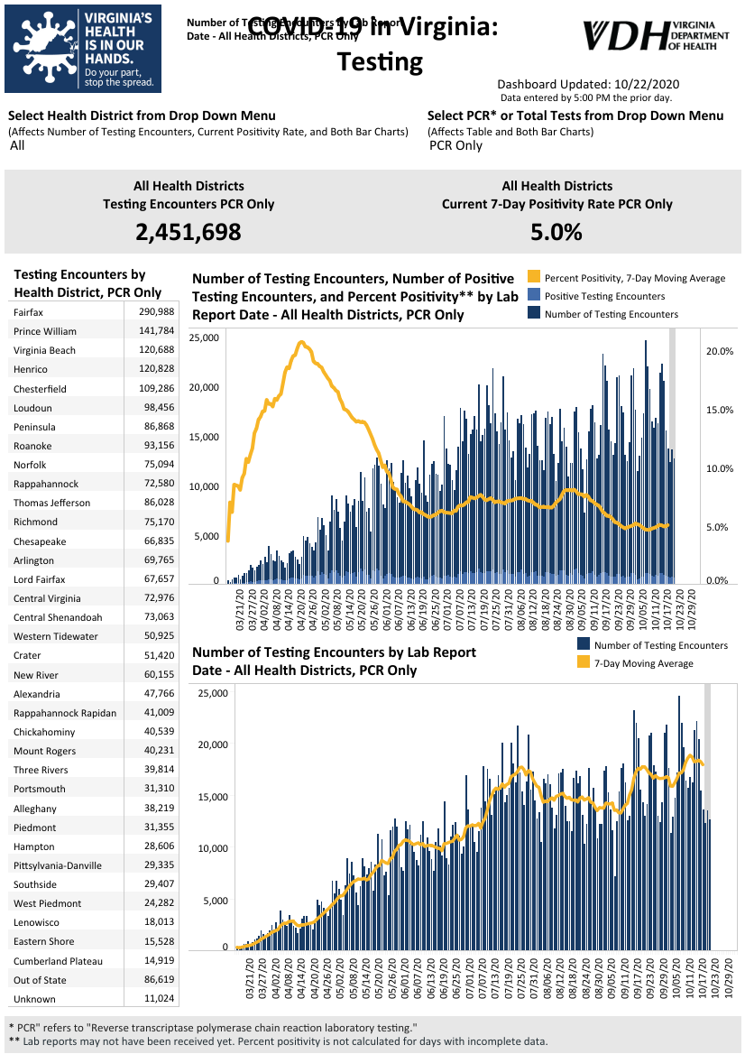
Graphs obtained from Virginia Department of Health: https://www.vdh.virginia.gov/coronavirus/
October 22 - Coronavirus: CDC changes definition of ‘close contact’

The Centers for Disease Control and Prevention have changed its definition of a “close contact,” which impacts the agency’s recommendation on who should quarantine amid the coronavirus pandemic.

WTVR

October 21 - Could Virginia be heading for a new COVID-19 case peak?
Though a University of Virginia model now projects a potential new peak in Virginia COVID-19 cases in November, a top state health official says it’s too soon to tell whether an uptick in cases over the past few weeks is indicative of a bigger trend.

https://www.virginiamercury.com/2020/10/21/could-virginia-be-heading-for-a-new-covid-19-case-peak/

October 20 - Covid is accelerating across the globe as U.S. and Europe head into flu season
The coronavirus pandemic is accelerating across the globe as U.S. cases climb and at least 10 other countries, half in Europe, report record highs in average daily new cases.

https://www.cnbc.com/2020/10/20/covid-is-accelerating-across-the-globe-as-us-and-europe-head-into-flu-season.html
October 21 - More than 1,000 new COVID cases reported in VA Wednesday
The Virginia Department of Health is reporting 168,772 total cases of COVID-19 in the commonwealth as of Wednesday, October 21, going back to the beginning of the pandemic in March. That’s up from 167,754 reported Tuesday, a 1,018-case increase, which is a bigger increase than the 926 new cases reported from Monday to Tuesday.
https://www.wdbj7.com/2020/10/21/more-than-1000-new-covid-cases-reported-in-va-wednesday/
October 20 - Northern Virginia back into moderate range of community transmission of COVID-19
Community transmission of coronavirus in Northern Virginia has moved back into the moderate range for the first time since mid-August, according to new data from the Virginia Department of Health.
…
The northwest and eastern regions of Virginia are also at moderate levels of community transition of the virus, while the southwestern regions are approaching substantial levels of transmission and the central region is experiencing substantial levels of transmission.
https://www.insidenova.com/headlines/northern-virginia-back-into-moderate-range-of-community-transmission-of-covid-19/article_3a2e703e-12df-11eb-99d3-8bf7faea8c39.html
October 20 - Chesterfield, Richmond and Henrico among top 12 counties with highest number of COVID-19 cases in the state, White House report says

ABC News has obtained the most recent weekly White House Coronavirus Task Force briefing for state governors. According to the weekly briefing, Virginia is in the “orange zone” for coronavirus cases.

According to the report, last week Virginia reported 51 to 100 new cases per 100,000 population — the 34th highest rate in the country.

WRIC

Virginia Developments
October 21- Governor Northam Signs New Laws to Support COVID-19 Response, Reform Policing

Governor Ralph Northam today announced he has signed 16 new laws and proposed changes to five bills that will support the Commonwealth’s ongoing COVID-19 response and advance criminal justice reform.
“I am proud to sign new laws that strengthen our COVID-19 response efforts and make our criminal system more equitable,” said Governor Northam. “I am grateful to legislators for their hard work this session, and look forward to signing more critically important legislation in the coming days.”

https://www.governor.virginia.gov/newsroom/all-releases/2020/october/headline-860965-en.html

October 21 - Governor Northam Announces $65.8 Million to Increase Child Care Access,
Help Providers

Governor Ralph Northam and First Lady Pamela Northam today announced $65.8 million in new funding to increase access to child care and support child care providers amid the ongoing COVID-19 pandemic. This new investment is supported by $58.3 million in Coronavirus Relief Fund dollars as well as a reallocation of $7.5 million in Child Care and Development Block Grant (CCDBG) funding through the federal Coronavirus Aid, Recovery, and Economic Security (CARES) Act. First Lady Northam made the announcement during a virtual meeting of the Children’s Cabinet.

https://www.governor.virginia.gov/newsroom/all-releases/2020/october/headline-860972-en.html

October 21 - Masks will be strongly encouraged at Virginia polling places, but not mandatory

Virginia voters who show up on Election Day without a mask or visibly sick will be asked to put a mask on or cast their ballot outside the polling place, but they won’t be denied access if they refuse, according to state election officials.

Virginia Mercury
October 20 - As payouts begin, Virginia Employment Commission says money still left in Lost Wages Assistance program
After weeks of delays, Virginians have started receiving payments from the Lost Wages Assistance program.
https://www.msn.com/en-us/news/us/as-payouts-begin-virginia-employment-commission-says-money-still-left-in-lost-wages-assistance-program/ar-BB1abAA5
October 16 - Commonwealth Identifies New Ways to Return Unclaimed Property to Virginians During COVID-19 Pandemic
Governor Ralph Northam today announced that the Department of the Treasury’s Unclaimed Property Program returned more than $67.8 million in unclaimed property to Virginians in fiscal year 2020, representing over 111,000 asset accounts. New virtual outreach has been implemented this year to assist individuals with filing their claims amid the ongoing COVID-19 pandemic.
https://www.governor.virginia.gov/newsroom/all-releases/2020/october/headline-860880-en.html

PPE, Testing, Treatment, & Vaccines

October 22 - States struggle to draft COVID-19 vaccine plans while in the dark on details, funding

Across the hundreds of pages of plans that state officials sent to the Centers for Disease Control and Prevention on distributing and tracking the yet-to-be-approved COVID-19 vaccines, there are more questions so far than answers on how exactly vaccine programs will be carried out.

https://www.virginiamercury.com/2020/10/22/states-struggle-to-draft-covid-19-vaccine-plans-while-in-the-dark-on-details-funding/

October 21 - Virginia lays out plans for distributing COVID-19 vaccines

While a covid-19 vaccine is not yet available, Virginia is already planning how it will be distributed.

The initial phase one plan would get health care, essential workers and older people vaccinated first.
https://www.nbc12.com/2020/10/21/virginia-lays-out-plans-distributing-covid-vaccines/

October 19 - U.S. DEPARTMENT OF LABOR ISSUES FREQUENTLY ASKED QUESTION AND ANSWER CONFIRMING N95 RESPIRATORS PROTECT AGAINST THE CORONAVIRUS

The U.S. Department of Labor’s Occupational Safety and Health Administration (OSHA) has published a set of Frequently Asked Questions (FAQ) on how N95 respirators effectively protect wearers from coronavirus exposure.

https://www.dol.gov/newsroom/releases/osha/osha20201019-0

Virginia and U.S. Economy
October 21- Amid Continuing Pandemic, Families Wait for Housing Help

Our pandemic reality is precarious. And many Virginians have struggled like never before to keep the lights on and pay the rent.

Since a special session began in the summer, members of the General Assembly have acted on a series of rules intended to provide relief for both tenants and landlords trying to make ends meet.

https://www.wvtf.org/post/amid-continuing-pandemic-families-wait-housing-help#stream/0

October 20 - Va. saw jobs recovery drop in September

After recovering a total of 68,000 jobs in August, Virginia saw its labor force fall by 71,954, or 1.7%, in September, according to employment statistics released Tuesday by the Virginia Employment Commission. Between September 2019 and September 2020, the VEC estimates that Virginia has lost 207,100 jobs a 5.1% decrease.

https://www.virginiabusiness.com/article/va-saw-jobs-recovery-drop-in-september/?utm_source=newsletter&utm_medium=email&utm_campaign=daily

October 15 - CVS to hire thousands of pharmacy techs as it prepares for more Covid-19 cases, rollout of vaccine

CVS Health said Monday that it wants to immediately hire 15,000 employees to prepare for an expected rise in Covid-19 and flu cases this fall and winter.

More than 10,000 of those will be full-time and part-time licensed pharmacy technicians who can help dispense medications and administer Covid-19 tests.

https://www.cnbc.com/2020/10/19/cvs-to-hire-15000-employees-as-it-prepares-more-covid-19-cases-vaccine.html

Education
October 21 - A ‘secret sauce’ to increasing enrollment

Every organization wants to believe they have a special organizational culture, a “secret sauce” that gives rise to special outcomes. Leaders want to believe that a mission statement, a set of core values or goals, permeates their organization and translates into concrete behaviors that generate verifiable and desirable outcomes.

https://www.ccdaily.com/2020/10/a-secret-sauce-to-increasing-enrollment/?fbclid=IwAR2gVXXw-V1DFQtwbqpFtYQjR4io5K11cIB4jJzLAXe2kTDOItot8AJVJyU

October 21 - Can new forms of parent engagement be an education game changer post-COVID-19?
…
While there are many schools and organizations around the globe that have long practiced and advocated for teaching and learning approaches that employ innovative pedagogies and put student agency at the center, they have until now remained the exception rather than the norm. The question is: will the COVID-19 pandemic help change that? In particular, will parents’ recent insight into their children’s learning be a new driver for change?

https://www.brookings.edu/blog/education-plus-development/2020/10/21/can-new-forms-of-parent-engagement-be-an-education-game-changer-post-covid-19/

October 21 - Are The Risks Of Reopening Schools Exaggerated?

Despite widespread concerns, two new international studies show no consistent relationship between in-person K-12 schooling and the spread of the coronavirus. And a third study from the United States shows no elevated risk to childcare workers who stayed on the job.

https://www.npr.org/2020/10/21/925794511/were-the-risks-of-reopening-schools-exaggerated

October 20 - More Virginia colleges scrap traditional spring break

A growing number of Virginia colleges are announcing that spring break will be canceled or modified in an effort to mitigate the spread of COVID-19.

https://www.virginiabusiness.com/article/more-virginia-colleges-scrap-traditional-spring-break/?utm_source=newsletter&utm_medium=email&utm_campaign=daily

October 20 - Colleges turned training for online instruction into overdrive. Can it last?

You can't "unexpand what people now know," one instructor said. But logistics, cost and burnout are likely barriers to permanent virtual expansion.

Students weren't the only ones disrupted when the pandemic forced colleges and universities to shutter their campuses and move activities online.

https://www.educationdive.com/news/colleges-turned-training-for-online-instruction-into-overdrive-can-it-last/586833/
October 20 - Women Are Falling Behind

Large-scale study backs up other research showing relative declines in women's research productivity during COVID-19.

https://www.insidehighered.com/news/2020/10/20/large-scale-study-backs-other-research-showing-relative-declines-womens-research

October 15 - Op-Ed: America’s Community Colleges: Time to Step Up

The country is facing two major workforce crises—one immediate, the other longer-term—that America’s community and technical colleges are uniquely equipped to address.

https://www.jff.org/what-we-do/impact-stories/pathways-to-prosperity-network/americas-community-colleges-time-to-step-up/

October 14 - ‘We Haven’t Begun to Feel the Real Economic Damage’

A Chronicle survey explores the impact of the pandemic on fall enrollments and how colleges are planning for the spring

Two-thirds of institutions responding to a new survey by The Chronicle reported drops in undergraduate enrollment this fall, with community colleges experiencing the steepest declines during a semester of pandemic-fueled challenges.

The Chronicle of Higher Education

October 14 - Despite COVID Recession, Financial Aid Out of Reach for Disadvantaged Students

The price of four year universities in the country have continued to climb over the years, making it more difficult for many families to afford the costs.

That’s the conclusion of a recent study conducted by University of Michigan that found that less students are applying for financial aid, meaning fewer low-income students are applying.

https://wdet.org/posts/2020/10/14/90143-despite-covid-recession-financial-aid-out-of-reach-for-disadvantaged-students/?autoplay=1

Unemployment Data
October 22 - Virginia’s Unemployment Insurance Weekly Claims for Week Ending October 17th
Seasonally unadjusted weekly initial unemployment insurance claims remained elevated and increased by 25% during the latest filing week
The Virginia Employment Commission (VEC) announced that the number of initial claims filed in the October 17 filing week was more than five times the number filed during the comparable week in 2019, according to figures released today.

For the filing week ending October 17, the figure for seasonally unadjusted initial claims in Virginia was 11,365. The latest claims figure was an increase of 2,255 claimants from the previous week but was in line with claims volumes trends seen in recent months following April’s peak.

For the most recent filing week, continued weeks claimed totaled 129,300, which was a 9.1% decrease from the previous week, but 112,532 higher than the 16,768 continued claims from the comparable week last year. This drop indicated a continuation of its recent declining trend. The continued claims total is mainly comprised of those recent initial claimants who continued to file for unemployment insurance benefits during the COVID-19 pandemic.

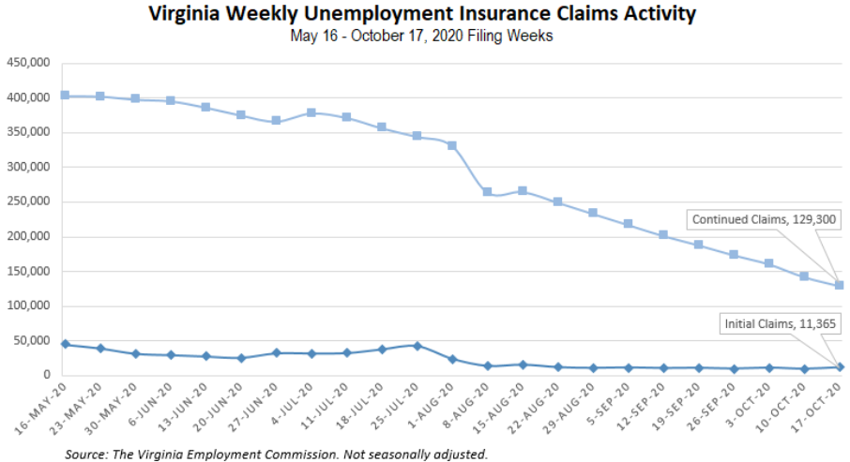
Nationwide, in the week ending October 17, the advance figure for seasonally adjusted initial claims was 787,000, a decrease of 55,000 from the previous week's revised level. The previous week's level was revised down by 56,000 from 898,000 to 842,000. The advance number of actual initial claims under state programs, unadjusted, totaled 756,617 in the week ending October 17, a decrease of 73,125 (or -8.8 percent) from the previous week. There were 186,748 initial claims in the comparable week in 2019. Looking at preliminary data, most states reported decreases on a seasonally unadjusted basis. California’s preliminary weekly change (-17,206) was the largest decrease among states. Florida’s preliminary weekly change (-11,944) was the second largest decrease. Others included Georgia (-10,131), New York (-9,902), Michigan (-9,474), and Washington (-5,768). Virginia’s preliminary weekly change (+4,389) was the third largest increase among states.
https://www.vec.virginia.gov/UI-press-release
PDF: https://www.vec.virginia.gov/sites/default/files/news-12358-Initial%20Claims%20Press%20Release%2010%2017%202020.pdf
For additional information on who is claiming unemployment insurance in Virginia, access the VEC’s U.I. claims data dashboard (https://www.vec.virginia.gov/ui-claims-dashboard) that is updated the following Monday after the weekly claims press release.
October 22 - American jobless claims fall below 800,000 for the first time since mid-March
Claims for unemployment benefits inched lower last week, the Department of Labor said Thursday. Still millions of Americans continue to rely on government aid to make ends meet.
https://www.cnn.com/2020/10/22/economy/unemployment-benefits-coronavirus/index.html
October 20 - The Virginia unemployment rate rose to 6.2 percent in September while total nonfarm payroll employment increased by 9,200
The recent changes in these measures reflect the effects of the coronavirus (COVID-19) pandemic and efforts to contain it.
Virginia’s seasonally adjusted unemployment rate edged upward 0.1 of a percentage point in September to 6.2 percent, which is 3.5 percentage points above the rate from a year ago. According to household survey data in September, the labor force fell by 71,954, or 1.7 percent, to 4,279,495, as the number of unemployed residents declined by 2,546. The number of employed residents decreased by 69,408 to 4,015,630. Virginia’s seasonally adjusted unemployment rate continues to be below the national rate, which fell to 7.9 percent.
Virginia nonagricultural wage and salary employment, from the monthly establishment survey, rose by 9,200 jobs in September to 3,857,100. August’s preliminary estimate was revised downward by 2,300, subtracting from that month’s job gains. In September, private sector employment increased by 20,800 jobs to 3,151,300, while public sector payrolls decreased by 11,600 jobs to 705,800.
Employment rose in nine of eleven major industry sectors, was unchanged in one, and declined in one. The largest job gains during September occurred in leisure and hospitality with an increase of 5,400 jobs to 331,700 and professional and business services (+5,400 jobs) to 740,300. Other increases include trade and transportation (+3,500 jobs) to 647,400, manufacturing (+2,700 jobs) to 228,400, finance (+1,600 jobs) to 208,900, miscellaneous (+1,200 jobs) to 194,500, information (+800 jobs) to 66,200, construction (+100 jobs) to 207,900, and education and health services (+100 jobs) to 518,900. Mining was unchanged at 7,100 jobs over the month while government employment fell by 11,600 jobs to 705,800. Much of the decrease within that sector occurred in local government (-10,300 jobs), but employment also fell in state government (-2,000 jobs), while federal government rose slightly (+700 jobs).
https://www.vec.virginia.gov/latest-release
PDF: https://www.vec.virginia.gov/sites/default/files/news-12356-September2020pressreleaseemhheader.pdf
Other Resources
- Virginia State Resources: https://www.virginia.gov/coronavirus/support-for-businesses/#854620
- FAQs from Workers Regarding Covid-19:
English:https://www.governor.virginia.gov/media/governorvirginiagov/governor-of-virginia/pdf/Frequently-Asked-Questions-from-Workers-Regarding-COVID-19.pdf
Spanish:https://www.governor.virginia.gov/media/governorvirginiagov/governor-of-virginia/pdf/Las-Preguntas-Mas-Frecuentes-para-los-Empleados-Sobre-COVID-19.pdf
- Support for affected workers: https://www.virginia.gov/coronavirus/employment-and-financial-support/#855804
- F.A.Q. on Coronavirus Relief for Small Businesses, Freelancers https://www.nytimes.com/article/small-business-loans-stimulus-grants-freelancers-coronavirus.html
- The Paycheck Protection Program (PPP), a provision of the CARES Act, offers forgivable low-interest loans to small businesses facing uncertainty during the COVID-19 emergency, so businesses can retain workers, maintain payroll, and cover certain other existing overhead costs. https://www.sba.gov/funding-programs/loans/coronavirus-relief-options/paycheck-protection-program-ppp
- COVID 19 Testing Information and Locations: https://www.vdh.virginia.gov/coronavirus/covid-19-testing/

WARN Notices
WARN Notices due to COVID-19 have significantly dropped off in Virginia starting in mid-June 2020. While no single factor can be attributed to this fact, the slow down does not mean that businesses have stopped laying off; many large businesses that were covered by the WARN Act up to this point have likely already felt the pandemic’s impact and reported accordingly. As any new spikes in WARN activity as a result of COVID-19 are reported the charts in this section will be updated accordingly.
http://www.vec.virginia.gov/warn-notices

