COVID-19 Update
Thursday, October 15, 2020
Virginia Daily Key Statistics
(Please note that the VDH and VHHA numbers may vary slightly due to reporting times.)
Virginia’s Daily COVID-19 Statistics-Virginia Department of Health: http://www.vdh.virginia.gov/coronavirus/ (This page is updated daily before 10 AM. Numbers are preliminary and close out at 5 PM the day before posting. Case counts reflect what has been reported to VDH by healthcare providers and laboratories.)
Tests Administered (PCR): 2,326,802 (137,010 or 6.3% increase from last week)
Total Cases: 162,941 (7,406 or 4.8% increase from last week)
Total Hospitalizations: 11,704 11,393 (311 or 2.7% increase from last week)
Total Deaths: 3,388 (60 or 1.8% increase from last week)
Current 7-Day Positivity Rate: 4.7% (Last Week: 4.8%)
COVID in Virginia’s Hospitals Dashboard: https://www.vhha.com/communications/virginia-hospital-covid-19-data-dashboard
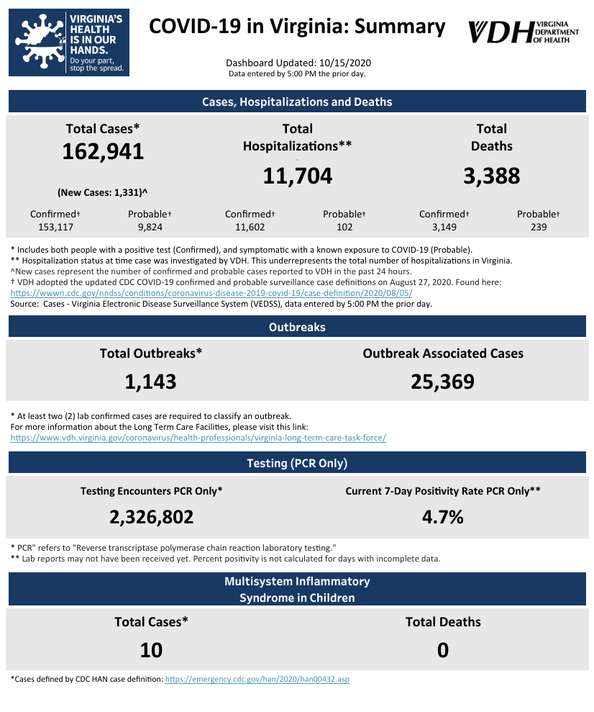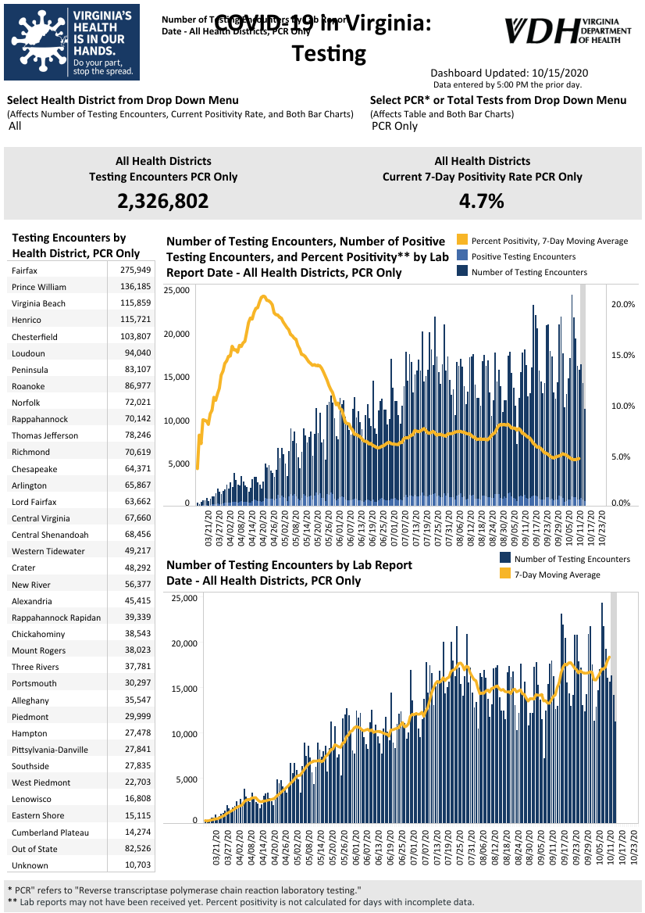Graphs obtained from Virginia Department of Health: https://www.vdh.virginia.gov/coronavirus/
October 15 - Virginia Oct. 15 COVID-19 update: 1,331 new cases, 7 new deaths reported; Va. one of many states seeing case increases
Virginia reported another 1,331 new coronavirus cases on Thursday, the commonwealth’s highest one-day addition since early August.
https://www.wavy.com/news/health/coronavirus/virginia-oct-15-covid-19-update-1331-new-cases-7-new-deaths-reported-va-one-of-many-states-seeing-case-increases/
October 15 - 4 dead, more than 80 infected after COVID-19 outbreak at Virginia retirement community
Chesterfield County’s Health District Director Dr. Alexander Samuel confirms to 8News that more than 80 people have tested positive for coronavirus at Tyler’s Retreat at Iron Bridge.
https://www.wjhl.com/local-coronavirus-coverage/4-dead-more-than-80-infected-after-covid-19-outbreak-at-virginia-retirement-community/
October 14 - Percent positive rate remains steady among VA COVID tests
The Virginia Department of Health is reporting 161,610 total cases of COVID-19 in the commonwealth as of Wednesday, October 14, going back to the beginning of the pandemic in March. That’s up from 160,805 reported Tuesday, an 805-case increase, which is a smaller increase than the 1,235 new cases reported from Monday to Tuesday.
2,292,562 PCR (polymerase chain reaction) tests have been conducted, with a 4.5 percent positive rate over the last week, the same as the percentage reported Monday and Tuesday.
https://www.wdbj7.com/2020/10/14/percent-positive-rate-remains-steady-among-va-covid-tests/
October 14 - Richmond-area COVID-19 Cases and Hospitalizations Continue Rising

Health officials say COVID-19 cases and hospitalizations are rising in the Richmond area.
At a news conference Wednesday afternoon, Dr. Melissa Viray, deputy director of the Richmond City Health Department, said the increase is being driven partly by outbreaks at long term care facilities, but also by exposures at weddings, restaurants and workplaces.

https://www.wvtf.org/post/richmond-area-covid-19-cases-and-hospitalizations-continue-rising#stream/0
October 13 - Virginia reporting highest average of new cases in two months, metrics still down in Hampton Roads
Virginia’s average of new daily coronavirus cases is at its highest point in two months as cases and hospitalizations keep trending up statewide.
The Virginia Department of Health reported 1,235 new cases on Tuesday, bringing the commonwealth’s average up to 1,089 per day. Its cases per 100,000 residents has gone up to 12.8, which is considered high, but the percent of positive tests has gone down due to more overall testing.
Virginia is among dozens of states across the country seeing increases in new cases, with more than 50,000 new cases reported daily across the U.S., per the New York Times. That’s 10,000 more per day compared to a month ago. 700 people on average are dying each day from COVID-19 in the U.S.
https://www.wavy.com/news/health/coronavirus/virginia-oct-13-covid-19-update-virginia-reporting-highest-average-of-new-cases-in-two-months-metrics-still-down-in-hampton-roads/
October 12 - The Covid-19 pandemic has claimed far more lives than reported, study says; On top of that, the U.S. has fared much worse than most high-income countries, a separate study found.
Far more Americans have died as a result of the Covid-19 pandemic than have been counted and reported, according to new research published Monday in the Journal of the American Medical Association.
"For every two Americans that we know of who are dying of Covid-19, another American is dying," said Dr. Steven Woolf, author of the new research and director emeritus of the Center on Society and Health at Virginia Commonwealth University.
https://www.nbcnews.com/health/health-news/covid-19-pandemic-has-claimed-far-more-lives-reported-study-n1242970

Virginia Developments
October 15 - Governor Northam Authorizes Hazard Pay for Home Health Workers
Governor Ralph Northam today announced $73 million in federal Coronavirus Aid, Recovery, and Economic Security (CARES) Act funding to provide hazard pay to home health personal care attendants who served high-risk populations during the early months of the COVID-19 pandemic.
https://www.governor.virginia.gov/newsroom/all-releases/2020/october/headline-860858-en.html
October 14 - Virginia House passes COVID-19 relief, justice reform legislation
Virginia House passed eight bills during its Special Session on Wednesday on police and criminal justice reform and COVID-19 relief.
https://www.nbc12.com/2020/10/14/virginia-house-passes-covid-relief-justice-reform-legislation/
October 14 - Richmond health officials warn city is seeing increase in COVID-19 exposures
The Richmond Health District is sounding a cautionary alarm about COVID-19 cases in the city.
In recent weeks, case numbers have gone up, but Dr. Melissa Viray, Richmond/Henrico Health Districts Deputy Director, says there’s still time to change the trajectory.
NBC12
October 13 - Governor Northam says he has recovered from COVID-19
Governor Northam briefed the commonwealth Tuesday on the status of COVID-19 across the state; it was his first such briefing since he and his wife were diagnosed with the virus last month.
He said he and his wife have been cleared by doctors to leave isolation and are several days removed from symptoms, and have recovered from the virus. He said he was isolated with no contact with other people for 18 days, and 65 staffers were told to quarantine for two weeks after the governor tested positive; he said as far as he has been told, none of those staffers tested positive.
WDBJ
October 13 - HCA Virginia Hospitals host “Crush the Crisis” opioid take-back day October 24
With the opioid crisis still raging throughout the nation, HCA Virginia Hospitals in the Central Virginia area will be taking part in the “Crush the Crisis,” an opioid drug take-back day, which will allow the community to safely dispose of unused or expired opioid medications.
…
“Stress related to the COVID-19 pandemic may be exacerbating the opioid crisis by causing Americans to have feelings of anxiety, grief, social isolation, financial worry, and general uncertainty, all of which can affect those with substance use disorders and those at risk of developing one,” said Dr. Jake O’Shea, chief medical officer of HCA Virginia and HCA Healthcare Capital Division. “Now, more than ever, it’s critically important to get unused pain medications out of homes and to educate the community about the serious threat of opioid misuse and abuse.”
https://henricodoctors.com/about/newsroom/hca-virginia-hospitals-host-crush-the-crisis-opioid-take-back-day-october-24
October 14 - Report shows 4,500 ‘excess deaths’ in Virginia during pandemic

New research from Virginia Commonwealth University shows that an additional 4,500 Virginians died between March and August over would be expected based on historical data — a measure known as excess deaths.

https://www.virginiamercury.com/2020/10/14/deaths-are-increasing-in-virginia-and-across-the-country-but-its-not-all-because-of-covid-19/

October 12 - Carilion Clinic receives $1 million grant for telemedicine in southwest Virginia
Carilion Clinic said Monday that it had received a $947,983 grant for telemedicine expansion.
The grant was awarded by the U.S. Department of Agriculture as part of its 2020 Distance Learning and Telemedicine Grant program.
https://www.wfxrtv.com/news/health/carilion-clinic-receives-1-million-grant-for-telemedicine/
October 10 - Dozens of COVID-19 cases reported at 2 veterans care centers in Virginia
Dozens of COVID-19 cases have been reported at two veterans care centers in Virginia.
The Sitter & Barfoot Veterans Care Center in Richmond has 49 cases impacting 39 residents and 10 staff, the Virginia Department of Veterans Services said Friday.
https://abcnews.go.com/US/dozens-covid-19-cases-reported-veterans-care-centers/story?id=73537122
October 8 - VDEM Announces $1.7M in Supplemental COVID-19 Emergency Management Performance Grant Program Health Equity Awards
The Virginia Department of Emergency Management is announcing $1,792,748 in federal assistance for the Fiscal Year (FY) 2020 COVID-19 Emergency Management Performance Grant Supplemental Health Equity (EMPG-S). The EMPG-S funding was allocated to Virginia as a part of the CARES Act stimulus package in response to COVID-19.
https://www.vaemergency.gov/vdem-announces-1-7m-in-supplemental-covid-19-emergency-management-performance-grant-program-health-equity-awards/
October 8 - How Virginians can receive energy bill assistance during COVID-19
The moratorium on utility service disconnection expired on Monday, but Dominion Energy and The Virginia Department of Social Services are stepping in to help.
Earlier this week, Dominion Energy announced they would not be disconnecting power from their customers.
https://www.wtvr.com/rebound/coronavirus-money-help/how-virginians-can-receive-energy-bill-assistance-during-covid-19

PPE, Testing, Treatment, & Vaccines
October 14 - Eli Lilly and Johnson & Johnson have paused COVID-19 vaccine trials. Why experts say that's reassuring, not frightening.

Recent pauses to two large-scale COVID-19 vaccine trials and a treatment study should reassure people — not frighten them — vaccine experts said, though it is a reminder of the messiness of science.

https://www.usatoday.com/story/news/health/2020/10/13/covid-19-vaccine-trials-on-hold-eli-lilly-johnson-johnson/3643936001/

October 13 - COVID-19 Update: Johnson & Johnson, Pfizer, AstraZeneca Vaccines

Johnson & Johnson pauses trial, Pfizer wants to enroll teens, and fewer Americans are willing to be vaccinated. Here's a roundup of today's news about COVID-19 vaccines.

https://www.managedhealthcareexecutive.com/view/covid-19-update-johnson-johnson-pfizer-astrazeneca-vaccines

October 11 - UVA testing antibody ‘cocktail’ for COVID-19 prevention efforts

Researchers at the University of Virginia are hoping to make a huge impact on COVID-19 prevention efforts with their new antibody cocktail trial, saying it could be the next best thing to a vaccine.

“The idea is that we can prevent infection with people who are being exposed in their homes with a spouse or a roommate who has COVID-19," UVA Infectious Diseases researcher Dr. William Petri said.

https://www.nbc29.com/2020/10/11/uva-testing-antibody-cocktail-covid-prevention-efforts/

October 9 - Virginia is preparing for an unprecedented vaccination campaign. Here’s the state’s plan.
…
Virginia’s plan, released to the Mercury Friday, shows the size and scale of a public health campaign designed to protect millions against a historic virus. The plan was submitted to the federal Centers for Disease Control and Prevention for review this week and remains “a living document as more information is understood, more vaccines are introduced, and any other considerations develop,” wrote Joseph Hilbert, the Virginia Department of Health’s deputy commissioner for governmental and regulatory affairs, in a Friday email.

https://www.virginiamercury.com/2020/10/09/virginia-prepares-for-an-unprecedented-vaccination-campaign/

Virginia and U.S. Economy
October 15 - Va. tourism had record 2019, but 2020 won’t follow suit; Va. Tourism Corp. projects tourism revenue expected to drop by $10B this year

Although Virginia’s tourism industry boasted $27 billion in 2019 visitor spending, the commonwealth’s tourism revenue for 2020 is expected to decrease by $10 billion, a 37% drop compared to last year, according to the Virginia Tourism Corp.

https://www.virginiabusiness.com/article/va-tourism-had-record-2019-but-2020-wont-follow-suit/

October 15- Update on delayed $300 lost wages assistance payment in Virginia

Out-of-work Virginians who expected an extra $300 in lost wages assistance added to their bank account on Thursday, October 15 may have to wait a little longer.
Joyce Fogg, the spokesperson for the Virginia Employment Commission, confirmed to CBS 6 reporter Cameron Thompson that the funds will be released today and should appear in accounts starting today and continuing over the next few days.

WTVR

October 15 - Unemployment benefits delayed two days straight

The Virginia Employment Commission (VEC) says unemployment benefits will be delayed for a couple of days.

The VEC says there are two reasons to blame. Virginia voter registration portal restored after fiber cut caused outage. The first reason being a system outage this week that took services offline for hours and a federal holiday on Monday, making banks closed.

NBC12

October 14- Small Business Administration announces plan to forgive nearly 70% of PPP loans

Millions of small businesses that received Paycheck Protection Program loans have been waiting for answers on how and when their loans would be forgiven. Now, the Small Business Administration has announced a plan that would forgive almost 70% of all the loans it gave out.

WTVR

October 14 - Virginia Releases September 2020 Revenue Report

Governor Ralph Northam today announced that September General Fund revenue increased 7.6 percent from the previous year, driven by growth in payroll withholding, corporate, and recordation tax collections.

“Virginia’s General Fund revenues are increasing, and we have been able to avoid the major revenue shocks that other states are experiencing because of the ongoing pandemic,” said Governor Northam. “This is the result of the proactive measures we have taken to mitigate the impacts of the virus on our economy and put the Commonwealth on the path toward a strong recovery.”

https://www.governor.virginia.gov/newsroom/all-releases/2020/october/headline-860850-en.html

October 13 - Labor market recovery continues but at a slower pace, new survey shows

A report from economists at Virginia Commonwealth University and Arizona State University also shows that some of the earnings losses suffered early in the pandemic were temporary in nature.

The labor market continued its recovery the week of Sept. 27 to Oct. 3, but at a slower pace than at the start of the recovery, according to a report by economists from Virginia Commonwealth University and Arizona State University.

https://news.vcu.edu/article/Labor_market_recovery_continues_but_at_a_slower_pace_new_survey

Education
October 15 - Report: Enrollment Continues to Trend Downward

The National Student Clearinghouse Research Center has bad news. Again.
Its latest fall 2020 enrollment report continues to show downward trajectories nearly across the board in higher education. As of Sept. 24, undergraduate enrollment is now 4 percent lower than it was last fall -- a 1.5-percentage-point decrease from earlier this semester.

Inside Higher Ed

October 14 - Why Virginia colleges have reported vastly different COVID case counts

More than 1,500 students at James Madison University have tested positive for the coronavirus in the past two months. Two other universities in the state, Virginia Tech and the University of Virginia, have reported 1,000 cases or more each.

https://richmond.com/news/local/education/why-virginia-colleges-have-reported-vastly-different-covid-case-counts/article_b9cba800-2467-5734-b196-bab26116a3ac.html

October 14 - Virginia Tech, Radford University offer advice, and tests, as fall breaks near
Midway through the fall semester, Virginia Tech and Radford University are taking efforts to prevent a resurgence of COVID-19, with a mix of dos, don’ts and more tests.
Tech “strongly discouraged” students this week from traveling or hosting visitors over Friday’s Fall Break.

https://roanoke.com/news/local/education/virginia-tech-radford-university-offer-advice-and-tests-as-fall-breaks-near/article_f69853c0-d158-547a-9765-c21ba0a325a7.html

October 13- Strategies colleges used to increase enrollment this fall
While most community colleges have seen a dip in fall enrollments, a sliver of them have actually seen their numbers increase – and it wasn’t by happenstance.

To date, public two-year colleges nationally have seen fall enrollment drop an average of 7.5%. (The National Student Clearinghouse is expected this week to publish updated fall enrollments.) But institutions such as the Community College of Baltimore County in Maryland, Dabney S. Lancaster Community College in Virginia and Edison State Community College in Ohio have bucked the trend with enrollment increases this fall.

https://www.ccdaily.com/2020/10/strategies-colleges-used-to-increase-enrollment-this-fall/

October 13 - UVA to give option of course credit instead of letter grade

The University of Virginia is giving students the option of receiving course credit without a letter grade.

The Daily Progress reported Monday that the move is being made in the wake of students suffering stress, anxiety and internet connectivity troubles in the face of the COVID-19 pandemic.

https://dailyprogress.com/news/state-and-regional/uva-to-give-option-of-course-credit-instead-of-letter-grade/article_abf6f007-1487-5d4f-ab28-d0480d75b0a7.html

Unemployment Data
October 15 - Virginia’s Unemployment Insurance Weekly Claims for Week Ending October 10th
Seasonally unadjusted weekly initial unemployment insurance claims decreased by 16% during the latest filing week and fell to their lowest level since the onset of the Pandemic’s impacts on employment in mid-March
The Virginia Employment Commission (VEC) announced that the number of continued claims filed in the October 10 filing week was nearly two thirds lower than its May 16 peak, according to figures released today.

For the filing week ending October 10, the figure for seasonally unadjusted initial claims in Virginia was 9,110. The latest claims figure was a decrease of 1,733 claimants from the previous week and continued the overall trend of lower claims volumes seen in recent months following April’s peak.

For the most recent filing week, continued weeks claimed totaled 142,220, which was an 11.5% decrease from the previous week, but 125,354 higher than the 16,866 continued claims from the comparable week last year. This drop indicated an acceleration of its recent declining trend. The continued claims total is mainly comprised of those recent initial claimants who continued to file for unemployment insurance benefits during the COVID-19 pandemic.

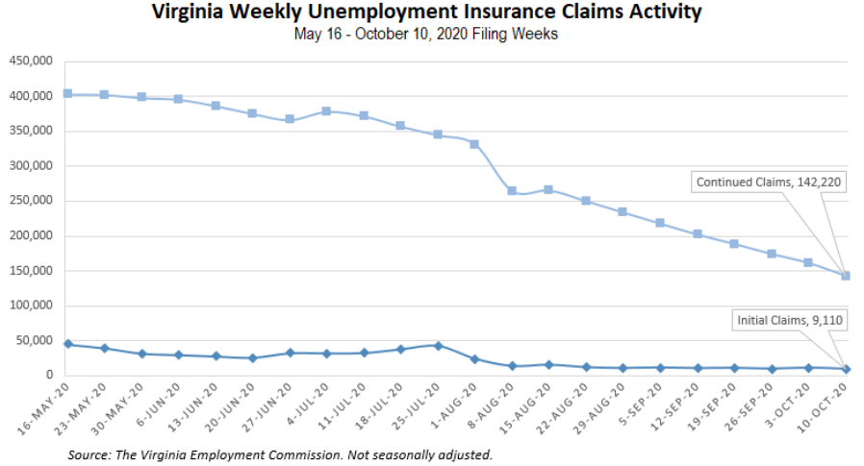
Nationwide, in the week ending October 10, the advance figure for seasonally adjusted initial claims was 898,000, an increase of 53,000 from the previous week's revised level. The previous week's level was revised up by 5,000 from 840,000 to 845,000. The advance number of actual initial claims under state programs, unadjusted, totaled 885,885 in the week ending October 10, an increase of 76,670 (or 9.5 percent) from the previous week. There were 201,677 initial claims in the comparable week in 2019. Looking at preliminary data, most states reported increases on a seasonally unadjusted basis. Indiana’s preliminary weekly change (+18,788) was the largest increase among states. Illinois’ preliminary weekly change (+9,805) was the second largest increase. Others included Massachusetts (+9,582), Georgia (+8,526), Washington (+6,083), and New York (+4,514). Virginia’s preliminary weekly change (+1,162) was the 15th largest increase among states.
PDF of press release: https://www.vec.virginia.gov/sites/default/files/news-12348-Initial%20Claims%20Press%20Release%2010%2010%202020.pdf
For additional information on who is claiming unemployment insurance in Virginia, access the VEC’s U.I. claims data dashboard (https://www.vec.virginia.gov/ui-claims-dashboard) that is updated the following Monday after the weekly claims press release.

October 15 - US jobless claims rise to 898,000 with layoffs still high
The number of Americans seeking unemployment benefits rose last week by the most in two months, to 898,000, a historically high number and evidence that layoffs remain a hindrance to the economy’s recovery from the pandemic recession.
Thursday’s report from the Labor Department coincides with other recent data that have signaled a slowdown in hiring. The economy is still roughly 10.7 million jobs short of recovering all the 22 million jobs that were lost when the pandemic struck in early spring.
https://www.wdbj7.com/2020/10/15/us-jobless-claims-likely-remain-high-as-layoffs-persist/
October 15 - Persistently high U.S. weekly jobless claims point to labor market scarring
The number of Americans filing new claims for jobless benefits rose to a two-month high last week, stoking fears the COVID-19 pandemic was inflicting lasting damage to the labor market.
https://www.reuters.com/article/usa-economy-idUSKBN2701S9

Other Resources
- Virginia State Resources: https://www.virginia.gov/coronavirus/support-for-businesses/#854620
- FAQs from Workers Regarding Covid-19:
English:https://www.governor.virginia.gov/media/governorvirginiagov/governor-of-virginia/pdf/Frequently-Asked-Questions-from-Workers-Regarding-COVID-19.pdf
Spanish:https://www.governor.virginia.gov/media/governorvirginiagov/governor-of-virginia/pdf/Las-Preguntas-Mas-Frecuentes-para-los-Empleados-Sobre-COVID-19.pdf
- Support for affected workers: https://www.virginia.gov/coronavirus/employment-and-financial-support/#855804
- F.A.Q. on Coronavirus Relief for Small Businesses, Freelancers https://www.nytimes.com/article/small-business-loans-stimulus-grants-freelancers-coronavirus.html
- The Paycheck Protection Program (PPP), a provision of the CARES Act, offers forgivable low-interest loans to small businesses facing uncertainty during the COVID-19 emergency, so businesses can retain workers, maintain payroll, and cover certain other existing overhead costs. https://www.sba.gov/funding-programs/loans/coronavirus-relief-options/paycheck-protection-program-ppp
- COVID 19 Testing Information and Locations: https://www.vdh.virginia.gov/coronavirus/covid-19-testing/
WARN Notices
WARN Notices due to COVID-19 have significantly dropped off in Virginia starting in mid-June 2020. While no single factor can be attributed to this fact, the slow down does not mean that businesses have stopped laying off; many large businesses that were covered by the WARN Act up to this point have likely already felt the pandemic’s impact and reported accordingly. As any new spikes in WARN activity as a result of COVID-19 are reported the charts in this section will be updated accordingly.
http://www.vec.virginia.gov/warn-notices

