COVID-19 Update
Thursday, October 1, 2020
Virginia Daily Key Statistics
(Please note that the VDH and VHHA numbers may vary slightly due to reporting times.)
Virginia’s Daily COVID-19 Statistics-Virginia Department of Health: http://www.vdh.virginia.gov/coronavirus/ (This page is updated daily before 10 AM. Numbers are preliminary and close out at 5 PM the day before posting. Case counts reflect what has been reported to VDH by healthcare providers and laboratories.)
Tests Administered (PCR): 2,074,236 (121,271 or 6.2% increase from last week)
Total Cases: 148,721 (5,229 or 3.6% increase from last week)
Total Hospitalizations: 11,092 (323 or 3% increase from last week)
Total Deaths: 3,228 (115 or 3.7% increase from last week)
Current 7-Day Positivity Rate: 4.5% (Last Week: 5.3%)
COVID in Virginia’s Hospitals Dashboard: https://www.vhha.com/communications/virginia-hospital-covid-19-data-dashboard
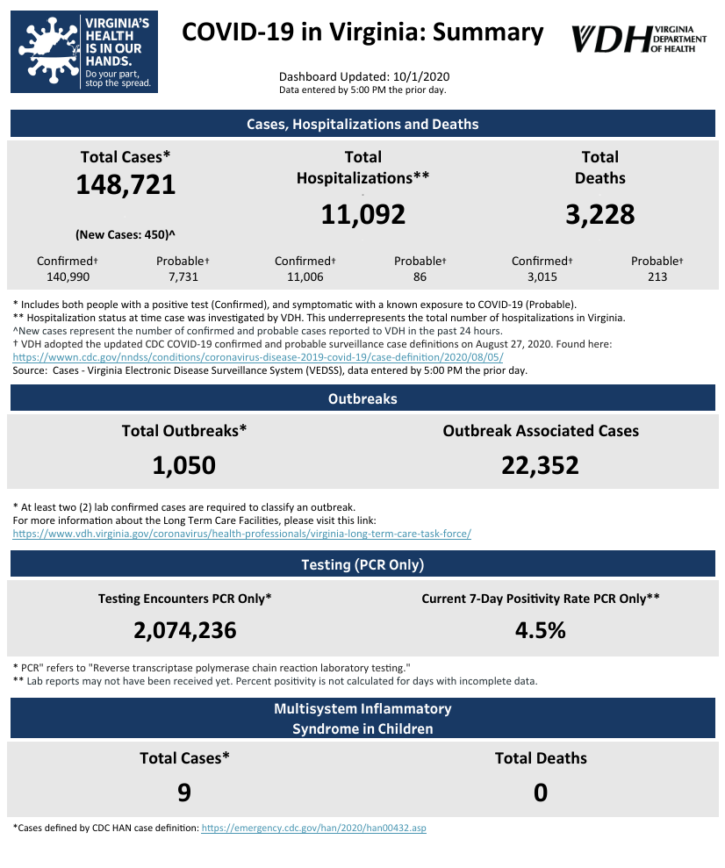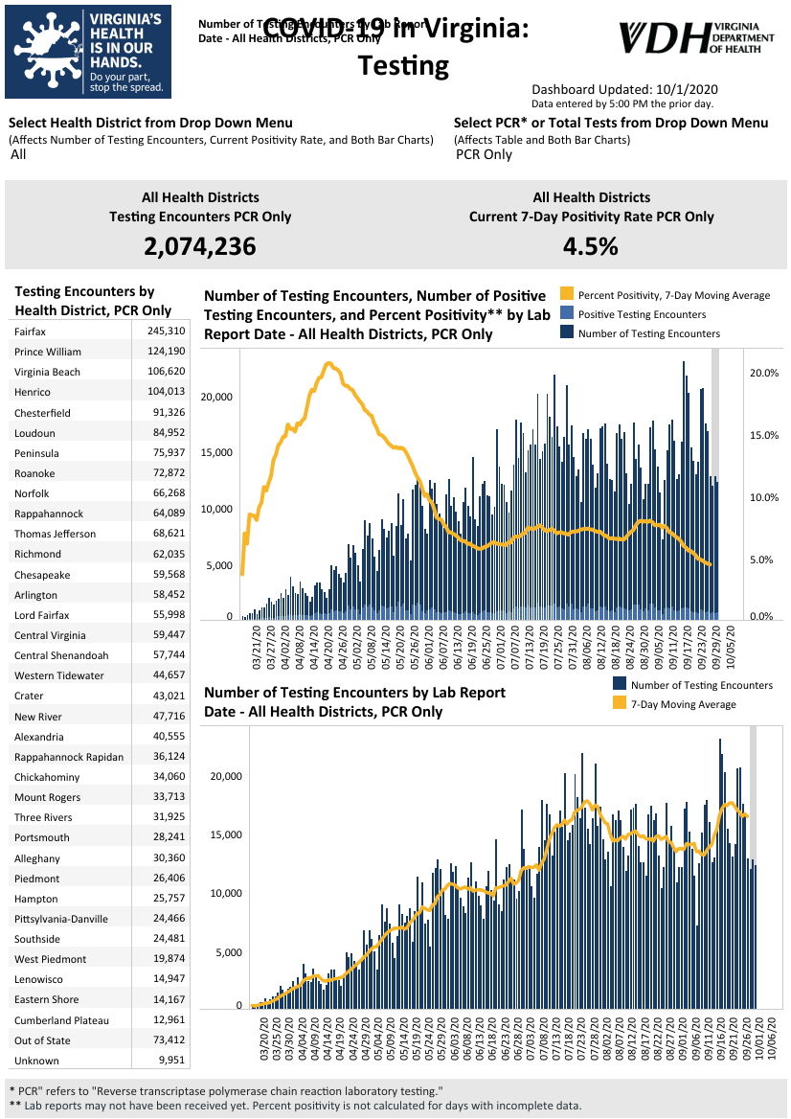Graphs obtained from Virginia Department of Health: https://www.vdh.virginia.gov/coronavirus/

October 1 - COVID-19 cases increase by 450 in 24 hours | State’s testing rate under 5% for sixth consecutive day

The Virginia Department of Health (VDH) reported 148,721 total positive coronavirus tests throughout the state Thursday - a 450 case increase in the last 24 hours.
The state totals stand at 3,228 deaths with 11,092 hospitalizations since the pandemic began.

https://www.nbc12.com/2020/09/30/covid-cases-increase-by-hours-states-testing-rate-under-sixth-consecutive-day/?fbclid=IwAR1JV3PA_kW7QRgxXBnRD6aJG07HBb55dDhm8YykjEHg7RRr_rKrhesbtCw

October 1 - Virginia Launches New Open Data Portal to Enhance COVID-19 Response and Recovery

Governor Ralph Northam today announced that the Virginia Open Data Portal now includes more than a dozen new COVID-19 datasets from the Virginia Department of Health. The launch of the new Virginia Open Data Portal, which is a collaboration between the Office of the Chief Data Officer and the Library of Virginia, was accelerated amid the ongoing COVID-19 pandemic to provide greater access to the data informing public health officials and allow Virginians to interact with it.
https://www.governor.virginia.gov/newsroom/all-releases/2020/october/headline-860664-en.html

October 1 - COVID-19 in Virginia: LIVE updates for Thursday, October 1

In an effort to provide accurate, easy-to-read information on the on-going COVID-19 outbreak and its impact on our community, WTVR.com will update this post with the day's local coronavirus headlines and statistics.

https://www.wtvr.com/news/coronavirus/covid-19-in-virginia-live-updates-for-thursday-october-1?fbclid=IwAR2THHJkAFHcfJJRIE1tsINE2moyauBrToIKVWLATqwfPnS2Cq_HlZRWUfA

September 29 - Virginia, Northern Virginia see slight uptick in COVID-19 cases; test positivity rates remain low

As the world suffered its 1 millionth death due to COVID-19, Virginia and Northern Virginia reported a slight uptick in the number of new coronavirus cases on Tuesday, as often happens after several days of a downward trend.

However, the state's seven-day average test positivity rate fell to 4.6%, marking the fourth straight day it has been below 5%, according to the Virginia Department of Health. The seven-day average test positivity rate in the Prince William health district fell to a low of 6%; it was as high as 36.7% on April 18.

https://www.insidenova.com/headlines/virginia-northern-virginia-see-slight-uptick-in-covid-19-cases-test-positivity-rates-remain-low/article_e17bd168-0260-11eb-982f-5b58d1d2c3f6.html

September 29 - Virginia lawmakers warn of ‘deteriorating’ conditions in two federal prisons as COVID-19 spreads

Members of Virginia’s congressional delegation from both political parties are pressing the U.S. Department of Justice’s internal watchdogs to include two state correctional facilities in the agency’s ongoing inspections during the pandemic.

https://www.virginiamercury.com/2020/09/29/virginia-lawmakers-warn-of-deteriorating-conditions-in-two-federal-prisons-as-covid-19-spreads/

September 29 - 31 prison inmates with coronavirus have died in Virginia
Figures from the Virginia Department of Corrections show that 31 prison inmates with COVID-19 have died since the start of the pandemic.

The Richmond Times-Dispatch reported Tuesday that the highest toll has been at the Deerfield Correctional Center. It’s home to many geriatric prisoners and prisoners with chronic health problems.

https://wtop.com/virginia/2020/09/31-prison-inmates-with-coronavirus-have-died-in-virginia/

September 28 - Virginia health department launches pandemic dashboard tied to CDC school reopening metrics

The Virginia Department of Health has launched a new pandemic dashboard, designed in part to help localities determine whether it's safe to reopen schools and when to adopt mitigation measures if necessary to control the spread of COVID-19.

Some of the information from the dashboard has been provided to local governments and health departments since the summer, but it is now being made available publicly and will be updated regularly.

https://www.insidenova.com/headlines/virginia-health-department-launches-pandemic-dashboard-tied-to-cdc-school-reopening-metrics/article_7f9c9ef2-01b9-11eb-bac0-8f2e55600a59.html

September 27 - Virginia COVID-19 hospitalizations at lowest level since early July

Hospitalizations for treatment of COVID-19 fell to their lowest levels statewide in nearly three months, the Virginia Hospital and Healthcare Association reported Sunday morning.

The association, which has been providing data on COVID-19 patients at the state's 115 hospitals since early April, said 868 patients were hospitalized, the lowest level since July 6, when only 783 were hospitalized. Hospitalizations statewide peaked at 1,625 on May 8. The number of hospitalized patients has tended to be lower on weekends, but it has now been fewer than 1,000 every day since Sept. 17.

https://www.insidenova.com/headlines/virginia-covid-19-hospitalizations-at-lowest-level-since-early-july/article_07cd9520-00c9-11eb-8f51-47e58b3241d7.html

Virginia Developments

September 30 - Virginia removed from travel advisory lists in New York, New Jersey, Connecticut

The state health departments in New York, New Jersey, and Connecticut updated their travel advisory lists on Tuesday and removed Virginia from their lists. The other state removed was Arizona while Colorado was added.
https://www.wtkr.com/news/virginia-dropped-from-travel-advisory-lists-in-new-york-new-jersey-connecticut
September 28 - Governor Northam Announces More Than $1.7 Million for Projects That Help Virginians Impacted by COVID-19 on the Peninsula
Governor Ralph Northam today announced more than $1.7 million in Community Development Block Grants (CDBG) for three projects in James City and York counties and the city of Williamsburg that will assist local governments and community partners in meeting the needs of Virginia families and small businesses impacted by the ongoing COVID-19 pandemic.

https://www.governor.virginia.gov/newsroom/all-releases/2020/september/headline-860633-en.html

September 28 - Governor Northam Announces More Than $8.4 Million to Support COVID-19 Recovery and Response Efforts in Rural Virginia
Governor Ralph Northam today announced more than $8.4 million in Community Development Block Grants (CDBG) for 14 projects that will help rural communities across Virginia respond to recover from the public health and economic impacts of the COVID-19 pandemic.
https://www.governor.virginia.gov/newsroom/all-releases/2020/september/headline-860632-en.html

PPE, Testing, and Treatment

September 30 - Huge Study of Coronavirus Cases in India Offers Some Surprises to Scientists

With 1.3 billion people jostling for space, India has always been a hospitable environment for infectious diseases of every kind. And the coronavirus has proved to be no exception: The country now has more than six million cases, second only to the United States.

https://www.nytimes.com/2020/09/30/health/covid-india-children.html?campaign_id=9&emc=edit_nn_20201001&instance_id=22691&nl=the-morning&regi_id=117602237&section_index=2&section_name=the_latest_news&segment_id=39520&te=1&user_id=6f1448f3fcade225296d82c1d20d7605

September 30 - PPE Acquisition Less Of A Challenge Than At Beginning Of Pandemic

In the early days of the COVID-19 pandemic, a plethora of problems created delays for health care providers trying to obtain personal protective equipment such as medical gowns, masks and gloves.

However, after months of the pandemic, many problems in the PPE supply chain have diminished, according to state health care groups.

https://www.dnronline.com/news/shenandoah_valley_business_journal/ppe-acquisition-less-of-a-challenge-than-at-beginning-of-pandemic/article_6e98ce59-b6a2-5a2c-aad6-a1cd44089408.html

September 25 - Here’s How the Pandemic Finally Ends

The microscopic bundles of RNA, wrapped in spiky proteins, latch on to human cells, hijack them, use them as factories to replicate, and then leave them for dead. It’s a biological blitzkrieg—an invasion so swift and unexpected that the germs are free to jump from host to host with little interference.

https://www.politico.com/news/magazine/2020/09/25/how-covid-19-pandemic-ends-421122

Virginia and U.S. Economy

October 1 - Top U.S. airlines starting 32,000 furloughs as bailout hopes fade

American Airlines and United Airlines, two of the largest U.S. carriers, said they were beginning furloughs of over 32,000 workers on Thursday as hopes faded for a last-minute bailout from Washington.

https://www.reuters.com/article/us-health-coronavirus-usa-airlines/top-u-s-airlines-starting-32000-furloughs-as-bailout-hopes-fade-idUSKBN26L0KV

September 30 - AHLA: Va. stands to lose 86K+ hotel jobs without federal support

Virginia stands to lose 86,821 hotel-related jobs if Congress doesn’t extend Paycheck Protection Program loans or expand the Main Street Lending program, according to projections released Wednesday by the American Hotel & Lodging Association (AHLA) — and the state may lose all but about 500 hotels to foreclosure.

https://www.virginiabusiness.com/article/ahla-va-stands-to-lose-86k-hotel-jobs-without-federal-support/?utm_source=newsletter&utm_medium=email&utm_campaign=daily

September 28 - How the U.S. economic response to the coronavirus pandemic stacks up to the rest of the world
The world reached a grim milestone as 1 million people have died from the coronavirus since the pandemic started, with more than 200,000 of those deaths coming from the U.S. alone.

But while the U.S. health response to the coronavirus pandemic has faced criticism, the economic response has been among the best in the world.

https://www.cnbc.com/2020/09/28/how-the-us-economic-response-to-the-coronavirus-pandemic-stacks-up-to-the-rest-of-the-world.html

Education

October 1 - COVID-19 clusters pop up at VMI, W&L
The number of coronavirus cases in Lexington has nearly doubled in the last week as both Virginia Military Institute and Washington and Lee University report dozens of infections.

https://roanoke.com/news/local/covid-19-clusters-pop-up-at-vmi-w-l/article_97c9e4ef-d789-5bc5-b8c6-a7e6db5f56b6.html#tracking-source=home-top-story

October 1 - Liberty University reports 121 active COVID-19 cases
Liberty University on Wednesday reported 121 active COVID- 19 cases among its students and employees, continuing a downward trend from the peak of 141 cases reported two weeks earlier.

https://newsadvance.com/news/local/liberty-university/liberty-university-reports-121-active-covid-19-cases/article_87cfb650-152c-53c1-92a4-f9cb610c1a03.html

September 30 - Virginia Tech to test those at higher risk for COVID-19; total cases reach 1,000

Virginia Tech will begin more frequent testing of students and employees at higher risk of contracting the virus that causes COVID-19, the university announced Wednesday.

Tech President Tim Sands made the announcement on the same day the university reached 1,000 positive cases of the coronavirus since early August.

https://roanoke.com/news/local/education/virginia-tech-to-test-those-at-higher-risk-for-covid-19-total-cases-reach-1/article_4abb4307-2f57-5378-8119-f23da44f5261.html#tracking-source=home-top-story-1

September 30 - Virginia colleges and universities see drop in enrollment, but far less than initially anticipated
Early head counts from Virginia’s colleges and universities show an overall 1.3 percent decline in student enrollment this fall — a total of 6,658 students, according to a new report from the State Council of Higher Education for Virginia.

https://www.virginiamercury.com/2020/09/30/virginia-colleges-and-universities-see-drop-in-enrollment-but-far-less-than-initially-anticipated/

September 29 - Fall enrollment down nearly 10% at community colleges

Early estimates indicate that fall enrollment at Virginia’s community colleges is down nearly 10% compared to fall 2019, and down by 6.6% at private four-year universities, according to the State Council of Higher Education for Virginia in a study released Tuesday. However, public four-year universities are holding steady, with enrollment down by only 0.2%.

https://www.virginiabusiness.com/article/fall-enrollment-down-nearly-10-at-community-colleges/?utm_source=newsletter&utm_medium=email&utm_campaign=daily

September 29 - First $1,000 job training grants given to VA Ready scholars affected by pandemic

Launched in late July, a program aimed at encouraging unemployed Virginians to pursue new careers has already awarded 20 participants $1,000 each for earning job training credentials. Of those, 17 people have found new jobs, all with Newport News Shipbuilding.

https://www.dailypress.com/business/jobs/vp-bz-coronavirus-va-ready-20200929-tx73k7hxgvdjjhlchaops6jnpe-story.html

September 29 - New Virginia COVID-19 site guiding school re-entry weathers early glitches

Virginia’s new pandemic metrics dashboard, meant as a resource to help local school administrators determine whether it is safe for in-person learning to resume, was operating smoothly by mid-morning Tuesday after initial technical problems.

The Virginia Department of Health’s specialized dashboard will assist communities in monitoring case trends, disease transmission and the availability of hospital beds — but for hours after its debut Monday, many of the site’s features were not accessible.

https://wtop.com/virginia/2020/09/glitches-mar-launch-of-new-virginia-covid-19-site-guiding-school-re-entry/
September 28 - Inside pandemic-era schools: Quiet hallways, masks and more reliance on technology
On Friday afternoon, William Byrd High School history teacher Cristy Spencer spent the first few minutes of class talking honestly with the seven students seated in front of her.
“This is hard,” she told them.

https://roanoke.com/news/local/inside-pandemic-era-schools-quiet-hallways-masks-and-more-reliance-on-technology/article_af89c19c-079f-5589-9333-878515b90d14.html#tracking-source=home-top-story

Unemployment Data
Virginia’s Unemployment Insurance Weekly Claims for Week Ending September 26th
~ Seasonally unadjusted weekly initial unemployment insurance claims decreased by 11.4% during the latest filing week and fell to their lowest level since the onset of the Pandemic’s impacts on employment in mid-March ~

The Virginia Employment Commission (VEC) announced that the number of initial claims filed from mid-March through the September 26, 2020 filing week totaled 1,167,032, or 28.4%, of pre-pandemic payroll employment, according to figures released today.

For the filing week ending September 26, the figure for seasonally unadjusted initial claims in Virginia was 9,377. The latest claims figure was a decrease of 1,205 claimants from the previous week and continued the overall trend of lower claims volumes seen in recent months following April’s peak.

For the most recent filing week, continued weeks claimed totaled 173,717, which was a 7.7% decrease from the previous week, but 156,577 higher than the 17,140 continued claims from the comparable week last year. They have declined at a consistent pace since mid-August—around 6.8% a week. The continued claims total is mainly comprised of those recent initial claimants who continued to file for unemployment insurance benefits during the COVID-19 pandemic.

For additional information on who is claiming unemployment insurance in Virginia, access the VEC’s U.I. claims data dashboard (https://www.vec.virginia.gov/ui-claims-dashboard) that is updated no later than the following Monday after the weekly claims press release.

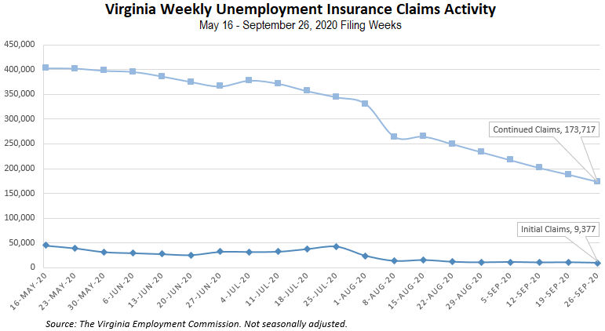
Nationwide, in the week ending September 26, the advance figure for seasonally adjusted initial claims was 837,000, a decrease of 36,000 from the previous week's revised level. The previous week's level was revised up by 3,000 from 870,000 to 873,000. The advance number of actual initial claims under state programs, unadjusted, totaled 786,942 in the week ending September 26, a decrease of 40,263 (or -4.9 percent) from the previous week. There were 172,968 initial claims in the comparable week in 2019. Looking at preliminary data, most states reported decreases on a seasonally unadjusted basis. Florida’s preliminary weekly change (-9,668) was the largest decrease among states. Others included Texas (-8,353), Georgia (-6,349), New York (-3,222), and Oregon (-2,762). Virginia’s preliminary weekly change (+681) was the seventh largest increase.
PDF of press release:
https://www.vec.virginia.gov/sites/default/files/news-12303-Initial%20Claims%20Press%20Release%209%2026%202020.pdf
For additional information on who is claiming unemployment insurance in Virginia, access the VEC’s U.I. claims data dashboard (https://www.vec.virginia.gov/ui-claims-dashboard) that is updated the following Monday after the weekly claims press release.

September 29 - Unemployed workers will see a delay in $300-a-week unemployment benefits in Virginia

Unemployed Virginians will have to wait a little longer for extra help. A new federal program that would provide more money is now delayed by two weeks.

The news came days before unemployed workers expected to receive that money.

https://www.13newsnow.com/article/money/unemployed-workers-will-see-a-delay-in-300-a-week-unemployment-benefits-in-virginia/291-31f59d5a-8a3f-4576-a61d-5ae09fb2df9c

September 28 - Stimulus Update: $2.2 Trillion Stimulus Package Proposal Unveiled, Includes $1,200 Stimulus Checks And $600 Unemployment Benefits

Nancy Pelosi and House Democrats unveiled a revised coronavirus stimulus package proposal earlier today. The relief package is an updated version of the $3.4 trillion HEROES Act that House Democrats passed in May and comes in at $2.2 trillion in cost. This bill “provides the absolutely needed resources to protect lives, livelihoods and the life our democracy over the coming months,” said Pelosi in a letter to her Democratic colleague.

https://www.forbes.com/sites/shaharziv/2020/09/28/stimulus-update-22-trillion-stimulus-package-proposal-unveiled-includes-1200-stimulus-checks-and-600-unemployment-benefits/#2389c34b5b21

September 24 - Unemployment in Virginia continue to decline, but questions regarding benefits continue

At its peak in April, initial unemployment claims in Virginia rose to 147,000. Since then it has been declining, but many people who are still unemployed due to COVID-19 continue to have questions regarding their benefits.

“Still trying to help people find jobs, and there are plenty of jobs out there. There are over 400,000 on the website that are advertised,” Joyce Fogg with the Virginia Employment Commission said.

However, even with jobs available, the latest numbers show just over 10,000 people are filing an initial claim and more than 201,000 are filing continued claims.

https://www.whsv.com/2020/09/23/unemployment-in-virginia-continue-to-decline-but-questions-regarding-benefits-continue/

September 24 - Unemployment rates down in 41 states, July 2020 to August 2020

Unemployment rates were lower in August 2020 in 41 states, higher in 2 states, and stable in 7 states and the District of Columbia. All 50 states and the District had jobless rate increases from a year earlier. The national unemployment rate fell by 1.8 percentage points over the month to 8.4 percent but was 4.7 points higher than in August 2019.

https://www.bls.gov/opub/ted/2020/unemployment-rates-down-in-41-states-july-2020-to-august-2020.htm

September 24 - Another 870,000 Americans file new unemployment claims

New US jobless claims reach 870,000 last week as layoffs remain elevated 6 months after the coronavirus pandemic struck the economy. This is roughly the same number as the week before who filed new claims. These numbers do not include those who file with a special government program meant to help those in the "gig economy" and otherwise are not eligible for traditional unemployment.

The number of people seeking unemployment benefits each week is still high, and the economy has recovered only about half the 22 million jobs that were lost to the pandemic.

https://www.wtvr.com/news/national/coronavirus/another-870-000-americans-file-new-unemployment-claims

September 24 - U.S. Risks Repeating 2009 Mistakes as Economic Recovery Slows

In the wake of the last recession, government spending dried up, dragging out the recovery. Policymakers warn against letting it happen again.

https://www.nytimes.com/2020/09/24/business/economy/us-economy-pandemic.html

Other Resources
- Virginia State Resources: https://www.virginia.gov/coronavirus/support-for-businesses/#854620
- FAQs from Workers Regarding Covid-19:
English:https://www.governor.virginia.gov/media/governorvirginiagov/governor-of-virginia/pdf/Frequently-Asked-Questions-from-Workers-Regarding-COVID-19.pdf
Spanish:https://www.governor.virginia.gov/media/governorvirginiagov/governor-of-virginia/pdf/Las-Preguntas-Mas-Frecuentes-para-los-Empleados-Sobre-COVID-19.pdf
- Support for affected workers: https://www.virginia.gov/coronavirus/employment-and-financial-support/#855804
- F.A.Q. on Coronavirus Relief for Small Businesses, Freelancers https://www.nytimes.com/article/small-business-loans-stimulus-grants-freelancers-coronavirus.html
- The Paycheck Protection Program (PPP), a provision of the CARES Act, offers forgivable low-interest loans to small businesses facing uncertainty during the COVID-19 emergency, so businesses can retain workers, maintain payroll, and cover certain other existing overhead costs. https://www.sba.gov/funding-programs/loans/coronavirus-relief-options/paycheck-protection-program-ppp
- COVID 19 Testing Information and Locations: https://www.vdh.virginia.gov/coronavirus/covid-19-testing/

WARN Notices
WARN Notices due to COVID-19 have significantly dropped off in Virginia starting in mid-June 2020. While no single factor can be attributed to this fact, the slow down does not mean that businesses have stopped laying off; many large businesses that were covered by the WARN Act up to this point have likely already felt the pandemic’s impact and reported accordingly. As any new spikes in WARN activity as a result of COVID-19 are reported the charts in this section will be updated accordingly.
http://www.vec.virginia.gov/warn-notices

Virginia News
Virginia Mercury: https://www.virginiamercury.com/

National News
Sign up for The New York Times Morning Briefing: https://www.nytimes.com/series/us-morning-briefing
The Daily podcast: https://www.nytimes.com/column/the-daily

