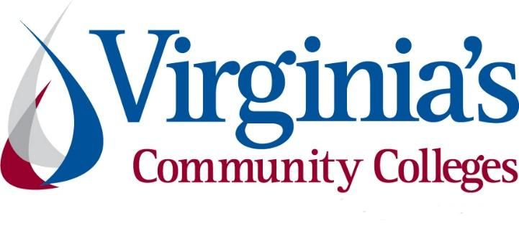
COVID-19 Update
Thursday, October 8, 2020
Virginia Daily Key Statistics
(Please note that the VDH and VHHA numbers may vary slightly due to reporting times.)
Virginia’s Daily COVID-19 Statistics-Virginia Department of Health: http://www.vdh.virginia.gov/coronavirus/ (This page is updated daily before 10 AM. Numbers are preliminary and close out at 5 PM the day before posting. Case counts reflect what has been reported to VDH by healthcare providers and laboratories.)
The case count reported on Thursday, October 8, includes 689 cases that should have been reported on Wednesday, October 7, but were not because of a surveillance system reporting issue.
Tests Administered (PCR): 2,189,792 (115,556 or 5.6% increase from last week)
Total Cases: 155,535 (6,814 or 4.6% increase from last week)
Total Hospitalizations: 11,393 (301 or 2.7% increase from last week)
Total Deaths: 3,328 (100 or 3.1% increase from last week)
Current 7-Day Positivity Rate: 4.8% (Last Week: 4.5%)
COVID in Virginia’s Hospitals Dashboard: https://www.vhha.com/communications/virginia-hospital-covid-19-data-dashboard
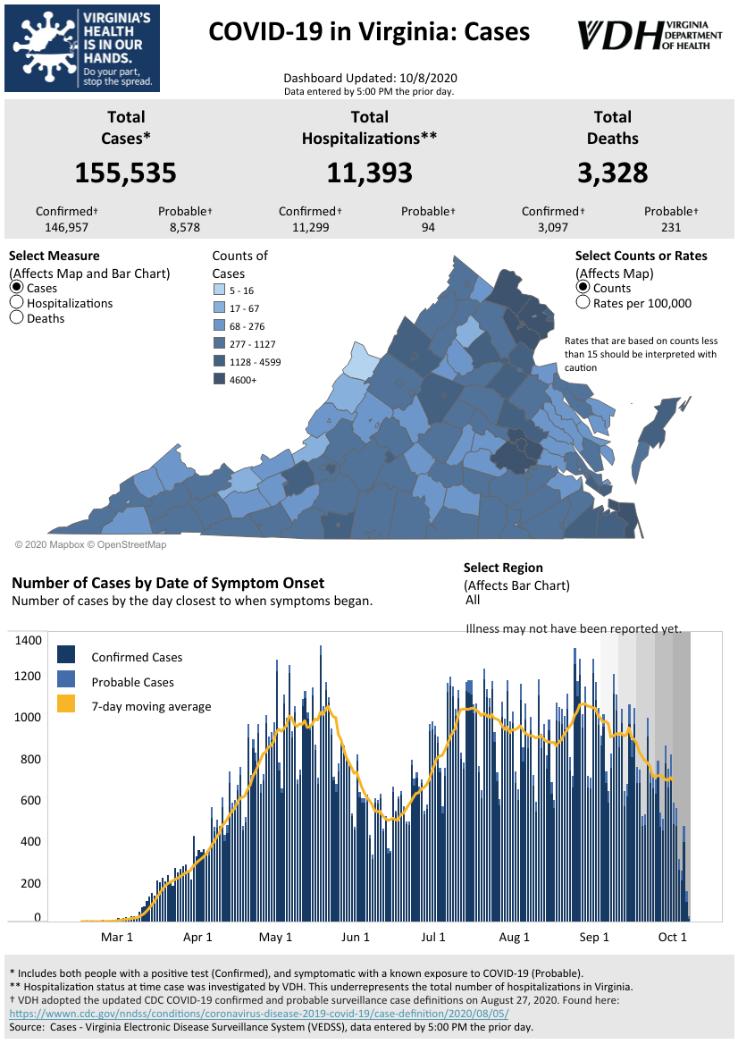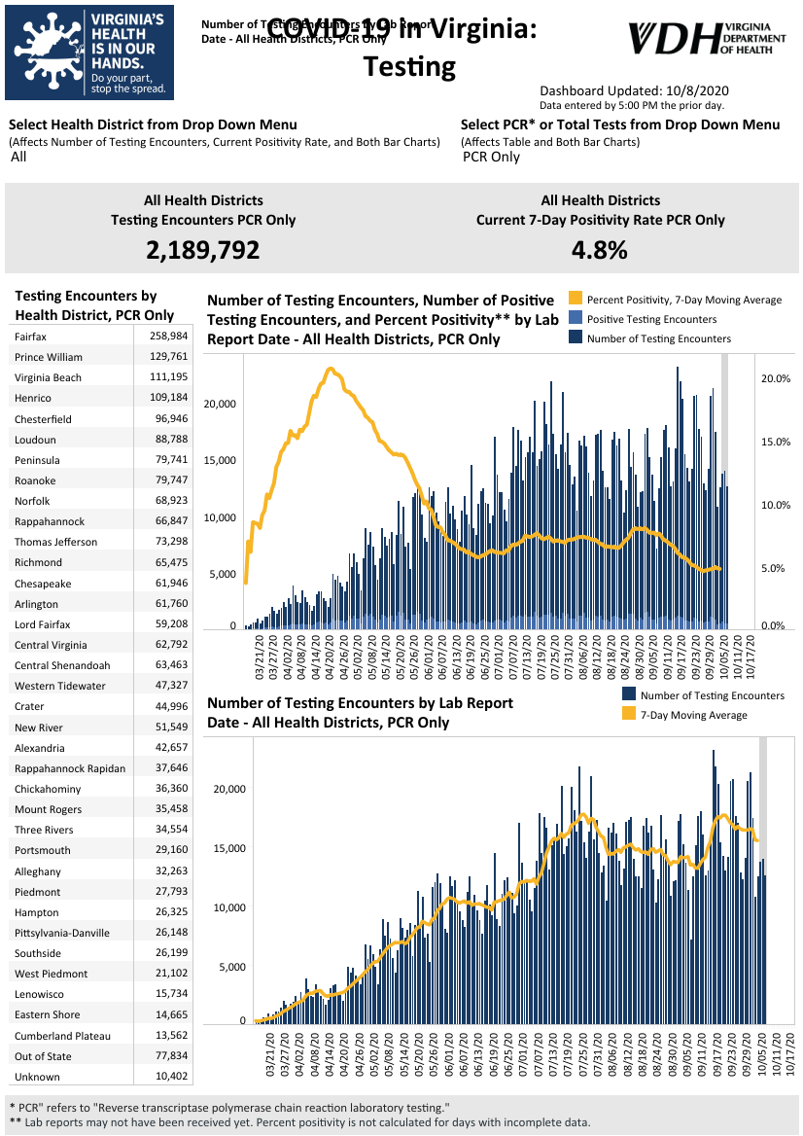Graphs obtained from Virginia Department of Health: https://www.vdh.virginia.gov/coronavirus/
October 8 - New cases of COVID-19 in Virginia more than triple; hospitalizations are down
The Virginia Department of Health is reporting 155,535 total cases of COVID-19 in the commonwealth as of Thursday, October 8, going back to the beginning of the pandemic in March. That’s up from 153,691 reported Wednesday, an 1,844-case increase, which is a much larger increase than the 509 new cases reported from Tuesday to Wednesday.

https://www.wdbj7.com/2020/10/08/new-cases-of-covid-19-in-virginia-more-than-triple-hospitalizations-are-down/

October 6 - Gov. Ralph Northam says he’s developed mild COVID symptoms

Virginia’s governor said he has developed mild symptoms of the coronavirus a little less than two weeks after he and the state’s first lady tested positive.

Ralph Northam said Monday that he had “a little bit of cold-like symptoms over the weekend” and had lost his sense of taste and smell, The Washington Post reported.

https://www.wsls.com/news/virginia/2020/10/06/gov-ralph-northam-says-hes-developed-mild-covid-symptoms/

October 6 - 'The guidelines work': Northam addresses his health, in-person learning during COVID-19

On Sept. 24, Governor Ralph Northam and his wife Pam tested positive for COVID-19 after one of their close staff members tested positive.

They have been in quarantine in the Governor's Mansion ever since.

Now, the Commonwealth's most powerful couple is just 48 hours away from ending their isolation, so ABC7 Northern Virginia Bureau Chief Tim Barber snagged a one-on-one interview with the Governor to discuss how he is doing and other timely, pandemic-related topics.

https://wjla.com/news/local/ralph-northam-covid-19-virginia

October 6 - COVID-19: Virginia’s count of new positive cases drops

The Virginia Department of Health is reporting 153,182 total cases of COVID-19 in the commonwealth as of Tuesday, October 6, going back to the beginning of the pandemic in March. That’s up from 152,557 reported Monday, a 625-case increase, which is a smaller increase than the 687 new cases reported from Sunday to Monday.

2,154,168 PCR (polymerase chain reaction) tests have been conducted, with a 4.9 percent positive rate over the last week, up from the 4.8 percent reported the last two days.

https://www.wdbj7.com/2020/10/06/covid-19-virginias-count-of-new-positive-cases-drops/

October 5 - Virginia COVID-19 cases up 2,870 over the weekend

The Virginia Department of Health reported Monday that the statewide total for COVID-19 cases is 152,557 — an increase of 2,870 from the 149,687 reported Friday.

https://richmond.com/news/state-and-regional/virginia-covid-19-cases-up-2-870-over-the-weekend/article_ad82fee4-a583-5660-9c71-c251a44d4469.html

Virginia Developments
October 7 - Governor Northam Announces Additional Funding for Rent and Mortgage Relief

Governor Ralph Northam today announced he is directing $12 million in additional funding from the federal Coronavirus Aid, Relief, and Economic Security (CARES) Act to Virginia’s Rent and Mortgage Relief Program (RMRP), due to high demand for financial assistance. The program assists households and landlords with rent and mortgage payments to avoid eviction or foreclosure due to COVID-19.

https://www.governor.virginia.gov/newsroom/all-releases/2020/october/headline-860749-en.html

October 7 - Governor Northam Allocates $30 Million in CARES Act Funding to Fast-Track Broadband Projects

Governor Ralph Northam today announced that Virginia is allocating $30 million in funding from the federal Coronavirus Aid, Recovery, and Economic Security (CARES) Act to improve broadband access in underserved localities.

https://www.governor.virginia.gov/newsroom/all-releases/2020/october/headline-860746-en.html

October 7 - SNAP Emergency Allotments will continue in October

Virginia’s Supplemental Nutrition Assistance Program announced Wednesday that it will release emergency allotments of benefits again in October.

https://www.wfxrtv.com/news/commonwealth-news/snap-emergency-allotments-will-continue-in-october/

October 6 - Governor Northam Announces Expansion of Innovative Workforce Program to Help Get Virginians Back to Work

Governor Ralph Northam today announced that Virginia will invest $1.7 million over the next two years to expand the innovative Network2Work program, a unique workforce development initiative established by Piedmont Virginia Community College (PVCC) that connects job seekers with local job networks and support services. The Commonwealth will work in partnership with the Virginia Community College System to scale up the Network2Work model in the Shenandoah Valley, Hampton Roads, and Greater Richmond regions.

“People across our Commonwealth are facing unprecedented and far-reaching impacts of the ongoing COVID-19 pandemic, and challenging times like these call for innovative solutions,” said Governor Northam.

https://www.governor.virginia.gov/newsroom/all-releases/2020/october/headline-860718-en.html

October 3 - COVID-19 exposure app off to a slow start in Virginia

Usage of a smartphone app intended to notify people if they might have been exposed to the coronavirus is off to a relatively slow start in Virginia.

As of Oct. 1, just over 576,000 Virginians had downloaded the state’s COVIDWISE app since its launch eight weeks ago, according to the Richmond Times-Dispatch. That’s about 7 percent of the state’s population, or 13 percent of the estimated number of users with a smartphone.

https://wtop.com/virginia/2020/10/covid-19-exposure-app-off-to-a-slow-start-in-virginia/

October 1 - Northam wants to extend Virginia’s ban on utility cutoffs again. Regulators say it will still expire Monday.

Gov. Ralph Northam asked state regulators Thursday to again extend their ban on utility cutoffs during the pandemic, just 16 days after they said they would not issue any more extensions.

The State Corporation’s Commission responded Thursday afternoon and said the ban will still expire Monday.

https://www.pilotonline.com/government/virginia/vp-nw-scc-extension-20201001-sedphlicprdtre7uzsv4lvijeu-story.html

October 1 - Virginia Launches New Open Data Portal to Enhance COVID-19 Response and Recovery

Governor Ralph Northam today announced that the Virginia Open Data Portal now includes more than a dozen new COVID-19 datasets from the Virginia Department of Health. The launch of the new Virginia Open Data Portal, which is a collaboration between the Office of the Chief Data Officer and the Library of Virginia, was accelerated amid the ongoing COVID-19 pandemic to provide greater access to the data informing public health officials and allow Virginians to interact with it.
https://www.governor.virginia.gov/newsroom/all-releases/2020/october/headline-860664-en.html

PPE, Testing, and Treatment
October 8 - Governor Northam Announces Manufacturer of Personal Protective Equipment to Expand, Creating 180 New Jobs in Virginia Beach

Governor Ralph Northam today announced that Premium-PPE, a manufacturer of AmeriShield branded masks and personal protective equipment, will invest $5.3 million to expand its operation in the City of Virginia Beach. The company will purchase additional equipment to increase manufacturing capacity and meet growing demand, creating 180 new jobs.

https://www.governor.virginia.gov/newsroom/all-releases/2020/october/headline-860774-en.html

October 6 - VCU Health team shows experimental cancer drug could be promising COVID-19 treatment

A team of scientists led by Dr. Paul Dent at VCU Massey Cancer Center has discovered that an experimental cancer drug called AR-12 prevents the virus causing COVID-19 from infecting cells and multiplying. The team’s findings were published online in the journal Biochemical Pharmacology. The team is now taking steps to develop a clinical trial to test the new treatment.

https://www.vcuhealth.org/news/vcu-team-shows-experimental-cancer-drug-could-be-promising-covid-19-treatment

September 30 - Gleaning for the World donates thousands of PPE to Centra

Gleaning for the World has made a large donation to Centra Health. They dropped off almost 78,000 items at Lynchburg General Hospital Wednesday morning.Among those items were masks and protective coveralls.

https://www.wdbj7.com/2020/09/30/gleaning-for-the-world-donates-thousands-of-ppe-to-centra/

Virginia and U.S. Economy
October 8 - A shocking number of women dropped out of the workforce last month

Hundreds of thousands of women — nearly eight times more than the number of men — dropped out of the US labor force last month, as the pandemic continues to exacerbate inequalities in America's economy.

About 617,000 women left the workforce in September alone, compared with only 78,000 men, according to government data released Friday. Half of the women who dropped out were in the prime working age of 35-44.

https://www.cnn.com/2020/10/07/economy/women-workforce-coronavirus/index.html

October 7 - Va. hotels continue slow recovery; Lodging revenue still down 43% compared to last year

Virginia hotel revenues remained below pre-pandemic levels last week, according to data from STR Inc., a CoStar Group division that provides weekly market data on the U.S. hospitality industry.
For the week of Sept. 27 through Oct. 3, hotel revenues in Virginia decreased by 43% and rooms sold declined by 27%, compared to the same week last year. The previous week saw a 52% decline in revenue and a 33% decrease in rooms sold. Compared to last year, the average daily rate (ADR) paid for hotel rooms dropped 22% to $86.20, while revenue per available room (RevPAR) fell to $41.25, a 43% decline.

https://www.virginiabusiness.com/article/va-hotels-continue-slow-recovery/

October 7 - Tracking the COVID-19 Recession’s Effects on Food, Housing, and Employment Hardships

The unemployment rate is very high and millions report that their households did not get enough to eat or are not caught up on rent payments. We are able to track the extent of this hardship thanks to nearly real-time data from several sources on the unfolding economic crisis.

https://www.cbpp.org/research/poverty-and-inequality/tracking-the-covid-19-recessions-effects-on-food-housing-and

October 6 - Virginia’s unemployment trust fund to run dry next week, will seek loan from federal government

The Virginia Employment Commission said Monday that the money it pays out in unemployment benefits to out-of-work Virginians will run out sometime next week. Joyce Fogg, a spokesperson for the agency, said VEC expects to apply for a loan from the federal government by the end of this week to shore up the fund.

https://www.pilotonline.com/business/jobs/vp-bz-coronavirus-virginia-unemployment-trust-fund-20201006-46hga5tynrbyfen2opo2x2bufm-story.html

October 6 - Fed chair warns of economic tragedy if America can't control the coronavirus

America is on the long road to economic recovery from the pandemic recession, but dark clouds remain on the horizon.

The recovery is far from complete, and the US economy remains of danger of shifting into reverse once again. One major risk factor: A rise in Covid-19 infections, Federal Reserve Chairman Jerome Powell said Tuesday at the National Association for Business Economics annual meeting.

https://www.cnn.com/2020/10/06/economy/fed-powell-coronavirus-stimulus/index.html

October 6 – Hampton Roads State of the Region report offers sobering look at COVID-19 impacts: Employment, hotel occupancy, import tonnage, market share fell

Old Dominion University’s Dragas Center for Economic Analysis & Policy’s 2020 State of the Region report for Hampton Roads offers a sobering look at how the pandemic has harmed the regional economy and left tens of thousands of Hampton Roads residents jobless.

Employment in Hampton Roads fell dramatically, hotel occupancy continues to be outpaced by 2019 after bottoming out in April and import tonnage and market share at the Port of Virginia dropped this year. Full recovery from COVID-19 is likely to take years, according to ODU’s latest annual report about the regional economy, which was released Tuesday.

https://www.virginiabusiness.com/article/hampton-roads-state-of-the-region-report-offers-sobering-look-at-covid-19-impacts/

October 2 – AP Explains: 5 key takeaways from the September jobs report

Just how resilient is the U.S. economy’s recovery from the coronavirus recession? The weakening of the nation’s job-generating machine in September — for a third straight month — reinforced doubts.

https://apnews.com/article/virus-outbreak-archive-economy-3bcee18299c7203312a174602c39f1d7

Education
October 8 – Virginia’s K-12 schools to receive additional $220 mil in CARES Act funding
Governor Ralph Northam announced Thursday K-12 public schools in Virginia will receive an additional $220 million in CARES Act funding to help the schools support COVID-19 preparedness and response efforts for the 2020–2021 school year.

WTVR

Governor’s Press Release: https://www.governor.virginia.gov/newsroom/all-releases/2020/october/headline-860767-en.html

October 7 – Amazon Donates $1 Million to Arlington and Alexandria Schools
Amazon will donate $1 million to fund basic needs for kids in Arlington and Alexandria public schools, according to a news release today. The Arlington-based organization Communities In Schools will distribute the money through its “Right Now Needs Fund,” which provides food, clothing, and school supplies.
Families receive Education Assistance Product Vouchers that they can use to purchase “carefully curated items that students need to be successful at school, including food, school

supplies for at-home learning, warm clothing, hygiene items, and more,” writes the company... Amazon has also donated WiFi devices and headsets so that kids could better learn from home during the pandemic.
https://www.washingtonian.com/2020/10/07/amazon-donates-1-million-to-arlington-and-alexandria-schools/
October 7 – US Colleges Struggle to Balance COVID-19 With Classes
Colleges and universities are seeing an increase of cases of COVID-19 as students return to campus, with some seeing rapid increases while others are keeping a lid on the spread of disease.
Four sources are compiling information about colleges and COVID-19, including case-tracking maps: The New York Times, The Chronicle of Higher Education, Davidson College’s College Crisis Initiative (C2i), and Inside Higher Education.
https://www.voanews.com/student-union/us-colleges-struggle-balance-covid-19-classes
October 6 – Even In COVID-19 Hot Spots, Many Colleges Aren’t Aggressively Testing Students
Of the colleges and universities that have chosen to hold classes in person this fall, most are not conducting widespread testing of their students for the coronavirus, an NPR analysis has found. With only weeks remaining before many of those schools plan to send students home for the end of the semester, the findings raise concerns that communities around the U.S. could be exposed to new outbreaks.
https://www.npr.org/2020/10/06/919159473/even-in-covid-hot-spots-many-colleges-arent-aggressively-testing-students
October 1 – The number of COVID cases at Virginia college campuses has surpassed 5,000
Colleges across Virginia opened their campuses this fall knowing they would see cases of the coronavirus. Now, a month or more into the semester, the total number of cases on college campuses in the state has reached 5,300.

https://richmond.com/news/local/education/the-number-of-covid-cases-at-virginia-college-campuses-has-surpassed-5-000/article_e8a7a163-c264-59ac-991d-4208f76001b1.html

Unemployment Data
October 8 – Virginia’s Unemployment Insurance Weekly Claims for Week Ending October 3rd
Seasonally unadjusted weekly initial unemployment insurance claims remained elevated and increased by 15.6% during the latest filing week
The Virginia Employment Commission (VEC) announced that the number of continued claims filed in the October 3rd filing week was nearly ten times larger than in the comparable week in 2019, according to figures released today.

For the filing week ending October 3, the figure for seasonally unadjusted initial claims in Virginia was 10,843. The latest claims figure was an increase of 1,466 claimants from the previous week but continued the overall trend of lower claims volumes seen in recent months following April’s peak.

For the most recent filing week, continued weeks claimed totaled 160,764, which was a 7.5% decrease from the previous week, but 143,924 higher than the 16,840 continued claims from the comparable week last year. They have declined at a consistent pace since mid-August—around 6.9% a week. The continued claims total is mainly comprised of those recent initial claimants who continued to file for unemployment insurance benefits during the COVID-19 pandemic.

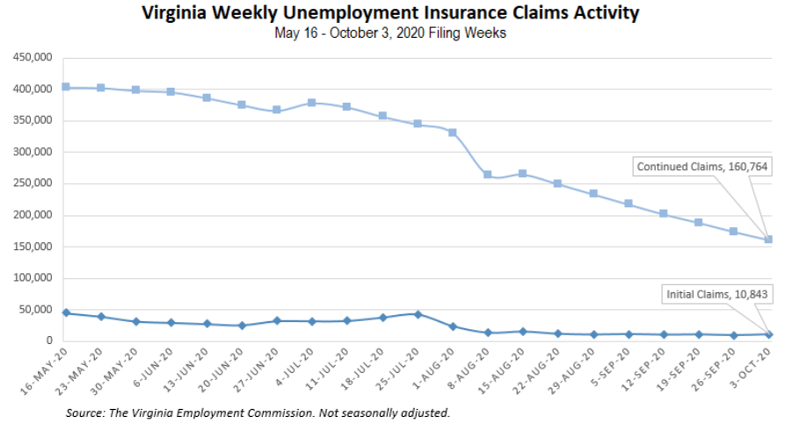
Nationwide, in the week ending October 3, the advance figure for seasonally adjusted initial claims was 840,000, a decrease of 9,000 from the previous week’s revised level. The previous week’s level was revised up by 12,000 from 837,000 to 849,000. The advance number of actual initial claims under state programs, unadjusted, totaled 804,307 in the week ending October 3, an increase of 5,312 (or 0.7 percent) from the previous week. There were 188,106 initial claims in the comparable week in 2019. Looking at preliminary data, most states reported increases on a seasonally unadjusted basis. Florida’s preliminary weekly change (+7,827) was the largest increase among states. Illinois’ preliminary weekly change (+6,646) was the second largest increase. Virginia’s preliminary weekly change (+3,266) was the third largest increase.
PDF of press release: https://www.vec.virginia.gov/UI-press-release
For additional information on who is claiming unemployment insurance in Virginia, access the VEC’s U.I. claims data dashboard (https://www.vec.virginia.gov/ui-claims-dashboard) that is updated the following Monday after the weekly claims press release.
October 8 – More Virginians file first-time unemployment claims compared with a week ago

Nearly 11,000 Virginians filed a first-time unemployment claim last week, an increase of 1,466 people compared with the prior week, according to weekly data released Thursday by the Virginia Employment Commission.

The agency said 10,843 new claims were filed during the week ending Oct. 3.
The number of people still receiving unemployment benefits week-to-week fell for the seventh week, and stands at 160,764, a 7.5% drop from the week prior.

https://www.pilotonline.com/business/jobs/vp-bz-coronavirus-unemployment-claims-1009-20201008-qesews35rvhsrjvxxqygvjxiey-story.html

October 8 - Va. weekly initial jobless claims increase by 15%; Number of continuing unemployment claims is down 7.5%, however

The number of weekly initial jobless claims in Virginia increased by 15% last week, but the number of weekly continuing unemployment claims dropped by 7.5%, the Virginia Employment Commission reported Thursday.

https://www.virginiabusiness.com/article/va-weekly-initial-jobless-claims-increase-by-15/

October 8 - US layoffs remain elevated as 840,000 seek jobless aid

The number of Americans seeking unemployment benefits fell slightly last week to a still-high 840,000, evidence that job cuts remain elevated seven months into the pandemic recession.

https://apnews.com/article/virus-outbreak-donald-trump-layoffs-jobless-claims-economy-1cb1beda4154ff3966c0cd1f0e974f0c

Other Resources
- Virginia State Resources: https://www.virginia.gov/coronavirus/support-for-businesses/#854620
- FAQs from Workers Regarding Covid-19:
English:https://www.governor.virginia.gov/media/governorvirginiagov/governor-of-virginia/pdf/Frequently-Asked-Questions-from-Workers-Regarding-COVID-19.pdf
Spanish:https://www.governor.virginia.gov/media/governorvirginiagov/governor-of-virginia/pdf/Las-Preguntas-Mas-Frecuentes-para-los-Empleados-Sobre-COVID-19.pdf
- Support for affected workers: https://www.virginia.gov/coronavirus/employment-and-financial-support/#855804
- F.A.Q. on Coronavirus Relief for Small Businesses, Freelancers https://www.nytimes.com/article/small-business-loans-stimulus-grants-freelancers-coronavirus.html
- The Paycheck Protection Program (PPP), a provision of the CARES Act, offers forgivable low-interest loans to small businesses facing uncertainty during the COVID-19 emergency, so businesses can retain workers, maintain payroll, and cover certain other existing overhead costs. https://www.sba.gov/funding-programs/loans/coronavirus-relief-options/paycheck-protection-program-ppp
- COVID 19 Testing Information and Locations: https://www.vdh.virginia.gov/coronavirus/covid-19-testing/

WARN Notices
WARN Notices due to COVID-19 have significantly dropped off in Virginia starting in mid-June 2020. While no single factor can be attributed to this fact, the slow down does not mean that businesses have stopped laying off; many large businesses that were covered by the WARN Act up to this point have likely already felt the pandemic’s impact and reported accordingly. As any new spikes in WARN activity as a result of COVID-19 are reported the charts in this section will be updated accordingly.
http://www.vec.virginia.gov/warn-notices

