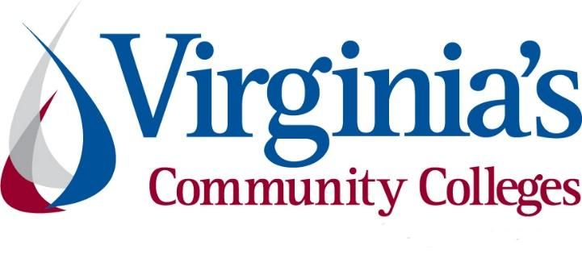
COVID-19 Update
Thursday, September 24, 2020
Virginia Daily Key Statistics
(Please note that the VDH and VHHA numbers may vary slightly due to reporting times.)
Virginia’s Daily COVID-19 Statistics-Virginia Department of Health: http://www.vdh.virginia.gov/coronavirus/ (This page is updated daily before 10 AM. Numbers are preliminary and close out at 5 PM the day before posting. Case counts reflect what has been reported to VDH by healthcare providers and laboratories.)
Tests Administered (PCR): 1,952,965 (130,953 or 6.7% increase from last week)
Total Cases: 143,492 (6,032 or 4.4% increase from last week)
Total Hospitalizations: 10,769 (305 or 2.9% increase from last week)
Total Deaths: 3,113 (193 or 6.6% increase from last week)
Current 7-Day Positivity Rate: 5.3% (Last Week: 6.7%)
COVID in Virginia’s Hospitals Dashboard: https://www.vhha.com/communications/virginia-hospital-covid-19-data-dashboard
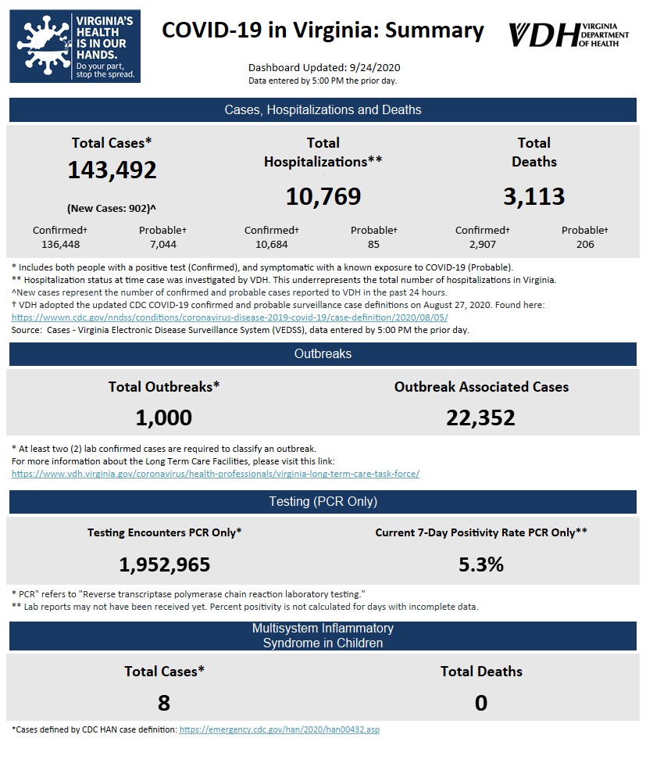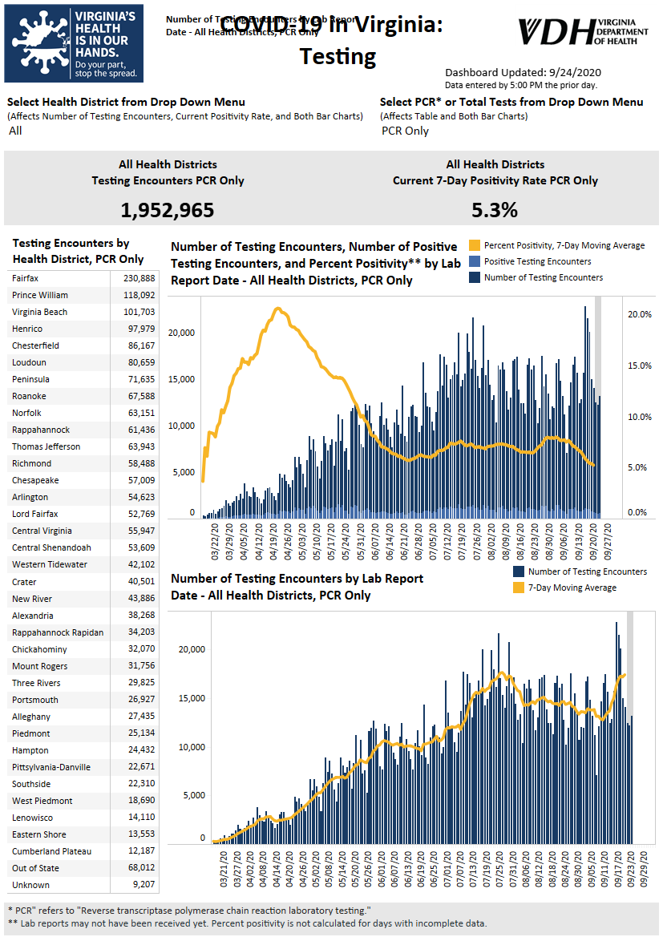Graphs obtained from Virginia Department of Health: https://www.vdh.virginia.gov/coronavirus/
September 24 - Virginia Sept. 24 COVID-19 update: 902 new cases, 24 new deaths; VDH still inputting backlogged death data

Virginia reported 902 new COVID-19 cases and 24 new deaths on Thursday.

The Virginia Department of Health says it’s still in the process of inputting backlogged death data into its system, which is now expected to go through Friday, September 25. Deaths are steady overall at about 10 per day. 3,113 Virginians have now died due to COVID-19.

https://www.wavy.com/news/health/coronavirus/virginia-sept-24-covid-19-update-902-new-cases-24-new-deaths-vdh-still-inputting-backlogged-death-data/

September 23 - Ten inmates at Deerfield Correctional Center now dead from COVID-19

Ten inmates with COVID-19 at the Deerfield Correctional Center have now died. The rural Southside prison holds many elderly and otherwise vulnerable inmates.

The Roanoke Times

September 23 - Health department, DOC collaborate to manage Deerfield COVID-19 outbreak

The Virginia Department of Health and Department of Corrections are working together to manage the COVID-19 outbreak at Deerfield Correctional Center, which is home to the state’s largest cohort of geriatric male inmates.

https://www.nbc12.com/2020/09/23/health-department-doc-collaborate-manage-deerfield-covid-outbreak/

September 22 - Virginia's COVID-19 test positivity rate hits new low

The percentage of test results for COVID-19 that come back positive has fallen to its lowest level statewide since the very first day that data was reported, the Virginia Department of Health said Tuesday.

https://www.insidenova.com/headlines/virginias-covid-19-test-positivity-rate-hits-new-low/article_5d4e887a-fce0-11ea-a00e-0790865ffe46.html

September 21 - Virginia COVID-19 deaths surpass 3,000, nearly half at long-term care facilities

The Virginia Department of Health reported Monday that the statewide total for COVID-19 cases is 141,138, an increase of 2,436 from the 138,702 reported Friday.
...
According to the VDH website, there have been 3,021 COVID-19 deaths in Virginia — 2,816 confirmed and 205 probable. That’s an increase of 72 from the 2,949 reported Friday. Nearly half of the deaths — 1,496 — are associated with outbreaks at long-term care facilities.

https://roanoke.com/news/local/virginia-covid-19-deaths-surpass-3-000-nearly-half-at-long-term-care-facilities/article_03c1e7dc-9fdf-5fec-b331-903726880c1a.html

September 18 - State health department confirms first child death due to COVID-19 in Virginia

A teenager from the state’s Southside Health District has become the first child in Virginia to die as a result of COVID-19, health department officials announced Friday.

https://www.pilotonline.com/coronavirus/vp-nw-child-death-virginia-20200918-ca5olpkaefdcbfcccgayguajoy-story.html

Virginia Developments
September 24- Governor Northam Announces Expansion of Rent and Mortgage Relief Program for Landlords
Governor Ralph Northam today announced the expansion of the Rent and Mortgage Relief Program (RMRP), which first launched at the end of June with $50 million in federal Coronavirus Aid, Relief, and Economic Security (CARES) Act funding to assist households facing eviction or foreclosure due to COVID-19. Landlords can now apply to receive financial assistance for current and past-due rental payments dating back to April 1, 2020 on behalf of their tenants who qualify for RMRP. This new application is available in addition to the existing tenant-based application.
https://www.governor.virginia.gov/newsroom/all-releases/2020/september/headline-860556-en.html
September 23 - New energy assistance program to provide expanded relief to Virginia households affected by COVID-19
Households in need of assistance meeting energy needs may be eligible to receive aid through the Virginia COVID-19 Energy Assistance Program.
The new program will assist low-income households that would not typically be eligible for other energy assistance programs offered by the Virginia Department of Social Services (VDSS) due to financial or vulnerable individual (a household member who is age 60 or over, disabled, or under age six) criteria.
http://www.emporiaindependentmessenger.com/news/article_0b67bff6-fcde-11ea-9fe4-cb49602230e6.html
September 22 - Virginia COVID-19 Restrictions and Workplace Standards Challenged by Manufacturers’ Association
A manufacturers’ association and several employers have filed a lawsuit to enjoin Virginia’s Emergency Temporary Standard for Infectious Disease Prevention related to COVID-19, which the Virginia Safety and Health Codes Board adopted on July 15, 2020.
https://www.natlawreview.com/article/virginia-covid-19-restrictions-and-workplace-standards-challenged-manufacturers

September 22 - Virginia lawmakers demand response from Federal Bureau of Prisons after conditions worsen at state prisons amid COVID-19 pandemic
Virginia lawmakers are demanding answers from the Federal Bureau of Prisons (BOP) regarding reports of troubling conditions at state facilities amid COVID-19.
On Tuesday, U.S. Senator Mark R. Warner and Tim Kaine (both D-VA), along with Reps. A. Donald McEachin (D-VA) and Morgan Griffith (R-VA) expressed their frustrations with BOP's Director Michael Carvajal’s for failure to respond to a letter sent earlier this year. The lawmakers pressed for answers concerning an ongoing lack of personal protective equipment (PPE) and "diminished quality of life for incarcerated individuals."
https://www.wtkr.com/news/virginia-lawmakers-demand-response-from-federal-bureau-of-prisons-after-conditions-worsen-at-state-prisons-amid-covid-19-pandemic
September 22 - More than $6 million raised for COVID-19 Response Fund
Since the Central Virginia COVID-19 Response Fund was activated in March 2020, $6.1 million has been raised to help the community.
https://www.nbc12.com/2020/09/22/virginia-strong-nbc-viewers-help-raise-covid-response-fund/
September 21 - Governor Northam Announces Expansion of $70 Million Rebuild VA Grant Fund for Small Businesses, Nonprofits Impacted by COVID-19
Governor Ralph Northam today announced that Rebuild VA, the $70 million economic recovery fund launched in August, is expanding its eligibility criteria to allow more small businesses to apply. Businesses that received funding from the federal Coronavirus Aid, Relief, and Economic Security (CARES) Act and supply chain partners of businesses whose normal operations were impacted by the COVID-19 pandemic are now eligible to receive grants of up to $10,000. Businesses that have received federal funds must certify that they will only use the Rebuild VA grant for recurring expenses and that the grant will not be used to cover the same expenses as the other CARES Act funds.
https://www.governor.virginia.gov/newsroom/all-releases/2020/september/headline-860478-en.html
September 21 - Virginia's transportation funding plan was finally in place. 'Then COVID-19 hit.'
Jeff Southard could see Virginia turning the corner on long-term funding of transportation as he prepared to retire this year after 15 years at the helm of an alliance of companies that build highways and bridges, and produce the asphalt and concrete for the work.
The General Assembly had just passed a sweeping transportation package that raised gasoline taxes and made a major commitment to passenger rail and public transit in addition, as well as bond funding for improvements to Interstate 81 in western Virginia. The omnibus legislation also set the stage for a long-term shift away from relying on gasoline taxes for transportation funding.
https://fredericksburg.com/news/state-and-regional/virginias-transportation-funding-plan-was-finally-in-place-then-covid-19-hit/article_10fd3ae1-22b1-59f6-b6d4-d305ea2bb559.html
PPE, Testing, and Treatment
September 23- Should front-line medical workers get the coronavirus vaccine first? Not necessarily

Health workers treating patients with the coronavirus may be at the top of the line to get a vaccine once one is approved. But that’s not necessarily the obvious move.

https://www.cnbc.com/2020/09/23/should-front-line-medical-workers-get-the-coronavirus-vaccine-first-not-necessarily.html

September 23 - Virginia Beach company expands, producing millions of masks for people nationwide

A few months ago, News 3 first introduced you to Premium-PPE, a Virginia Beach-based company making masks in Hampton Roads for people all around the country.

At the time, they were making 1 to 2 million masks a month with one machine. Since then, they've added 10 more machines, and are now making 8 to 10 million masks a month and continuing to grow.

https://www.wtkr.com/news/virginia-beach-company-expands-producing-millions-of-masks-for-people-nationwide

September 22 - Local business opens personal protective equipment to the public

TSSI in Harrisonburg provides equipment to the United States Department of Defense and other federal agencies. At the start of the COVID-19 pandemic, the company was only supplying those agencies with Personal Protective Equipment, or PPE, like masks.

In July, Virginia Governor Ralph Northam passed the “Emergency Temporary Standard" requiring businesses to give employees PPE. Now, TSSI is opening PPE products to those in the community who may have trouble finding them. This includes, non-profit organizations, businesses, faith-based groups and more.

https://www.whsv.com/2020/09/22/local-business-opens-personal-protective-equipment-to-the-public/

September 21 - VCU scientists studying cancer drug as COVID-19 treatment; AR-12 medication prevents coronavirus from replicating in cells

A group of scientists at Virginia Commonwealth University’s Massey Cancer Center discovered that an experimental cancer drug keeps the virus that causes COVID-19 from infecting cells and replicating. Their findings were published Monday in the Biochemical Pharmacology journal and will be tested in a clinical trial at VCU Health.

https://www.virginiabusiness.com/article/vcu-scientists-studying-cancer-drug-as-covid-19-treatment/

September 21 - VHHA partners with new Va.-based company for medical-grade masks; Olivian, founded in March, produces masks domestically

The Virginia Hospital & Healthcare Association and its Shared Services Corp. subsidiary have partnered with a newly founded Richmond-area business to obtain domestically produced medical-grade face masks for hospitals and other health care providers in Virginia, VHHA announced Monday.

https://www.virginiabusiness.com/article/vhha-partners-with-new-va-based-company-for-medical-grade-masks/

September 17 - It could be months before rapid COVID-19 testing is widespread in Virginia, VDH says

Virginia is trying to ramp up rapid testing for COVID-19 but health officials say it could be a while before the use is widespread.

https://www.wavy.com/news/local-news/richmond/it-could-be-months-before-rapid-covid-19-testing-is-widespread-in-virginia-vdh-says/

Virginia and U.S. Economy
September 23 - Va. hotel revenues continue to slip

Virginia hotel revenues continued to worsen last week after a small improvement during the Labor Day weekend, according to data from STR Inc., a CoStar Group division that provides weekly market data on the U.S. hospitality industry.

https://www.virginiabusiness.com/article/va-hotel-revenues-continue-to-slip/?utm_source=newsletter&utm_medium=email&utm_campaign=daily

September 22 - State delegate joins business owners in lawsuit challenging Virginia’s virus workplace safety regulations

A state delegate joined the Virginia Manufacturers Association and other business owners to challenge emergency COVID-19 safety regulations adopted by the state’s Safety and Health Codes Board in July.

https://www.virginiamercury.com/2020/09/22/state-delegate-joins-several-business-owners-in-lawsuit-against-virginias-workplace-safety-regulations/

Education
September 23 - New Dashboard Tracks Coronavirus Cases In Schools Across 47 States

A new national effort asks K-12 schools to voluntarily — and anonymously — report their confirmed and suspected coronavirus cases, along with the safety strategies they're using.
...
The COVID-19 School Response Dashboard, which NPR is reporting on exclusively, was created with the help of several national education organizations. Right now it shows an average of 230 cases per 100,000 students, and 490 per 100,000 staff members, in the first two weeks of September. The responses come from public, private and charter schools in 47 states, serving roughly 200,000 students both in person and online, as of Tuesday, Sept. 22.

https://www.npr.org/2020/09/23/915738935/new-dashboard-tracks-coronavirus-cases-in-schools-across-47-states

September 22 - Governor Northam Announces Refinancing Plan to Save Virginia Colleges and Universities More Than $300 Million Over Next Two Years

Governor Ralph Northam today announced a higher education refinancing plan that will save Virginia’s public colleges and universities more than $300 million over the next two years. The Commonwealth of Virginia will take advantage of low interest rates by refinancing bonds issued by the Treasury Board of Virginia (TBV) and the Virginia College Building Authority (VCBA), which institutions of higher education use for capital projects. The Governor was joined by George Mason University President Dr. Gregory Washington and state legislators for the announcement at the university’s Fairfax campus.

https://www.governor.virginia.gov/newsroom/all-releases/2020/september/headline-860518-en.html

September 22 - Virginia college Greek life changes in the face of COVID-19

There are no dodgeball games, cookouts or other rushing events at Virginia Commonwealth University’s campus in Richmond, but fraternities and sororities are still recruiting new brothers and sisters.

The Greek chapters at VCU, and many other Virginia schools, are using Zoom to recruit new members. Some fraternities and sororities believe the challenge of social distancing has strengthened bonds amongst each other as well as their philanthropy efforts.

https://godanriver.com/news/state/wire/virginia-college-greek-life-changes-in-the-face-of-covid-19/article_e81340e0-c9e6-51fa-9d16-4ab1ac3630ca.html

September 21 - Colleges Become Reservoirs of Covid Ready to Spill Over

College administrators and government officials summoned students back to campus. Now, they are presiding over viral reservoirs poised to release a flood of infected undergraduates at Thanksgiving -- if they make it that far.

Schools have turned into de facto sanitariums: Covid-19 infections are sweeping student populations, though health departments are seeing relatively few hospitalizations or deaths so far. Colleges that tried to hold classes in person have had to send students into seclusion.

https://www.bloomberg.com/news/articles/2020-09-21/colleges-become-reservoirs-of-covid-threatening-to-spill-over

September 19 - Spring classes at Virginia community colleges to stay online, says Chancellor DuBois

Most classes at Virginia’s community colleges will remain online early next year.
The system’s chancellor, Glenn DuBois, announced the decision on Friday, months before the spring semester at the 23 colleges. DuBois says he’s doing so to “minimize the disruptions” for students from COVID-19.

https://www.wavy.com/news/local-news/newport-news/spring-classes-at-virginia-community-colleges-to-stay-online/

A letter from the chancellor to our students: https://www.vccs.edu/blog/a-letter-from-the-chancellor-to-our-students/

Unemployment Data
September 24 - Virginia’s Unemployment Insurance Weekly Claims for Week Ending September 19th
Seasonally unadjusted weekly initial unemployment insurance claims remained elevated and increased by 4.8% during the latest filing week
The Virginia Employment Commission (VEC) announced that the number of initial claims filed during the September 19 filing week was nearly five times larger than the comparable week in 2019, according to figures released today.
For the filing week ending September 19, the figure for seasonally unadjusted initial claims in Virginia was 10,582. The latest claims figure was an increase of 482 claimants from the previous week but continued the overall trend of lower claims volumes seen in recent months following April’s peak.
For the most recent filing week, continued weeks claimed totaled 188,195, which was a 6.7% decrease from the previous week, but 170,944 higher than the 17,251 continued claims from the comparable week last year. They have declined at a consistent pace since mid-August—around 6.6% a week. The continued claims total is mainly comprised of those recent initial claimants who continued to file for unemployment insurance benefits during the COVID-19 pandemic.
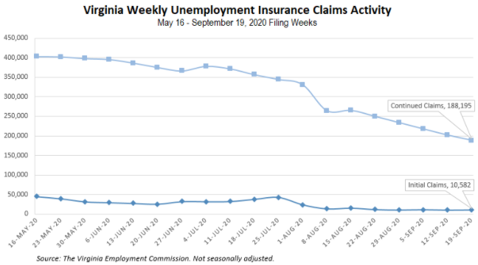
Nationwide, in the week ending September 19, the advance figure for seasonally adjusted initial claims was 870,000, an increase of 4,000 from the previous week's revised level. The previous week's level was revised up by 6,000 from 860,000 to 866,000. The advance number of actual initial claims under state programs, unadjusted, totaled 824,542 in the week ending September 19, an increase of 28,527 (or 3.6 percent) from the previous week. There were 175,394 initial claims in the comparable week in 2019. Looking at preliminary data, most states reported increases on a seasonally unadjusted basis. New York’s preliminary weekly change (+9,403) was the largest increase among states. Others included Georgia (+6,387), California (+4,439), Massachusetts (+4,407), and New Jersey (+4,025). Virginia’s preliminary weekly change (+2,392) was the eighth largest increase.
https://www.vec.virginia.gov/node/12292
PDF of press release:
https://www.vec.virginia.gov/sites/default/files/news-12292-Initial%20Claims%20Press%20Release%209%2019%202020.pdf
For additional information on who is claiming unemployment insurance in Virginia, access the VEC’s U.I. claims data dashboard (https://www.vec.virginia.gov/ui-claims-dashboard) that is updated the following Monday after the weekly claims press release.
September 24 - Unemployment in Virginia continue to decline, but questions regarding benefits continue

At its peak in April, initial unemployment claims in Virginia rose to 147,000. Since then it has been declining, but many people who are still unemployed due to COVID-19 continue to have questions regarding their benefits.

“Still trying to help people find jobs, and there are plenty of jobs out there. There are over 400,000 on the website that are advertised,” Joyce Fogg with the Virginia Employment Commission said.

However, even with jobs available, the latest numbers show just over 10,000 people are filing an initial claim and more than 201,000 are filing continued claims.

https://www.whsv.com/2020/09/23/unemployment-in-virginia-continue-to-decline-but-questions-regarding-benefits-continue/

September 24 - Unemployment rates down in 41 states, July 2020 to August 2020

Unemployment rates were lower in August 2020 in 41 states, higher in 2 states, and stable in 7 states and the District of Columbia. All 50 states and the District had jobless rate increases from a year earlier. The national unemployment rate fell by 1.8 percentage points over the month to 8.4 percent but was 4.7 points higher than in August 2019.

https://www.bls.gov/opub/ted/2020/unemployment-rates-down-in-41-states-july-2020-to-august-2020.htm

September 24 - Another 870,000 Americans file new unemployment claims

New US jobless claims reach 870,000 last week as layoffs remain elevated 6 months after the coronavirus pandemic struck the economy. This is roughly the same number as the week before who filed new claims. These numbers do not include those who file with a special government program meant to help those in the "gig economy" and otherwise are not eligible for traditional unemployment.

The number of people seeking unemployment benefits each week is still high, and the economy has recovered only about half the 22 million jobs that were lost to the pandemic.

https://www.wtvr.com/news/national/coronavirus/another-870-000-americans-file-new-unemployment-claims

September 24 - U.S. Risks Repeating 2009 Mistakes as Economic Recovery Slows

In the wake of the last recession, government spending dried up, dragging out the recovery. Policymakers warn against letting it happen again.

https://www.nytimes.com/2020/09/24/business/economy/us-economy-pandemic.html

Other Resources
- Virginia State Resources: https://www.virginia.gov/coronavirus/support-for-businesses/#854620
- FAQs from Workers Regarding Covid-19:
English:https://www.governor.virginia.gov/media/governorvirginiagov/governor-of-virginia/pdf/Frequently-Asked-Questions-from-Workers-Regarding-COVID-19.pdf
Spanish:https://www.governor.virginia.gov/media/governorvirginiagov/governor-of-virginia/pdf/Las-Preguntas-Mas-Frecuentes-para-los-Empleados-Sobre-COVID-19.pdf
- Support for affected workers: https://www.virginia.gov/coronavirus/employment-and-financial-support/#855804
- F.A.Q. on Coronavirus Relief for Small Businesses, Freelancers https://www.nytimes.com/article/small-business-loans-stimulus-grants-freelancers-coronavirus.html
- The Paycheck Protection Program (PPP), a provision of the CARES Act, offers forgivable low-interest loans to small businesses facing uncertainty during the COVID-19 emergency, so businesses can retain workers, maintain payroll, and cover certain other existing overhead costs. https://www.sba.gov/funding-programs/loans/coronavirus-relief-options/paycheck-protection-program-ppp
- COVID 19 Testing Information and Locations: https://www.vdh.virginia.gov/coronavirus/covid-19-testing/

WARN Notices
WARN Notices due to COVID-19 have significantly dropped off in Virginia starting in mid-June 2020. While no single factor can be attributed to this fact, the slow down does not mean that businesses have stopped laying off; many large businesses that were covered by the WARN Act up to this point have likely already felt the pandemic’s impact and reported accordingly. As any new spikes in WARN activity as a result of COVID-19 are reported the charts in this section will be updated accordingly.
http://www.vec.virginia.gov/warn-notices

