COVID-19 Update
Thursday, September 17, 2020
Virginia Daily Key Statistics
(Please note that the VDH and VHHA numbers may vary slightly due to reporting times.)
Virginia’s Daily COVID-19 Statistics-Virginia Department of Health: http://www.vdh.virginia.gov/coronavirus/ (This page is updated daily before 10 AM. Numbers are preliminary and close out at 5 PM the day before posting. Case counts reflect what has been reported to VDH by healthcare providers and laboratories.) updated 9/17
Tests Administered (PCR): 1,822,012 (111,456 or 6.5% increase from last week)
Total Cases: 137,460 (6,935 or 5.3% increase from last week)
Total Hospitalizations: 10,464 (379 or 3.8% increase from last week)
Total Deaths: 2,920 (212 or 7.8% increase from last week)
Current 7-Day Positivity Rate: 6.7% (Last Week: 7.6%)
COVID in Virginia’s Hospitals Dashboard: https://www.vhha.com/communications/virginia-hospital-covid-19-data-dashboard
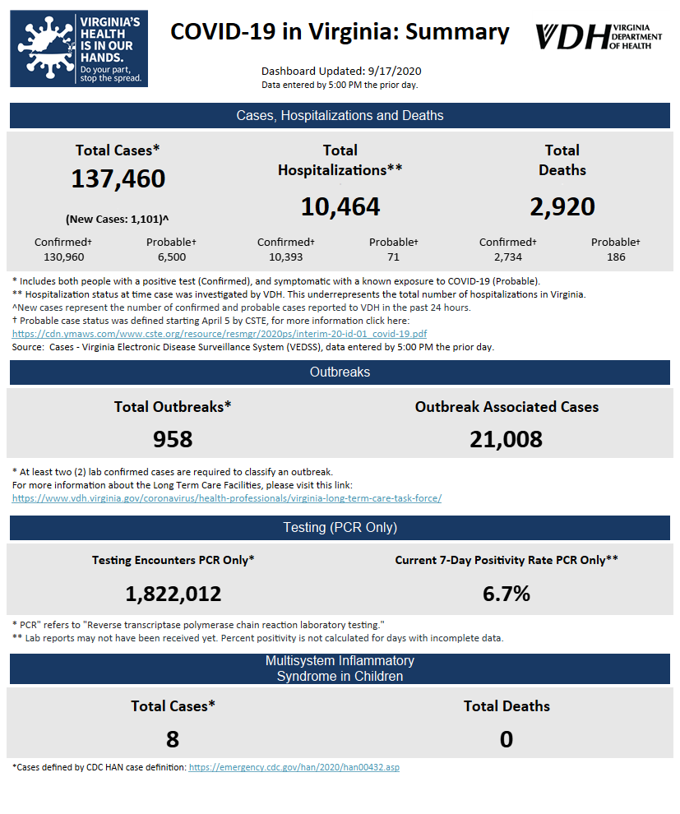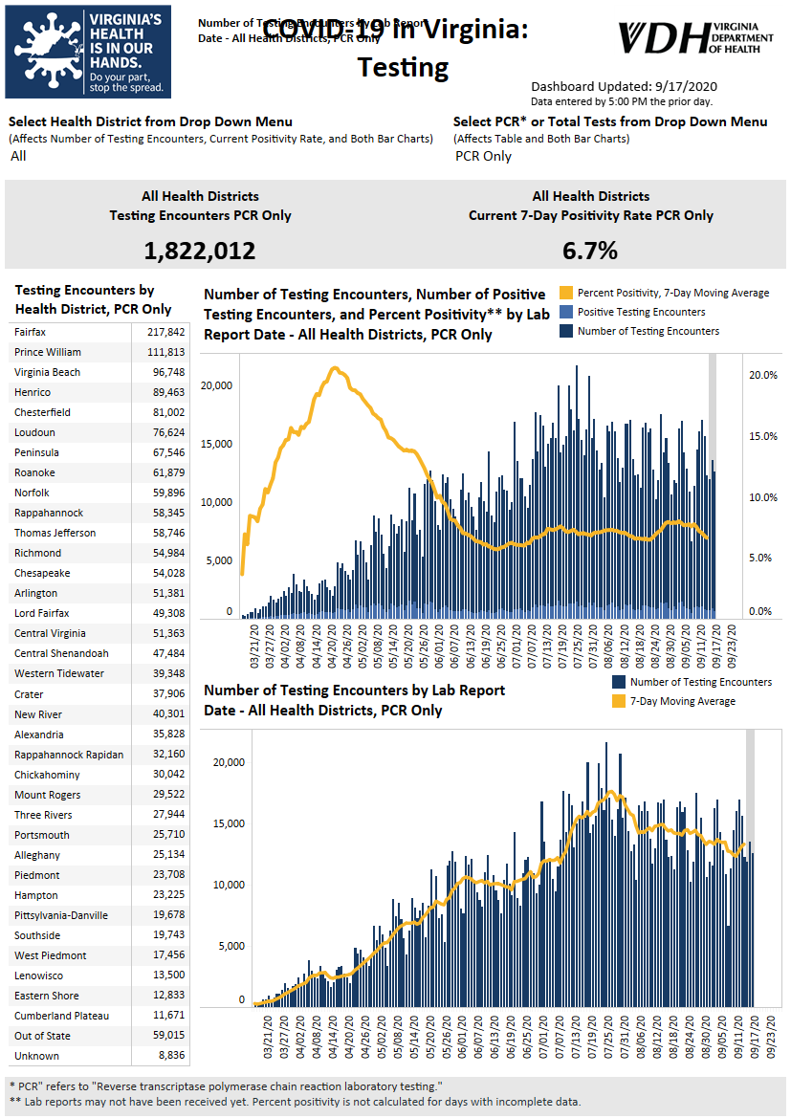Graphs obtained from Virginia Department of Health: https://www.vdh.virginia.gov/coronavirus/
September 17 - Virginia COVID-19 cases rise by 1,101 on Thursday

As of Thursday, September 17, Virginia has had 137,460 total cases of COVID-19, including confirmed lab tests and clinical diagnoses, according to the Virginia Department of Health.

That total reflects an 1,101case increase since Wednesday, out of 23,051 tests newly added to the system, which comes out to 4.8% of the newest tests coming back positive. 36 additional deaths were reported on Wednesday, leaving the death toll at 2,920. According to the Virginia Department of Health, the death data for Sept. 17 has an existing data backlog.

https://www.whsv.com/2020/09/17/virginia-covid-19-cases-rise-by-1101-on-thursday/

September 16 - Governor updates commonwealth on COVID-19; southwest VA averages are highest in state

The Virginia Department of Health is reporting 135,514 total cases of COVID-19 in the commonwealth as of Tuesday, September 15, going back to the beginning of the pandemic. That’s up from 134,571 reported Monday, a 943-case increase, which is a bigger increase than the 757 new cases reported from Sunday to Monday.

https://www.wdbj7.com/2020/09/15/montgomery-county-rises-on-hotspot-list-virginia-positive-test-percentage-drops/

Virginia Developments
September 17 - States Are Using Much-Needed Temporary Flexibility in SNAP to Respond to COVID-19 Challenges
Since March, states have been using temporary SNAP (food stamp) flexibility to provide emergency benefit supplements, maintain benefits to households with children missing school meals, and ease program administration during the pandemic. These options have allowed states to deliver more food assistance to struggling families, help manage rising and ongoing administrative demands, and ensure that participants maintain much-needed benefits.
https://www.cbpp.org/research/food-assistance/states-are-using-much-needed-temporary-flexibility-in-snap-to-respond-to
September 16 - Senate approves 12-month utility debt repayment plans with bipartisan support
The Virginia Senate passed legislation Wednesday that will require all utilities except those controlled by municipal authorities to offer 12-month payment plans to residential customers who have been unable to pay their bills due to the COVID-19 pandemic.
https://www.virginiamercury.com/blog-va/senate-approves-12-month-utility-debt-repayment-plans-with-bipartisan-support/

September 16 - As the VDH has access to more death certificates, COVID-19's deadly impact is showing more and more

The statistical accounting of the deadly disease COVID-19 finally is catching up to its reality.
The latest numbers from the Virginia Department of Health are showing an explosion of COVID-19 deaths in the West Piedmont Health District, which covers Martinsville and the counties of Henry, Patrick and Franklin.

Martinsville Bulletin

September 16 - Virginia ranked third nationwide for having most virus-related restrictions

The Virginia Department of Health continues to work through its data backlog and has reported 141 new deaths in the last two days.

As was the case with four new deaths reported Tuesday in the Rappahannock Area Health District, some fatalities happened weeks ago and were just added to the state database.

https://fredericksburg.com/news/local/virginia-ranked-third-nationwide-for-having-most-virus-related-restrictions/article_a62b8702-e48a-54f9-847e-78516f063403.html
September 16 - Virginia Senate panel kills paid sick leave COVID-19 bill
A Virginia Senate committee has killed legislation that would have required employers to provide up to two weeks of paid sick leave for workers who have to quarantine because of COVID-19.
https://www.nbc12.com/2020/09/16/virginia-senate-panel-kills-paid-sick-leave-covid-bill/
September 16 - Governor Northam Proposes Voter Protection Measures Ahead of November General Election

Governor Ralph Northam today announced proposals to expand access to voting for the November 3rd General Election amid the ongoing COVID-19 pandemic. The measures were unveiled by the Governor during a virtual Joint Meeting of the House Appropriations, House Finance, Senate Finance and Appropriations Committees, and will be considered by legislators during the special General Assembly session set to begin this afternoon.

https://www.governor.virginia.gov/newsroom/all-releases/2020/august/headline-859958-en.html

September 16 - VPLC launches calculator to help determine SNAP eligibility

A new eligibility calculator may help people determine if they are eligible for the Supplemental Nutrition Assistance Program.

The Virginia Poverty Law Center says the calculator shows people if they are eligible for benefits and how much they could potentially receive.

https://www.cbs19news.com/story/42642139/vplc-launches-calculator-to-help-determine-snap-eligibility
September 15 - Academy launched to help 20 NoVa tech firms pivot for COVID-19
McLean-based Amplifier Advisors and a group of university, government, corporate and community partners on Tuesday announced the launch of the Tandem Product Academy, which will assist a cohort of 20 Northern Virginia tech companies to pivot their business models to respond to the COVID-19 economy.
https://www.virginiabusiness.com/article/academy-launched-to-help-20-nova-tech-firms-pivot-for-covid-19/
September 15 - Virginia will suspend utility shutoffs until October, SCC rules

Virginia’s State Corporation Commission agreed to extend an existing moratorium on utility disconnections until Oct. 5.

But regulators warned it would be the last time they granted an extension on the shutoff ban, which has already been renewed twice since the SCC first imposed it on March 16 — just a few days after Virginia’s first confirmed case of COVID-19.

https://www.virginiamercury.com/2020/09/15/virginia-will-suspend-utility-shutoffs-until-october-scc-rules/?fbclid=IwAR0wYI0TitidFhBHZq74bUY2THzIdGgxYCgd-zYGmAXG1i_5s1Qwv198-Vc

September 15 - COVID-19 outbreaks hit state mental institutions in Virginia

Two more patients have died of COVID-19 at Piedmont Geriatric Hospital, bringing the total number of deaths to nine at the state psychiatric institution.

The Richmond-Times Dispatch reports that two patients infected during an outbreak that began in mid-July died earlier this month.

https://www.nbc12.com/2020/09/15/covid-outbreaks-hit-state-mental-institutions-virginia/?fbclid=IwAR0wYI0TitidFhBHZq74bUY2THzIdGgxYCgd-zYGmAXG1i_5s1Qwv198-Vc

September 15 - COVID-19 death toll rises in Danville, Pittsylvania County as outbreaks widen at long-term care facilities

The death toll from COVID-19 continues to rise in the Pittsylvania-Danville Health District at the same time outbreaks are widening at local long-term care facilities, according to data from the Virginia Department of Health.

Danville Register & Bee

September 14 - JLARC faults financing authority critical to Northam small business COVID-19 grant program

The Virginia Small Business Financing Authority, the state agency responsible for administering a new $71 million grant program for small businesses affected by the COVID-19 pandemic, is not doing its job in helping small firms get loans, according to a new report by the General Assembly’s watchdog agency.
Richmond Times-Dispatch
September 10 - Governor Northam Announces Easing of Restrictions in Hampton Roads

Governor Ralph Northam today announced that, due to significantly improved health metrics in the Eastern Region, localities in Hampton Roads will join the rest of the Commonwealth in Phase Three of the “Forward Virginia” plan to ease public health restrictions while mitigating the spread of COVID-19.

https://www.governor.virginia.gov/newsroom/all-releases/2020/september/headline-860331-en.html

PPE, Testing, and Vaccinations
September 16 - Contradicting The CDC, Trump Says COVID-19 Vaccine Could Be Ready By End Of Year

President Trump on Wednesday again said widespread distribution of a vaccine against the coronavirus would happen before the end of the year, directly contradicting Centers for Disease Control and Prevention Director Robert Redfield. The CDC chief testified earlier Wednesday that a vaccine would not be widely available until next spring or summer.

https://www.npr.org/sections/coronavirus-live-updates/2020/09/16/913560563/cdc-director-says-covid-vaccine-likely-wont-be-widely-available-until-next-year

September 16 - US outlines sweeping plan to provide free COVID-19 vaccines.

The federal government outlined a sweeping plan Wednesday to make vaccines for COVID-19 available for free to all Americans, even as polls show a strong undercurrent of skepticism rippling across the land.

Richmond Times-Dispatch

Virginia and U.S. Economy

September 15 - Four million Americans waited more than 4 weeks for their first unemployment check

When Annette Bellard evacuated her home due to Hurricane Laura in August, she said she had only $10 to get where she needed to go. The evacuation marked nearly two months without an unemployment check, which Bellard had been receiving up until she reported getting $110.08 in holiday pay from her employer.

https://www.nbc12.com/2020/09/15/four-million-americans-waited-more-than-weeks-their-first-unemployment-check/?fbclid=IwAR0wYI0TitidFhBHZq74bUY2THzIdGgxYCgd-zYGmAXG1i_5s1Qwv198-Vc

September 16 - Airlines, labor unions again push for another $25 billion in federal aid as more than 30,000 job cuts loom

Airline CEOs and labor unions Wednesday again pushed for billions in additional federal aid as a ban on industry job cuts is set to expire in two weeks and a recovery in travel demand hasn’t materialized.

https://www.cnbc.com/2020/09/16/airlines-labor-unions-again-push-for-another-25-billion-in-coronavirus-aid-as-more-than-30000-job-cuts-loom.html

September 15 - As Dan River Region bounces back from deep jobless hit, unemployment rates still more than double pre-pandemic times

Pittsylvania County, a vastly rural area deeply rooted in agriculture, didn't experience as harsh of a hit with job losses at the start of the coronavirus pandemic compared to Danville.
The main reason, according to Pittsylvania County Economic Development Director Matt Rowe, is because agriculture and forestry is the No. 1 industry.

Danville Register & Bee
September 14 - Va. restaurants report consumer spending down, costs up; At least 100K restaurants in the U.S. have closed since pandemic began
Consumer spending in Virginia restaurants remained well below normal levels in August while operational costs rose, according to a COVID-19 restaurant impact survey conducted by the National Restaurant Association. The organization surveyed 3,500 U.S. restaurant operators between Aug. 26 and Sept. 1.
In Virginia, 87% of restaurant operators surveyed responded that their total sales volume in August was lower than it was in August 2019 — and 58% reported that their restaurant’s operational costs are higher than they were prior to the pandemic.
https://www.virginiabusiness.com/article/va-restaurants-report-consumer-spending-down-costs-up/
Education
September 16 - How to Save Higher Education

There has never been a crisis in American higher education like the one we are facing today. While fall enrollment numbers are still in flux as colleges scramble to deal with an out-of-control pandemic, there is no question that all but the wealthiest institutions are facing deep financial pain and potential catastrophe. Even relatively conservative estimates like those published by the college financial planning firm Edmit suggest that, thanks to declining revenue and investment returns, one-third of all private colleges are now on track to run out of money within six years—a nearly 50 percent increase in estimates from 2019—and many are vulnerable to bankruptcy much sooner. Public universities, meanwhile, are about to be hammered by steep cuts in government funding, forcing them to raise prices, cut services, and turn away students, including millions of newly unemployed workers.

Washington Monthly
September 16 - UVa identifies cluster of coronavirus cases
The University of Virginia has identified a cluster of coronavirus cases in a residence hall and is mass testing students, according to a Wednesday tweet by the university.

UVa announced Wednesday evening that five cases were identified in the Balz-Dobie residence hall through wastewater and individual testing programs.

https://dailyprogress.com/news/uva/uva-identifies-cluster-of-coronavirus-cases/article_1c5b37a7-6326-57c8-980d-d9c0d2f4a0d6.html#tracking-source=home-breaking

September 16 - State considers $200 million aid request for K-12 as federal money fills gaps

Gov. Ralph Northam is urgently reviewing a request of $200 million in federal funds to help Virginia public school divisions operate in a school year like no other, after the coronavirus pandemic forced most public schools in Virginia to rely on remote learning.

https://richmond.com/news/state-and-regional/govt-and-politics/state-considers-200-million-aid-request-for-k-12-as-federal-money-fills-gaps/article_08c269f4-b3ca-5a57-8807-f31681f6c3f8.html

September 16 - As schools weigh a return to in-person learning, health officials won’t release details on COVID-19 outbreaks

The majority of Virginia’s local school districts started the year remotely. But as divisions across the state weigh a return to in-person learning over the next few weeks, the Virginia Department of Health is still providing limited information on COVID-19 cases linked to K-12 schools.

Virginia Mercury

September 16 - Public Viewpoint: COVID-19 Work and Education Survey

STRADA Education Network: Millions of Americans are aspiring adult learners — individuals without college degrees who are seriously considering enrolling in additional education. Looking specifically at adults ages 25 to 44, we see their interest in enrolling has increased since the onset of COVID-19. Our new findings, however, reveal they are also less confident about the value of additional education than they were a year ago, they face critical barriers to enrollment, and they do not clearly understand how to connect their education to careers. Comparing their perspectives from a year ago with the present, we can see what has — and hasn’t — changed for aspiring adult learners and what they care about most in their education.

Adults considering enrolling in education are less likely than a year ago to believe it will be worth the cost and get them a good job.

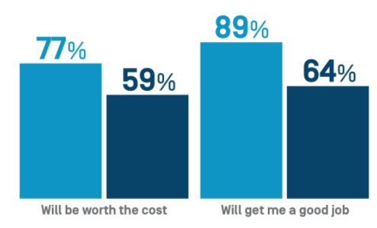

https://www.stradaeducation.org/publicviewpoint/#latest

September 15 - Efforts falter to require schools to provide in-person options

An effort to require Virginia school districts provide in-person classes to students with poor internet access during the COVID-19 pandemic is most likely dead.

House Bill 5009, introduced by Del. Mark Cole, R-Fredericksburg, would require public schools to offer in-person classes to elementary, middle and high school students who have substandard internet connections at home.

Virginia Mercury

September 14 - Radford extends gathering limit until November

The city’s ban on gatherings of more than 50 will continue until at least Nov. 2.
The city council unanimously voted in favor of extending the emergency ordinance at its regular meeting Monday night.

https://roanoke.com/news/local/radford-extends-gathering-limit-until-november/article_0fd1cbd6-1fb7-503f-b35e-f5dfad44fbd5.html#tracking-source=home-top-story-1

September 14 - How to detect COVID-19 before an outbreak? Virginia Tech scientists testing wastewater as a bellwether

When COVID-19 forced Virginia Tech to evacuate in the spring, university researchers wasted no time finding a novel way to detect potential coronavirus outbreaks on campus.

Peter Vikesland, a professor of civil and environmental engineering, for several years has been studying how sewage treatment plants enable or inhibit antibiotic-resistant bacteria.

https://roanoke.com/news/local/how-to-detect-covid-19-before-an-outbreak-virginia-tech-scientists-testing-wastewater-as-a/article_e47368e9-3cdc-530c-82ea-c0a4ea98dab6.html

Unemployment Data
September 17 - Virginia’s Unemployment Insurance Weekly Claims for Week Ending September 12th
Seasonally unadjusted weekly initial unemployment insurance claims remained elevated but decreased by 9.3% during the latest filing week
The Virginia Employment Commission (VEC) announced that the number of continued claims filed during the September 12 filing week was fifty percent lower than their May 16 filing week peak, according to figures released today.
For the filing week ending September 12, the figure for seasonally unadjusted initial claims in Virginia was 10,100. The latest claims figure was a decrease of 1,035 claimants from the previous week, and the lowest weekly total since the onset of the COVID-19 pandemic’s employment impacts in mid-March.
For the most recent filing week, continued weeks claimed totaled 201,616, which was a 7.3% decrease from the previous week, but 183,773 higher than the 17,843 continued claims from the comparable week last year. They also declined by 50% from their May 16, 2020 filing week peak of 403,557 claims. The continued claims total is mainly comprised of those recent initial claimants who continued to file for unemployment insurance benefits during the COVID-19 pandemic.
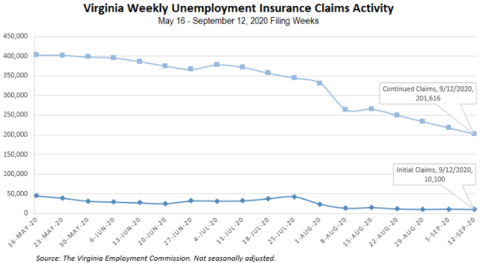
Nationwide, in the week ending September 12, the advance figure for seasonally adjusted initial claims was 860,000, a decrease of 33,000 from the previous week's revised level. The previous week's level was revised up by 9,000 from 884,000 to 893,000. The advance number of actual initial claims under state programs, unadjusted, totaled 790,021 in the week ending September 12, a decrease of 75,974 (or -8.8 percent) from the previous week. There were 173,134 initial claims in the comparable week in 2019. Looking at preliminary data, most states reported decreases on a seasonally unadjusted basis. Texas’s preliminary weekly change (-15,647) was the largest decrease among states. Others included California (-13,179), Louisiana (-9,257), Georgia (-8,240), and Florida (-6,435). Virginia’s preliminary weekly change (+486) was the seventh largest increase.
https://www.vec.virginia.gov/node/12273
PDF of press release:
https://www.vec.virginia.gov/sites/default/files/news-12273-Initial%20Claims%20Press%20Release%209%2012%202020.pdf
For additional information on who is claiming unemployment insurance in Virginia, access the VEC’s U.I. claims data dashboard (https://www.vec.virginia.gov/ui-claims-dashboard) that is updated the following Monday after the weekly claims press release.
September 17 - Va. initial jobless claims slightly drop last week; Number of ongoing claims down 50% from May 16 peak

Virginia saw a slight decrease in the number of initial jobless claims last week, the Virginia Employment Commission reported Thursday, but the number of ongoing claims has dropped to 50% from the May 16 filing week peak, when 403,557 Virginians filed for unemployment.

https://www.virginiabusiness.com/article/va-initial-jobless-claims-slightly-drop-last-week/

September 17 - Around 860,000 people filed for first-time jobless benefits last week
Another 860,000 people filed for first-time unemployment benefits last week, a slight decline from the previous week amid a sluggish recovery in the labor market.

https://www.nbcnews.com/business/economy/around-860-000-people-filed-first-time-jobless-benefits-last-n1240278

Other Resources
- Virginia State Resources: https://www.virginia.gov/coronavirus/support-for-businesses/#854620
- FAQs from Workers Regarding Covid-19:
English:https://www.governor.virginia.gov/media/governorvirginiagov/governor-of-virginia/pdf/Frequently-Asked-Questions-from-Workers-Regarding-COVID-19.pdf
Spanish:https://www.governor.virginia.gov/media/governorvirginiagov/governor-of-virginia/pdf/Las-Preguntas-Mas-Frecuentes-para-los-Empleados-Sobre-COVID-19.pdf
- Support for affected workers: https://www.virginia.gov/coronavirus/employment-and-financial-support/#855804
- F.A.Q. on Coronavirus Relief for Small Businesses, Freelancers https://www.nytimes.com/article/small-business-loans-stimulus-grants-freelancers-coronavirus.html
- The Paycheck Protection Program (PPP), a provision of the CARES Act, offers forgivable low-interest loans to small businesses facing uncertainty during the COVID-19 emergency, so businesses can retain workers, maintain payroll, and cover certain other existing overhead costs. https://www.sba.gov/funding-programs/loans/coronavirus-relief-options/paycheck-protection-program-ppp
- COVID 19 Testing Information and Locations: https://www.vdh.virginia.gov/coronavirus/covid-19-testing/

WARN Notices
WARN Notices due to COVID-19 have significantly dropped off in Virginia starting in mid-June 2020. While no single factor can be attributed to this fact, the slow down does not mean that businesses have stopped laying off; many large businesses that were covered by the WARN Act up to this point have likely already felt the pandemic’s impact and reported accordingly. As any new spikes in WARN activity as a result of COVID-19 are reported the charts in this section will be updated accordingly.
http://www.vec.virginia.gov/warn-notices

