COVID-19 Update
Thursday, September 10, 2020
Virginia Daily Key Statistics
(Please note that the VDH and VHHA numbers may vary slightly due to reporting times.)
Virginia’s Daily COVID-19 Statistics-Virginia Department of Health: http://www.vdh.virginia.gov/coronavirus/ (This page is updated daily before 10 AM. Numbers are preliminary and close out at 5 PM the day before posting. Case counts reflect what has been reported to VDH by healthcare providers and laboratories.)
Tests Administered (PCR): 1,710,556 (91,503 or 5.7% increase from last week)
Total Cases: 130,525 (6,857 or 5.5% increase from last week)
Total Hospitalizations: 10,085 (344 or 3.5% increase from last week)
Total Deaths: 2,708 (56 or 2.1% increase from last week)
Current 7-Day Positivity Rate: 7.6% (Last Week: 7.7%)
COVID in Virginia’s Hospitals Dashboard: https://www.vhha.com/communications/virginia-hospital-covid-19-data-dashboard
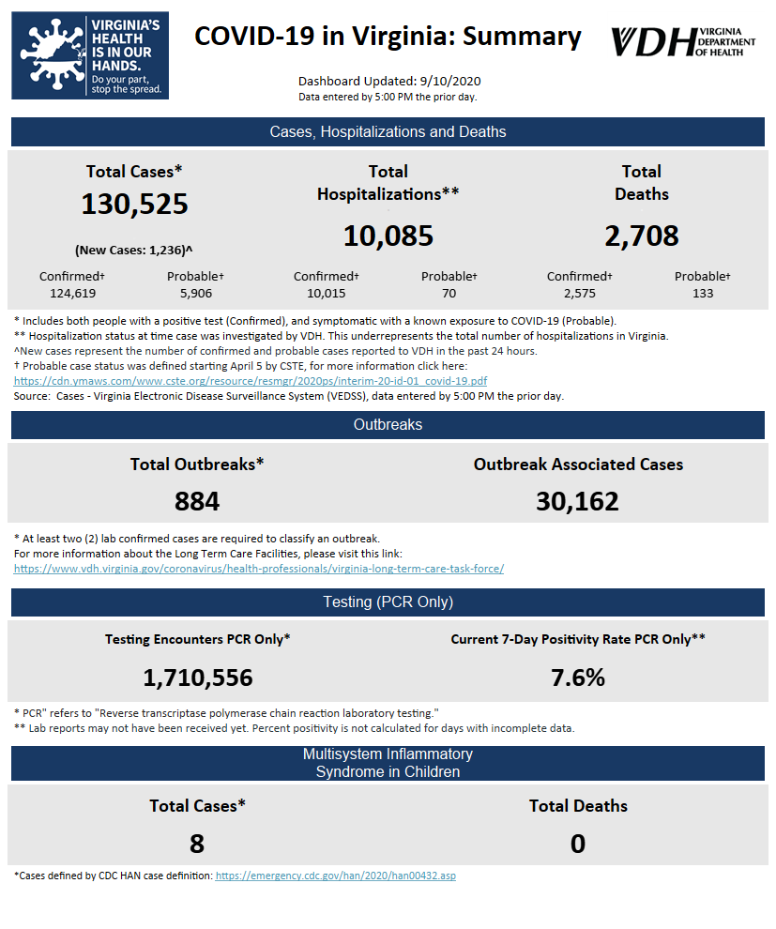
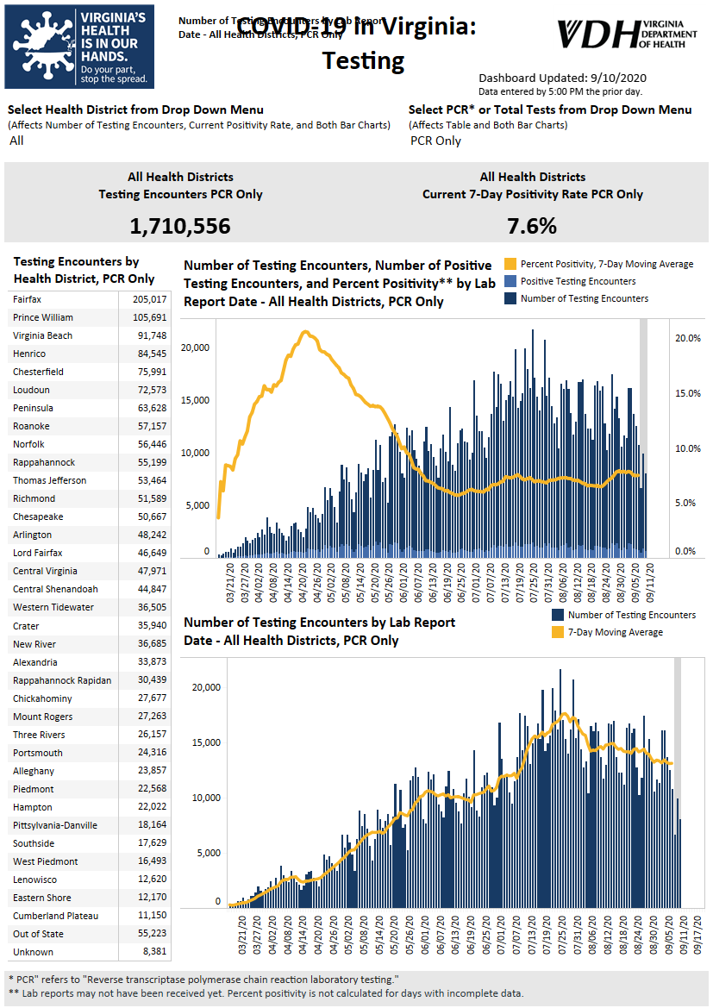Graphs obtained from Virginia Department of Health: https://www.vdh.virginia.gov/coronavirus/
September 10 - More than 1K new COVID cases reported in Virginia; hospitalizations up

The Virginia Department of Health is reporting 130,525 total cases of COVID-19 in the commonwealth as of Thursday, September 10, going back to the beginning of the pandemic. That’s up from 129,289 reported Wednesday, a 1,236-case increase, which is a bigger increase than the 882 new cases reported from Tuesday to Wednesday.

https://www.wdbj7.com/2020/09/10/more-than-1k-new-covid-cases-reported-in-virginia-hospitalizations-up/

September 9 - Virginia percentage of positive COVID tests drops; Radford leaves hotspot top ten list

The Virginia Department of Health is reporting 129,289 total cases of COVID-19 in the commonwealth as of Wednesday, September 9, going back to the beginning of the pandemic. That’s up from 128,407 reported Tuesday, an 882-case increase, which is a larger increase than the 836 new cases reported from Monday to Tuesday.

https://www.wdbj7.com/2020/09/09/virginia-percentage-of-positive-covid-tests-drops-radford-leaves-hotspot-top-ten-list/

September 8 - Number of COVID-19 hospital discharges increases in Virginia; total cases up by 836

On the first day of school for many in the Richmond area, the Virginia Department of Health reported on Tuesday a total of 128,407 COVID-19 cases in the state — an 836-case jump from Monday and a 6,792-case increase from a week ago.

https://richmond.com/news/state-and-regional/number-of-covid-19-hospital-discharges-increases-in-virginia-total-cases-up-by-836/article_33af91a3-47e5-52c9-8b02-4fa06f93bf76.html

September 8 - Harrisonburg Records Highest Single Day Of New COVID-19 Cases

Harrisonburg reported 143 new COVID-19 cases on Tuesday — the highest single day of new cases since the first city patient tested positive on March 12, according to the latest data from the Virginia Department of Health.

Tuesday’s figures are more than double Monday’s new case count of 58 in Harrisonburg.

https://www.dnronline.com/dnronline/harrisonburg-records-highest-single-day-of-new-covid-19-cases/article_f850f9e2-b022-50d8-86c6-e23fb253a48d.html

September 8 - COVID-19 rates stay steady statewide, with spikes at some colleges
Virginia Tech, JMU see big increases since last week.

Virginia had 7,813 new COVID-19 cases and 106 deaths from Aug. 31 to Sept. 8, according to the Virginia Department of Health, with the state’s positivity rate at 7.7%, up .3% from the previous week.
...

Several universities have started reporting COVID-19 rates among students, faculty and staff members, although they’re using different methods. Some are reporting daily, while others are providing weekly updates.

https://www.virginiabusiness.com/article/covid-19-rates-stay-steady-statewide-with-spikes-at-some-colleges/

Virginia Developments

September 10 - ‘A massive cost’: Senate committee tables COVID-19 workers’ comp expansion

Legislation extending COVID-19-related workers’ compensation coverage to first responders, teachers and health care workers hit a snag on Wednesday when a Virginia Senate committee delayed a vote on its version of the bill.

https://www.virginiamercury.com/2020/09/10/senate-committee-tables-workers-comp-expansion-casting-doubt-on-the-future-of-the-legislation/

September 9 - Virginia governor addresses concerns over COVID-19 surge at colleges- VIDEO

Ralph Northam details new voter protection laws and his state’s response to the pandemic, including a contact tracing app.

https://www.goodmorningamerica.com/news/video/virginia-governor-addresses-concerns-covid-19-surge-colleges-72905390

September 9 – Senate GOP emergency relief plan leaves out direct aid to states

Senate Republicans unveiled their latest coronavirus relief proposal Tuesday but were met with swift objections from Democrats.

The GOP plan failed to include direct aid to cities and states, a priority for Democrats, or rental relief or nutrition assistance, and it appeared it wouldn’t go far enough to resolve a months long stalemate over providing additional emergency aid to Americans. The Senate plans a vote later this week.

https://www.virginiamercury.com/2020/09/09/senate-gop-emergency-relief-plan-leaves-out-direct-aid-to-states/

September 9 - Virginia jail on lockdown after positive tests for COVID-19

Officials in Virginia say a regional jail is on lockdown after approximately 70% of its inmates recently tested positive for COVID-19.

https://wtop.com/coronavirus/2020/09/virginia-jail-on-lockdown-after-positive-tests-for-covid-19/

September 9 - COVID-19 outbreak at Virginia's largest women's prison concerns inmate advocates

Forty-one offenders recently tested positive for COVID-19 at the Fluvanna Correctional Center for Women, which had largely been keeping the virus at bay.

Richmond Times-Dispatch

September 8 - Essential workers in Virginia denied compensation for COVID-19; new bill could change that

…
Virginia’s Workers Compensation Act gives employees that incur certain injuries on the job the opportunity to have their medical bills, rehabilitation costs and lost wages covered. But currently, lawmakers say essential workers who die or are disabled from COVID-19 can be denied benefits.

https://www.wavy.com/news/politics/virginia-politics/essential-workers-in-virginia-denied-compensation-for-covid-19-new-bill-could-change-that/

PPE, Testing, and Vaccinations
September 8 - Sewage surveillance: Virginia Tech testing wastewater to track COVID-19 on campus

Virginia Tech researchers are going underground to try to slow the spread of COVID-19 on campus.

“One of the beauties of going and looking at wastewater is essentially that we get a signal before people necessarily are obviously sick,” said Peter Vikesland, a civil and environmental engineering professor at Virginia Tech.

https://www.wsls.com/news/local/2020/09/08/sewage-surveillance-virginia-tech-testing-wastewater-to-track-covid-19-on-campus/
Virginia and U.S. Economy
September 10 - Virginia Issues August 2020 Revenue Report
Governor Ralph Northam today announced that August General Fund revenue collections decreased 0.2 percent from the previous year.
“Despite trying economic conditions, collections from payroll withholding and sales taxes remained steady,” said Governor Northam. “We look forward to September’s receipts, which will provide more insight into Virginia’s financial picture.”
https://www.governor.virginia.gov/newsroom/all-releases/2020/september/headline-860324-en.html
September 10 - ‘A massive cost’: Senate committee tables COVID-19 workers’ comp expansion

Legislation extending COVID-19-related workers’ compensation coverage to first responders, teachers and health care workers hit a snag on Wednesday when a Virginia Senate committee delayed a vote on its version of the bill.

https://www.virginiamercury.com/2020/09/10/senate-committee-tables-workers-comp-expansion-casting-doubt-on-the-future-of-the-legislation/

September 9 - Bill to ensure workers' compensation in COVID-19 cases appears dead in Virginia Senate

Faced with a major cost to local government, the Senate is not likely to consider legislation that would have required workers’ compensation to pay for a wide range of local government employees who contract COVID-19.

https://fredericksburg.com/news/state-and-regional/bill-to-ensure-workers-compensation-in-covid-19-cases-appears-dead-in-virginia-senate/article_7fcd002f-7fb7-5c22-8ab0-665b152fa72f.html

September 9 - Job postings down 20% over last year, low-wage and high-wage jobs both hit hard

Job posting site Indeed.com is reporting new data that shows what many job seekers have felt, there are 20 percent fewer job openings posted now compared to a year ago.

https://www.wtvr.com/news/national/coronavirus/job-postings-down-20-over-last-year-low-wage-and-high-wage-jobs-both-hit-hard

Education

September 10 - How Community Colleges Are Serving the Most Vulnerable

Two-year colleges worked quickly to help students get through the pandemic, pivoting to drive-through food banks and community partnerships.

https://www.insidehighered.com/news/2020/09/10/community-colleges-pivot-support-their-vulnerable-students

September 6: A New Front in America’s Pandemic: College Towns

IOWA CITY, Iowa — Last month, facing a budget shortfall of at least $75 million because of the pandemic, the University of Iowa welcomed thousands of students back to its campus — and into the surrounding community.

New York Times

September 8 - College reopenings push K-12 schools online

The temperature was in the 70s in State College, Pennsylvania on Friday, but the local school board voted to call a “snow day,” cancel classes, and have students in the town’s public schools stay home. Cases of COVID-19 in the area had spiked, and the school district’s board of directors needed time to decide what to do.

https://www.theverge.com/2020/9/8/21427421/college-opening-grade-school-virtual-learning-covid-outbreak-penn-state-iowa

September 8 - COVID-19 rates stay steady statewide, with spikes at some colleges

Virginia had 7,813 new COVID-19 cases and 106 deaths from Aug. 31 to Sept. 8, according to the Virginia Department of Health, with the state’s positivity rate at 7.7%, up .3% from the previous week.

https://www.virginiabusiness.com/article/covid-19-rates-stay-steady-statewide-with-spikes-at-some-colleges/?utm_source=newsletter&utm_medium=email&utm_campaign=daily

September 8 - Virginia Tech to move 70 students to free up quarantine space

Virginia Tech is moving 70 students out of their residence hall to free up more quarantine space on campus for COVID-19 patients.

The university on Tuesday alerted students living in East Eggleston Hall that Tech would give them a 20% rebate in housing costs in exchange for relocating this week to other dorms on campus.

Roanoke Times

September 8 - An examination of U.Va.’s COVID-19 Dashboard: What it does and what metrics it lacks

As colleges and universities across the country return their students to campus, many have established trackers or dashboards with the intention of being transparent about the number of COVID-19 cases in their communities. Compared to other universities in Virginia, U.Va.’s dashboard has many similar features — but also lacks some capabilities, such as not reporting the community’s COVID-19 positivity rate.

https://www.cavalierdaily.com/article/2020/09/an-examination-of-u-va-s-covid-19-dashboard-what-it-does-and-what-metrics-it-lacks

September 4 - As virus cases mount, who’s overseeing Virginia universities?

As colleges and universities across Virginia reopen their campuses to students — leading, in some cases, to surging cases of COVID-19 — many have done so with plans that weren’t vetted by the Virginia Department of Health or even, in some cases, their local health departments.

https://www.virginiamercury.com/2020/09/04/as-virus-cases-mount-whos-overseeing-virginia-universities/

September 3- Tracking Coronavirus Cases at U.S. Colleges and Universities

As colleges start the academic year amid a pandemic, coronavirus cases are turning up by the thousands.

A New York Times survey of more than 1,500 American colleges and universities — including every four-year public institution, every private college that competes in N.C.A.A. sports and others that identified cases — has revealed at least 51,000 cases and at least 60 deaths since the pandemic began.

New York Times

Unemployment Data
September 10 - Virginia’s Unemployment Insurance Weekly Claims for Week Ending September 5th
Seasonally unadjusted weekly initial unemployment insurance claims remained elevated and increased by 8.1% during the latest filing week
The Virginia Employment Commission (VEC) announced that the number of initial claims filed from mid-March through the September 5, 2020 filing week totaled 1,136,973, which was nearly 28% of pre-pandemic, payroll employment, according to figures released today.
For the filing week ending September 5, the figure for seasonally unadjusted initial claims in Virginia was 11,135. The latest claims figure was an increase of 830 claimants from the previous week, continuing the overall trend of lower claims volumes seen in recent months following April’s peak.
For the most recent filing week, continued weeks claimed totaled 217,485, which was a 6.8% decrease from the previous week, but 200,069 higher than the 17,416 continued claims from the comparable week last year. They also declined by 46.1% from their May 16, 2020 filing week peak of 403,557 claims. The continued claims total is mainly comprised of those recent initial claimants who continued to file for unemployment insurance benefits during the COVID-19 pandemic.
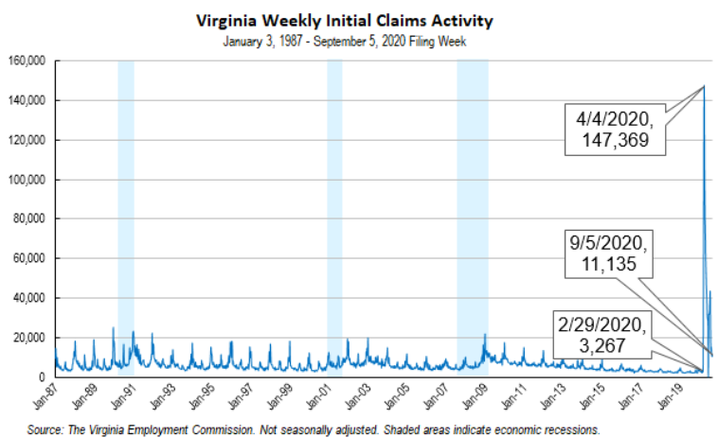
Nationwide, in the week ending September 5, the advance figure for seasonally adjusted initial claims was 884,000, unchanged from the previous week's revised level. The previous week's level was revised up by 3,000 from 881,000 to 884,000. The advance number of actual initial claims under state programs, unadjusted, totaled 857,148 in the week ending September 5, an increase of 20,140 (or 2.4 percent) from the previous week. There were 160,342 initial claims in the comparable week in 2019. Looking at preliminary data, most states reported decreases on a seasonally unadjusted basis. Florida’s preliminary weekly change (-9,049) was the largest decrease among states. Others included Kentucky (-7,486), Michigan (-5,609), Illinois (-2,889), and Pennsylvania (-2,835). Virginia’s preliminary weekly change (+3,704) was the fifth largest increase.
https://www.vec.virginia.gov/UI-press-release
PDF of press release: https://www.vec.virginia.gov/sites/default/files/news-12267-Initial%20Claims%20Press%20Release%209%205%202020.pdf
For additional information on who is claiming unemployment insurance in Virginia, access the VEC’s U.I. claims data dashboard (https://www.vec.virginia.gov/ui-claims-dashboard) that is updated the following Monday after the weekly claims press release.
September 10 - Another 884,000 Americans filed for unemployment benefits last week

America's jobs recovery might have hit a roadblock, as the number of workers filing for first-time unemployment benefits was unchanged between last week and the one prior.

Another 884,000 Americans filed for first-time jobless aid on a seasonally adjusted basis last week, the Labor Department reported on Thursday. The number of claims filed was unchanged from the prior week.

https://www.cnn.com/2020/09/10/economy/unemployment-benefits-coronavirus/index.html

September 10 - New unemployment filings down in Maryland and D.C. but up in Virginia

Unemployment claims fell in the District and Maryland, but rose significantly in Virginia last week.

In Virginia, there were more than 14,000 first-time claims for unemployment last week — more than double the 6,450 reported in Maryland. There were 1,385 first-time unemployment claims in D.C.

https://wtop.com/business-finance/2020/09/new-unemployment-filings-down-in-maryland-d-c-up-in-virginia/

Other Resources
- Virginia State Resources: https://www.virginia.gov/coronavirus/support-for-businesses/#854620
- FAQs from Workers Regarding Covid-19:
English:https://www.governor.virginia.gov/media/governorvirginiagov/governor-of-virginia/pdf/Frequently-Asked-Questions-from-Workers-Regarding-COVID-19.pdf
Spanish:https://www.governor.virginia.gov/media/governorvirginiagov/governor-of-virginia/pdf/Las-Preguntas-Mas-Frecuentes-para-los-Empleados-Sobre-COVID-19.pdf
- Support for affected workers: https://www.virginia.gov/coronavirus/employment-and-financial-support/#855804
- F.A.Q. on Coronavirus Relief for Small Businesses, Freelancers https://www.nytimes.com/article/small-business-loans-stimulus-grants-freelancers-coronavirus.html
- The Paycheck Protection Program (PPP), a provision of the CARES Act, offers forgivable low-interest loans to small businesses facing uncertainty during the COVID-19 emergency, so businesses can retain workers, maintain payroll, and cover certain other existing overhead costs. https://www.sba.gov/funding-programs/loans/coronavirus-relief-options/paycheck-protection-program-ppp
- COVID 19 Testing Information and Locations: https://www.vdh.virginia.gov/coronavirus/covid-19-testing/

WARN Notices
WARN Notices due to COVID-19 have significantly dropped off in Virginia starting in mid-June 2020. While no single factor can be attributed to this fact, the slow down does not mean that businesses have stopped laying off; many large businesses that were covered by the WARN Act up to this point have likely already felt the pandemic’s impact and reported accordingly. As any new spikes in WARN activity as a result of COVID-19 are reported the charts in this section will be updated accordingly.
http://www.vec.virginia.gov/warn-notices

