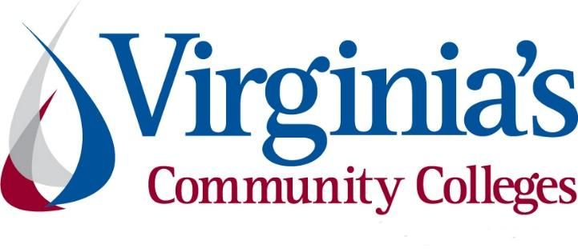
COVID-19 Update
Thursday, August 27, 2020
Virginia Daily Key Statistics
(Please note that the VDH and VHHA numbers may vary slightly due to reporting times.)
Virginia’s Daily COVID-19 Statistics-Virginia Department of Health: http://www.vdh.virginia.gov/coronavirus/ (This page is updated daily before 10 AM. Numbers are preliminary and close out at 5 PM the day before posting. Case counts reflect what has been reported to VDH by healthcare providers and laboratories.)
Tests Administered (PCR): 1,521,180 (102,845 or 7.3% increase from last week)
Total Cases: 116,579 (6,697 or 6.1% increase from last week)
Total Hospitalizations: 9,391 (393 or 4.4% increase from last week)
Total Deaths: 2,527 (100 or 4.1% increase from last week)
Current 7-Day Positivity Rate: 6.5% (Last Week: 6.5%)
COVID in Virginia’s Hospitals Dashboard: https://www.vhha.com/communications/virginia-hospital-covid-19-data-dashboard/
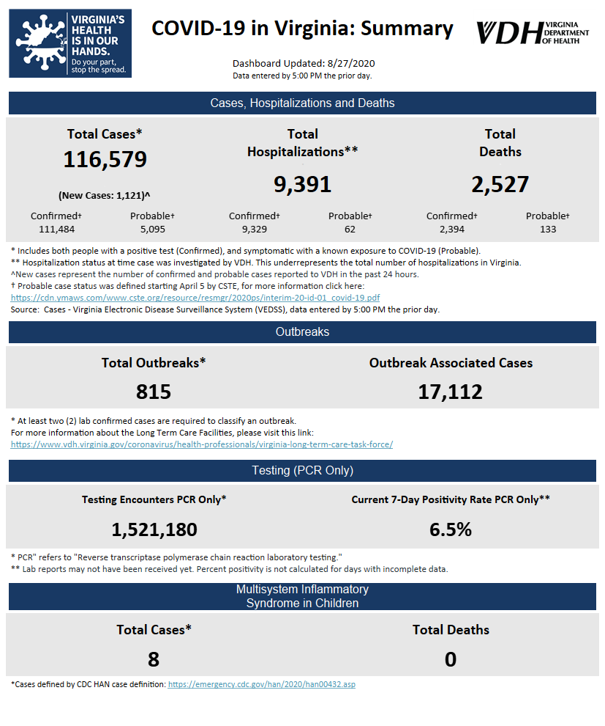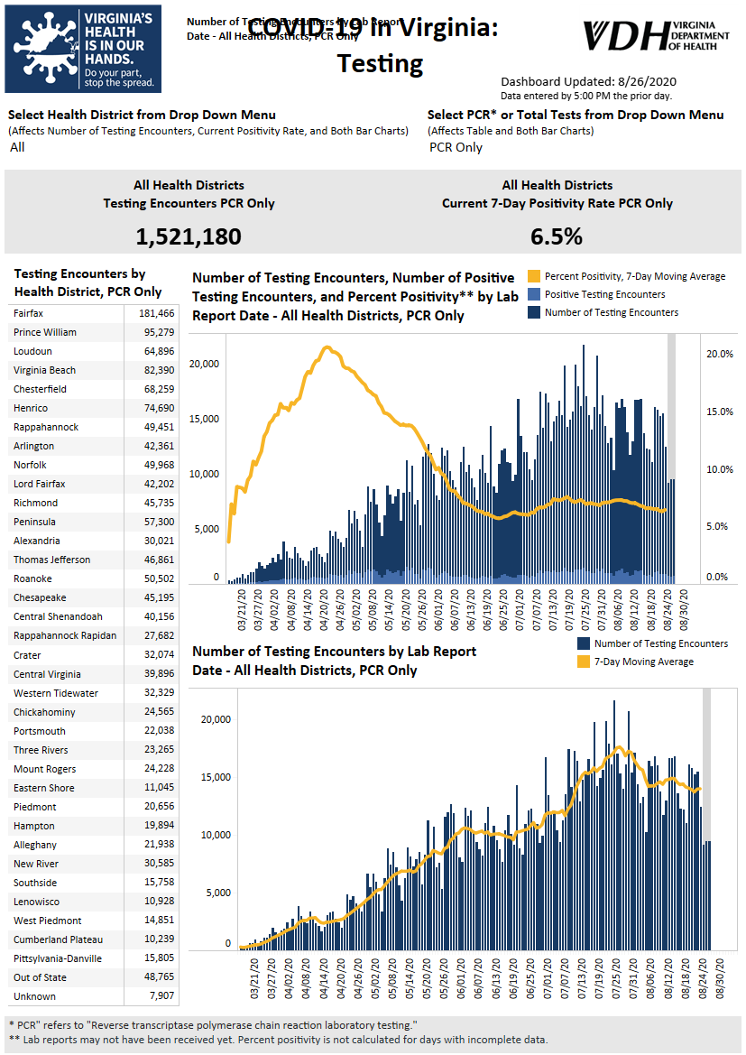Graphs obtained from Virginia Department of Health: https://www.vdh.virginia.gov/coronavirus/
August 27 - Virginia reports 1,121 new cases of COVID-19 Thursday

The Virginia Department of Health reported 1,121 new coronavirus cases Thursday, bringing the state’s tally to 116,579.

At least 2,527 Virginians have died from the virus as of Thursday morning, an increase of 12 from Wednesday.

Of the total cases, 111,484 are confirmed and 5,095 are probable, meaning those patients are symptomatic and have had a known exposure to the illness.

https://www.pilotonline.com/news/health/vp-nw-covid-thursday-august-27-hampton-roads-20200827-h4vqd7g6rjgwblyssgkqvaibx4-story.html#rt=chartbeat-flt

August 26 - Number of COVID-19 patients discharged from Virginia hospitals nears 15,000; State currently only using 21% of its ventilators

The number of people who have been discharged from a hospital after testing positive for coronavirus continues to increase - a glimpse at recoveries throughout Virginia.

As of Wednesday, Aug. 26, 14,682 people have been discharged following hospitalization for coronavirus since the pandemic began. The state also reports that it currently has 3,587 beds available with only 21% of its ventilators in use.

https://www.nbc12.com/2020/08/25/number-covid-patients-discharged-virginia-hospitals-nears/

August 25 - Virginia still not seeing improvement in COVID-19 metrics

With local cases still crawling higher, the modelers at the Virginia Department of Health and the University of Virginia expect the Lord Fairfax Health District to see its peak in new weekly cases in early November, compared to late September for the state as a whole.

https://www.nvdaily.com/nvdaily/virginia-still-not-seeing-improvement-in-covid-19-metrics/article_02533cf6-4085-55e7-8b79-3651c7622a10.html

August 24 - Northern Virginia struggles with new COVID-19 cases, hospitalizations as state numbers improve

As the state continues to find success in battling COVID-19 in other parts of the state, signs point to a continued struggle in Northern Virginia.

Inside NOVA

August 24 – New COVID-19 cases continue to decline statewide; deaths are up

State watches numbers as college students start classes

The Virginia Department of Health has reported 113,630 COVID-19 cases as of Aug. 24, an increase of 6,209 cases in the past week. The state also saw 86 more deaths from the coronavirus last week, bringing the total to 2,471.

The number of new deaths is up from the previous week’s total of 58, but the number of new cases declined from the previous week, which saw 6,672 new cases. The statewide positivity rate is 6.4%, an improvement from recent weeks — although state health officials are watching numbers closely as some colleges start classes in person.

Virginia Business
Virginia Developments
August 27 - Metropolitan Business League launches COVID-19 relief fund for businesses

The Metropolitan Business League has launched a relief fund for businesses impacted by COVID-19 and social justice demonstrations.

The CARE RVA Rebuild Project, which is in partnership with Venture Richmond, Virginia Community Capital and Virginia LISC, will help provide emergency funds for small, women and minority-owned businesses that have been financially impacted.

https://www.nbc12.com/2020/08/27/metropolitan-business-league-launches-covid-relief-fund-businesses/

August 26 - House committee votes to expand workers’ comp, mandate paid quarantine leave

Virginia workers scored a preliminary victory on Wednesday when a House committee approved two bills on workers’ compensation and paid quarantine leave — both major concerns amid the ongoing COVID-19 pandemic.

Virginia Mercury

August 26 - VA Supreme Court Dismisses Lawsuit Challenging Governor's COVID Restrictions

The Supreme Court of Virginia dismissed the joint case of a restaurant owner in Fredericksburg and an event venue owner in Loudon County who sued Gov. Ralph Northam over his COVID-19 restrictions. They asked the court to block the safety measures outlined in his executive orders, which they said severely limit their operations.

https://vpm.org/news/articles/15993/va-supreme-court-dismisses-lawsuit-challenging-governors-covid-restrictions
August 26 - Rejected Virginia bill aimed to protect those refusing to take COVID-19 vaccine due to religious beliefs
A Virginia house bill that was shut down in special session Tuesday would have protected the rights of people who don’t want to take a COVID-19 vaccine when one is available due to religious beliefs.
https://www.wsls.com/news/local/2020/08/26/rejected-virginia-bill-aimed-to-protect-those-refusing-to-take-covid-19-vaccine-due-to-religious-beliefs/
August 25 - Virus-related guidelines for Virginia workplaces to be enforced starting Thursday

Virginia businesses have had about a month to implement new occupational safety and health guidelines to help prevent the spread of the coronavirus. Starting Thursday, workplaces not following those guidelines could be punished with fines and/or closure for repeat offenders.

The Winchester Star

August 25 - Governor Northam and VMFA Announce Recipients of Artist Relief Grants

Governor Ralph Northam, First Lady Pamela Northam, and Virginia Museum of Fine Arts Director and CEO Alex Nyerges today announced 40 Virginia artists who will receive $5,000 grants through a special program to help visual artists impacted by COVID-19. The Virginia Artist Relief Fellowship Program, which launched in June, will distribute a total of $200,000 in funding.

https://www.governor.virginia.gov/newsroom/all-releases/2020/august/headline-860077-en.html

August 21 - Virginia Receives Approval to Expand Access to Health Care through State-Based Exchange

Governor Ralph Northam today announced that Virginia has been approved to proceed with a state-based health insurance exchange. Approval from the Centers for Medicare & Medicaid Services allows Virginia to take over some functions of its current federal exchange beginning with open enrollment this November and puts the Commonwealth on a path to full control by 2023.

https://www.governor.virginia.gov/newsroom/all-releases/2020/august/headline-860017-en.html

COVID 19 Testing
August 27 - Is Your State Doing Enough Coronavirus Testing?

The number of daily coronavirus tests being conducted in the United States is only 52 percent of the level considered necessary to mitigate the spread of the virus, as many states struggle to increase testing and catch up to the recent surge in cases.

https://www.nytimes.com/interactive/2020/us/coronavirus-testing.html

August 26 - Senate Bill Aims to Put Nursing Homes First in COVID-19 Testing

At the onset of the coronavirus pandemic, a majority of outbreaks in Virginia took place in nursing homes. Now, a bill proposed by Sen. Ben Chafin (R-Russell) calls on the Commissioner of Health to prioritize nursing home residents and staff when testing for COVID-19.

https://vpm.org/news/articles/16013/senate-bill-aims-to-put-nursing-homes-first-in-covid-19-testing

August 25 - UVa to start producing 75,000 COVID nasal swabs per week

The University of Virginia is providing 60,000 nasal swabs to the state each week in support of high-priority coronavirus testing.

UVa officials worked with a local engineer to design the swabs and the school plans to produce 75,000 a week, according to a press release. Of those, 15,000 will remain at UVa Health to support testing locally.

https://dailyprogress.com/news/local/uva-to-start-producing-75-000-covid-nasal-swabs-per-week/article_fe644f4e-25ef-5c39-acf2-f5a9594a8f3e.html

U.S. Economy

August 27 - U.S. economy plunged an annualized 31.7% in second quarter

The U.S. economy shrank at an alarming annual rate of 31.7% during the April-June quarter as it struggled under the weight of the viral pandemic, the government estimated Thursday. It was the sharpest quarterly drop on record.

The Commerce Department downgraded its earlier estimate of the U.S. gross domestic product last quarter, finding that the devastation was slightly less than the 32.9% annualized contraction it had estimated at the end of July. The previous worst quarterly drop since record-keeping began in 1947 was a 10% annualized loss in 1958.

https://www.nbc12.com/2020/08/27/us-economy-plunged-an-annualized-second-quarter/

Education
August 27 - Virginia Tech optimistic on managing finances, containing 'inevitable outbreaks' of COVID-19

Virginia Tech President Tim Sands told members of the board of visitors Tuesday he is optimistic the university can overcome “inevitable outbreaks” of COVID-19 as Tech enters its first week of the fall semester.

The Roanoke Times

August 26 - Editorial: As online schooling begins, digital disparities no longer can be overlooked

For weeks, K-12 school divisions, colleges and universities across Virginia have grappled over a difficult and, at times, divisive question: Amid the COVID-19 pandemic, is it safe to reopen school buildings this fall?
…
As online schooling takes shape, digital disparities no longer can be overlooked. Earlier this month, the State Council of Higher Education for Virginia (SCHEV) released “A Closer Look at Virginia’s Digital Divide in Education” — a detailed report identifying barriers some students and families face as they try to log on for classes.

https://richmond.com/opinion/editorial/editorial-as-online-schooling-begins-digital-disparities-no-longer-can-be-overlooked/article_acb4b5f9-2ea6-5289-a0bc-87550783ba60.html

August 26 - In person or online? Here are 100 public universities to watch during the pandemic.

The coronavirus pandemic has forced colleges and universities around the country to rethink how they are teaching as the fall semester gets under way. Some are primarily online, others primarily in person. Some have hybrid plans balanced between both methods. And some are still deciding.

https://www.washingtonpost.com/education/2020/08/26/100-public-universities-to-watch-coronavirus/

August 26 - Tracking Coronavirus Cases at U.S. Colleges and Universities

As college students and professors return to campus in the midst of a pandemic, coronavirus cases are turning up by the thousands.

A New York Times survey of more than 1,500 American colleges and universities — including every four-year public institution, every private college that competes in N.C.A.A. sports and others that identified cases — has revealed at least 26,000 cases and 64 deaths since the pandemic began.

https://www.nytimes.com/interactive/2020/us/covid-college-cases-tracker.html

August 25 - Richmond-area community colleges expected to see enrollment up during the pandemic. Instead, they're seeing a decline.

As the COVID-19 pandemic threatened to shut down in-person learning at four-year universities, the area’s community colleges had hoped for a spike in enrollment.

The thought was that students would see the value in taking their online courses through the less expensive two-year colleges instead of paying full price for four-year schools without getting much if any of the so-called college experience.

Culpeper Star Exponent
August 25 - Virginia Colleges Steer Millions in No-Bid Contracts to New Covid-19 Testing Company
At least three Virginia universities have hired a fledgling New Orleans-based company on no-bid contracts to provide Covid-19 tests to students before allowing them to move into campus dorms, sparking criticism from some faculty members and students.
The Chronicle of Higher Education

August 25 - College life activities driving up count of COVID-19 cases

What happened in Radford could happen in Blacksburg if students rush headlong into the college life they want to experience rather than the one COVID-19 has given them.

https://roanoke.com/news/local/college-life-activities-driving-up-count-of-covid-19-cases/article_349f981f-9641-53d4-90b1-be4a4b68bc8b.html#tracking-source=home-top-story

August 24 - Virginia Colleges Reopen with COVID-19 Data Available

Virginia college students returning to campus amid the COVID-19 pandemic have been equipped with masks, hand sanitizer and disinfectant wipes. Now, many also have coronavirus testing data available at their fingertips.

Some Virginia universities have unveiled COVID-19 dashboards to track infections as students return to campus.

https://www.nbc12.com/2020/08/24/virginia-colleges-reopen-with-covid-data-available/

August 24 - House ed chair seeks to halt ED’s new training grants

The chairman of the House Education and Labor Committee is asking U.S. Education Secretary Betsy DeVos to withdraw the Reimagine Workforce Preparation (RWP) grant competition, which would provide state workforce agencies with funding for short-term programming, including career pathway programs for unemployed and underemployed workers in jobs affected by COVID.

Rep. Bobby Scott (D-Virginia) said in an August 24 letter to DeVos that the competition was created outside the allowable uses of CARES Act Education Stabilization funding, noting in particular industry-recognized apprenticeship programs (IRAPs).

https://www.ccdaily.com/2020/08/house-ed-chair-seeks-to-nix-eds-new-training-grants/

Unemployment Data
August 27 - Virginia’s Unemployment Insurance Weekly Claims for Week Ending August 22nd
Seasonally unadjusted weekly initial unemployment insurance claims decreased by 24.5% from the previous filing week and fell to their lowest level since the onset of the Pandemic’s impacts on employment in mid-March
The Virginia Employment Commission (VEC) announced that the number of initial claims filed during the August 22, 2020 filing week fell to near the average weekly volume in 2009, according to figures released today.
For the filing week ending August 22, the figure for seasonally unadjusted initial claims in Virginia was 11,436. The latest claims figure was a decline of 3,715 claimants from the previous week, resuming the trend of steady decreases during August.
For the most recent filing week, continued weeks claimed totaled 249,745, which was a 5.8% decrease from the previous week but 230,488 higher than the 19,257 continued claims from the comparable week last year. They had leveled off in mid-August before picking up recent months’ declining trend in the most recent filing week. The continued claims total is mainly comprised of those recent initial claimants who continued to file for unemployment insurance benefits during the COVID-19 pandemic.
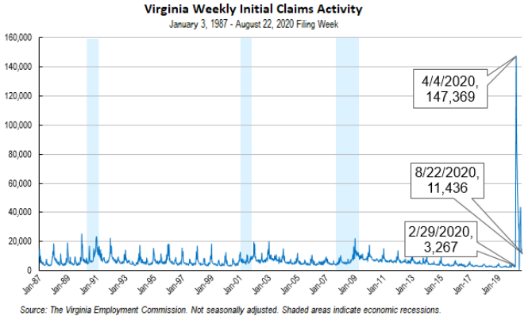
Nationwide, in the week ending August 22, the advance figure for seasonally adjusted initial claims was 1,006,000, a decrease of 98,000 from the previous week's revised level. The previous week's level was revised down by 2,000 from 1,106,000 to 1,104,000. The advance number of actual initial claims under state programs, unadjusted, totaled 821,591 in the week ending August 22, a decrease of 67,958 (or -7.6 percent) from the previous week. There were 176,867 initial claims in the comparable week in 2019. Looking at preliminary data, most states reported decreases while 12 states reported weekly increases on a seasonally unadjusted basis. Florida’s preliminary weekly change (-27,051) was the largest decrease among states. Others included Texas (-9,082), New Jersey (-6,057), North Carolina (-4,508), and Georgia (-4,043). Virginia’s preliminary weekly change (-2,281) was the 14th largest decrease among states.
https://www.vec.virginia.gov/node/12124
PDF of press release: https://www.vec.virginia.gov/sites/default/files/news-12124-Initial%20Claims%20Press%20Release%208%2022%202020.pdf
For additional information on who is claiming unemployment insurance in Virginia, access the VEC’s U.I. claims data dashboard (https://www.vec.virginia.gov/ui-claims-dashboard) that is updated the following Monday after the weekly claims press release.
August 27 - Another 1 million Americans filed for unemployment insurance benefits last week

Another 1 million American workers filed for first-time unemployment benefits last week on a seasonally adjusted basis, the Labor Department reported Thursday.

The report met economists' expectations, and was a small decline from the prior week, but the report was still somewhat of a disappointment. So far, we've only seen one week — at the start of August — with fewer than a million claims since March, when the pandemic started to take its toll on America's job market.

https://www.cnn.com/2020/08/27/economy/unemployment-benefits-coronavirus/index.html

August 26 - Virginia getting FEMA grant to help those unemployed due to pandemic

Virginia has been approved for a Federal Emergency Management Agency grant to help people who have lost their jobs due to the coronavirus pandemic.

According to a release, the grant is under the Lost Wages Assistance program, which will allow Virginia to provide $300 per week to those unemployed due to COVID-19 on top of their regular unemployment benefit.

https://www.cbs19news.com/story/42550130/virginia-getting-fema-grant-to-help-those-unemployed-due-to-pandemic

August 26 - More than 5 million people won’t get the $300 unemployment boost right now

Most states have gotten approval to offer workers at least $300 a week in extra unemployment benefits.

But more than a dozen haven’t — and that leaves millions of workers without additional aid and wondering when, or if, it will come.

https://www.cnbc.com/2020/08/26/more-than-5-million-people-wont-get-the-300-unemployment-boost-right-now.html

August 24 - U.S. employment rising slightly but still mostly flat, survey says

More COVID-19 cases recently have likely created economic uncertainty.

A survey released Monday by Virginia Commonwealth University and Arizona State University economists indicates that coronavirus-fueled economic uncertainty may have paused the nation’s labor market recovery, which stands at 63.8% employment.

https://www.virginiabusiness.com/article/u-s-employment-rising-slightly-but-still-mostly-flat-survey-says/

Other Resources
- Virginia State Resources: https://www.virginia.gov/coronavirus/support-for-businesses/#854620
- FAQs from Workers Regarding Covid-19:
English:https://www.governor.virginia.gov/media/governorvirginiagov/governor-of-virginia/pdf/Frequently-Asked-Questions-from-Workers-Regarding-COVID-19.pdf
Spanish:https://www.governor.virginia.gov/media/governorvirginiagov/governor-of-virginia/pdf/Las-Preguntas-Mas-Frecuentes-para-los-Empleados-Sobre-COVID-19.pdf
- Support for affected workers: https://www.virginia.gov/coronavirus/employment-and-financial-support/#855804
- F.A.Q. on Coronavirus Relief for Small Businesses, Freelancers https://www.nytimes.com/article/small-business-loans-stimulus-grants-freelancers-coronavirus.html
- The Paycheck Protection Program (PPP), a provision of the CARES Act, offers forgivable low-interest loans to small businesses facing uncertainty during the COVID-19 emergency, so businesses can retain workers, maintain payroll, and cover certain other existing overhead costs. https://www.sba.gov/funding-programs/loans/coronavirus-relief-options/paycheck-protection-program-ppp
- COVID 19 Testing Information and Locations: https://www.vdh.virginia.gov/coronavirus/covid-19-testing/
WARN Notices
WARN Notices due to COVID-19 have significantly dropped off in Virginia starting in mid-June 2020. While no single factor can be attributed to this fact, the slow down does not mean that businesses have stopped laying off; many large businesses that were covered by the WARN Act up to this point have likely already felt the pandemic’s impact and reported accordingly. As any new spikes in WARN activity as a result of COVID-19 are reported the charts in this section will be updated accordingly.
http://www.vec.virginia.gov/warn-notices
Virginia News
Virginia Mercury: https://www.virginiamercury.com/
National News
Sign up for The New York Times Morning Briefing: https://www.nytimes.com/series/us-morning-briefing
The Daily podcast: https://www.nytimes.com/column/the-daily

