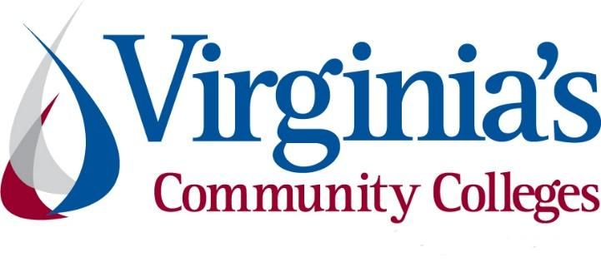
COVID-19 Update
Thursday, August 20, 2020
Virginia Daily Key Statistics
(Please note that the VDH and VHHA numbers may vary slightly due to reporting times.)
Virginia’s Daily COVID-19 Statistics-Virginia Department of Health: http://www.vdh.virginia.gov/coronavirus/ (This page is updated daily before 10 AM. Numbers are preliminary and close out at 5 PM the day before posting. Case counts reflect what has been reported to VDH by healthcare providers and laboratories.)
Tests Administered (PCR): 1,418,335 (116,426 or 8.9% increase from last week)
Total Cases: 109,882 (6,260 or 6.0% increase from last week)
Total Hospitalizations: 8,998 (406 or 4.7% increase from last week)
Total Deaths: 2,427 (64 or 2.7% increase from last week)
Current 7-Day Positivity Rate: 6.5% (Last Week: 7.3%)
COVID in Virginia’s Hospitals Dashboard: https://www.vhha.com/communications/virginia-hospital-covid-19-data-dashboard/
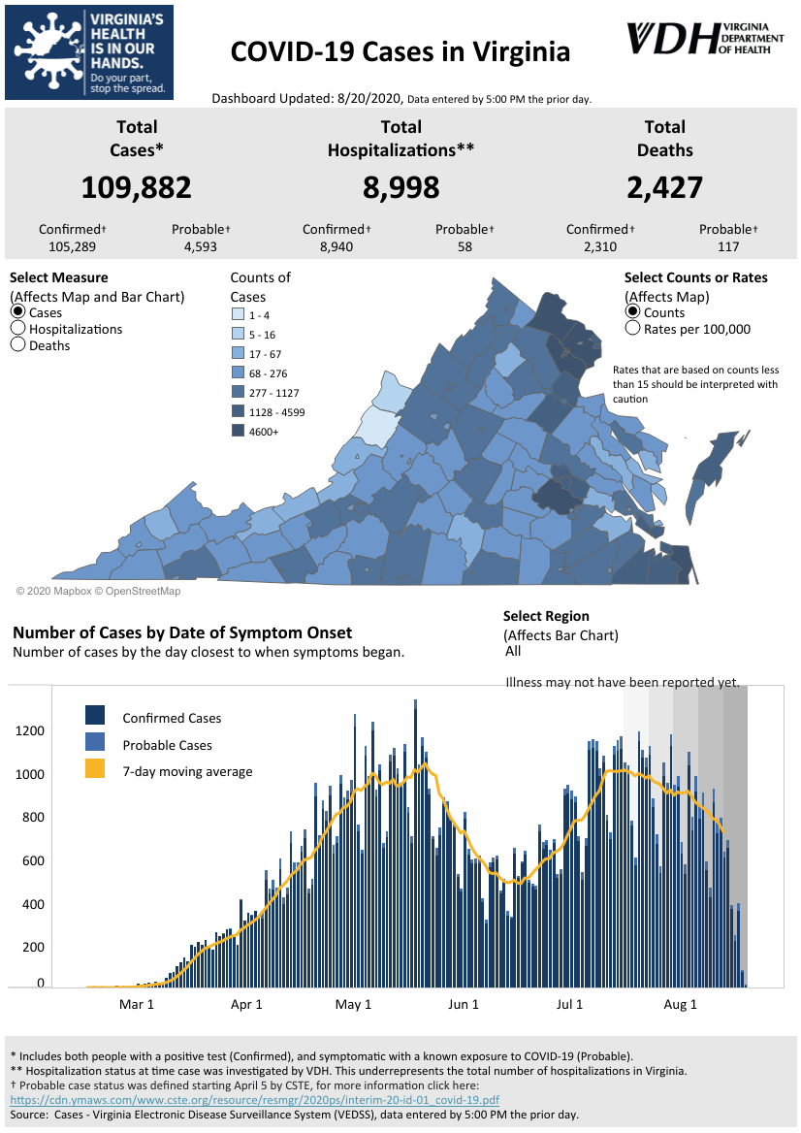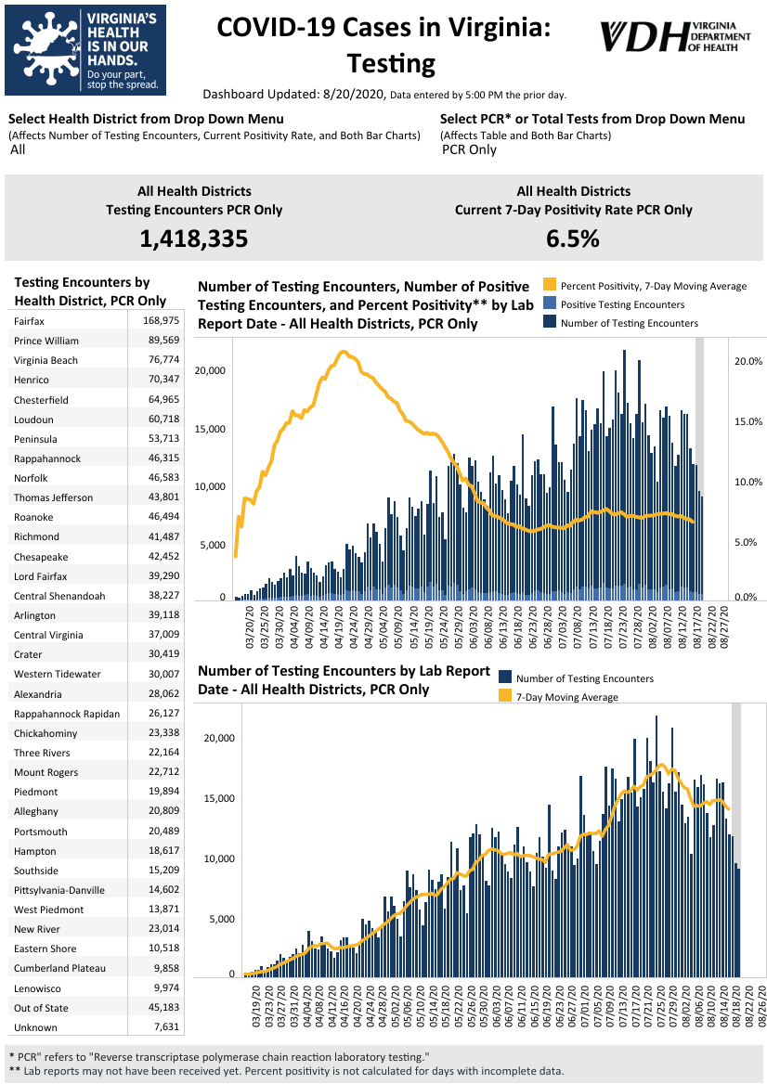Graphs obtained from Virginia Department of Health: https://www.vdh.virginia.gov/coronavirus/
August 20 - Virginia’s COVID-19 cases increase by 863, positivity rate decreases to 6.5%

The Virginia Department of Health (VDH) reported 109,882 total positive coronavirus tests throughout the state Thursday - an 863 case increase since Wednesday.

The state total stands at 2,427 deaths with 8,998 hospitalizations since the pandemic began.

A total of 1,535,931 people have now been tested. And the positivity rate, which is supposed to determine the pace of reopening, dropped to 6.5 percent. At the peak of the pandemic, that figure was more than 20 percent.

NBC 12

August 20 - After surge, coronavirus cases begin to fall in Hampton Roads

Virginia's Hampton Roads region saw such a surge in coronavirus cases last month that Gov. Ralph Northam imposed restrictions on alcohol sales and gatherings. But the number of cases is beginning to fall in the area.

https://richmond.com/news/state-and-regional/after-surge-coronavirus-cases-begin-to-fall-in-hampton-roads/article_1b75c485-7555-5110-8cba-4178aabf5647.html

August 19 - Could antigen tests solve Virginia’s testing problems? Experts say it’s not so simple.

Calling the current turnaround time for COVID-19 test results “unacceptable,” Gov. Ralph Northam announced last week that Virginia would join a consortium of other states to pursue a mass purchase of 500,000 rapid antigen tests — a relatively new technology when it comes to diagnosing cases of the virus.

Virginia Mercury

August 18 - Almost 6 months in, Black and Latino residents are still 80% of Richmond’s COVID cases. Health officials point to why

When Virginia first released race and ethnicity data, it confirmed what many were already suspecting: Black and Latino Virginians were the most vulnerable to a virus that runs rampant in close quarters and would heavily impact low-wage workers without paid sick leave and enough workplace protections.

Richmond Times-Dispatch

August 18 - Targeted restrictions may be ahead as Northern Virginia moves into 'chronic' phase of COVID-19 response, leaders warn

Northern Virginia’s response to the COVID-19 pandemic is moving from the “critical” phase to the “chronic” phase, and some targeted restrictions may need to be implemented to prevent the virus from spreading further, some of the region’s top elected leaders warned Tuesday.

Inside NOVA
August 18 - COVID-19 Presents New Re-Entry Barriers for Former Inmates

The COVID-19 pandemic has created unprecedented barriers to the already difficult process of former inmates navigating their return to society, leaving advocates scrambling for new ways to help.

The crisis has halted some reentry programs entirely, limited the resources available to their clients or forced them to operate virtually. Advocates say some returning citizens will find the help simply isn’t there.

Governing

Virginia Developments
August 19 - Queen of Virginia Skill & Entertainment generates nearly $6 million for COVID relief fund
Queen of Virginia Skill & Entertainment turned over $6.8 million to the state treasury this month. According to a press release, $5.75 million of that went into the COVID-19 Relief Fund, while over $800,000 will be distributed to localities that host Queen games. Central Virginia localities received a total of $102,240.
The release states that Queen has over 5,700 skill games located in restaurants, bars and convenience stores across the Commonwealth. A new state law went into effect on July 1 requiring skill game manufacturers and distributors to pay $1,200 to the state for each game. Each month 84% of these taxes go to the COVID-19 Relief Fund and the rest are divided up among the localities.
https://www.wric.com/business/queen-of-virginia-skill-entertainment-generates-nearly-6-million-for-covid-relief-fund/
August 18 - Governor Northam Signs Executive Order to Address Impacts of COVID-19 in State-Operated Psychiatric Hospitals
Governor Ralph Northam has issued Executive Order Seventy to help mitigate the spread of COVID-19 at Virginia’s state-operated psychiatric hospitals and ensure the safety of patients and staff during the ongoing health crisis.
https://www.governor.virginia.gov/newsroom/all-releases/2020/august/headline-859954-en.html
August 18 - Governor Northam Proposes Voter Protection Measures Ahead of November General Election
Governor Ralph Northam today announced proposals to expand access to voting for the November 3rd General Election amid the ongoing COVID-19 pandemic. The measures were unveiled by the Governor during a virtual Joint Meeting of the House Appropriations, House Finance, Senate Finance and Appropriations Committees, and will be considered by legislators during the special General Assembly session set to begin this afternoon.
“As we continue to navigate this pandemic, we must take additional steps to make it easier to vote, not harder,” said Governor Northam. “With these measures, we will protect public health and ensure Virginians can safely exercise their right to vote in the November election. Whether you put your ballot in the mail or vote in-person, voting will be safe and secure in our Commonwealth.
https://www.governor.virginia.gov/newsroom/all-releases/2020/august/headline-859958-en.html
August 14 - Governor Northam Unveils Priorities for Upcoming Special Session
Governor Northam today unveiled his administration’s key priorities for the upcoming Virginia General Assembly special session, set to begin on Tuesday, August 18th.
Legislators will reconvene to address Virginia’s biennial budget, which has been severely impacted by the ongoing global pandemic. In addition, Governor Northam is proposing several measures to advance equity, reform policing, and protect the safety, health, and welfare of Virginians during this crisis.
https://www.governor.virginia.gov/newsroom/all-releases/2020/august/headline-859923-en.html
August 5 - Comcast Extends Free Public WIFI Access to Everyone for the Remainder of 2020
As cities and towns across the country begin to open up, Comcast is continuing its efforts to help people connect to the Internet during the COVID-19 crisis. Today, the company announced it will extend free access to its 1.5 million public Xfinity WiFi hotspots to anyone who needs them, including non-customers, through the end of 2020.
Virginia Chamber
Xfinity Hotspots

COVID 19 Testing
August 19 - Could antigen tests solve Virginia’s testing problems? Experts say it’s not so simple.
Calling the current turnaround time for COVID-19 test results “unacceptable,” Gov. Ralph Northam announced last week that Virginia would join a consortium of other states to pursue a mass purchase of 500,000 rapid antigen tests — a relatively new technology when it comes to diagnosing cases of the virus.
The potential purchasing agreement is still preliminary, but a total of 10 states are now involved, from neighboring Maryland and North Carolina to Utah and Arkansas, according to Northam’s spokeswoman, Alena Yarmosky.
https://www.virginiamercury.com/2020/08/19/could-antigen-tests-solve-virginias-testing-problems-experts-say-its-not-so-simple/
August 15 - Forty percent of U.S. Covid-19 tests come back too late to be clinically meaningful, data show
...
Health experts say two days or less is optimal for returning Covid-19 test results to make them useful for stopping transmission. If test results take more than three days, people are unlikely to self-quarantine and getting in touch with the people they interact with during that time — potentially spreading virus — can be difficult.
…
A survey run by CNBC in partnership with Dynata, a global data and survey firm, suggests almost 40% of Americans had to wait more than three days for their results, rendering them — by Jha’s definition — useless.

https://www.cnbc.com/2020/08/15/forty-percent-of-us-covid-19-tests-come-back-too-late-to-be-clinically-meaningful-data-show.html

Virginia Economy

August 20 - Virginia to add $300 in federal funds to unemployment

Virginians on unemployment will get an extra $300 on top of what the state pays out.
Gov. Ralph Northam’s administration said this week that state is preparing to pay the extra benefit and is exploring ways to provide an extra $100 allowed under President Donald Trump’s executive order.

https://www.wtvr.com/rebound/coronavirus-money-help/virginia-to-add-300-in-federal-funds-to-unemployment

August 19 - Virginia applying to participate in Trump’s $300-a-week unemployment supplement

After a week of deliberation, Gov. Ralph Northam’s administration said Wednesday that Virginia is in the process of applying for federal funds made available by President Donald Trump to supplement state unemployment benefits by $300 a week.

https://www.virginiamercury.com/2020/08/19/virginia-applying-to-participate-in-trumps-300-a-week-unemployment-supplement/

August 18 - Weekly unemployment claims fall again in Virginia and Hampton Roads

Virginia and Hampton Roads have reported a second straight week of declines in unemployment claims.

The Virginia Employment Commission said 13,265 people statewide filed a new claim for the week ending Aug. 8. That’s a 45% decline compared with the previous week.

https://www.pilotonline.com/inside-business/vp-ib-unemployment-numbers-0818-20200818-wex54k7ggzdn7abomw6ema2l3m-story.html

August 18- Northam cuts spending priorities to fill $2.7 billion shortfall

Gov. Ralph Northam promised the General Assembly on Tuesday that he remains committed to “the progressive budget” it passed this year, but said the coronavirus pandemic paralyzed the state’s economy and drained tax revenues needed to pay for the priorities of the Democratic-controlled legislature.

https://richmond.com/news/state-and-regional/northam-cuts-spending-priorities-to-fill-2-7-billion-shortfall/article_a0ca3468-2d05-5348-b442-d29d396fec62.html
August 18 - U.S. hotel industry faces foreclosure wave; Va. spared for now, but could change in winter
The U.S. hotel industry is facing an historic wave of foreclosures due to the pandemic, according to findings released Tuesday from the American Hotel & Lodging Association (AHLA), but Virginia might be an exception — for now.
https://www.virginiabusiness.com/article/u-s-hotel-industry-faces-foreclosure-wave/
August 16 - Rolls-Royce to close Virginia aircraft parts plant in 2021 because of COVID-19, eliminating 280 jobs

Rolls-Royce North America said it plans to close its aircraft-part manufacturing plant in Prince George County, Virginia, by the middle of 2021.

The closure, which will eliminate 280 jobs, is due to a drop-off in business amid the COVID-19 crisis, company spokesman Donald Campbell said in a statement Saturday.

https://www.usatoday.com/story/money/cars/2020/08/16/rolls-royce-prince-george-plant-closing-job-cuts-coronavirus/5594727002/

August 14 - Virginia faces $2.7 billion revenue shortfall, but plans no layoffs or cuts in current programs

Gov. Ralph Northam expects Virginia to receive up to $2.7 billion less in revenues than previously projected for the two-year state budget because of the recession caused by the coronavirus pandemic, but he expects to avoid laying off state employees or cutting essential public services.

Northam is preparing to lay out the new revenue forecast for the General Assembly when it convenes in special session on Tuesday. Lawmakers will revise the budget they approved in March on the same day the governor declared a public health emergency that froze more than $2.2 billion in new spending.

https://richmond.com/news/virginia/virginia-faces-2-7-billion-revenue-shortfall-but-plans-no-layoffs-or-cuts-in-current/article_2e001aa8-f7f6-5db1-8428-cc6756f74b92.html

Education
August 20 - Here’s how Virginia school systems are planning to reopen

The Virginia Department of Education has created an interactive map that shows how each public school system in Virginia is planning to reopen.

According to the VDOE, all school systems have offered the option for students to learn in a fully virtual mode if they choose. Sixty of the 132 divisions – including Henrico – will reopen in fully virtual mode for all students.

https://www.henricocitizen.com/articles/heres-how-virginia-school-systems-are-planning-to-reopen/

August 19- Will you get a refund if COVID-19 closes your campus?

Many colleges are welcoming students back for in-person learning and dormitory living this fall semester. Looming over everything: Campuses could shut back down at any time.
With COVID-19 cases still high, many colleges are developing shutdown contingency plans alongside their reopening arrangements.
https://apnews.com/2e0f0d026b0c396f12f8c96a202cab0f

August 19 - Chapel Hill and Notre Dame Are Just the Beginning

On Monday, after just one week of in-person classes, the University of North Carolina at Chapel Hill reported 135 new coronavirus cases among students and staff over seven days, and announced it would go all-online for undergraduate instruction. The next day, the University of Notre Dame took instruction online for at least two weeks, after tallying 147 positive cases since the beginning of the month (that number has since increased to 222).

These early experiences suggest that learning in person this fall may be harder to pull off than some college leaders anticipated. Should other colleges take the experiences of UNC and Notre Dame, which started their semesters relatively early, as a warning?

https://www.chronicle.com/article/chapel-hill-and-notre-dame-are-just-the-beginning?cid=gen_sign_in

August 19 - 'Their preparation was not enough': Virginia Tech reacts as UNC, others close campuses

Virginia Tech leaders are urging students to comply with public health guidelines as the abrupt closure Monday of the University of North Carolina at Chapel Hill, and other colleges’ recent actions, send shock waves through the campus and higher education communities.

Richmond Times-Dispatch

August 19 - Going remote makes it harder for colleges to reach first-generation students

Their patient was flatlining, so Elizabeth Padilla Ortiz and her colleagues needed to act fast. She began chest compressions, but much of what happened afterward was a blur. “It was just an adrenaline rush,” she says.

The patient was a dummy in a simulation lab at the University of California, San Francisco (UCSF). Padilla Ortiz and her companions were high schoolers, part of a UCSF program called Health Pathways aimed at getting Oakland students from low-income families into careers in health care by providing them with hands-on experience. In Padilla Ortiz’s case, it succeeded.

https://www.theverge.com/21372574/colleges-online-remote-learning-first-generation-students

August 19 - Students Reporting Depression and Anxiety at Higher Rates

About one-third of undergraduate, graduate and professional school students screened during the summer were found to have depression or anxiety, or both, which is a higher rate than seen in years past, according to a new report by the Student Experience in the Research University, or SERU, Consortium.

The consortium, a higher education research collaborative between the University of California, Berkeley, the University of Minnesota and other institutions, used patient health questionnaires to screen 30,725 undergraduate students at nine research universities from May to July and found that 35 percent of them were positive for major depressive disorder and 39 percent for generalized anxiety disorder.

https://www.insidehighered.com/quicktakes/2020/08/19/students-reporting-depression-and-anxiety-higher-rates

Unemployment Data
August 20 - Virginia’s Unemployment Insurance Weekly Claims for Week Ending August 15th
Seasonally unadjusted weekly initial unemployment insurance claims rose by 14.2% from the previous filing week as continued claims showed little change during that period
The Virginia Employment Commission (VEC) announced that the number of initial claims filed from mid-March through the August 15, 2020 filing week totaled 1,104,097 or 27% of pre-pandemic, payroll employment, according to figures released today.
For the filing week ending August 15, the figure for seasonally unadjusted initial claims in Virginia was 15,151. The latest claims figure was an increase of 1,886 claimants from the previous week, reversing some of the declines reported in early August.
For the most recent filing week, continued weeks claimed totaled 265,225, which was essentially unchanged from the previous week but 245,425 higher than the 19,800 continued claims from the comparable week last year. They had trended downward in recent months before leveling off in the most recent filing week. The continued claims total is mainly comprised of those recent initial claimants who continued to file for unemployment insurance benefits during the COVID-19 pandemic.
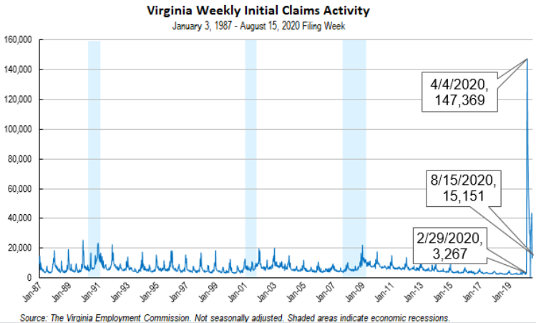
Nationwide, in the week ending August 15, the advance figure for seasonally adjusted initial claims was 1,106,000, an increase of 135,000 from the previous week's revised level. The previous week's level was revised up by 8,000 from 963,000 to 971,000. The advance number of actual initial claims under state programs, unadjusted, totaled 891,510 in the week ending August 15, an increase of 52,776 (or 6.3 percent) from the previous week. There were 171,386 initial claims in the comparable week in 2019. Looking at preliminary data, most states reported increases while 15 states, Puerto Rico, and the Virgin Islands reported weekly decreases on a seasonally unadjusted basis. New Jersey’s preliminary weekly change (+10,809) was the largest increase among states. Others included New York (+9,766), Texas (+9,112), Washington (+4,981), and Florida (+4,738). Virginia’s preliminary weekly change (+3,506) was the sixth largest increase among states.
https://www.vec.virginia.gov/UI-press-release
PDF of press release: https://www.vec.virginia.gov/sites/default/files/news-12106-Initial%20Claims%20Press%20Release%208%2015%202020.pdf
For additional information on who is claiming unemployment insurance in Virginia, access the VEC’s U.I. claims data dashboard (https://www.vec.virginia.gov/ui-claims-dashboard) that is updated the following Monday after the weekly claims press release.
August 20 - Virginia applying to participate in Trump’s $300-a-week unemployment supplement

After a week of deliberation, Gov. Ralph Northam’s administration said Wednesday that Virginia is in the process of applying for federal funds made available by President Donald Trump to supplement state unemployment benefits by $300 a week.

But officials cautioned many questions remain about the program, including ongoing uncertainty about how long the additional funds will last as more and more states seek to tap into the program.

https://www.nbc12.com/2020/08/19/virginia-applying-participate-trumps-a-week-unemployment-supplement/

August 20 - Va. saw slight uptick in initial jobless claims last week; Since mid-March, more than 1.1M Virginians have filed initial unemployment claims

More than 15,000 Virginians filed initial jobless claims last week — an increase of more than 1,800 claims from the previous week, according to the Virginia Employment Commission.

The week before last, Virginia saw its initial unemployment claims fall by 46%. In Virginia, 265,225 people remained unemployed last week, which was essentially unchanged from the previous week, but 245,425 higher than the 19,800 continued claims from the same period last year. People receiving unemployment benefits through the VEC must file weekly unemployment claims in order to continue receiving benefits.

https://www.virginiabusiness.com/article/va-saw-slight-uptick-in-initial-jobless-claims-last-week/

August 20 - U.S. Jobless Claims Unexpectedly Increase to More Than 1 Million

Applications for U.S. unemployment benefits unexpectedly increased last week, a stumble for the labor market in its long road to recovery.

Initial jobless claims in regular state programs rose by 135,000 to more than 1.1 million in the week ended Aug. 15, Labor Department data showed Thursday. Continuing claims -- the total number of Americans claiming ongoing unemployment assistance in those programs -- decreased to 14.8 million in the week ended Aug. 8, the lowest since early April.

https://www.bloomberg.com/news/articles/2020-08-20/u-s-jobless-claims-unexpectedly-increase-to-more-than-1-million

Other Resources
- Virginia State Resources: https://www.virginia.gov/coronavirus/support-for-businesses/#854620
- FAQs from Workers Regarding Covid-19:
English:https://www.governor.virginia.gov/media/governorvirginiagov/governor-of-virginia/pdf/Frequently-Asked-Questions-from-Workers-Regarding-COVID-19.pdf
Spanish:https://www.governor.virginia.gov/media/governorvirginiagov/governor-of-virginia/pdf/Las-Preguntas-Mas-Frecuentes-para-los-Empleados-Sobre-COVID-19.pdf
- Support for affected workers: https://www.virginia.gov/coronavirus/employment-and-financial-support/#855804
- F.A.Q. on Coronavirus Relief for Small Businesses, Freelancers https://www.nytimes.com/article/small-business-loans-stimulus-grants-freelancers-coronavirus.html
- The Paycheck Protection Program (PPP), a provision of the CARES Act, offers forgivable low-interest loans to small businesses facing uncertainty during the COVID-19 emergency, so businesses can retain workers, maintain payroll, and cover certain other existing overhead costs. https://www.sba.gov/funding-programs/loans/coronavirus-relief-options/paycheck-protection-program-ppp
- COVID 19 Testing Information and Locations: https://www.vdh.virginia.gov/coronavirus/covid-19-testing/

WARN Notices
WARN Notices due to COVID-19 have significantly dropped off in Virginia starting in mid-June 2020. While no single factor can be attributed to this fact, the slow down does not mean that businesses have stopped laying off; many large businesses that were covered by the WARN Act up to this point have likely already felt the pandemic’s impact and reported accordingly. As any new spikes in WARN activity as a result of COVID-19 are reported the charts in this section will be updated accordingly.
http://www.vec.virginia.gov/warn-notices

Virginia News
Virginia Mercury: https://www.virginiamercury.com/

National News
Sign up for The New York Times Morning Briefing: https://www.nytimes.com/series/us-morning-briefing
The Daily podcast: https://www.nytimes.com/column/the-daily

