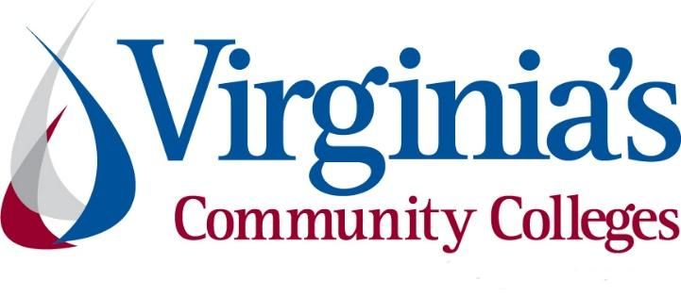
COVID-19 Update
Thursday, August 13, 2020
Virginia Daily Key Statistics
(Please note that the VDH and VHHA numbers may vary slightly due to reporting times.)
Virginia’s Daily COVID-19 Statistics-Virginia Department of Health: http://www.vdh.virginia.gov/coronavirus/ (This page is updated daily before 10 AM. Numbers are preliminary and close out at 5 PM the day before posting. Case counts reflect what has been reported to VDH by healthcare providers and laboratories.)
Tests Administered (PCR): 1,301,909 (110,605 or 9.3% increase from last week)
Total Cases: 103,622 (7,755 or 8.1% increase from last week)
Total Hospitalizations: 8,592 (409 or 5.0% increase from last week)
Total Deaths: 2,363 (64 or 2.8% increase from last week)
Current 7-Day Positivity Rate: 7.3% (Last Week: 7.3%)
COVID in Virginia’s Hospitals Dashboard: https://www.vhha.com/communications/virginia-hospital-covid-19-data-dashboard/
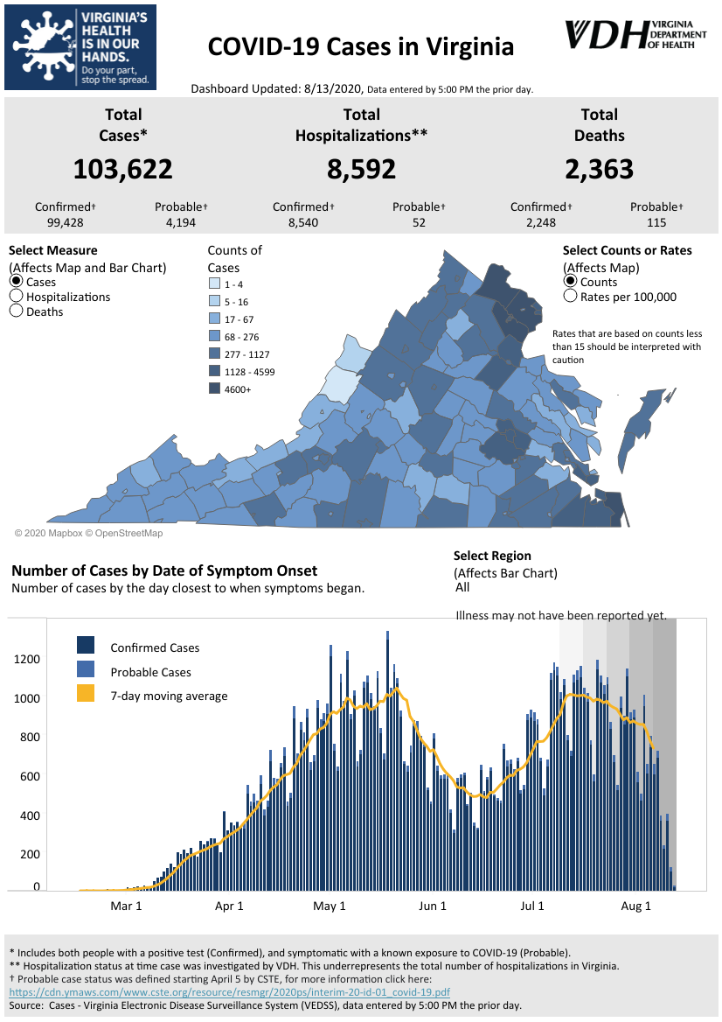
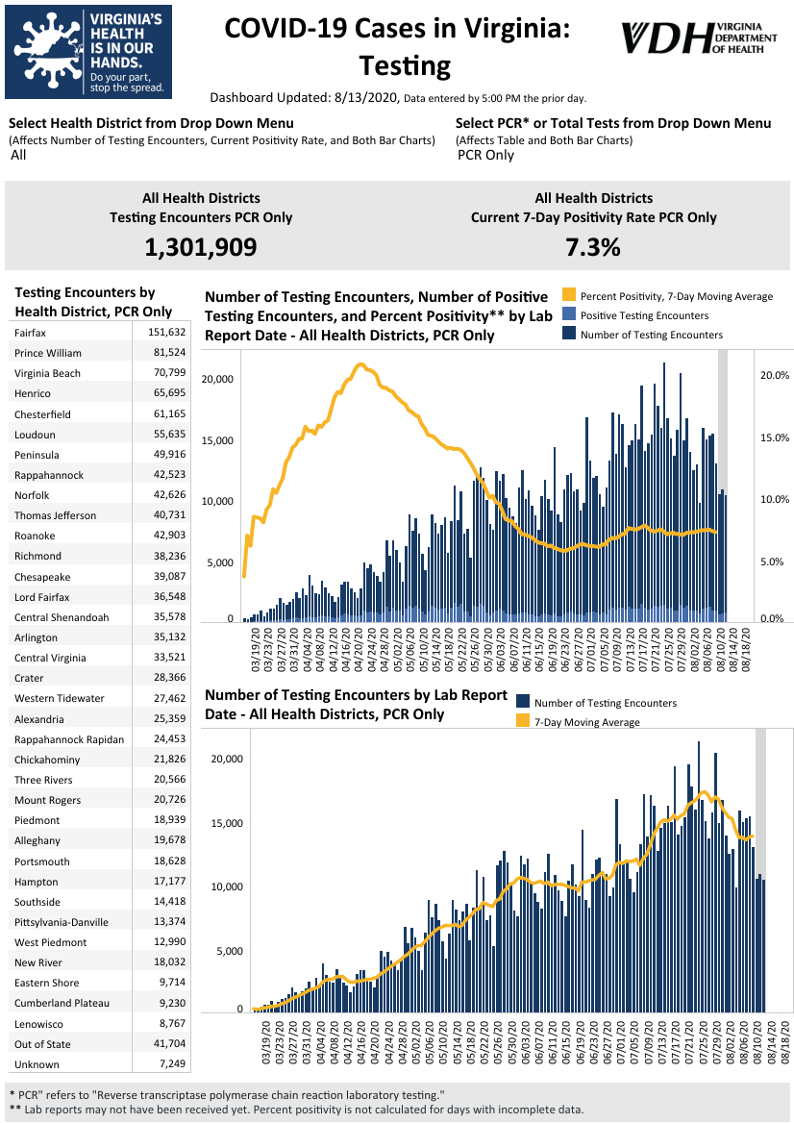
Graphs obtained from Virginia Department of Health: https://www.vdh.virginia.gov/coronavirus/
August 13 - Governor Northam Announces Launch of Pediatric Coronavirus Serology Study

Governor Ralph Northam today announced that the Virginia Department of Health (VDH) will conduct a pediatric coronavirus disease serology study in Northern Virginia. Interim results from Virginia’s ongoing adult serology study show an estimated 2.4 percent of adults statewide have antibodies to COVID-19. The new pediatric study, completed in collaboration with Inova Health System, will measure the proportion of children and teens with antibodies to COVID-19.

https://www.governor.virginia.gov/newsroom/all-releases/2020/august/headline-859892-en.html

August 13 - Virginia COVID-19 cases increase by 1,101 from Wednesday

The Virginia Department of Health reported Thursday that the statewide total for COVID-19 cases is 103,622 — an increase of 1,101 from the 102,521 reported Wednesday.

The 103,622 cases consist of 99,428 confirmed cases and 4,149 probable cases. There are 2,363 COVID-19 deaths in Virginia — 2,248 confirmed and 115 probable. That’s an increase of 11 from the 2,352 reported Wednesday.

https://richmond.com/news/local/virginia-covid-19-cases-increase-by-1-101-from-wednesday/article_3b268368-147c-5583-ab3c-fa8a28cfad87.html

August 13- The True Coronavirus Toll in the U.S. Has Already Surpassed 200,000

Across the United States, at least 200,000 more people have died than usual since March, according to a New York Times analysis of estimates from the Centers for Disease Control and Prevention. This is about 60,000 higher than the number of deaths that have been directly linked to the coronavirus.

The New York Times

August 13 - Virginia to study presence of coronavirus antibodies in N.Va. children

Virginia health officials announced Thursday that they are conducting a study of coronavirus antibodies in children and teens in the state’s Washington suburbs.

The study will look at as many as 1,000 people under 20 who are receiving care at participating clinical sites. It is being conducted with Inova Health System and will determine the proportion of children and teens with covid-19 antibodies.

https://www.washingtonpost.com/local/coronavirus-dc-maryland-virginia/2020/08/13/639f4818-dd5f-11ea-b205-ff838e15a9a6_story.html

Virginia Developments
August 13 - Dominion Energy directs $1M to help small businesses, residents pay energy bills
Businesses can receive up to $1K to pay off accrued bills during pandemic
Virginia small businesses and residential customers can receive support to pay their energy bills through Richmond-based Dominion Energy Inc.’s $1 million EnergyShare program, the company announced Thursday.
Small businesses, nonprofit organizations and houses of worship can receive up to $1,000 to go toward unpaid Dominion Energy Virginia electric bills that have accrued during the pandemic. Due to coronavirus impacts, the utility committed an additional $1 million to its $13 million annual program to help customers in need of bill assistance. Of the funds Dominion Energy committed on Thursday, $500,000 will go toward business needs while the other half is reserved for residential customers. Small businesses will be able to apply beginning Sept. 1.
https://www.virginiabusiness.com/article/dominion-energy-directs-1m-to-help-small-businesses-residents-pay-energy-bills/
August 12 - Governor Northam Announces More Than $7 Million Awarded to Seven Localities for Housing Rehabilitation and Community Development
Governor Ralph Northam today announced more than $7 million in Community Development Block Grants (CDBG) for the counties of Brunswick, Floyd, and York and the towns of Blackstone, Glade Spring, La Crosse, and White Stone. The funding will support housing rehabilitation and business district improvements to assist low- to moderate-income individuals and households.
https://www.governor.virginia.gov/newsroom/all-releases/2020/august/headline-859859-en.html
August 12 - $8.79M in CARES Act funding going to affordable housing

Following Gov. Ralph Northam’s announcement on Aug. 7 that the eviction moratorium would be extended through Sept. 7, U.S. Sens. Mark R. Warner and Tim Kaine on Monday announced that $8.79 million in federal Coronavirus Aid, Relief, and Economic Security (CARES) Act funding will go to affordable housing in Virginia.

https://www.virginiabusiness.com/article/8-79m-in-cares-act-funding-going-to-affordable-housing/?utm_source=newsletter&utm_medium=email&utm_campaign=daily

August 12 - Galax has less than 10,000 residents. Why was it leading the state in new COVID-19 infections?
Around 30,000 people crowded downtown Galax last year during the first week of August, gathering in Felts Park for the city’s annual, internationally known Old Fiddlers’ Convention.

The same week this year, the streets of the small Southwestern Virginia city are quiet. Many of the local businesses, especially the antique shops and art galleries, are closed. The 2020 Old Fiddlers’ Convention — its 85th year — was canceled for the first time since World World II. This time, the cause was biological. Donald Trausneck, an officer for the local Moose Lodge, told the Mount Airy News in May that the “very difficult decision” was spurred by public safety concerns amid the COVID-19 pandemic.
https://www.virginiamercury.com/2020/08/12/galax-has-less-than-10000-residents-why-was-it-leading-the-state-in-new-covid-19-infections/
August 11 - Daycares in Central Virginia report dire futures due to COVID-19, survey says
A recent survey of more than 100 daycares and childcare centers in Central Virginia revealed that a majority would need some financial assistance to survive.
https://www.wtvr.com/rebound/coronavirus-money-help/daycares-in-central-virginia-report-dire-futures-due-to-covid-19-survey-says
August 10 - Tidewater’s child care crisis: Pandemic drives underlying need, parents see limited access, high costs
…
Amid the COVID-19 outbreak with most school divisions adopting reopening plans that include students staying home most days, the need for child care has increased drastically and parents are now left searching for safe and reliable care in a pandemic.
https://www.dailypress.com/tidewater-review/va-tr-kw-child-care-accessibility-0805-20200810-qje474f3vfgp5ilxyztwlkoiaa-story.html
August 7 - Virginia Supreme Court Grants Temporary Statewide Eviction Moratorium
Governor Ralph Northam today announced a temporary statewide moratorium on eviction proceedings in Virginia. The moratorium, which will begin on Monday, August 10 and remain in effect through Monday, September 7, halts all eviction proceedings related to failure to pay rent. Governor Northam requested this moratorium in a letter to Virginia Supreme Court Chief Justice Donald Lemons on July 24.
https://www.governor.virginia.gov/newsroom/all-releases/2020/august/headline-859818-en.html

Support for Businesses
August 13 - Governor Northam Announces GO Virginia Funding to Support Economic Recovery, Regional Workforce Development, and Entrepreneurial Ecosystems
Governor Ralph Northam today announced that Growth and Opportunity for Virginia (GO Virginia) will award more than $5.5 million to support projects that will help address economic and public health challenges created by the COVID-19 pandemic. The four regional projects and one statewide competitive project receiving funding are focused on strengthening the health sciences workforce pipeline, advancing new renewable energy ventures, and developing a regional services network for entrepreneurs.
https://www.governor.virginia.gov/newsroom/all-releases/2020/august/headline-859900-en.html
August 11 - Governor Northam Awards Funding for 18 Community Development Projects Across Virginia
Governor Ralph Northam today announced that 18 communities across the Commonwealth will receive $278,000 in Virginia Main Street grants to accelerate the economic revitalization of their downtown districts as part of Virginia’s COVID-19 economic recovery strategy.
https://www.governor.virginia.gov/newsroom/all-releases/2020/august/headline-859857-en.html

COVID 19 Testing
August 12 - Coronavirus update: Companies test antibody drugs to treat, prevent COVID-19. Here's the latest.
With a coronavirus vaccine still months off, companies are rushing to test what may be the next best thing: drugs that deliver antibodies to fight the virus right away, without having to train the immune system to make them.

Antibodies are proteins the body makes when an infection occurs; they attach to a virus and help it be eliminated. Vaccines work by tricking the body into thinking there’s an infection so it makes antibodies and remembers how to do that if the real bug turns up.
https://richmond.com/news/national/coronavirus-update-companies-test-antibody-drugs-to-treat-prevent-covid-19-heres-the-latest/article_1b2d59df-b22e-5812-a858-e245e8f5a4e9.html
August 10- Virginia’s nursing homes prepare for sweeping new testing requirement
The news release raised more questions than it answered.

On July 22, the U.S. Centers for Medicare and Medicaid Services announced “new resources” to help nursing homes combat the ongoing spread of COVID-19. Between the announcement of an additional $5 billion in funding and plans to deliver rapid antigen tests to facilities, CMS made an unexpected declaration: All nursing homes in states with a percent positivity rate of 5 percent or higher would be required to conduct weekly testing of all staff members.
https://www.virginiamercury.com/2020/08/10/virginias-nursing-homes-are-staring-down-the-barrel-of-another-sweeping-new-testing-requirement/
August 11- COVID-19 testing turnarounds stretch to two weeks for some in the Roanoke region
Results for COVID-19 tests in the Roanoke region are taking anywhere from two days to two weeks, with the lag making it more difficult to curb the spread of the disease, Dr. Molly O’Dell said Tuesday.

O’Dell said once the test turnaround time stretches beyond 48 hours, it is harder to identify others who many have come into contact with the person infected with the coronavirus.
https://roanoke.com/news/local/covid-19-testing-turnarounds-stretch-to-two-weeks-for-some-in-the-roanoke-region/article_77105a48-b636-52ba-a740-606f393dbe44.html
Virginia Economy
August 13 - How local cities plan to use federal COVID-19 funds

The Commonwealth of Virginia is in the process of distributing $644.6 million in federal COVID-19 relief funding to local governments in its second and final round of allocations.

Over the past few weeks, many local city councils started the process of receiving their portion of the money.

https://www.wtkr.com/news/how-local-cities-plan-to-use-federal-covid-19-funds

August 10- Views differ on how halting evictions will affect Virginia's economy

With more than 6,000 eviction cases pending statewide, Northam requested the suspension to prevent people who have been affected by COVID-19 and the subsequent economic restrictions from losing their homes. He intends to work with the General Assembly during next week’s special session to put stronger tenant protections on the books.

“This decision comes at a time when we are still battling this public health crisis and need all Virginians to maintain safe, stable housing,” Northam said in a statement.

https://www.insidenova.com/news/state/views-differ-on-how-halting-evictions-will-affect-virginias-economy/article_8cff987b-884a-5cbb-833d-e5ea30e669a1.html

August 7 - Construction continues to struggle during pandemic; Industry has recovered only 59% of jobs lost since crisis began

The nonresidential construction industry lost 4,000 jobs in July, as compared to June, the Associated Builders and Contractors (ABC) announced Friday. The construction industry as a whole, however, has added 639,000 jobs during the past three months — recovering approximately 59% of the jobs lost during the pandemic.

https://www.virginiabusiness.com/article/construction-continues-to-struggle-during-pandemic/

Education
August 13 - More than 10% of Va. students don’t have broadband access at home

While Virginia school districts and higher education institutions are finalizing fall plans in light of the pandemic, an analysis released Wednesday by the State Council on Higher Education for Virginia (SCHEV) shows that more than 200,000 K-12 students and more than 60,000 college students in Virginia lack broadband access at home.

https://www.virginiabusiness.com/article/more-than-10-of-va-students-dont-have-broadband-access-at-home/?utm_source=newsletter&utm_medium=email&utm_campaign=daily
SCHEV Report: https://drive.google.com/file/d/1IFZkDV43_43oCdxK8YkCsu9Tq09LctM2/view
August 12 - EDITORIAL: As job opportunities shift, Virginia’s community colleges are able to adapt

In 2016, the Virginia General Assembly made a critical investment to keep the commonwealth’s workforce strong. Lawmakers passed the New Economy Workforce Credential Grant Program, a bill supporting “FastForward” short-term career training in high-demand fields. The programs were designed to be completed in 6 to 12 weeks, with students footing only one-third of the cost.

https://starexponent.com/opinion/editorial-as-job-opportunities-shift-virginia-s-community-colleges-are-able-to-adapt/article_8111ad2a-034e-5d4b-b1b7-5c5f19ce7a64.html

August 10 - 40% Of College Freshmen Likely Won’t Attend This Fall

Following news Friday that 20% of Harvard freshmen have chosen to defer, a new survey out today suggests it will be even worse for the rest of higher education with 40% of expected freshmen attending 4-year residential colleges saying they are likely or highly likely to not attend this fall. On top of this, 28% of returning students say they are not going back or haven’t decided yet. Earlier surveys from late April suggested enrollment drops of as much as 20%. Higher ed leaders were hoping for more certainty as the school year got closer, but instead it looks like the forecast has thrown them a late-breaking curve ball and has substantially worsened.

https://www.forbes.com/sites/brandonbusteed/2020/08/10/40-of-college-freshmen-likely-wont-attend-this-fall/?ss=education#1e14ad831800

August 10 - Trump order gives 35 million student loan borrowers a break until 2021. What we know so far

After Republicans and Democrats failed to agree on the details of another stimulus package last week, President Donald Trump signed an executive order on Saturday that gives people with student debt another three-month break from their bills, during which interest will not accrue.

As a result, more than 35 million people with federal student loans won’t have to resume their payments until January 2021.

https://www.cnbc.com/2020/08/10/trump-extends-payment-pause-for-student-loan-borrowers-until-2021.html

August 10 - At Home, Workers Seek Alternative Credentials

When COVID-19 closed down school and college campuses in March, many children and young people were forced to start studying remotely. At the same time, interest in online training and certificate programs soared.

Several leading massive open online course providers, coding bootcamps and business schools offering non-degree credentials reported manyfold increases in web traffic, inquiries and enrollments. Though big surges took place in April and May, they quickly started to flatten for most providers. They did not, however, return to their original baseline.

Inside Higher Ed
August 4 - CTE POLICY WATCH: COVID-19 Research Round-up (Part II)
A collection of research articles on the impact of COVID 19 on CTE programming
https://ctepolicywatch.acteonline.org/2020/08/covid-research-round-up-part-ii.html

Unemployment Data
August 13 - Virginia’s Unemployment Insurance Weekly Claims for Week Ending August 8th
Seasonally unadjusted weekly initial unemployment insurance claims fell by 44.5% from the previous filing week as continued claims fell by 20.2% during that period
The Virginia Employment Commission (VEC) announced that the latest number of weekly initial claims filed fell to less than one tenth of their pandemic peak set during the April 4, 2020 filing week.
For the filing week ending August 8, the figure for seasonally unadjusted initial claims in Virginia was 13,265. The latest claims figure was a decrease of 10,653 claimants from the previous week, and resulted in a decline of 69% over the last two filing weeks.
For the most recent filing week, continued weeks claimed totaled 264,410, down 66,991 from the previous week, but 244,425 higher than the 19,985 continued claims from the comparable week last year. They have trended downward over the last three months and accelerated their decline during the most recent filing week. The continued claims total is mainly comprised of those recent initial claimants who continued to file for unemployment insurance benefits during the COVID-19 pandemic.
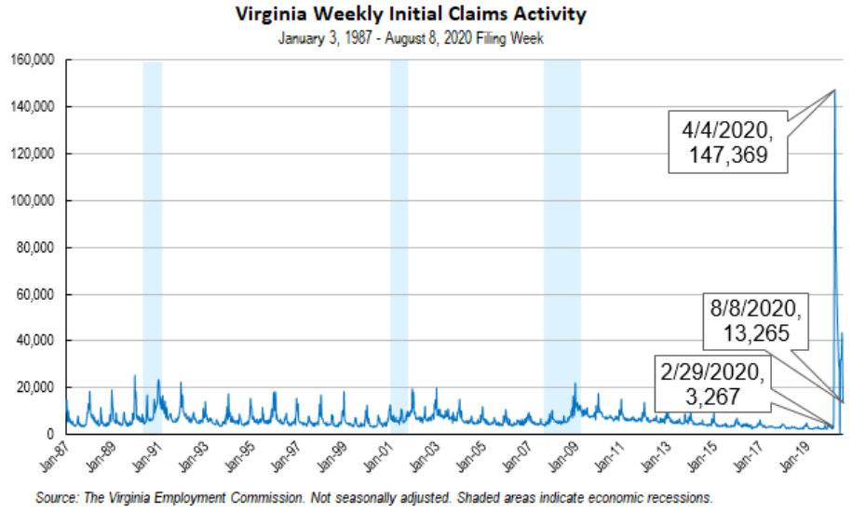
Nationwide, in the week ending August 8, the advance figure for seasonally adjusted initial claims was 963,000, a decrease of 228,000 from the previous week's revised level. The previous week's level was revised up by 5,000 from 1,186,000 to 1,191,000. The advance number of actual initial claims under state programs, unadjusted, totaled 831,856 in the week ending August 8, a decrease of 156,453 (or -15.8 percent) from the previous week. There were 186,914 initial claims in the comparable week in 2019. Looking at preliminary data, most states reported decreases while four states reported weekly decreases of 10,000 or more on a seasonally unadjusted basis. Florida’s preliminary weekly change (-23,180) was the largest drop among states. Other decreases over 10,000 included New York (-21,905), Georgia (-11,652), and Texas (-11,233). Virginia’s preliminary weekly change (-9,157) was the fifth largest decline among states.
https://www.vec.virginia.gov/UI-press-release
PDF of press release: https://www.vec.virginia.gov/sites/default/files/Release-8-8-2020.pdf
For additional information on who is claiming unemployment insurance in Virginia, access the VEC’s U.I. claims data dashboard (https://www.vec.virginia.gov/ui-claims-dashboard) that is updated the following Monday after the weekly claims press release.
August 13 - Va. initial jobless claims dropped 46% last week; U.S. first-time claims fall below 1 million for first time since pandemic began

Initial unemployment claims in Virginia fell by 46% last week, according to a Thursday release from the Virginia Employment Commission.

More than 13,000 Virginians filed initial jobless claims last week — a decrease of more than 10,000 claims from the previous week, according to a VEC statement released Thursday.

For the first time since the pandemic began, the number of initial claims filed in the U.S. dropped below 1 million....

https://www.virginiabusiness.com/article/va-initial-jobless-claims-dropped-46-last-week/

August 13 - US jobless claims fall below 1 million but remain high

WASHINGTON (AP) — The number of laid-off workers applying for unemployment aid fell below 1 million last week for the first time since the viral pandemic intensified five months ago, yet still remains at a high level.

https://apnews.com/d0dc7c4719667d1a7f69cc9b8ab204c9

August 10 - Will Virginia sign on to Trump’s plan to boost unemployment benefits by $400?

Governors, lawmakers and state unemployment agencies on Monday wrestled with confusion created by President Donald Trump’s executive action extending unemployment benefits, and it appeared some states could settle for $300 a week in benefits instead of the $400 that the president touted.
…
In Virginia, a spokesperson for Democratic Gov. Ralph Northam was noncommittal. “We are continuing to review newly-released details from the US Department of Labor to determine how — and if — we can proceed,” said Northam’s spokeswoman, Alena Yarmosky, noting the state is already working with limited resources responding to the medical needs presented by the pandemic.

https://www.virginiamercury.com/blog-va/will-virginia-sign-on-to-trumps-plan-to-boost-unemployment-benefits-by-400/

Other Resources
- Virginia State Resources: https://www.virginia.gov/coronavirus/support-for-businesses/#854620
- FAQs from Workers Regarding Covid-19:
English:https://www.governor.virginia.gov/media/governorvirginiagov/governor-of-virginia/pdf/Frequently-Asked-Questions-from-Workers-Regarding-COVID-19.pdf
Spanish:https://www.governor.virginia.gov/media/governorvirginiagov/governor-of-virginia/pdf/Las-Preguntas-Mas-Frecuentes-para-los-Empleados-Sobre-COVID-19.pdf
- Support for affected workers: https://www.virginia.gov/coronavirus/employment-and-financial-support/#855804
- F.A.Q. on Coronavirus Relief for Small Businesses, Freelancers https://www.nytimes.com/article/small-business-loans-stimulus-grants-freelancers-coronavirus.html
- The Paycheck Protection Program (PPP), a provision of the CARES Act, offers forgivable low-interest loans to small businesses facing uncertainty during the COVID-19 emergency, so businesses can retain workers, maintain payroll, and cover certain other existing overhead costs. https://www.sba.gov/funding-programs/loans/coronavirus-relief-options/paycheck-protection-program-ppp
- COVID 19 Testing Information and Locations: https://www.vdh.virginia.gov/coronavirus/covid-19-testing/

WARN Notices
WARN Notices due to COVID-19 have significantly dropped off in Virginia starting in mid-June 2020. While no single factor can be attributed to this fact, the slow down does not mean that businesses have stopped laying off; many large businesses that were covered by the WARN Act up to this point have likely already felt the pandemic’s impact and reported accordingly. As any new spikes in WARN activity as a result of COVID-19 are reported the charts in this section will be updated accordingly.
http://www.vec.virginia.gov/warn-notices

Virginia News
Virginia Mercury: https://www.virginiamercury.com/

National News
Sign up for The New York Times Morning Briefing: https://www.nytimes.com/series/us-morning-briefing
The Daily podcast: https://www.nytimes.com/column/the-daily

