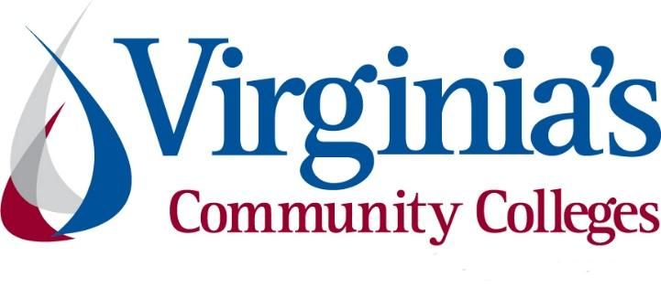
COVID-19 Update
Thursday, August 6, 2020

Virginia Daily Key Statistics
(Please note that the VDH and VHHA numbers may vary slightly due to reporting times.)
Virginia’s Daily COVID-19 Statistics-Virginia Department of Health: http://www.vdh.virginia.gov/coronavirus/ (This page is updated daily before 10 AM. Numbers are preliminary and close out at 5 PM the day before posting. Case counts reflect what has been reported to VDH by healthcare providers and laboratories.)
Tests Administered (PCR): 1,191,304 (99,689 or 9.1% increase from last week)
Total Cases: 95,867 (6,963 or 7.8% increase from last week)
Total Hospitalizations: 8,183 (397 or 5.1% increase from last week)
Total Deaths: 2,299 (158 or 7.4% increase from last week)
Current 7-Day Positivity Rate: 7.3% (Last Week: 7.2%)
COVID in Virginia’s Hospitals Dashboard: https://www.vhha.com/communications/virginia-hospital-covid-19-data-dashboard/

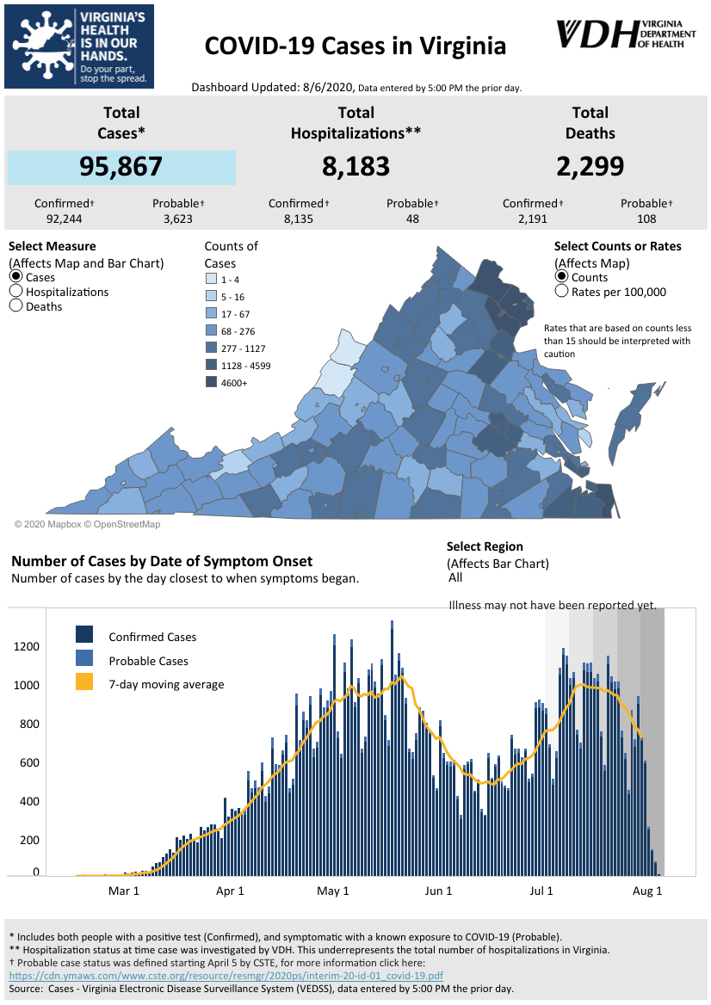
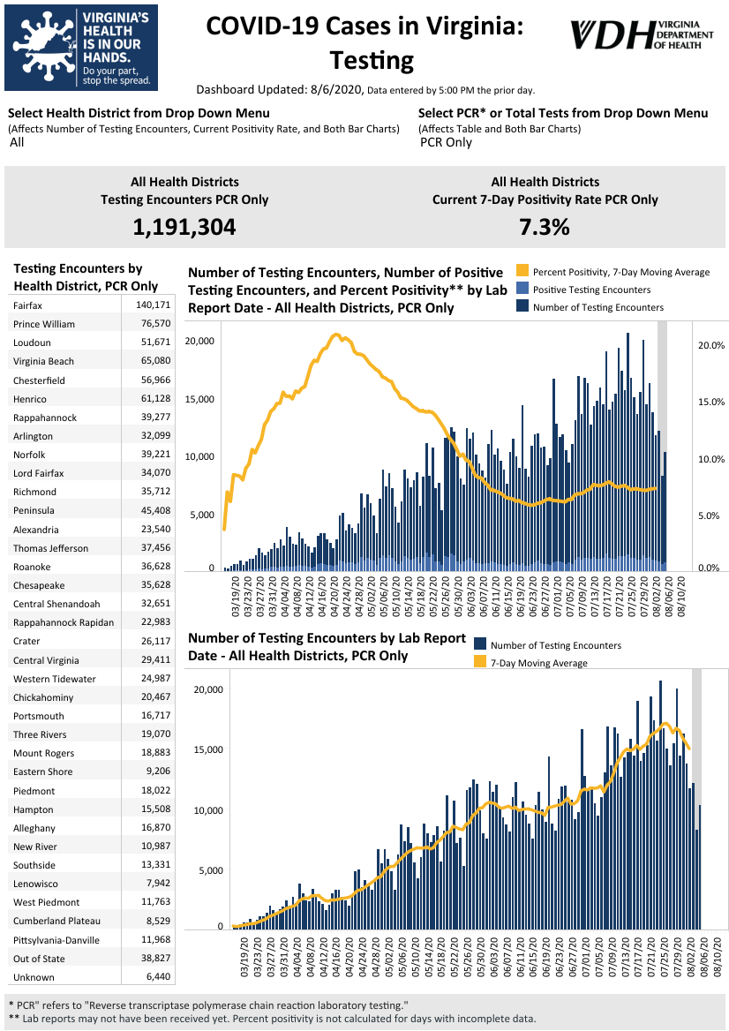
Graphs obtained from Virginia Department of Health: https://www.vdh.virginia.gov/coronavirus/
August 6 - Statewide COVID-19 cases increase by 818 since Wednesday

The Virginia Department of Health reported Thursday that the statewide total for COVID-19 cases is 95,867 — an increase of 818 from the 95,049 reported Wednesday.

The 95,867 cases consist of 92,244 confirmed cases and 3,623 probable cases. There are 2,299 COVID-19 deaths in Virginia — 2,191 confirmed and 108 probable. That’s an increase of 25 from the 2,274 reported Wednesday.

The VDH defines probable COVID-19 cases as people who are symptomatic with a known exposure to COVID-19, but whose cases have not been confirmed with a positive test.

https://richmond.com/news/virginia/statewide-covid-19-cases-increase-by-818-since-wednesday/article_f4ab048c-92e3-55c0-b182-f61876c33dac.html

August 5 - Nearly 800 new COVID-19 cases confirmed in Virginia | Positivity rate at 7.2%

The Virginia Department of Health (VDH) reported 95,049 total positive coronavirus tests throughout the state Wednesday - a 798 case increase since Tuesday.

The rise in cases is often attributed to the increased amount of testing happening through the commonwealth.

A total of 1,283,136 people have now been tested. And the positivity rate, which is supposed to determine the pace of reopening, is at 7.2 percent - which remained the same as since the day before. At the peak of the pandemic, that figure was more than 20 percent.

https://www.nbc12.com/2020/08/05/nearly-new-covid-cases-confirmed-virginia-positivity-rate/

August 4 - The Coronavirus Is Never Going Away

The coronavirus that causes COVID-19 has sickened more than 16.5 million people across six continents. It is raging in countries that never contained the virus. It is resurging in many of the ones that did. If there was ever a time when this coronavirus could be contained, it has probably passed. One outcome is now looking almost certain: This virus is never going away.
The coronavirus is simply too widespread and too transmissible. The most likely scenario, experts say, is that the pandemic ends at some point—because enough people have been either infected or vaccinated—but the virus continues to circulate in lower levels around the globe. Cases will wax and wane over time. Outbreaks will pop up here and there. Even when a much-anticipated vaccine arrives, it is likely to only suppress but never completely eradicate the virus. (For context, consider that vaccines exist for more than a dozen human viruses but only one, smallpox, has ever been eradicated from the planet, and that took 15 years of immense global coordination.) We will probably be living with this virus for the rest of our lives.

https://www.theatlantic.com/health/archive/2020/08/coronavirus-will-never-go-away/614860/

Support for Virginians
August 6 - Virginia first to roll out pandemic app from Apple, Google

Virginia has rolled out a smartphone app to automatically notify people if they might have been exposed to the coronavirus, becoming the first U.S. state to use new pandemic technology created by Apple and Google.

But hopes for a nationwide app that can work seamlessly across state borders remain unrealized, and there are no known federal plans to create one. State officials say their new app won’t work as well outside Virginia, at least until a group of coordinating public health agencies gets a national server up and running and other states join in.

https://apnews.com/46b54442d8faf71dab0a5c97b87374d7

August 5 - Virginia launches its COVID-19 exposure notification app

Virginia health officials launched a smartphone app Wednesday that alerts users if they were in close contact with other app users who later test positive for COVID-19.

Called COVIDWISE, the software was developed for the state using a technology platform created by Google and Apple with the aim of letting users know if they were potentially exposed while maintaining privacy.

The software does not track or store personal or location data and only uses Bluetooth to log when app users are close together, according to developers. If an app user later tests positive, VDH confirms the results and provides the user with a PIN, which they can then enter into the app, triggering a virtual contact tracing.

https://www.virginiamercury.com/blog-va/virginia-launches-its-covid-19-exposure-notification-app/

July 31 - Sentara, Truist launch emergency meals program with state; Va. sent $1.4M in CARES Act funding to We Care initiative

As Feeding America projects that more than 1 million Virginians will face food insecurity this year, Norfolk-based Sentara Healthcare, Optima Health and Truist Financial Corp., along with the state government, launched the “We Care” COVID-19 Virginia Emergency Fund Support Plan to provide free meals to families during the pandemic.

The state committed $1.4 million of its federal Coronavirus Aid, Relief, and Economic Security (CARES) Act funding to the initiative, and Sentara and Charlotte, North Carolina-based Truist each committed $500,000.

https://www.virginiabusiness.com/article/sentara-truist-launch-emergency-meals-program-with-state/

COVID 19 Testing
August 4- Virginia Joins Bipartisan, Interstate Compact to Expand Rapid Antigen Testing

Governor Ralph Northam today announced a cutting-edge interstate compact to expand the use of rapid antigen testing in Virginia. Governor Northam joined Maryland Governor Larry Hogan, Louisiana Governor John Bel Edwards, Massachusetts Governor Charlie Baker, Michigan Governor Gretchen Whitmer, and Ohio Governor Mike DeWine in this bipartisan agreement with the Rockefeller Foundation, which represents the first interstate testing compact of its kind among governors during the COVID-19 pandemic.

https://www.governor.virginia.gov/newsroom/all-releases/2020/august/headline-859785-en.html
PPE/Contact Tracing
August 5 - Efforts To Hire Spanish-Speaking Contact Tracers Continue

On June 5, Chesterfield-County resident Karen Chacón started to experience some symptoms of COVID-19, like what felt like a mosquito in her throat. “Physically, I felt tired,” Chacón said. “I felt sleepy, like my battery wasn’t full.”

About a week later, she decided to get tested. The next day, she noticed her sense of smell was gone. “I called my husband and I started crying and I told him ‘That’s it. Definitely. It’s the virus,’” she said.

https://vpm.org/news/articles/15427/efforts-to-hire-spanish-speaking-contact-tracers-continue

Virginia Economy
August 6 - The Workforce Is About to Change Dramatically

In march, tens of millions of American workers—mostly in white-collar industries such as tech, finance, and media—were thrust into a sudden, chaotic experiment in working from home. Four months later, the experiment isn’t close to ending. For many, the test run is looking more like the long run.

Google announced in July that its roughly 200,000 employees will continue to work from home until at least next summer. Mark Zuckerberg has said he expects half of Facebook’s workforce to be remote within the decade. Twitter has told staff they can stay home permanently.

The Atlantic

August 5 - Virginia caught more than 3,000 fraudulent jobless claims, stopped $50 million in payments

About 3,000 fraudulent claims doesn’t seem like much when it’s less than three-tenths of a percent of all the unemployment applications that have been filed in Virginia.

The Virginia Employment Commission had handled 1,008,797 initial unemployment claims between mid-March and July 18, an unheard of number that would have normally taken years to amass, not months.

https://www.dailypress.com/business/jobs/vp-bz-buzz-unemployment-fraud-20200805-4yct3srrbvdthhl76sv3r4coxq-story.html

Education
August 5 - COVID-19 screening tool is part of new app rolling out at Virginia Tech

Virginia Tech is moving ahead with plans to have students return to campus, and said it is rolling out a smartphone app to screen students and staff for COVID-19.

The safety app and screening tool is called “Hokie Ready.”

The app, which is available for download on both Android and iPhone platforms, asks users some basic questions: Have you traveled internationally in the last 14 days? Have you knowingly been exposed to somebody who tested positive for COVID-19 in the last 14 days?

https://wtop.com/coronavirus/2020/08/a-covid-19-screening-tool-is-part-of-a-new-app-rolling-out-at-virginia-tech/

August 5 - Radford bans gatherings of more than 50 as college students return

Radford City Council on Tuesday banned gatherings of more than 50 people through August in anticipation of a spike of COVID-19 cases as Radford University students return to campus.

The emergency ordinance that council members adopted at a special meeting comes as thousands of students are moving into the city, which has seen COVID-19 cases increase from 11 to 34 in the last 30 days.

The Roanoke Times

August 4- Nearly 100 VCU faculty members call for virtual fall semester as UVA, other Va. colleges delay in-person classes

Nearly 100 Virginia Commonwealth University professors are formally asking the school to switch to a fully virtual fall semester.

In a resolution approved Tuesday, the VCU chapter of the American Association of University Professors called on President Michael Rao to “immediately declare that classes for the Fall 2020 semester should be held exclusively online, except in cases where in-person education is deemed absolutely necessary.” The switch would make VCU the state’s largest college to hold classes completely online this fall.

https://richmond.com/news/virginia/nearly-100-vcu-faculty-members-call-for-virtual-fall-semester-as-uva-other-va-colleges/article_1ea094de-ee6a-5e6c-9145-57b1fcf2ffda.html
August 3- As the Coronavirus Comes to School, a Tough Choice: When to Close

More than 200 employees have been barred from work in Georgia’s largest school district. A high school in Indiana had to shift to online learning after just two days. And students in Mississippi were forced to quarantine after classmates tested positive for the coronavirus during the first week of classes.

The new academic year is off to a chaotic start as schools open in some parts of the country while infections continue to rage. Already in the South and the Midwest, students and teachers have brought the virus to school with them, triggering quarantines, delayed openings and temporary shutdowns as positive tests roll in.

New York Times

August 3 - State Won't Be Approving School Reopening Plans

Public schools and private day schools for students with disabilities in Virginia have to submit reopening plans to the state before they begin fall instruction, but there isn’t an approval process for these plans.

Gov. Ralph Northam’s office said in June that the Virginia Department of Education will be signing off on school districts’ plans. But that’s not the case. A spokesperson for VDOE said state staff members will simply be reviewing the plans: “If we feel there are issues the school division needs to address based on our review, we’re going to communicate with the school division.”

VDOE’s communications director Charles Pyle said, “We are not approving these plans: there is not an approval mechanism or process.”

https://vpm.org/news/articles/15372/state-wont-be-approving-school-reopening-plans

July 30 - National Student Clearinghouse Research Center to Quantify How the COVID-19 Pandemic Impacts Student Transfer within Higher Ed Over the Next Two Years

The National Student Clearinghouse Research Center, with financial grants from Ascendium Education Group and the ECMC Foundation, announced today that the Research Center will launch a new research report series that addresses student transfer, mobility, and progress in near-real-time, to quantify the impact of COVID-19 on higher education in the United States.

https://www.studentclearinghouse.org/blog/national-student-clearinghouse-research-center-to-quantify-how-the-covid-19-pandemic-impacts-student-transfer-within-higher-ed-over-the-next-two-years/

Unemployment Data
August 6 - Virginia’s Unemployment Insurance Weekly Claims for Week Ending August 1st; Seasonally unadjusted weekly initial unemployment insurance claims fell by 44.3% from the previous filing week as continued claims fell by 3.9% during that period
The Virginia Employment Commission (VEC) announced that the latest number of weekly initial claims filed fell to their lowest level since mid-March.

For the filing week ending August 1, the figure for seasonally unadjusted initial claims in Virginia was 23,918, reversing recent weeks’ trend of rising claims. The latest claims figure was a decrease of 19,048 claimants from the previous week and fell well below the 46,277 filed during the March 21, 2020 filing week—the beginning of the current period of highly elevated weekly unemployment claims figures.

For the most recent filing week, continued weeks claimed totaled 331,401, down 13,425 from the previous week, but 311,613 higher than the 19,788 continued claims from the comparable week last year. They have trended downward in the last month and fell to their lowest level since April during the most recent filing week. The continued claims total is mainly comprised of those recent initial claimants who continued to file for unemployment insurance benefits during the COVID-19 pandemic.
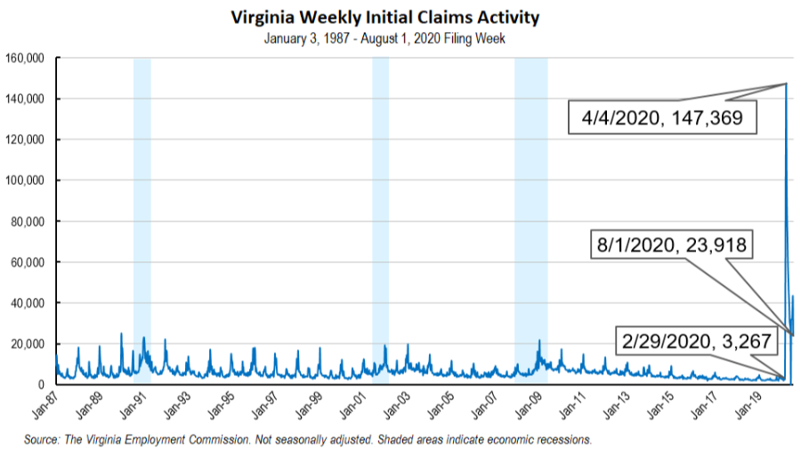
Nationwide, in the week ending August 1, the advance figure for seasonally adjusted initial claims was 1,186,000, a decrease of 249,000 from the previous week's revised level. The previous week's level was revised up by 1,000 from 1,434,000 to 1,435,000. The advance number of actual initial claims under state programs, unadjusted, totaled 984,192 in the week ending August 1, a decrease of 222,852 (or -18.5 percent) from the previous week. There were 179,879 initial claims in the comparable week in 2019. Looking at preliminary data, all states except Rhode Island (which reported an increase of seven claims) reported decreases while seven states reported weekly decreases of 10,000 or more on a seasonally unadjusted basis. Virginia’s preliminary weekly change (-16,976) was the second largest drop among states after Florida (-17,507). Other decreases over 10,000 included California (-16,123), Texas (-14,864), Georgia (-12,289), New Jersey (-12,228), and New York (-11,309).
https://www.vec.virginia.gov/UI-press-release
PDF of press release: https://www.vec.virginia.gov/sites/default/files/news-12092-Initial%20Claims%20Press%20Release%208%201%202020.pdf
For additional information on who is claiming unemployment insurance in Virginia, access the VEC’s U.I. claims data dashboard (https://www.vec.virginia.gov/ui-claims-dashboard) that is updated the following Monday after the weekly claims press release.
August 6 - Fewer Virginians filed new unemployment claims last week

The Virginia Employment Commission says 23,918 new unemployment claims were filed across the state last week, 44% fewer than the week earlier.

It was the first time in five weeks that claims had dropped from the week prior. It was also the first week that Virginians no longer had the benefit of an extra $600 a week in federal relief.

https://www.pilotonline.com/business/jobs/vp-bz-coronavirus-unemployment-claims-aug-20200806-tgc3bht54zarha6fpd77ubqyny-story.html

Other Resources
- Virginia State Resources: https://www.virginia.gov/coronavirus/support-for-businesses/#854620
- FAQs from Workers Regarding Covid-19:
English:https://www.governor.virginia.gov/media/governorvirginiagov/governor-of-virginia/pdf/Frequently-Asked-Questions-from-Workers-Regarding-COVID-19.pdf
Spanish:https://www.governor.virginia.gov/media/governorvirginiagov/governor-of-virginia/pdf/Las-Preguntas-Mas-Frecuentes-para-los-Empleados-Sobre-COVID-19.pdf
- Support for affected workers: https://www.virginia.gov/coronavirus/employment-and-financial-support/#855804
- F.A.Q. on Coronavirus Relief for Small Businesses, Freelancers https://www.nytimes.com/article/small-business-loans-stimulus-grants-freelancers-coronavirus.html
- The Paycheck Protection Program (PPP), a provision of the CARES Act, offers forgivable low-interest loans to small businesses facing uncertainty during the COVID-19 emergency, so businesses can retain workers, maintain payroll, and cover certain other existing overhead costs. https://www.sba.gov/funding-programs/loans/coronavirus-relief-options/paycheck-protection-program-ppp
- COVID 19 Testing Information and Locations: https://www.vdh.virginia.gov/coronavirus/covid-19-testing/

WARN Notices
WARN Notices due to COVID-19 have significantly dropped off in Virginia starting in mid-June 2020. While no single factor can be attributed to this fact, the slow down does not mean that businesses have stopped laying off; many large businesses that were covered by the WARN Act up to this point have likely already felt the pandemic’s impact and reported accordingly. As any new spikes in WARN activity as a result of COVID-19 are reported the charts in this section will be updated accordingly.
http://www.vec.virginia.gov/warn-notices

Virginia News
Virginia Mercury: https://www.virginiamercury.com/

National News
Sign up for The New York Times Morning Briefing: https://www.nytimes.com/series/us-morning-briefing
The Daily podcast: https://www.nytimes.com/column/the-daily

