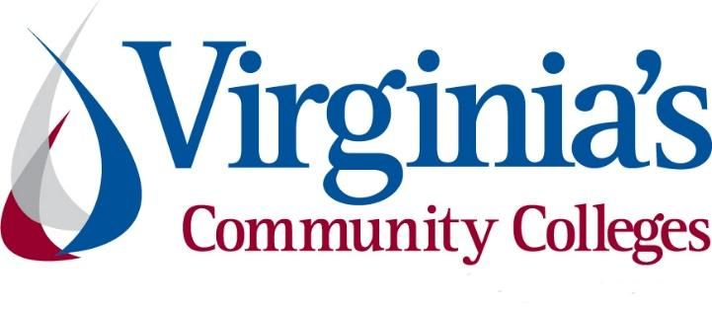
COVID-19 Update
Thursday, July 30, 2020
Virginia Daily Key Statistics
(Please note that the VDH and VHHA numbers may vary slightly due to reporting times.)
Virginia’s Daily COVID-19 Statistics-Virginia Department of Health: http://www.vdh.virginia.gov/coronavirus/ (This page is updated daily before 10 AM. Numbers are preliminary and close out at 5 PM the day before posting. Case counts reflect what has been reported to VDH by healthcare providers and laboratories.)
Tests Administered (PCR): 1,091,615 (122,470 or 12.63% increase from last week)
Total Cases: 88,904 (7,667 or 9.43% increase from last week)
Total Hospitalizations: 7,786 (349 or 4.7% increase from last week)
Total Deaths: 2,141 (87 or 4.2% increase from last week)
Current 7-Day Positivity Rate: 7.2% (Last Week: 7.7%)
COVID in Virginia’s Hospitals Dashboard: https://www.vhha.com/communications/virginia-hospital-covid-19-data-dashboard/

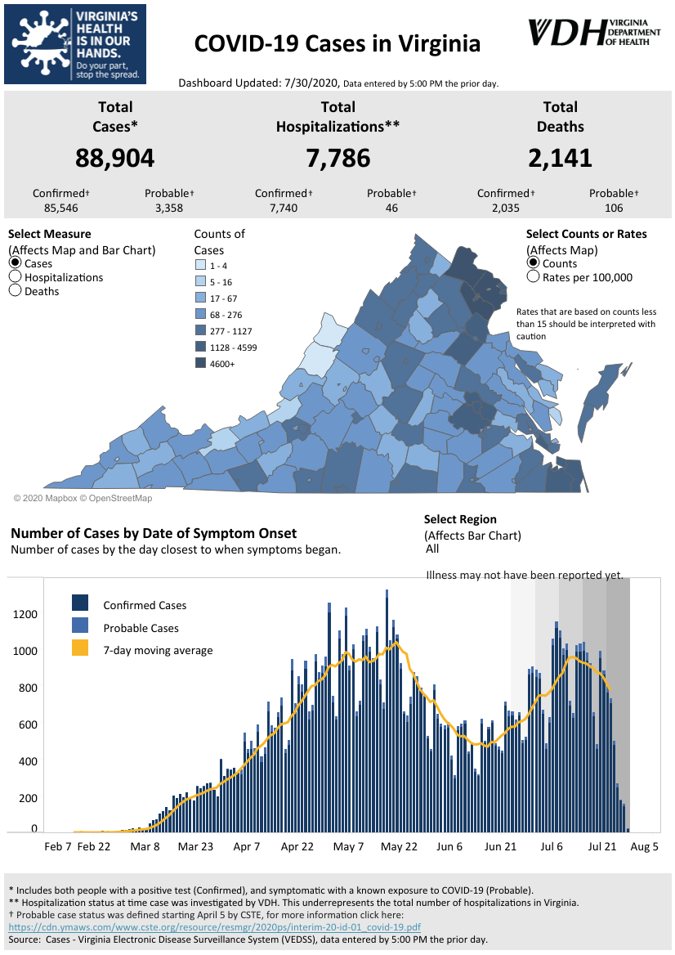
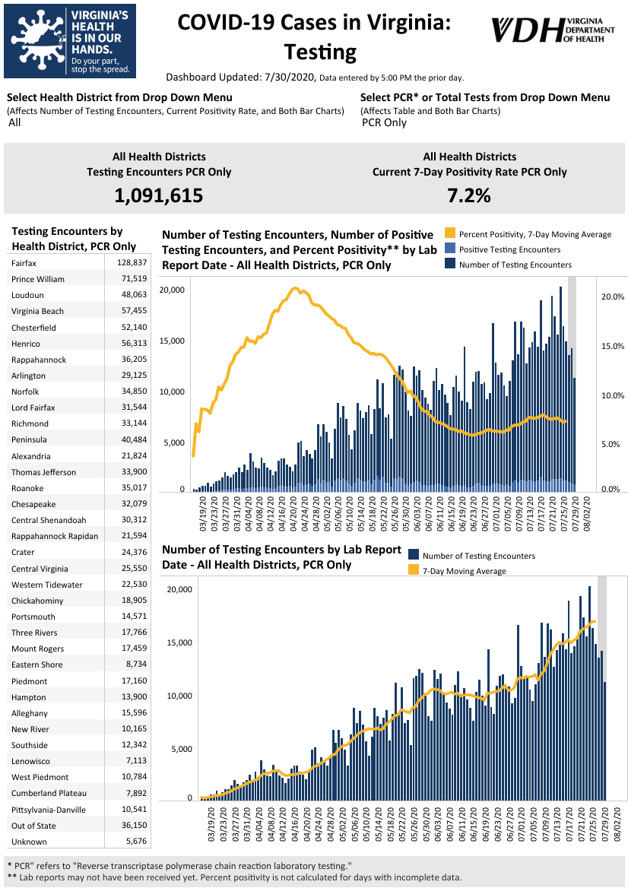
Graphs obtained from Virginia Department of Health: https://www.vdh.virginia.gov/coronavirus/
July 30 - Virginia Health Commissioner details 'big takeaways' from new COVID-19 study
Virginia's Health Commissioner said the preliminary results of a joint study with the University of Virginia indicate that 2.4% of adults in the Commonwealth have antibodies to COVID-19.
"The big takeaway from this, of course, is that the overwhelming majority, a very large portion of the population in the Commonwealth is still vulnerable to infection and must continue to take precautionary measures,” said Dr. Norm Oliver, who added the number was around what he was expecting.
https://www.wtvr.com/news/coronavirus/virginia-health-commissioner-details-big-takeaways-from-new-covid-19-study
July 29- Northam, U.S. senators ask for CDC’s help with covid-19 outbreak at immigrant detention center

Virginia Gov. Ralph Northam and the state’s two U.S. senators are urging President Trump to send the country’s top public health agency to respond to a coronavirus outbreak inside a privately owned immigrant detention center in the town of Farmville that immigrant advocates have called “a tinderbox” of infection.

The outbreak at the Farmville Detention Center is the largest at any such facility in the country, with 262 undocumented immigrants there being monitored after testing positive for the coronavirus, according to Immigration and Customs Enforcement.
https://www.washingtonpost.com/local/virginia-politics/northam-us-senators-ask-for-cdcs-help-with-covid-19-outbreak-at-immigrant-detention-center/2020/07/29/0e5d96ba-d0ef-11ea-9038-af089b63ac21_story.html
July 28 - Governor Northam Announces New Measures to Contain COVID-19 in Hampton Roads Region

Governor Ralph Northam today outlined new actions to mitigate the spread of COVID-19 in the Hampton Roads region, which has seen a recent increase in new cases, hospitalizations, and positive tests. The new restrictions will apply to the Cities of Virginia Beach, Chesapeake, Norfolk, Suffolk, Portsmouth, Hampton, Williamsburg, Newport News, Poquoson, James City County, and York County.

Beginning at midnight on Friday, July 31, restrictions will prohibit the on-site sale, consumption, and possession of alcohol after 10:00 p.m. in any restaurant, dining establishment, food court, brewery, microbrewery, distillery, winery, or tasting room. All restaurants, dining establishments, food courts, breweries, microbreweries, distilleries, wineries, and tasting rooms must close by midnight. Indoor dining in these establishments will be limited to 50 percent capacity. Public and private in-person gatherings over 50 people will be prohibited, down from a previous cap of 250 people.

https://www.governor.virginia.gov/newsroom/all-releases/2020/july/headline-859681-en.html

July 28 - Northam imposes new rules for Hampton Roads as virus cases mount; top federal official questions regional approach
It started with a scolding — and a vow to crack down on businesses that weren’t following the state’s safety orders.

Now, with cases rising throughout many parts of Virginia, Gov. Ralph Northam announced Tuesday that he was implementing new restrictions in Hampton Roads, a region he cited for one of the most troubling increases in caseloads.

“I want you to know we are putting a lot of attention on Hampton Roads,” he said, introducing three primary restrictions for the area. Starting midnight on Thursday, indoor dining is limited to 50 percent capacity, including food courts, breweries, wineries and distilleries. Social gatherings of more than 50 people are prohibited as part of a new emergency order.

https://www.virginiamercury.com/2020/07/28/northam-imposes-new-rules-for-hampton-roads-as-virus-cases-mount-top-federal-official-questions-regional-approach/

July 28 - County-by-county look at COVID-19 cases in Virginia; here's which areas saw biggest jumps Tuesday

The health department reported 992 more people tested positive for COVID-19 out of the 20,509 total tests processed since yesterday. That brings Virginia's total number of coronavirus cases to 86,994.

As of Tuesday's update, 7,686 (+39 from previous day) people had been hospitalized and 2,095 (+13) people had died as a result of COVID-19-related illnesses, according to updated Virginia Department of Health (VDH) data.

https://www.wtvr.com/news/coronavirus/county-by-county-covid-19-cases-virginia-tuesday-july-28

July 28 - UVA COVID-19 modeling predicts steep spike in virus cases in September

Virginia is not mentioned as a COVID-19 hotspot alongside states like California, Florida, and Texas, but new data gathered and models created by the University of Virginia Biocomplexity Institute predicts that the commonwealth is creeping closer and closer to a surge.

https://www.nbc12.com/2020/07/28/uva-covid-modeling-predicts-steep-spike-virus-cases-september/

Support for Virginians
July 28 - Governor Northam Announces $644.6 Million in Federal Coronavirus Relief Fund Dollars Distributed to Local Governments

Governor Ralph Northam today announced that the Commonwealth will distribute $644.6 million in federal COVID-19 relief funding to local governments in its second and final round of allocations. These payments represent the remaining 50 percent of local allocations and do not include $200.2 million that Fairfax County received directly from the federal government. The federal Coronavirus Aid, Relief, and Economic Security Act (CARES Act) established the Coronavirus Relief Fund (CRF) to provide funding to states and eligible units of local government navigating the COVID-19 pandemic.

Virginia received approximately $3.1 billion as its share of the $150 billion CRF. While the CARES Act does not require that states distribute funding to local governments with populations less than 500,000, the Governor recognizes that cities and counties of all sizes have expenses related to the ongoing COVID-19 pandemic and directed these federal dollars to localities.

https://www.governor.virginia.gov/newsroom/all-releases/2020/july/headline-859682-en.html

July 22 - Governor Northam Urges Virginians to Prepare for Hurricane Season Amid COVID-19 Pandemic
Governor Ralph Northam is reminding all Virginians to prepare now as peak hurricane season approaches and the Commonwealth continues to respond to the COVID-19 pandemic. Earlier today, the Governor and his cabinet joined state local public safety agencies for a virtual exercise to test Virginia’s hurricane readiness and address the challenges of managing disaster response and recovery efforts during the ongoing health crisis.
“Hurricane season brings added challenges this year due to the COVID-19 pandemic, and we are committed to ensuring that Virginians know their risks, get prepared, and stay informed,” said Governor Northam.
https://www.governor.virginia.gov/newsroom/all-releases/2020/july/headline-859664-en.html

Support for Businesses
July 28 - Virginia COVID-19 Workplace Safety Rules Now In Effect

As we previously reported, Virginia became the first state to issue mandatory COVID-19 workplace safety rules when the Virginia Safety and Health Codes Board (“VSHCB”) approved an emergency temporary standard on July 15, 2020. The final text has now been released and the new rules, which apply to most private employers, went into effect July 27, 2020. Employers who fail to comply may be subject to fines of up to $13,494 for a “serious” violation and up to $134,937 for a “repeat” or “willful” violation.

https://www.natlawreview.com/article/virginia-covid-19-workplace-safety-rules-now-effect
July 27 - Governor Northam Announces $70 Million Rebuild VA Economic Recovery Fund for Small Businesses, Nonprofits Impacted by COVID-19
Governor Ralph Northam today announced $70 million for small businesses and nonprofit organizations whose normal operations were disrupted by the COVID-19 pandemic. The funding will be made available through Rebuild VA, a new economic recovery fund, and grants of up to $10,000 will be awarded to approximately 7,000 applicants to cover eligible expenses.
https://www.governor.virginia.gov/newsroom/all-releases/2020/july/headline-859659-en.html

COVID 19 Testing
July 27 - Testing Results Take Too Long, U.S. Official Concedes

Speaking on CNN’s “State of the Union,” Mr. Giroir acknowledged that turnaround times were too long. But he asserted that while testing was still not widely available to anyone who wanted it — despite past claims from Mr. Trump that it would be — it was available to those who needed it.

Testing is considered crucial to understanding and stopping the spread of the coronavirus. When turnaround times extend beyond several days, it can render the information useless since those tested may have spread the virus to other people by the time their results are back.

New York Times

PPE/Contact Tracing
July 30 - Growing COVID-19 case numbers in Hampton Roads are straining contact tracing resources

A surge of COVID-19 cases in the Hampton Roads region is putting a strain on the area’s contact tracing workforce, Virginia Health Commissioner Dr. Norman Oliver said during a Wednesday news briefing.

“In the Virginia Beach area, for example, we’ve had to supplement the contact tracing with help from other local health districts,” he added. Oliver described the growing need as a “challenge” the Virginia Department of Health is prepared to meet. But it also underscores ongoing concerns from public health experts that a continued rise in COVID-19 cases could make the virus increasingly difficult to contain.

https://www.virginiamercury.com/2020/07/30/a-surge-of-covid-19-cases-in-hampton-roads-is-straining-contact-tracing-resources/

July 27 - Hampton participating in Health Equity Pilot Program, distributing PPE in underserved areas
The Virginia Department of Emergency Management and the Health Equity Working Group announced today a pilot program with the City of Hampton. The program is a state-local partnership, aimed to increase equitable access to personal protective equipment (PPE) and public health information in underserved and historically disadvantaged communities that have been disproportionately impacted by COVID-19.
https://hampton.gov/CivicAlerts.aspx?AID=4594

Virginia Economy
July 26- Job loss effects of pandemic hammer Black workers
The economic pain of the pandemic is being acutely felt by Black workers, according to data for Virginia.

Jobless claims by Black workers have exceeded those by white workers since late June, even though Black people make up only about a fifth of the state’s workforce.

The statistic is presented each week by the Virginia Employment Commission. The disparity is also in plain view daily at the agency’s Roanoke office, where people line up outside for an appointment to troubleshoot unpaid claims for emergency financial relief.
https://roanoke.com/business/job-loss-effects-of-pandemic-hammer-black-workers/article_7febce1e-c31f-5ba5-a9fd-f1c1c4f88bd9.html#tracking-source=home-top-story

Education
July 29- Editorial: As the fall draws closer, Virginia’s Community College System has a healthy mindset

Four months into the COVID-19 pandemic, students and families across Virginia continue to adapt to fall learning realities.

In K-12 schools, some districts have decided on virtual schooling for the start of the 2020-21 academic year. In other localities, families can choose between continuing online schooling and returning to in-person classes. And the passionate debate over different solutions proves one thing: A lot is on the line.

For college students, other factors complicate COVID-19 choices. The cost of tuition was an issue before the coronavirus tightened household and institutional budgets. The investment in a residential experience amid the pandemic is unsettling. The worry of committing to an academic major with uncertain job prospects is real.

Richmond Times-Dispatch

July 29- More Than 6,300 Coronavirus Cases Have Been Linked to U.S. Colleges

As college students and professors decide whether to head back to class, and as universities weigh how and whether to reopen, the coronavirus is already on campus.

A New York Times survey of every public four-year college in the country, as well as every private institution that competes in Division I sports or is a member of an elite group of research universities, revealed at least 6,300 cases tied to about 270 colleges over the course of the pandemic. And the new academic year has not even begun at most schools.

New York Times

July 29 - Will schools get help from Congress to reopen? Va. educators share concerns
School systems are struggling with critical decisions over how they should reopen, and U.S.

Sen. Mark Warner, D-Va., warned educators on Wednesday that it could be “a rocky couple of weeks” before Congress provides funding to help them deal with the coronavirus pandemic.
Warner said during a virtual meeting that Senate Democrats and Republicans are more than $100 billion apart on what they are proposing to spend for K-12 schools in new COVID-19 legislation.

About $70 billion of a GOP proposal would go to secondary schools, while Warner said he supports a Democratic proposal to spend $175 billion.

https://wtop.com/congress/2020/07/will-schools-get-help-from-congress-to-reopen-va-educators-share-concerns/
July 28 - Local college, university leaders discuss pandemic challenges for the fall
Leaders from a number of local colleges and universities on Tuesday talked about the challenges they face as they prepare for an unpredictable fall semester during the coronavirus pandemic.

Ronald Mason, president of the University of the District of Columbia, said in the online discussion that his school acquired about 400,000 square feet of space in D.C. to be used for workforce training and learning centers, where students can work while staying far apart from each other

https://wtop.com/education/2020/07/local-college-university-leaders-discuss-pandemic-challenges-for-the-fall/
July 23- Virginia’s largest school insurer says worker’s compensation is unlikely for teachers who catch COVID-19

Virginia’s largest insurer for local school divisions had a clear message for administrators on Monday: Don’t worry about COVID-related worker’s compensation claims from school employees.

“The burden of proof to determine that’s where you contracted the disease is going to be tough to do,” said Lee Brannon, the senior school specialist for VACORP, during an online summit for the Coalition of Small and Rural Schools of Virginia. As public schools weigh their options for reopening in the fall, Brannon said he’s received questions from “a lot of people” about what would happen if a teacher — or any other school employee — filed for worker’s compensation after contracting COVID-19 on the job.

https://www.virginiamercury.com/2020/07/23/virginias-largest-school-insurer-says-workers-compensation-is-unlikely-for-teachers-who-catch-covid-19/

Unemployment Data
July 30 - Virginia’s Unemployment Insurance Weekly Claims for Week Ending July 25th
Seasonally unadjusted weekly initial unemployment insurance claims rose by 13.2% from the previous filing week as continued claims fell by 3.4% during that period
The Virginia Employment Commission (VEC) announced that the total number of initial claims filed from the beginning of the pandemic in Mid-March of 2020 through the July 25, 2020 filing week was more than double the average number filed during the last three economic recessions.

For the filing week ending July 25, the figure for seasonally unadjusted initial claims in Virginia was 42,966. The latest claims figure was an increase of 5,020 claimants from the previous week and rose to its highest level since May.

For the most recent filing week, continued weeks claimed totaled 344,826, down 12,272 from the previous week, but 324,629 higher than the 20,197 continued claims from the comparable week last year. They have trended downward in the last month and fell to their lowest level since April during the most recent filing week. The continued claims total is mainly comprised of those recent initial claimants who continued to file for unemployment insurance benefits during the COVID-19 pandemic.
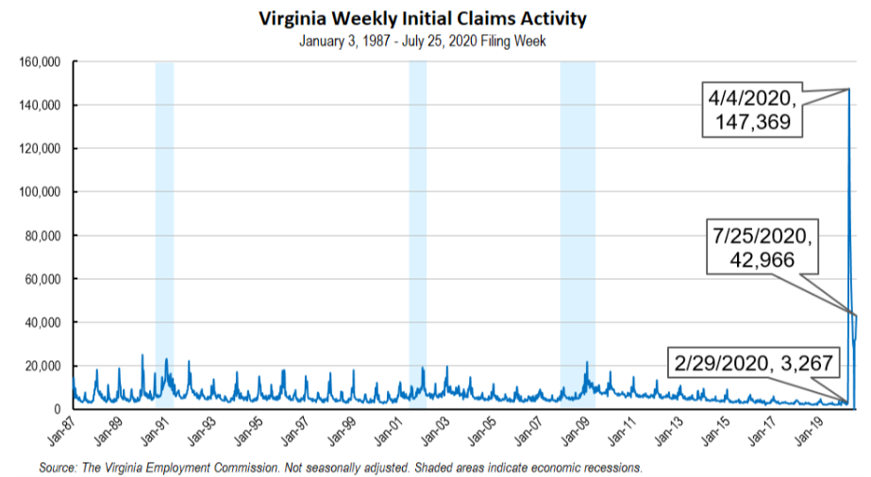
Nationwide, in the week ending July 25, the advance figure for seasonally adjusted initial claims was 1,434,000, an increase of 12,000 from the previous week's revised level. The previous week's level was revised up by 6,000 from 1,416,000 to 1,422,000. The advance number of actual initial claims under state programs, unadjusted, totaled 1,205,871 in the week ending July 25, a decrease of 171,054 (or -12.4 percent) from the previous week. There were 178,897 initial claims in the comparable week in 2019. Looking at preliminary data, most states reported decreases while nine states reported weekly increases on a seasonally unadjusted basis. Virginia’s preliminary weekly change (+8,578) was the largest increase among states. Increases over 1,000 included Nevada (+6,125), Indiana (+2,698), Missouri (+1,925), Kansas (+1,502), and New Jersey (+1,466).
https://www.vec.virginia.gov/UI-press-release
PDF of press release: https://www.vec.virginia.gov/sites/default/files/news-12075-Initial%20Claims%20Press%20Release%207%2025%202020.pdf
For additional information on who is claiming unemployment insurance in Virginia, access the VEC’s U.I. claims data dashboard (https://www.vec.virginia.gov/ui-claims-dashboard) that is updated the following Monday after the weekly claims press release.
July 30 - Va. saw nation’s second-highest jobless spike last week; News comes amid reports that U.S. GDP sank to lowest point on record in Q2
Coming on the heels of reports that the U.S. domestic gross product in the second quarter dropped to its lowest point since 1947, the U.S. Department of Labor reported Thursday that Virginia saw the second-highest increase in initial jobless claims in the nation last week.
The Department of Labor reported Thursday morning that 46,524 Virginians filed initial claims last week, which is a nearly 10,000 spike from the week prior. More than 37,000 Virginians filed initial jobless claims the week before last.
https://www.virginiabusiness.com/article/va-saw-second-highest-jobless-spike-in-nation-last-week/
July 30 - Unemployment Claims Rise for Second Consecutive Week
An additional 830,000 people filed for unemployment through a program created by Congress to help gig workers and others who do not normally qualify for jobless benefits.
The number of people who filed for unemployment benefits rose for the second consecutive week last week as coronavirus cases surged around the country.
Roughly 1.43 million people filed for unemployment last week, the Department of Labor said Thursday. The figure is a 12,000 increase from the previous week. Unemployment claims had been falling for four months from a peak in March.
The number of people collecting jobless benefits also increased to 17 million, up from 16.2 million the week prior.
Another 830,000 people filed for benefits through the Pandemic Unemployment Program, a program created by Congress to help gig workers, self-employed workers and others who do not normally qualify for unemployment benefits.
https://www.usnews.com/news/economy/articles/2020-07-30/unemployment-claims-rise-for-second-consecutive-week
Other Resources
- Virginia State Resources: https://www.virginia.gov/coronavirus/support-for-businesses/#854620
- FAQs from Workers Regarding Covid-19:
English:https://www.governor.virginia.gov/media/governorvirginiagov/governor-of-virginia/pdf/Frequently-Asked-Questions-from-Workers-Regarding-COVID-19.pdf
Spanish:https://www.governor.virginia.gov/media/governorvirginiagov/governor-of-virginia/pdf/Las-Preguntas-Mas-Frecuentes-para-los-Empleados-Sobre-COVID-19.pdf
- Support for affected workers: https://www.virginia.gov/coronavirus/employment-and-financial-support/#855804
- F.A.Q. on Coronavirus Relief for Small Businesses, Freelancers https://www.nytimes.com/article/small-business-loans-stimulus-grants-freelancers-coronavirus.html
- The Paycheck Protection Program (PPP), a provision of the CARES Act, offers forgivable low-interest loans to small businesses facing uncertainty during the COVID-19 emergency, so businesses can retain workers, maintain payroll, and cover certain other existing overhead costs. https://www.sba.gov/funding-programs/loans/coronavirus-relief-options/paycheck-protection-program-ppp
- COVID 19 Testing Information and Locations: https://www.vdh.virginia.gov/coronavirus/covid-19-testing/

WARN Notices
WARN Notices due to COVID-19 have significantly dropped off in Virginia starting in mid-June 2020. While no single factor can be attributed to this fact, the slow down does not mean that businesses have stopped laying off; many large businesses that were covered by the WARN Act up to this point have likely already felt the pandemic’s impact and reported accordingly. As any new spikes in WARN activity as a result of COVID-19 are reported the charts in this section will be updated accordingly.
http://www.vec.virginia.gov/warn-notices

Virginia News
Virginia Mercury: https://www.virginiamercury.com/

National News
Sign up for The New York Times Morning Briefing: https://www.nytimes.com/series/us-morning-briefing
The Daily podcast: https://www.nytimes.com/column/the-daily

