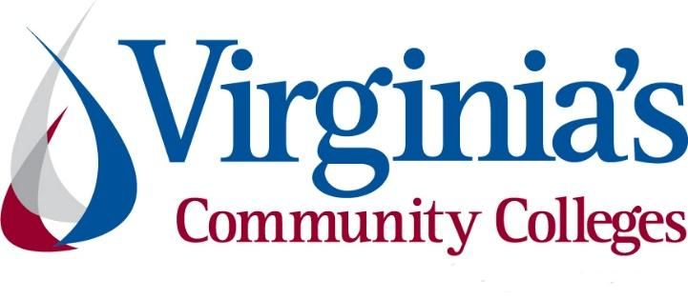
COVID-19 Update
Thursday, July 9, 2020
Virginia Daily Key Statistics
(Please note that the VDH and VHHA numbers may vary slightly due to reporting times.)
Virginia’s Daily COVID-19 Statistics-Virginia Department of Health: http://www.vdh.virginia.gov/coronavirus/ (This page is updated daily before 10 AM. Numbers are preliminary and close out at 5 PM the day before posting. Case counts reflect what has been reported to VDH by healthcare providers and laboratories.)
People Tested (PCR): 750,631 (79,071 or 11.8% increase from last week)
Total Cases: 67,988 (4,253 or 6.7% increase from last week)
Total Hospitalizations: 6,625 (292 or 4.6% increase from last week)
Total Deaths: 1,937 (121 or 6.7% increase from last week)
COVID in Virginia’s Hospitals Dashboard: https://www.vhha.com/communications/virginia-hospital-covid-19-data-dashboard/
July 9 - Virginia COVID-19 cases rise by 613 on Thursday
As of Thursday, July 9, Virginia has had 67,988 total cases of COVID-19, including confirmed lab tests and clinical diagnoses, according to the Virginia Department of Health.
That’s a rise of 613 positive cases since Tuesday, out of 17,431 tests newly added to the system, which comes out to 3.5% of the newest tests coming back positive.
https://www.whsv.com/2020/07/09/virginia-covid-19-cases-rise-by-613-on-thursday/

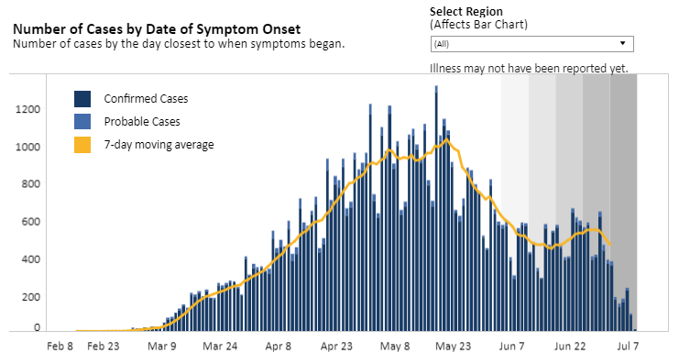
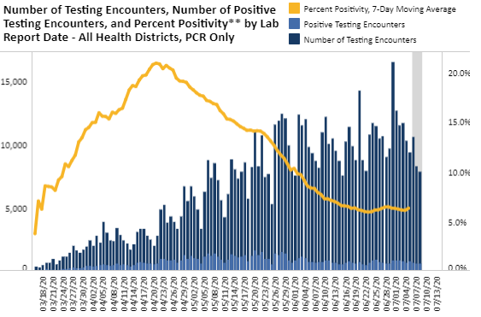
Graphs obtained from Virginia Department of Health: https://www.vdh.virginia.gov/coronavirus/
July 9 - How Coronavirus Cases Have Risen Since States Reopened
The current surge in coronavirus cases in the United States is being driven by states that were among the first to reopen their economies, decisions that epidemiologists warned could lead to a wave of infections.
https://www.nytimes.com/interactive/2020/07/09/us/coronavirus-cases-reopening-trends.html
July 8 – Every Virginia city, county has now had a coronavirus case; Bath County first case appeared in Wednesday's VDH data
https://www.wsls.com/news/local/2020/07/08/every-virginia-city-county-has-now-had-a-coronavirus-case/
July 8 - Virginia July 8 COVID-19 update: Hampton Roads sets record for new cases for 2nd straight day, Hampton, NN and VB set records
Hampton Roads set a record for new daily COVID-19 cases for the second straight day on Wednesday with 239, after reporting 230 on Tuesday.
It’s the second straight day above 200 cases and third in the past five days for the region, which has seen new daily cases nearly triple from earlier numbers in the pandemic.
https://www.wavy.com/news/health/coronavirus/virginia-july-8-covid-19-update-hampton-roads-sets-record-for-new-cases-for-2nd-straight-day-hampton-nn-and-vb-set-records/
July 7 - Virginia's COVID-19 stats starting to normalize
After recording just eight new COVID-19 deaths over the weekend and no new deaths on Monday, Virginia’s statistics started to normalize again Tuesday when the Virginia Department of Health reported it recorded 28 new deaths.
Amid fiery discussions of which states have and haven’t coped with COVID-19 well, gradually falling death rates have been tucked beneath headlines about soaring case counts. Virginia has not been fortunate by any means as it ranks No. 17 in the country — including Washington, D.C., and Puerto Rico — with 1,881 deaths and is one of the 24 states with at least 1,000 deaths attributed to COVID-19 since the beginning of the pandemic, according to data gathered by Real Clear Politics.
https://www.nvdaily.com/nvdaily/virginias-covid-19-stats-starting-to-normalize/article_6f2b764c-2600-55f2-9d90-bb9d424994d6.html
July 1 - JAMA study: 35% of excess deaths during pandemic’s early months tied to causes other than COVID-19
Since COVID-19’s spread to the United States earlier this year, death rates in the U.S. have risen significantly. But deaths attributed to COVID-19 only account for about two-thirds of the increase in March and April, according to a study published Wednesday in the Journal of the American Medical Association.
https://news.vcu.edu/article/JAMA_study_35_of_excess_deaths_during_pandemics_early_months

Rise in COVID 19 Cases Among Younger Virginians
July 7 - More young people getting COVID-19 in Virginia Beach
https://www.13newsnow.com/article/news/health/coronavirus/more-young-people-getting-covid-19-in-virginia-beach/291-0e293ad0-57e2-4dc0-bb0a-a6b52c3d86ab
July 7 - More than 50% of Roanoke Valley’s coronavirus cases are now younger than 40
https://www.wsls.com/news/local/2020/07/07/more-than-50-of-roanoke-valleys-coronavirus-cases-are-now-younger-than-40/
July 2 - Young adults show alarming new trend in attitude towards COVID-19: Health officials (Lynchburg)
https://wset.com/news/coronavirus/health-officials-an-alarming-new-trend-in-young-adults-attitude-towards-covid-19

Support for Virginians
July 5 - Evictions ramp up in Virginia as local courts decline governor’s request to continue moratorium
Courts around Virginia began working their way through a backlog of more than 12,000 eviction cases last week as a statewide moratorium expired, with many judges apparently declining a last-minute request from Gov. Ralph Northam to continue the stay at the local level.

“It’s a total patchwork,” said Christie Marra, the director of housing advocacy at the Virginia Poverty Law Center, which has asked Northam to use his executive authority to intervene more decisively. She said the current approach of leaving the decision to local courts is “absolutely not working.”
https://www.nbc12.com/2020/07/07/evictions-ramp-up-virginia-local-courts-decline-governors-request-continue-moratorium/
July 2 - After eviction freeze lifted, rent programs for tenants accessible
While the statewide freeze on evictions has expired, a new rent relief program has begun. Virginia is using $50 million of Coronavirus Aid, Relief, and Economic Security Act funds (CARES act) to help people facing evictions as a result of the coronavirus crisis, called the Virginia Rent and Mortgage Relief Program.
https://www.wric.com/news/virginia-news/after-eviction-freeze-lifted-rent-programs-for-tenants-accessible/

Support for Businesses
July 6 - Nearly 110K Virginia businesses received PPP funds; SBA releases data identifying only 16K Va. recipients of forgivable relief loans
The U.S. Small Business Administration has released a list of major recipients of its $659 billion Paycheck Protection Program small business relief program, with exact loan amounts redacted.
Of the nearly 110,000 small businesses that received funding in Virginia (including Virginia Business Media LLC), approximately 16,100 businesses in Virginia were named on the list of businesses that had benefited from the federal relief program, intended to assist small businesses meet payroll costs and make mortgage interest, rent and/or utilities payments due to the economic crisis caused by the COVID-19 pandemic.
https://www.virginiabusiness.com/article/sba-releases-data-identifying-ppp-recipients/
July 6 - Roanoke County launches small business relief grants; Applicants can receive up to $10K in funding
The Roanoke County Economic Development Department announced Monday it has launched a $1 million small business grant program to help businesses suffering from COVID-19 closures in the county and the town of Vinton.
The program is being funded through the federal Coronavirus Aid, Relief, and Economic Security (CARES) Act and will help businesses to cover operating expenses, develop online sales and ensure worker and customer safety.
https://www.virginiabusiness.com/article/roanoke-county-launches-small-business-relief-grants/
July 2 - 300+ Alexandria small businesses receive COVID-19 funding; Grant program hosted by Alexandria Economic Development Partnership
More than 300 small businesses in Alexandria were funded by the Alexandria Back to Business (ALX B2B) grants program in the wake of the COVID-19 crisis, the Alexandria Economic Development Partnership (AEDP) announced Thursday.
In May, Alexandria City Council committed $2.4 million from its federal CARES Act appropriations, and allocated an additional $2 million from the Alexandria Investment Fund for the local business assistance grants.
https://www.virginiabusiness.com/article/300-alexandria-small-businesses-receive-covid-19-funding/

PPE
July 9 - Primary care doctors in Virginia want more resources from state as demand for testing grows
…
Virginia, like the rest of the country, has spent months fighting supply shortages in an effort to build a comprehensive network of COVID-19 testing sites. But despite gradually increasing its numbers (the state averaged more than 11,000 tests per day over the last week), many primary care physicians are still reporting difficulties in sourcing the basic supplies that make in-office testing possible.
https://www.nbc12.com/2020/07/09/primary-care-doctors-virginia-want-more-resources-state-demand-testing-grows/
July 8 - CareFirst BlueCross BlueShield Establishes $5 Million Personal Protective Equipment Initiative for Coronavirus Relief
Today, CareFirst BlueCross BlueShield (CareFirst) announced its new initiative, “Care, delivered,” a $5 million public-private sector philanthropic endeavor that will distribute personal protective equipment (PPE) at no-cost to healthcare and social service organizations on the front lines of the pandemic. This initiative is part of CareFirst’s ongoing commitment to support the communities it serves as they navigate the complexities of this public health crisis.
https://individual.carefirst.com/individuals-families/news/2020/07/carefirst-bluecross-blueshield-establishes-5-mill/
Higher Education
July 3 - Faculty from at least 15 colleges and universities in Virginia sign petition surrounding reopening
In only three days, more than 600 higher education employees from at least 15 different colleges and universities in Virginia have signed a petition highlighting requests for the fall.
...
Educators say they want to be allowed to make their own decision about whether they feel comfortable teaching in-person or remotely this fall. Faculty also say they want to approve the instructional plans for the fall and want adequate safety measures for their return.
https://www.nbc12.com/2020/07/03/faculty-least-colleges-universities-virginia-sign-petition-surrounding-reopening/

Unemployment Data
July 9 - Virginia’s Unemployment Insurance Weekly Claims for Week Ending July 4th; Seasonally unadjusted weekly initial unemployment insurance claims were essentially unchanged from the previous filing week as continued claims rose by 3.2% during that period
The Virginia Employment Commission (VEC) announced that the total number of initial claims filed in the four months from mid-March through the July 4, 2020 filing week totaled 938,559, surpassing all initial claims filed from mid-September 2014 to mid-March of this year.
For the filing week ending July 4, the figure for seasonally unadjusted initial claims in Virginia was 31,825. The latest claims figure was a decrease of 130 claimants from the previous week. The weekly growth was flat from the previous week and well below the weekly peak in unemployment insurance claims reached during the April 4 filing week.
For the most recent filing week, continued weeks claimed totaled 378,607, up 11,893 from the previous week, and 359,637 higher than the 18,970 continued claims from the comparable week last year. The continued claims total is mainly comprised of those recent initial claimants who continued to file for unemployment insurance benefits during the COVID-19 pandemic. Continued claims during the July 4 filing week equaled 40% of all initial claims filed during the pandemic to this point. This percentage has leveled off in recent weeks.

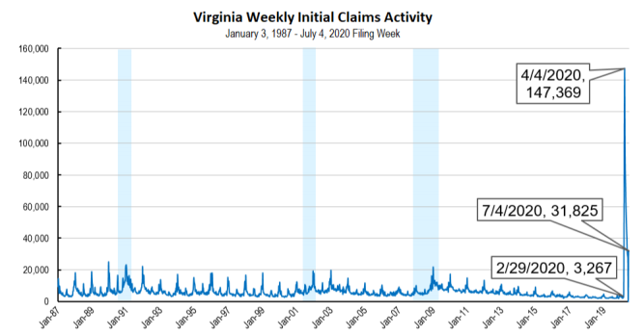

Nationwide, in the week ending July 4, the advance figure for seasonally adjusted initial claims was 1,314,000, a decrease of 99,000 from the previous week's revised level. The previous week's level was revised down by 14,000 from 1,427,000 to 1,413,000. The advance number of actual initial claims under state programs, unadjusted, totaled 1,399,699 in the week ending July 4, a decrease of 31,644 (or -2.2 percent) from the previous week. There were 231,995 initial claims in the comparable week in 2019. Most states reported decreases while five states reported weekly decreases greater than 10,000. These were in Indiana (-20,741), Florida (-17,300), Georgia (-13,895), Oklahoma (-10,843), and California (-10,239). Virginia’s weekly change was the 13th largest increase among states.
https://www.vec.virginia.gov/UI-press-release
PDF of press release: https://www.vec.virginia.gov/sites/default/files/news-12031-Initial%20Claims%20Press%20Release%207%204%202020.pdf
For additional information on who is claiming unemployment insurance in Virginia, access the VEC’s U.I. claims data dashboard (https://www.vec.virginia.gov/ui-claims-dashboard) that is updated the following Monday after the weekly claims press release.
July 9 - Layoffs stuck at high level as 1.3 million filed for unemployment benefits last week
More than 1.3 million Americans applied for unemployment benefits last week, a historically high pace that shows that many employers are still laying people off in the face of a resurgent coronavirus.
The persistently elevated level of layoffs are occurring as a spike in virus cases has forced six states to reverse their move to reopen businesses. Those six - Arizona, California, Colorado, Florida, Michigan and Texas - make up one-third of the U.S. economy. Fifteen other states have suspended their re-openings. Collectively, the pullback has stalled a tentative recovery in the job market and is likely triggering additional layoffs.
July 9 - Va. among highest in nation for jobless claims last week; 50M+ Americans remain unemployed during pandemic
Virginia had the fourth-highest increase in initial jobless claims in the nation last week, according to U.S. Department of Labor (DOL) statistics released Thursday.
https://www.virginiabusiness.com/article/va-among-highest-in-nation-for-jobless-claims-last-week/

Virginia Economy
July 9 - Virginia Issues Year-End Revenue Report
Governor Ralph Northam today announced that Virginia ended fiscal year 2020 with a deficit of approximately $236.5 million in general fund revenue collections. While the shortfall was expected due to the impacts of COVID-19 on the state’s economy and budget, it is smaller than anticipated, and overall, revenues increased 2.0 percent over fiscal year 2019.
News Release: https://www.governor.virginia.gov/newsroom/all-releases/2020/july/headline-859135-en.html

Other Resources
● Virginia State Resources: https://www.virginia.gov/coronavirus/support-for-businesses/#854620
●FAQs from Workers Regarding Covid-19:
English:https://www.governor.virginia.gov/media/governorvirginiagov/governor-of-virginia/pdf/Frequently-Asked-Questions-from-Workers-Regarding-COVID-19.pdf
Spanish:https://www.governor.virginia.gov/media/governorvirginiagov/governor-of-virginia/pdf/Las-Preguntas-Mas-Frecuentes-para-los-Empleados-Sobre-COVID-19.pdf
●Support for affected workers: https://www.virginia.gov/coronavirus/employment-and-financial-support/#855804
●F.A.Q. on Coronavirus Relief for Small Businesses, Freelancers https://www.nytimes.com/article/small-business-loans-stimulus-grants-freelancers-coronavirus.html
●The Paycheck Protection Program (PPP), a provision of the CARES Act, offers forgivable low-interest loans to small businesses facing uncertainty during the COVID-19 emergency, so businesses can retain workers, maintain payroll, and cover certain other existing overhead costs. https://www.sba.gov/funding-programs/loans/coronavirus-relief-options/paycheck-protection-program-ppp
●COVID 19 Testing Information and Locations: https://www.vdh.virginia.gov/coronavirus/covid-19-testing/

WARN Notices
WARN Notices due to COVID-19 have significantly dropped off in Virginia starting in mid-June 2020. While no single factor can be attributed to this fact, the slow down does not mean that businesses have stopped laying off; many large businesses that were covered by the WARN Act up to this point have likely already felt the pandemic’s impact and reported accordingly. As any new spikes in WARN activity as a result of COVID-19 are reported the charts in this section will be updated accordingly.
http://www.vec.virginia.gov/warn-notices

Virginia News
Virginia Mercury: https://www.virginiamercury.com/

National News
Sign up for The New York Times Morning Briefing: https://www.nytimes.com/series/us-morning-briefing
The Daily podcast: https://www.nytimes.com/column/the-daily

