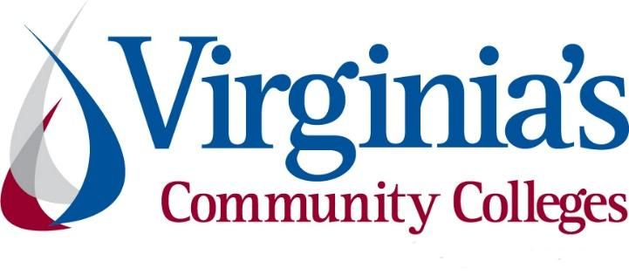
COVID-19 Update
Thursday, July 2, 2020
Virginia Daily Key Statistics - (please note that the VDH and VHHA numbers may vary slightly due to reporting times.)
Virginia’s Daily COVID-19 Statistics-Virginia Department of Health: http://www.vdh.virginia.gov/coronavirus/ (This page is updated daily before 10 AM. Numbers are preliminary and close out at 5 PM the day before posting. Case counts reflect what has been reported to VDH by healthcare providers and laboratories.)
People Tested (PCR): 671,560 (81,156 or 13.7% increase from last week)
Total Cases: 63,735 (3,789 or 6.3% increase from last week)
Total Hospitalizations: 6,333 (338 or 5.6% increase from last week)
Total Deaths: 1,816 (141 or 8.4% increase from last week)
COVID in Virginia’s Hospitals Dashboard: https://www.vhha.com/communications/virginia-hospital-covid-19-data-dashboard/
July 2 - Virginia July 2 COVID-19 update: Hampton Roads reports another daily high in new cases, record 53 in Norfolk
While Virginia’s new daily COVID-19 numbers are staying steady, Hampton Roads is continuing to see record breaking numbers.
https://www.wavy.com/news/health/coronavirus/virginia-july-2-covid-19-update-hampton-roads-reports-another-daily-high-in-new-cases-record-53-in-norfolk/
July 2 - More than 1,500 Va. inmates tested positive for COVID-19, but officials say relatively few are ill
More than 1,500 of Virginia's 29,000 prison inmates have been infected with COVID-19, but officials say roughly nine out of ten had no symptoms and almost all are now believed virus free.
The Virginia Department of Corrections had tested 22,538 inmates for the virus as of Tuesday as part of a large-scale "point prevalence" testing program. The results show that while it has infected about 5% of the prison population, the coronavirus has thus far not led to widespread serious illness as had been feared.
https://www.richmond.com/news/virginia/more-than-1-500-va-inmates-tested-positive-for-covid-19-but-officials-say-relatively/article_54a7123c-72b7-555e-8c20-790fbc561e9b.html
June 30 - What Virginia's Coronavirus Data Shows as Phase 3 Begins
As phase three reopening starts in Virginia on Wednesday, July 1, state data shows progress in containing the coronavirus.
A smaller portion of those who are tested are testing positive, the number of new cases has plateaued, the rate at which cases are doubling has slowed and hospitals have enough ventilators and beds.
https://www.nbcwashington.com/news/local/what-virginias-coronavirus-data-shows-as-phase-3-begins/2343830/
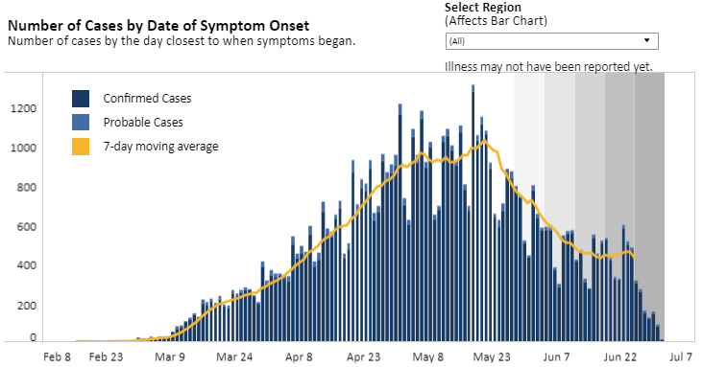
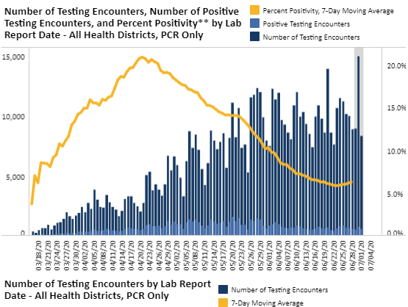
Graphs obtained from Virginia Department of Health: https://www.vdh.virginia.gov/coronavirus/
June 30 - Governor Northam Prohibits Congregating in Bars, Stresses Caution As Virginia Moves to Phase Three
Governor Ralph Northam today announced that bar seating will remain prohibited in restaurants as the Commonwealth moves into Phase Three at midnight tonight. While key health indicators in Virginia are improving, the Governor made clear that he is taking a cautious approach and is prepared to implement tighter restrictions if needed.
To reduce the likelihood of patrons gathering in bar areas without observing social distancing guidelines, bar seating and congregating areas of restaurants will remain closed except for those passing through. Restaurants may use non-bar seating in the bar area, as long as a minimum of six feet between tables is provided.
News Release: https://www.governor.virginia.gov/newsroom/all-releases/2020/june/headline-859008-en.html
Phase Three Guidelines: https://www.governor.virginia.gov/media/governorvirginiagov/governor-of-virginia/pdf/Virginia-Forward-Phase-Three-Guidelines.pdf

June 30 - More than 8,000 COVID-19 patients discharged from Virginia hospitals
The number of people who have been discharged from a hospital after testing positive for coronavirus continues to increase - a glimpse at how many people are recovering from the virus in the state.
As of Tuesday, June 30, 8,080 people have been discharged following hospitalization for coronavirus. The state also reports that it currently has 3,909 beds available with only 20% of its ventilators in use.
https://www.nbc12.com/2020/06/29/more-than-covid-patients-discharged-virginia-hospitals/
June 29 - COVID-19 Cases Still Trending Upward in Southwest Virginia
Virginia’s statewide COVID-19 numbers have been trending down over the past few weeks. That’s encouraged state officials to ease restrictions on businesses and gatherings.
But the numbers in much of the southwest part of the state have been heading in the other direction, which has health professionals worried.
https://www.wvtf.org/post/covid-19-cases-still-trending-upward-southwest-virginia#stream/0
June 29 - Amid COVID-19 Pandemic, Virginia Named a Top Five State in National Emergency Preparedness Report
As Virginia hospitals continue to vigorously serve as frontline providers protecting community health during the COVID-19 global pandemic, a new national ranking lists the Commonwealth as one of the states best prepared to respond to public health emergencies when they arise. The Commonwealth of Virginia is tied for second among states in overall emergency preparedness rating in the recently released 2020 National Health Security Preparedness Index report from the Robert Wood Johnson Foundation and the Colorado School of Public Health.
https://www.vhha.com/communications/amid-covid-19-pandemic-virginia-named-a-top-five-state-in-national-emergency-preparedness-report/
The National Health Security Preparedness Index: https://nhspi.org/wp-content/uploads/2020/06/NHSPI_2020_Key_Findings.pdf

Support for Virginians
July 2 - Governor Northam Announces More Than $10.3 Million to Support 790 Affordable Housing Units
Governor Ralph Northam today announced more than $10.3 million in Affordable and Special Needs Housing (ASNH) loans for 14 projects across the Commonwealth, creating or preserving 790 affordable housing units for low-income and very low-income Virginians. The projects will support new construction and rehabilitation of affordable housing and permanent supportive housing for vulnerable populations and will leverage over $181 million in additional federal, state, local, and private lending resources.
“Quality affordable housing is essential to creating vibrant communities and ensuring that every Virginia family has the opportunity to thrive,” said Governor Northam. “That’s why I committed to doubling the Virginia Housing Trust Fund this past General Assembly session and will continue to prioritize efforts to transform our housing stock. This increased funding is even more critical as we work to address homelessness, reduce evictions, and help Virginians facing economic challenges due to the COVID-19 pandemic.”
News Release: https://www.governor.virginia.gov/newsroom/all-releases/2020/july/headline-859040-en.html
July 2 - Virginia 30 Day Fund reaches milestone
A nonprofit helping small businesses across Virginia that were impacted by the COVID-19 pandemic has now helped its 500th company.
https://www.cbs19news.com/story/42318052/virginia-30-day-fund-reaches-milestone
June 30 - Virginia sees historic Medicaid enrollment during COVID-19 pandemic
Virginia’s Medicaid enrollment has increased by 55,000 more people than anticipated since a March 12 declaration of emergency at the start of the COVID-19 pandemic. The rapid climb in enrollment numbers comes with questions about how the state will shoulder the costs if federal aid ends before Virginia’s economy fully recovers from the weight of the crisis.
https://www.virginiamercury.com/2020/06/30/virginia-sees-historic-medicaid-enrollment-during-covid-19-pandemic/?fbclid=IwAR2dRVifwLkLSbAVANYKxXzEextHRIfFxCL-MkbfcH7gZ8TkWfyRu6Um10s
June 29 - Governor Northam Launches Rent and Mortgage Relief Program to Assist Virginians Facing Eviction or Foreclosure
Governor Ralph Northam today launched the Virginia Rent and Mortgage Relief Program (RMRP), which will provide $50 million in federal Coronavirus Aid, Relief, and Economic Security (CARES) Act funding for households facing eviction or foreclosure due to COVID-19. RMRP will provide short-term financial assistance on behalf of households in the form of rent and mortgage payments.
News Release: https://www.governor.virginia.gov/newsroom/all-releases/2020/june/headline-858911-en.html
June 26 - Nearly 29K essential workers exposed to COVID-19; United Food and Commercial Workers International Union calls on Northam to protect workers
The United Food and Commercial Workers International Union (UFCW) said Friday that, among its 1.3 million members, 238 front-line workers have died from COVID-19 and nearly 29,000 workers have been infected or exposed to the virus. UFCW represents more than 10,100 workers in Virginia’s grocery stores, meatpacking plants and other essential businesses.
“With our country now 100 days into the COVID-19 pandemic, America’s front-line workers in Virginia and across the country still face many of the same dangers they faced on Day One,” UFCW International President Marc Perrone said in a statement.
https://www.virginiabusiness.com/article/nearly-29k-essential-workers-exposed-to-covid-19/

Support for Businesses
June 29 - Virginia moves forward with nation’s first COVID-19 workplace safety standards
Virginia moved forward Monday with establishing COVID-19 safety rules for the workplace. The regulations set standards for cleaning and social distancing and employers who fail to comply could face fines.
https://www.wric.com/news/virginia-news/virginia-moves-forward-with-nations-first-covid-19-workplace-safety-standards/
June 30 - Northam provides $30 million in emergency aid to doctors, other health providers
Gov. Ralph Northam is redirecting $30 million in state funds to pay for a 29% increase in Medicaid rates paid to primary care doctors, pediatricians and other health care providers who are struggling to survive the economic fallout from the coronavirus pandemic.
Northam is making the rate increase retroactive to March 1, using money that had been budgeted for Medicaid managed care organizations to pay for nonelective surgeries and other medical services that were canceled or curtailed because of the spread of COVID-19.
https://www.richmond.com/news/virginia/northam-provides-30-million-in-emergency-aid-to-doctors-other-health-providers/article_efaae9dd-dc71-5eb3-bdff-dd86ff9ffb3a.html

Higher Education
June 29 - Community colleges, businesses partner to get Virginians back to work; Virginia Ready Initiative participants receive $1K stipends, interview opportunities
The Virginia Ready Initiative (VA Ready) announced Monday a program that will provide stipends for unemployed Virginians to attend community college programs in an effort to find new industry jobs and overcome coronavirus-related economic hardships.
“We have people who need work and companies who need employees, so Virginia’s community colleges and employers are coming together to help,” Gov. Ralph Northam said in a statement. “If you choose a high-demand field, our community colleges will train you and then Virginia Ready will help you find a job and give you a $1,000 achievement award. This is one more way that Virginia is demonstrating that helping workers also helps business and our economy.”
https://www.virginiabusiness.com/article/community-colleges-businesses-partner-to-get-virginians-back-to-work/?utm_source=newsletter&utm_medium=email&utm_campaign=daily
June 28 - Community colleges – Setting a path forward after the pandemic
Community colleges in Virginia and across the nation have responded quickly to the COVID-19 pandemic, making contributions to enhance capabilities of emergency responders and health care professionals. Two-year public colleges have the unique capability to re-skill the workforce as the state and the nation prepare to return to productivity after the pandemic subsides.
https://newsadvance.com/opinion/community_viewpoint/community-colleges-setting-a-path-forward-after-the-pandemic/article_d807d542-5a0e-5b60-86d7-20d331c5c597.html
June 26 - How Is The Pandemic Impacting College Students? They’re Worried. Here’s How To Help.
For many college and university students looking toward the fall, questions left unanswered and swirling concerns about the year ahead have stamped the first semester of the new academic year with a question mark.
…
The ADVANCE program is specific to transfer students from Northern Virginia Community College to George Mason University, but the circumstances and concerns being brought up by the program’s students are reflective of what many are coping with, both on a local and national scale.
https://northernvirginiamag.com/family/education/2020/06/26/how-is-the-pandemic-impacting-college-students-theyre-worried-heres-how-to-help/

June 25 - Report Lays Out How Community Colleges Could Save Economy
A new report argues that community colleges are in the best position to upskill and train the millions of Americans who became unemployed due to the coronavirus pandemic.
https://www.insidehighered.com/quicktakes/2020/06/25/report-lays-out-how-community-colleges-could-save-economy
Full Report: https://opportunityamericaonline.org/wp-content/uploads/2020/06/Indispensable_Inst_FullReport.pdf

PPE
July 1 - NASA, University Hospitals develop new decontamination methods for PPE
NASA's Glenn Research Center and University Hospitals have collaborated to develop new ways to decontaminate personal protective equipment (PPE) for applications in aerospace and medicine to safeguard the health of workers caring for patients with COVID-19, according to a news release.
Researchers recently developed two new approaches that could enable healthcare professionals to sanitize masks on-site and safely reuse them, according to the release. The techniques may also be useful to the aerospace community when traditional sterilization methods aren't available.
https://www.modernhealthcare.com/safety-quality/nasa-university-hospitals-develop-new-decontamination-methods-ppe
June 30 - Engineering students manufacture protective gear for health systems
As health care systems raced to locate new sources of personal protective equipment during the first months of the COVID-19 pandemic, Virginia’s engineering schools stepped up with innovative plans for manufacturing in-demand PPE.
https://www.virginiabusiness.com/article/making-a-difference/

Unemployment Data
July 2 - Virginia’s Unemployment Insurance Weekly Claims for Week Ending June 27th; Seasonally unadjusted weekly initial unemployment insurance claims rose to their highest number since May during the latest filing week
The Virginia Employment Commission (VEC) announced that the number of initial claims filed from mid-March through the June 27, 2020 filing week totaled 906,734 or 22% of pre-pandemic, nonfarm employment, according to figures released today.
For the filing week ending June 27, the figure for seasonally unadjusted initial claims in Virginia was 31,955. The latest claims figure was an increase of 6,662 claimants from the previous week. The weekly total was the highest since May, but still well below the initial spike in unemployment insurance claims during the March 21 filing week.
For the most recent filing week, continued weeks claimed totaled 366,714, down 8,865 from the previous week, but 346,917 higher than the 19,797 continued claims from the comparable week last year. The continued claims total is mainly comprised of those recent initial claimants who continued to file for unemployment insurance benefits during the COVID-19 pandemic. Continued claims during the June 27 filing week equaled 40% of all initial claims filed during the pandemic to this point. This percentage has trended downward in recent weeks.

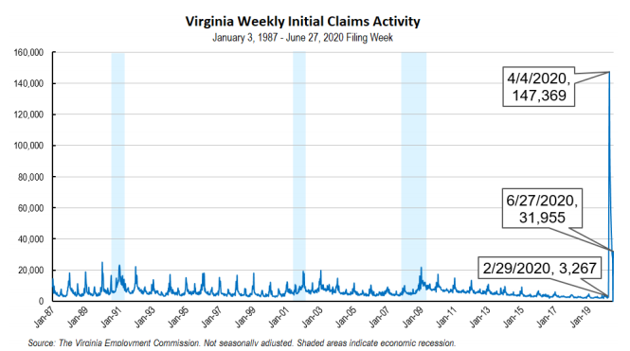
Nationwide, in the week ending June 27, the advance figure for seasonally adjusted initial claims was 1,427,000, a decrease of 55,000 from the previous week's revised level. The previous week's level was revised up by 2,000 from 1,480,000 to 1,482,000. The advance number of actual initial claims under state programs, unadjusted, totaled 1,445,481 in the week ending June 27, a decrease of 14,575 (or -1.0 percent) from the previous week. There were 224,565 initial claims in the comparable week in 2019. Most states reported decreases while three states reported weekly decreases greater than 10,000. These were in Oklahoma (-41,933), Florida (-11,075), and Maryland (-10,620). Virginia’s weekly change was the fourth largest increase among states.
https://www.vec.virginia.gov/node/12018
PDF of press release: https://www.vec.virginia.gov/sites/default/files/news-12018-Initial%20Claims%20Press%20Release%206%2027%202020.pdf
For additional information on who is claiming unemployment insurance in Virginia, access the VEC’s U.I. claims data dashboard (https://www.vec.virginia.gov/ui-claims-dashboard) that is updated the following Monday after the weekly claims press release.
July 2 - US unemployment falls to 11%, but new shutdowns are underway
U.S. unemployment fell to 11.1% in June as the economy added a solid 4.8 million jobs, the government reported Thursday. But the job-market recovery may already be faltering because of a new round of closings and layoffs triggered by a resurgence of the coronavirus.
While the jobless rate was down from 13.3% in May, it is still at a Depression-era level. And the data was gathered during the second week of June, just before a number of states began to reverse or suspend the reopenings of their economies to try to beat back the virus.
https://www.wsls.com/news/2020/07/01/a-predicted-surge-in-us-job-growth-for-june-might-not-last/

Virginia Economy
June 30 - Virginia's COVID shortfall could be less than $500 million. It initially looked twice as bad.
Virginia could lose less than half of the $1 billion in revenues it had expected to in the fiscal year that ended Tuesday, setting the stage for a potential restoration of spending that had been frozen in the new two-year budget that took effect Wednesday.
The final number won’t be known for more than a week as income tax payments continue to flow into the state treasury, but Secretary of Finance Aubrey Layne said Tuesday that the shortfall caused by the coronavirus pandemic could be less than $500 million in the fiscal year that ended Tuesday.
https://www.richmond.com/news/virginia/virginias-covid-shortfall-could-be-less-than-500-million-it-initially-looked-twice-as-bad/article_fefbf816-c69f-5bc2-bd50-9dc0ec13b6cc.html
June 30 - Governor Northam Announces More Than $4.2 Million to Stimulate Economic Recovery in Virginia’s Appalachian Region
Governor Ralph Northam today announced he is recommending more than $4.2 million in Appalachian Regional Commission (ARC) grants for 17 projects in the Appalachian region of Virginia, which encompasses 25 counties and eight independent cities in Southwest Virginia. ARC grants are used to stimulate economic development by funding projects such as infrastructure, entrepreneurship development, and workforce development. The federal commission will finalize approval of these project awards later this year.
News Release: https://www.governor.virginia.gov/newsroom/all-releases/2020/june/headline-859006-en.html
June 29 - State And Local Coalition Comes Together To Appeal For Federal Aid As Fiscal Year Ends
As a new fiscal year begins for most state and local governments, a coalition of state and local organizations, business groups, labor unions and others made a unified appeal to the U.S. Senate to immediately act on aid for state and local governments as public services and jobs are threatened by the COVID-19 pandemic.
https://www.nga.org/news/press-releases/state-and-local-coalition-comes-together-to-appeal-for-federal-aid-as-fiscal-year-ends/
June 25 - Charlottesville Chamber releases regional recovery blueprint
As part of its COVID-19 economic recovery initiative Project Rebound, the Charlottesville Regional Chamber of Commerce on Thursday released a blueprint outlining recovery action steps for the business community.
https://www.virginiabusiness.com/article/our-chance-to-restart-and-reinvent/

Other Resources
● Virginia State Resources: https://www.virginia.gov/coronavirus/support-for-businesses/#854620
●FAQs from Workers Regarding Covid-19:
English:https://www.governor.virginia.gov/media/governorvirginiagov/governor-of-virginia/pdf/Frequently-Asked-Questions-from-Workers-Regarding-COVID-19.pdf
Spanish:https://www.governor.virginia.gov/media/governorvirginiagov/governor-of-virginia/pdf/Las-Preguntas-Mas-Frecuentes-para-los-Empleados-Sobre-COVID-19.pdf
●Support for affected workers: https://www.virginia.gov/coronavirus/employment-and-financial-support/#855804
●F.A.Q. on Coronavirus Relief for Small Businesses, Freelancers https://www.nytimes.com/article/small-business-loans-stimulus-grants-freelancers-coronavirus.html
●The Paycheck Protection Program (PPP), a provision of the CARES Act, offers forgivable low-interest loans to small businesses facing uncertainty during the COVID-19 emergency, so businesses can retain workers, maintain payroll, and cover certain other existing overhead costs. https://www.sba.gov/funding-programs/loans/coronavirus-relief-options/paycheck-protection-program-ppp
●COVID 19 Testing Information and Locations: https://www.vdh.virginia.gov/coronavirus/covid-19-testing/

WARN Notices
*No WARN notices were received for the week ending June 26.*
Due to severe restrictions aimed at curbing the spread of coronavirus (COVID-19), some businesses are being forced to significantly reduce staff, and many will likely close altogether for at least some period of time.
The federal WARN Act requires covered employers to provide 60 days’ advance notice before terminating or laying off employees in connection with a plant closing or mass layoff. However, there are three exceptions to the 60 days’ notice requirement and two of these exceptions—for unforeseeable business circumstances and for faltering businesses—are likely to apply during the crisis that is unfolding from COVID-19.
**Businesses with fewer than 100 employees are not covered under the WARN Act and do not have to file WARN letters with the state. Therefore, this is not a comprehensive reflection of business closures in Virginia.
http://www.vec.virginia.gov/warn-notices

Virginia news:
● Virginia Mercury: https://www.virginiamercury.com/
National news:
● Sign up for The New York Times Morning Briefing: https://www.nytimes.com/series/us-morning-briefing
● The Daily podcast: https://www.nytimes.com/column/the-daily

