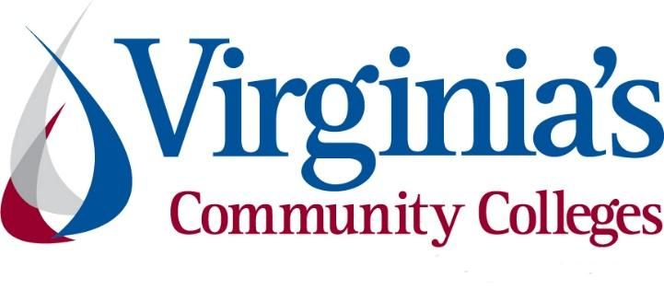
COVID-19 Update
Thursday, June 25, 2020
Virginia Daily Key Statistics - (please note that the VDH and VHHA numbers may vary slightly due to reporting times.)
Virginia’s Daily COVID-19 Statistics-Virginia Department of Health: http://www.vdh.virginia.gov/coronavirus/ (This page is updated daily before 10 AM. Numbers are preliminary and close out at 5 PM the day before posting. Case counts reflect what has been reported to VDH by healthcare providers and laboratories.)
People Tested (PCR): 590,404 (90,805 or 18.2% increase from last week)
Total Cases: 59,946 (3,708 or 6.6% increase from last week)
Total Hospitalizations: 5,995 (251 or 4.4% increase from last week)
Total Deaths: 1,675 (89 or 5.6% increase from last week)
COVID in Virginia’s Hospitals Dashboard: https://www.vhha.com/communications/virginia-hospital-covid-19-data-dashboard/
June 24 - New daily cases steady one week ahead of move to phase 3, Hampton Roads cases up slightly
Virginia reported its 14th day of cases below 600 in its last 17 on June 24, a day after Gov. Ralph Northam announced the commonwealth would move to phase 3 of its reopening plan next Wednesday, July 1.
Virginia’s 7-day average of cases has bumped up slightly in recent days to 534 on Wednesday, but the average has remained around that 500 mark for just over a week. That’s less than half Virginia’s peak 7-day average in cases (1,195) on May 31. Virginia continues to seeing improving figures as other states across the country, including North Carolina, see cases trend up, or in the case of Arizona, skyrocket.
https://www.wavy.com/news/virginia-june-24-covid-19-update-new-daily-cases-steady-one-week-ahead-of-move-to-phase-3-hampton-roads-cases-up-slightly/
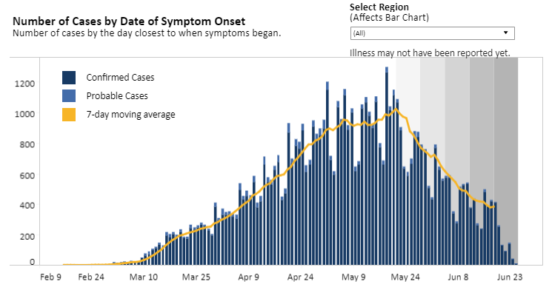
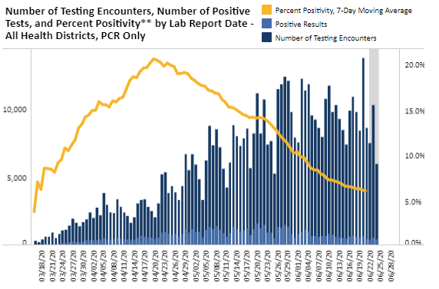
Graphs obtained from Virginia Department of Health: https://www.vdh.virginia.gov/coronavirus/

June 23 - Phase Three reopening to start July 1; Next phase of reopening will allow social gatherings of up to 250 people.
Virginia will enter Phase Three of the state’s Forward Virginia reopening plan on July 1, ending restrictions on restaurants, retail stores and bars, among other changes, Gov. Ralph Northam said Tuesday.
This gives us about three-and-a-half weeks of Phase Two where we have been able to follow the data,” Northam said during his Tuesday COVID-19 press conference. “There continue to be surges in other states, and we are monitoring that very closely.”
https://www.virginiabusiness.com/article/phase-three-reopening-to-start-july-1/?utm_source=newsletter&utm_medium=email&utm_campaign=daily
Phase Three Guidelines: https://www.governor.virginia.gov/media/governorvirginiagov/governor-of-virginia/pdf/Virginia-Forward-Phase-Three-Guidelines.pdf

Support for Virginians
June 23 - Supreme Court of Virginia reinstates some evictions effective immediately
The Supreme Court of Virginia ruled on Monday to allow landlords to evict tenants for issues other than failure to pay rent.
This is an amendment to the Fifth Order issued on June 8, which suspended all evictions through June 28. They said the amended order goes into effect effective immediately.
https://www.wric.com/news/virginia-news/supreme-court-of-virginia-reinstates-some-evictions-effective-immediately/
June 19 - Governor Northam Announces $246 Million to Support Response to COVID-19 in Long-Term Care Facilities
Governor Ralph Northam today announced new guidelines and testing requirements for reopening long-term care facilities, and outlined how the Commonwealth will direct $246 million, primarily from federal Coronavirus Aid, Relief, and Economic Security (CARES) Act funding, to support long-term care facilities in their response to COVID-19. In addition, the Governor is directing the Virginia Department of Health (VDH) to make public facility-specific data regarding COVID-19 cases and deaths associated with long-term care facilities.
News Release: https://www.governor.virginia.gov/newsroom/all-releases/2020/june/headline-858302-en.html

June 17 - New Virginia programs meant to offset economic effect of COVID-19
Virginia is launching new programs to combat the economic downturn caused by the response to the COVID-19 pandemic, including relief for artists.
https://www.washingtonexaminer.com/politics/new-virginia-programs-meant-to-offset-economic-effect-of-covid-19

Support for Businesses
June 23 - Virginia to create first pandemic workplace safety mandates in nation
The state of Virginia has proposed its own set of coronavirus-era safety rules that companies must implement to protect workers from infection — a first in the country and a potential way forward for other states in the face of federal inaction.

The emergency temporary standard was drafted by the state’s Department of Labor and Industry, under direction from Gov. Ralph Northam (D) in late May. It was being deliberated by the state’s 14-member health and safety board on Wednesday.
The governor’s office said the rules were prompted in large part by the lack of enforcement from the federal agency tasked with upholding workplace safety, the Occupational Safety and Health Administration.
https://www.washingtonpost.com/business/2020/06/24/virginia-safety-rules-covid/
June 19 - Loudoun County to fund 400 additional small businesses; Random drawing to be held Tuesday June 23
On Tuesday, June 23, the Loudoun County Board of Supervisors will hold a random drawing for the third round of grants from its COVID-19 Business Interruption Fund, which supports small businesses affected by the pandemic. The funding was allocated from the $36.1 million in federal funding to Loudoun County from the Coronavirus Aid, Relief and Economic Security (CARES) Act.
The drawing will provide $5,000 grants to 400 randomly selected businesses.
https://www.virginiabusiness.com/article/loudoun-county-to-fund-400-additional-small-businesses/

June 18 - Governor Northam Announces New Recovery Marketing Aid for Tourism Businesses
Governor Ralph Northam today announced that new recovery marketing funds are available to destination marketing organizations (DMO) across the Commonwealth that have been heavily impacted by the novel coronavirus pandemic. The WanderLOVE Recovery Grant Program, which is administered by the Virginia Tourism Corporation (VTC), will provide up to 50 grants to DMOs of up to $10,000 each.
News Release: https://www.governor.virginia.gov/newsroom/all-releases/2020/june/headline-858283-en.html
June 18 - U.S. Department of Labor Issues OSHA Guidance as Non-Essential Businesses Reopen and Employees Return to Work
The U.S. Department of Labor’s Occupational Safety and Health Administration (OSHA) has issued guidance to assist employers reopening non-essential businesses and their employees returning to work during the evolving coronavirus pandemic.
The guidance supplements the U.S. Department of Labor and U.S. Department of Health and Human Services’ previously developed Guidance on Preparing Workplaces for COVID-19 and the White House’s Guidelines for Opening up America Again. The guidelines provide general principles for updating restrictions originally put in place to slow the spread of the coronavirus. During each phase of the reopening process, employers should continue to focus on strategies for basic hygiene, social distancing, identification and isolation of sick employees, workplace controls and flexibilities, and employee training.
Guidance: https://www.osha.gov/Publications/OSHA4045.pdf
News Release: https://www.dol.gov/newsroom/releases/osha/osha20200618

Unemployment Data
June 25 - Virginia’s Unemployment Insurance Weekly Claims for Week Ending June 20th; Seasonally unadjusted weekly initial unemployment insurance claims dropped to their lowest number since March during the latest filing week
The Virginia Employment Commission (VEC) announced that the number of initial claims filed from mid-March through the June 20, 2020 filing week totaled 874,779, which surpassed 21% of pre-pandemic, nonfarm employment, according to figures released today.
For the filing week ending June 20, the figure for seasonally unadjusted initial claims in Virginia was 25,293. The latest claims figure was a decrease of 1,893 claimants from the previous week. The weekly total was the lowest since before the initial spike in unemployment insurance claims during the March 21 filing week.
For the most recent filing week, continued weeks claimed totaled 375,579, down 11,314 from the previous week, but 355,910 higher than the 19,669 continued claims from the comparable week last year. The continued claims total is mainly comprised of those recent initial claimants who continued to file for unemployment insurance benefits during the COVID-19 pandemic. Continued claims during the June 20 filing week equaled 43% of all initial claims filed during the pandemic to this point. This percentage has trended downward in recent weeks.
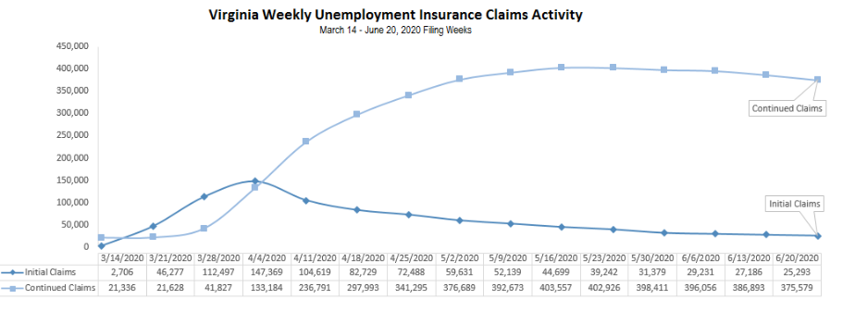
Nationwide, in the week ending June 20, the advance figure for seasonally adjusted initial claims was 1,480,000, a decrease of 60,000 from the previous week's revised level. The previous week's level was revised up by 32,000 from 1,508,000 to 1,540,000. The advance number of actual initial claims under state programs, unadjusted, totaled 1,457,373 in the week ending June 20, a decrease of 5,990 (or -0.4 percent) from the previous week.
https://www.vec.virginia.gov/UI-press-release
PDF of press release: https://www.vec.virginia.gov/sites/default/files/news-12007-Initial%20Claims%20Press%20Release%206%2020%202020.pdf
For additional information on who is claiming unemployment insurance in Virginia, access the VEC’s U.I. claims data dashboard (https://www.vec.virginia.gov/ui-claims-dashboard) that is updated the following Monday after the weekly claims press release.
June 19 - Virginia’s unemployment rate dropped to 9.4% in May
Virginia’s unemployment rate improved in May as the state began to reopen, with the number of people looking for work dropping to 9.4 percent of the civilian labor force, compared to 11.2 percent in April.
This positive development shows the state beginning to recover from the devastating economic effects of the coronavirus (COVID-19) pandemic. However, the May number is still 6.6 percent higher than the unemployment rate before the crisis in February, when just 2.8 percent of the labor force was unemployed.
https://forthuntherald.com/virginias-unemployment-rate-drops-to-9-4-in-may/
June 19 - 12K+ Virginians refuse to return to work amid pandemic; VEC reports 400K job vacancies as people continue filing jobless claims
More than 12,000 Virginians who have filed jobless claims during the pandemic have refused to return to work, the Virginia Employment Commission announced Friday, while there are approximately 400,000 job vacancies posted on the Virginia Workforce Connection website.
https://www.virginiabusiness.com/article/12k-virginians-refuse-to-return-to-work-amid-pandemic/

Higher Education
June 25 - Report Lays Out How Community Colleges Could Save Economy
A new report argues that community colleges are in the best position to upskill and train the millions of Americans who became unemployed due to the coronavirus pandemic.
https://www.insidehighered.com/quicktakes/2020/06/25/report-lays-out-how-community-colleges-could-save-economy
Full Report: https://opportunityamericaonline.org/wp-content/uploads/2020/06/Indispensable_Inst_FullReport.pdf

Virginia Economy
June 23 - HHS contracts Herndon company for COVID-19 modeling; GeoSpark Analytics to work on five-year, multimillion contract
Herndon-based artificial intelligence company GeoSpark Analytics Inc. announced Tuesday it has been awarded a five-year, multimillion-dollar contract to provide COVID-19 and infectious disease modeling for the Department of Health and Human Services (HHS).
https://www.virginiabusiness.com/article/hhs-contracts-herndon-company-for-covid-19-modeling/
June 18 - Va. hotel revenues still down by more than 60%; American Hotel & Lodging Association predicts it will take years to get back to pre-pandemic demand
Even as Phase Three of Virginia’s reopening plan looms on the horizon, Virginia hotels are continuing to see revenues dropping. in the second week in June by 64% compared to the same time a year ago, according to findings released Thursday by Old Dominion University’s Dragas Center for Economic Analysis and Policy.
https://www.virginiabusiness.com/article/va-hotel-revenues-still-down-by-more-than-60/

Other Resources
● Virginia State Resources: https://www.virginia.gov/coronavirus/support-for-businesses/#854620
●FAQs from Workers Regarding Covid-19:
English:https://www.governor.virginia.gov/media/governorvirginiagov/governor-of-virginia/pdf/Frequently-Asked-Questions-from-Workers-Regarding-COVID-19.pdf
Spanish:https://www.governor.virginia.gov/media/governorvirginiagov/governor-of-virginia/pdf/Las-Preguntas-Mas-Frecuentes-para-los-Empleados-Sobre-COVID-19.pdf
●Support for affected workers: https://www.virginia.gov/coronavirus/employment-and-financial-support/#855804
●F.A.Q. on Coronavirus Relief for Small Businesses, Freelancers https://www.nytimes.com/article/small-business-loans-stimulus-grants-freelancers-coronavirus.html
●The Paycheck Protection Program (PPP), a provision of the CARES Act, offers forgivable low-interest loans to small businesses facing uncertainty during the COVID-19 emergency, so businesses can retain workers, maintain payroll, and cover certain other existing overhead costs. https://www.sba.gov/funding-programs/loans/coronavirus-relief-options/paycheck-protection-program-ppp
●COVID 19 Testing Information and Locations: https://www.vdh.virginia.gov/coronavirus/covid-19-testing/

WARN Notices
*No WARN notices were received for the week. The information provided below is for the week of June 12.*
Due to severe restrictions aimed at curbing the spread of coronavirus (COVID-19), some businesses are being forced to significantly reduce staff, and many will likely close altogether for at least some period of time.
The federal WARN Act requires covered employers to provide 60 days’ advance notice before terminating or laying off employees in connection with a plant closing or mass layoff. However, there are three exceptions to the 60 days’ notice requirement and two of these exceptions—for unforeseeable business circumstances and for faltering businesses—are likely to apply during the crisis that is unfolding from COVID-19.
**Businesses with fewer than 100 employees are not covered under the WARN Act and do not have to file WARN letters with the state. Therefore, this is not a comprehensive reflection of business closures in Virginia.
http://www.vec.virginia.gov/warn-notices
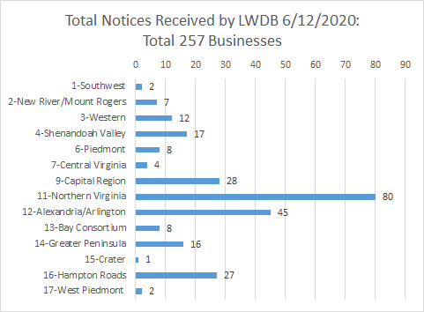
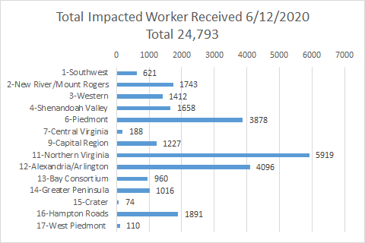
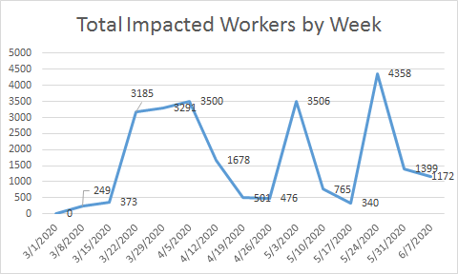

*The spike for the end of the week was caused by a single employer whose temporary furloughs resulted from the restrictions placed on non-essential medical procedures.
The above graphics do not represent all layoffs that have occurred in the Commonwealth of Virginia, only the businesses that have filed official notices with the Commonwealth or who have sought assistance from the workforce system.

Virginia news:
● Virginia Mercury: https://www.virginiamercury.com/
National news:
● Sign up for The New York Times Morning Briefing: https://www.nytimes.com/series/us-morning-briefing
● The Daily podcast: https://www.nytimes.com/column/the-daily (June 24: “The Epidemic of Unemployment”)

