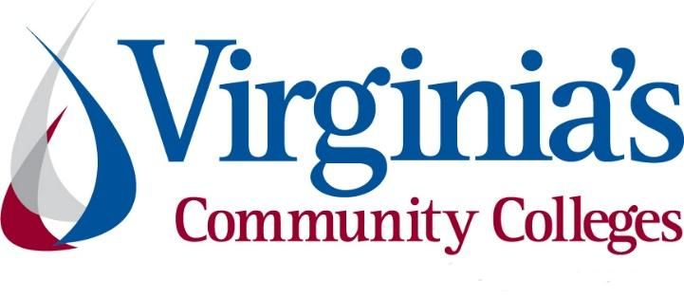
COVID-19 Update
Thursday, June 18, 2020
Virginia Daily Key Statistics - (please note that the VDH and VHHA numbers may vary slightly due to reporting times.)
Virginia’s Daily COVID-19 Statistics-Virginia Department of Health: http://www.vdh.virginia.gov/coronavirus/ (This page is updated daily before 10 AM. Numbers are preliminary and close out at 5 PM the day before posting. Case counts reflect what has been reported to VDH by healthcare providers and laboratories.)
People Tested (PCR): 499,599 (94,574 or 23.4% increase from last week)
Total Cases: 56,238 (3,591 or 6.8% increase from last week)
Total Hospitalizations: 5,744 (384 or 7.2% increase from last week)
Total Deaths: 1,586 (66 or 4.3% increase from last week)
COVID in Virginia’s Hospitals Dashboard: https://www.vhha.com/communications/virginia-hospital-covid-19-data-dashboard/
June 18 - Governor Northam Outlines Phase Three Guidelines to Lift Additional Public Health Restrictions
Governor Ralph Northam today presented the third phase of the “Forward Virginia” plan to continue easing public health restrictions while mitigating the spread of COVID-19. The Commonwealth does not yet have a targeted date for entering Phase Three.
News Release: https://www.governor.virginia.gov/newsroom/all-releases/2020/june/headline-858266-en.html
June 17 - Percentage of positive COVID-19 tests in Virginia down to 7.3% from April high of 22%
…
As the overall number of positive COVID-19 test results in Virginia grows, data from the VDH coronavirus dashboard show the percentage of positive results from testing is down. The seven-day average for percent of positive test results was at 7.3% as of Saturday, which is the most recent figure provided by the VDH. That's down from a peak of 22.2% on April 19.
https://www.richmond.com/news/virginia/update-percentage-of-positive-covid-19-tests-continues-downward-trend-in-virginia/article_68fe8e68-5510-52a9-9d68-5314ce71706e.html
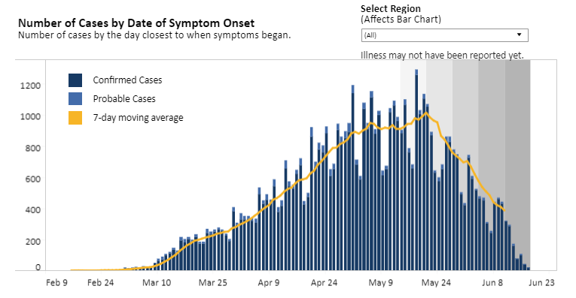
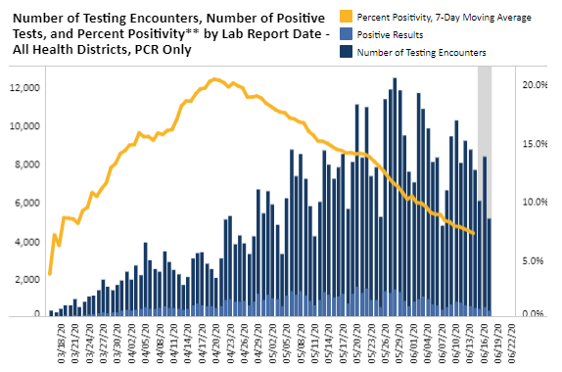
Graphs obtained from Virginia Department of Health: https://www.vdh.virginia.gov/coronavirus/
June 17 - Every Southwest Virginia county now has reported a COVID-19 case
With a case in Bland County, every jurisdiction in Southwest Virginia has now reported a case, according to the Mount Rogers Health District.
“We now have COVID-19 cases throughout our entire district and our entire region,” said Karen Shelton, M.D., director of the Mount Rogers Health District.
https://www.heraldcourier.com/news/every-southwest-virginia-county-now-has-reported-a-covid-19-case/article_bb1f73a6-b0dc-11ea-a892-8b841f89c54e.html
June 16 - As businesses reopen, COVID-19 spreads through 5 Roanoke-area restaurants
Five Roanoke-area restaurants are dealing with outbreaks of COVID-19 among their staffs, as the number of new infections continues to increase week over week in the Roanoke Valley, health officials said.
…
The Virginia Department of Health on Tuesday reported that daily cases of COVID-19 rose by 20 to 270 in Roanoke. O’Dell’s figures, which often differ from the state system due to reporting lags, showed 292 city residents who have been infected.
While statewide case numbers are showing a decline, those in the southwest region continue to rise.
https://www.roanoke.com/business/as-businesses-reopen-covid-19-spreads-through-5-roanoke-area-restaurants/article_e58c3675-92f8-589d-9c84-c3d27f8198e6.html
June 12 - Governor Northam Announces Expansion of Data Sharing Platform to Help Combat COVID-19
Governor Ralph Northam today announced that the Framework for Addiction Analysis and Community Transformation (FAACT), Virginia’s cross-agency, cloud-based, data-sharing and analytics platform, is expanding to help the Commonwealth mitigate the spread of COVID-19 and maintain an adequate supply of resources.
https://www.governor.virginia.gov/newsroom/all-releases/2020/june/headline-858149-en.html
June 10 - Impact of reopening on COVID-19 rates may not be known till late June: VDH chief says it will take 2-4 weeks for numbers to reach state dashboard
As the state enters week four of reopening, the Virginia Department of Health probably won’t know if there’s a broad increase in COVID-19 cases until late June, State Health Commissioner Dr. Norman Oliver said Wednesday.
https://www.virginiabusiness.com/article/impact-of-reopening-on-covid-19-rates-may-not-be-known-till-late-june/

COVID 19 Testing in Virginia
June 18 - Virginia Beach company offering COVID-19 test results in 30 minutes
One local company known for its instant drug and alcohol testing is now using its services to test essential employees for COVID-19.
https://www.wtkr.com/news/coronavirus/virginia-beach-company-offering-covid-19-test-results-in-30-minutes

PPE in Virginia
June 18 - VCU research shows masks can dramatically decrease COVID-19 deaths
A recent study from researchers at Virginia Commonwealth University suggests that mask-wearing policies can dramatically reduce per-capita death rates from COVID-19, based on an analysis of nearly 200 different countries.
https://www.virginiamercury.com/2020/06/18/the-most-important-variable-that-you-can-control-vcu-research-shows-masks-can-dramatically-decrease-covid-19-deaths/
June 14 - Virginia PPE purchases larger, costlier than first estimated
Virginia is on track to spend far more on buying masks, gloves, gowns and face shields than state officials had expected when they stepped into the global scramble for personal protective equipment.
But the state is getting more PPE, too.
https://www.pilotonline.com/news/health/dp-nw-virginia-ppe-20200614-sevzovew45ef3kgn37zzxml5he-story.html

Support for Virginians
June 12 - Governor Northam Announces New Tools for Virginia Workers and Job Seekers
Governor Ralph Northam today shared a new suite of technology tools to help Virginians take full advantage of the supportive services available through the Commonwealth’s workforce system. The Virginia Career Works Referral Portal is a statewide platform designed to streamline intake processes across state agencies and connect individuals with training, certification, education, and employment services to help them find a job or advance a career path. The new Virginia Career Works Dashboard is an innovative data visualization tool that makes information about Virginia’s labor market and workforce system more accessible to workers, businesses, and policymakers.
“Workers and families across Virginia are experiencing tremendous financial pain, as well as coping, in many cases, with the devastation of getting sick or losing a loved one to COVID-19,” said Governor Northam. “This ongoing health crisis requires our government systems to respond faster and with more flexibility than ever before. This strategic investment in our workforce technology infrastructure puts the Commonwealth is in a stronger position to help Virginians get back on their feet and overcome these unprecedented challenges.”
Virginia Career Works Referral Portal: https://app.virginia.myjourney.com/
Virginia Career Works Dashboard: https://virginiacareerworks.com/dashboards/
News Release: https://www.governor.virginia.gov/newsroom/all-releases/2020/june/headline-858058-en.html
June 12 - State extends utility disconnect ban to Aug. 31: Residential, business customers will have extended payment plans with no late fees.
The Virginia State Corporation Commission (SCC) announced Friday it has extended the moratorium on service disconnections for electricity, natural gas, water and sewer utilities customers until Aug. 31.
https://www.virginiabusiness.com/article/state-extends-utility-disconnect-ban-to-aug-31/

Support for Businesses
June 18 - New loan rules aim to help small businesses reopen in Virginia
During the second round of the Paycheck Protection Program loans, the Small Business Administration (SBA) says they have seen an uptick in applications. So far, the SBA has given out $510 billion in the program and recently made a few changes to the rules, to give small business owners more options.
https://www.wtvr.com/rebound/getting-back-to-work/new-loan-rules-aim-to-help-small-businesses-reopen-in-virginia
June 17 - Virginia’s proposed workplace safety rules would make social distancing mandatory
Virginia workplace safety regulators are proposing emergency COVID-19 rules for businesses that would make social distancing mandatory and require employers to notify their employees within 24 hours if a coworker tests positive for the virus.
https://www.virginiamercury.com/2020/06/17/virginias-proposed-workplace-safety-rules-would-make-social-distancing-mandatory/

Unemployment Data
June 18 - Virginia’s Unemployment Insurance Weekly Claims for Week Ending June 13th; Seasonally unadjusted weekly initial unemployment insurance claims dropped to their lowest number since March during the latest filing week
For the filing week ending June 13, the figure for seasonally unadjusted initial claims in Virginia was 27,186. The latest claims figure was a decrease of 2,045 claimants from the previous week. The weekly total was the lowest since before the initial spike in unemployment insurance claims during the March 21 filing week.
For the most recent filing week, continued weeks claimed totaled 386,893, down 9,163 from the previous week, but 367,430 higher than the 19,463 continued claims from the comparable week last year. The continued claims total is mainly comprised of those recent initial claimants who continued to file for unemployment insurance benefits during the COVID-19 pandemic. Continued claims during the June 13 filing week equaled 46% of all initial claims filed during the pandemic to this point. This percentage has trended downward in recent weeks.

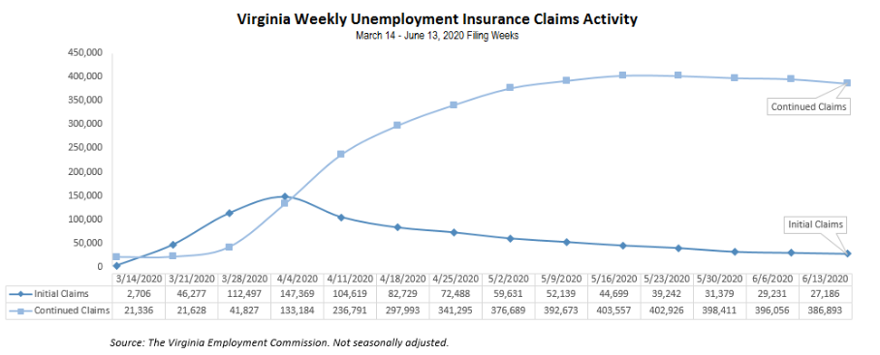
Nationwide, in the week ending June 13, the advance figure for seasonally adjusted initial claims was 1,508,000, a decrease of 58,000 from the previous week's revised level. The previous week's level was revised up by 24,000 from 1,542,000 to 1,566,000. The advance number of actual initial claims under state programs, unadjusted, totaled 1,433,027 in the week ending June 13, a decrease of 128,240 (or -8.2 percent) from the previous week.
https://www.vec.virginia.gov/UI-press-release
PDF of press release: https://www.vec.virginia.gov/sites/default/files/news-11993-Initial%20Claims%20Press%20Release%206%2013%202020.pdf
For additional information on who is claiming unemployment insurance in Virginia, access the VEC’s U.I. claims data dashboard (https://www.vec.virginia.gov/ui-claims-dashboard) that is updated the following Monday after the weekly claims press release.
June 18 - 386K+ remain unemployed in Va. during pandemic; Approximately 46M Americans are still jobless
More than 386,000 Virginians are still unemployed following the economic fallout from the COVID-19 pandemic, though the number of initial jobless claims across the commonwealth continues to decrease.
…
About 27,000 Virginians filed initial claims for unemployment last week, down from roughly 29,000 the prior week, according to the VEC. The state’s weekly unemployment numbers have continued to decline since peaking in early April, when 147,369 Virginians filed initial jobless claims in a single week. Last week there were 2,045 fewer claimants.
https://www.virginiabusiness.com/article/386k-remain-unemployed-in-va-during-pandemic/

Higher Education
June 12 - Colleges need to play a role in rebuilding the economy, panelists say: At Virginia Tech forum, Barkin and Moret say post-pandemic recovery will lean on institutions
As Virginia moves into its recovery phase from the COVID-19 pandemic, economic leaders say there is work to be done to support college students and Virginians who are changing careers, especially in terms of equal opportunities.
https://www.virginiabusiness.com/article/colleges-need-to-play-a-role-in-rebuilding-the-economy-panelists-say/
June 11 - Governor Northam Provides Guidance for Reopening Higher Education Institutions
Governor Ralph Northam today issued guidance for Virginia public and private higher education institutions as they develop plans to safely reopen their campuses and resume in-person instruction. This guidance document was developed by the Office of the Secretary of Education, the State Council of Higher Education for Virginia, and the Virginia Department of Health, and was informed by guidelines from the Centers for Disease Control and Prevention (CDC). The Governor is directing all of Virginia’s colleges and universities to create detailed reopening plans that demonstrate compliance with this new guidance.
News Release: https://www.governor.virginia.gov/newsroom/all-releases/2020/june/headline-857987-en.html

Virginia Economy
June 17 - Low Exposure, High Unemployment
These 13 Virginia localities had had relatively few confirmed cases of COVID-19, but saw their unemployment rates soar in April.
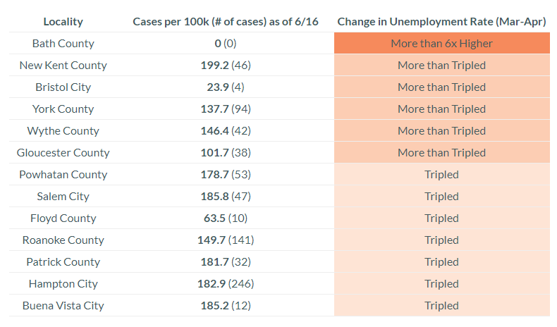
Note: Includes all counties with less than 200 COVID Cases per 100k as of 6/16/2020, and where the unemployment rate at least tripled from March to April of 2020.
https://www.vpap.org/visuals/visual/Low-Exposure-High-Impact/
June 15 - Governor Northam Announces $14.66 Million for New Economic Resilience and Recovery Program
Governor Ralph Northam today announced more than $14.66 million for a new Economic Resilience and Recovery Program to respond to the unprecedented economic conditions facing Virginia and address the near and long-term impacts of the COVID-19 pandemic. This initiative was created through a restructuring of Growth and Opportunity for Virginia (GO Virginia) funding. The program will focus resources on economic resilience and recovery while staying true to the GO Virginia mission of creating higher-paying jobs that strengthen and diversify regional economies.
News Release: https://www.governor.virginia.gov/newsroom/all-releases/2020/june/headline-858167-en.html
June 12 - Grant Program Available for Local Governments to Support Agriculture and Forestry Industries During COVID-19 Crisis and Beyond
Governor Ralph Northam today announced a new way for local governments to support agriculture- and forestry-based businesses during the COVID-19 emergency through the Governor’s Agriculture and Forestry Industries Development (AFID) Fund Planning Grant program.
https://www.governor.virginia.gov/newsroom/all-releases/2020/june/headline-858121-en.html

Other Resources
● Virginia State Resources: https://www.virginia.gov/coronavirus/support-for-businesses/#854620
●FAQs from Workers Regarding Covid-19:
English:https://www.governor.virginia.gov/media/governorvirginiagov/governor-of-virginia/pdf/Frequently-Asked-Questions-from-Workers-Regarding-COVID-19.pdf
Spanish:https://www.governor.virginia.gov/media/governorvirginiagov/governor-of-virginia/pdf/Las-Preguntas-Mas-Frecuentes-para-los-Empleados-Sobre-COVID-19.pdf
●Support for affected workers: https://www.virginia.gov/coronavirus/employment-and-financial-support/#855804
●F.A.Q. on Coronavirus Relief for Small Businesses, Freelancers https://www.nytimes.com/article/small-business-loans-stimulus-grants-freelancers-coronavirus.html
●The Paycheck Protection Program (PPP), a provision of the CARES Act, offers forgivable low-interest loans to small businesses facing uncertainty during the COVID-19 emergency, so businesses can retain workers, maintain payroll, and cover certain other existing overhead costs. https://www.sba.gov/funding-programs/loans/coronavirus-relief-options/paycheck-protection-program-ppp
●COVID 19 Testing Information and Locations: https://www.vdh.virginia.gov/coronavirus/covid-19-testing/

WARN Notices
Due to severe restrictions aimed at curbing the spread of coronavirus (COVID-19), some businesses are being forced to significantly reduce staff, and many will likely close altogether for at least some period of time.
The federal WARN Act requires covered employers to provide 60 days’ advance notice before terminating or laying off employees in connection with a plant closing or mass layoff. However, there are three exceptions to the 60 days’ notice requirement and two of these exceptions—for unforeseeable business circumstances and for faltering businesses—are likely to apply during the crisis that is unfolding from COVID-19.
**Businesses with fewer than 100 employees are not covered under the WARN Act and do not have to file WARN letters with the state. Therefore, this is not a comprehensive reflection of business closures in Virginia.
http://www.vec.virginia.gov/warn-notices
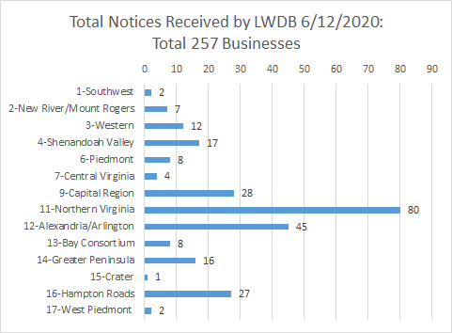
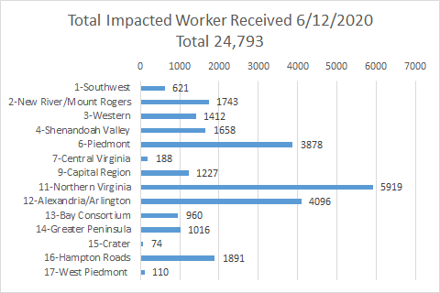
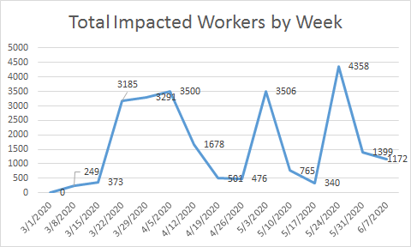

*The spike for the end of the week was caused by a single employer whose temporary furloughs resulted from the restrictions placed on non-essential medical procedures.
The above graphics do not represent all layoffs that have occurred in the Commonwealth of Virginia, only the businesses that have filed official notices with the Commonwealth or who have sought assistance from the workforce system.

Virginia news:
● Virginia Mercury: https://www.virginiamercury.com/
National news:
● Sign up for The New York Times Morning Briefing: https://www.nytimes.com/series/us-morning-briefing
● The Daily podcast: https://www.nytimes.com/column/the-daily

