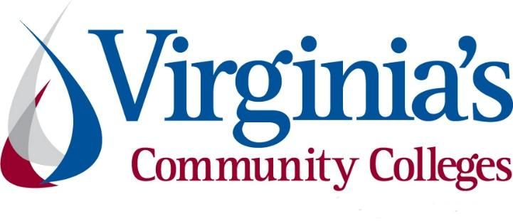
COVID-19 Update
Thursday, June 11, 2020
Virginia Daily Key Statistics - (please note that the VDH and VHHA numbers may vary slightly due to reporting times.)
Virginia’s Daily COVID-19 Statistics-Virginia Department of Health: http://www.vdh.virginia.gov/coronavirus/ (This page is updated daily before 10 AM. Numbers are preliminary and close out at 5 PM the day before posting. Case counts reflect what has been reported to VDH by healthcare providers and laboratories.)
People Tested (PCR): 405,025 (53,671 or 15.3% increase from last week)
Total Cases: 52,647 (4,791 or 10.0% increase from last week)
Total Hospitalizations: 5,360 (403 or 8.1% increase from last week)
Total Deaths: 1,520 (75 or 5.2% increase from last week)
COVID in Virginia’s Hospitals Dashboard: https://www.vhha.com/communications/virginia-hospital-covid-19-data-dashboard/
June 10 - Governor Northam Extends Executive Orders Bolstering Health Care Workforce, Giving Flexibility to Medicaid Providers
Governor Ralph Northam today extended Executive Orders Fifty-Seven and Fifty-Eight, which were originally signed in April and were due to expire on June 10.
News Release: https://www.governor.virginia.gov/newsroom/all-releases/2020/june/headline-857814-en.html
June 10 - Percent positivity keeps falling for Virginia COVID-19 cases as deaths surpass 1,500
As of Wednesday, June 10, Virginia has had 52,177 total cases of COVID-19, including confirmed lab tests and clinical diagnoses, according to the Virginia Department of Health.
That's a rise of 439 cases since Tuesday, out of 7,911 newly reported tests, which comes out to 5.5% of the newest tests coming back positive – a lower proportion than the current total state average.
https://www.whsv.com/content/news/Virginia-COVID-19-cases-rise-571156431.html
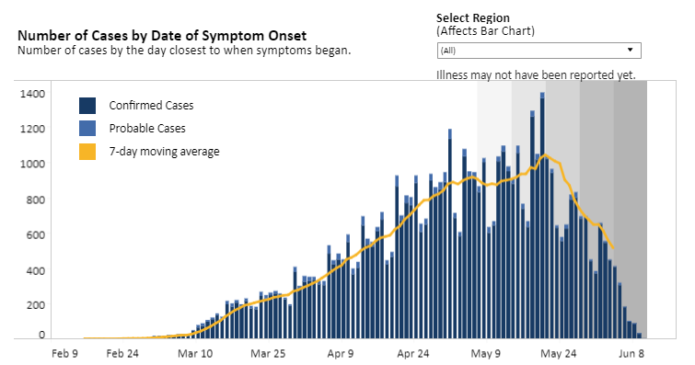
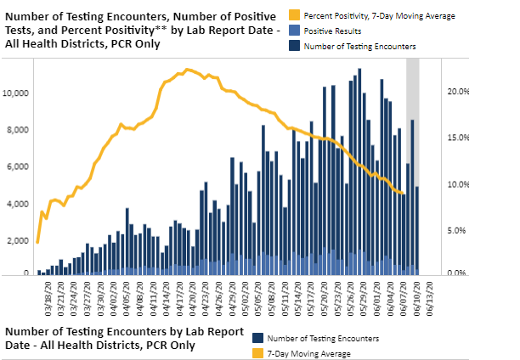Graphs obtained from Virginia Department of Health: https://www.vdh.virginia.gov/coronavirus/

June 9 - NoVa and Richmond to enter Phase Two June 12; Public, private schools to resume in-person classes in fall
Northern Virginia and the city of Richmond will enter Phase Two of Gov. Ralph Northam’s “Forward Virginia” plan Friday, June 12, joining the rest of the state in loosened restrictions on dining areas, personal care and grooming services and other nonessential businesses, Northam announced Tuesday. The state’s mask mandate in enclosed, public areas remains in place.
…
Also announced by Northam Tuesday, Virginia’s public and private schools will be open this fall, although classrooms will be socially distanced and youth sports will be different than usual, with no shared equipment and no football tackles for the time being.
https://www.virginiabusiness.com/article/schools-will-reopen-this-fall-for-in-person-classes-northam-says/?utm_source=newsletter&utm_medium=email&utm_campaign=daily
June 9 - Governor Northam Shares Guidance for Phased Reopening of PreK-12 Schools
Governor Ralph Northam today announced a phased approach that allows Virginia schools to slowly resume in-person classes for summer school and the coming academic year. The K-12 phased reopening plan was developed by the Office of the Secretary of Education, Virginia Department of Health, and the Virginia Department of Education and is informed by guidelines from the Centers for Disease Control and Prevention (CDC).
News Release: https://www.governor.virginia.gov/newsroom/all-releases/2020/june/headline-857292-en.html

COVID 19 Testing in Virginia
June 11 - CVS adds 37 additional COVID-19 testing sites across Virginia
CVS Health has added 37 additional drive-thru COVID-19 testing sites across Virginia.
The sites will be open on Friday, June 12.
With the additional sites, there will now be more than 75 COVID-19 testing sites at CVS Pharmacies across the state.
https://www.nbc12.com/2020/06/11/cvs-adds-additional-covid-testing-sites-across-virginia/

PPE in Virginia
June 9 - Localities getting CARES Act funding for federal election safety needs
Money from the Coronavirus Aid, Relief and Economic Security Act has now been distributed by the Virginia Department of Elections.
According to a release, the $9 million in funding is specifically to prevent, prepare for, and respond to the coronavirus for the 2020 federal election cycle.
https://www.cbs19news.com/story/42229544/localities-getting-cares-act-funding-for-federal-election-safety-needs
June 9 - Virginia Beach company making millions of masks during COVID-19 pandemic
A Virginia Beach small business is meeting big demands spawned by the COVID-19 pandemic.
https://www.wtkr.com/news/virginia-beach-company-making-millions-of-masks-during-covid-19-pandemic

Support for Virginians
June 9 - People Incorporated of Virginia offers rental assistance to those impacted by COVID-19
As businesses reopen and furloughed employees begin to return to work, the financial strains of COVID-19 remain.
A local agency is working to relieve the burden for families unable to pay rent.
…
There are 16 cities and counties across Virginia eligible, including Buchanan, Dickenson, Russell, Washington, and the City of Bristol.
https://wcyb.com/news/local/people-incorporated-of-virginia-offers-rental-assistance-to-those-impacted-by-covid-19
June 8 - Virginia Announces Temporary Moratorium on Evictions
Governor Ralph Northam today announced a temporary statewide moratorium on all eviction proceedings in Virginia. The Governor requested this moratorium in a letter sent to Virginia Supreme Court Chief Justice Donald Lemons this weekend.
The Chief Justice’s order issued today remains in effect through June 28 and modifies the Court’s earlier Declaration of Judicial Emergency in response to COVID-19. The temporary moratorium will halt all eviction proceedings for a period of nearly three weeks, as the Northam administration implements a comprehensive rent relief program for the thousands of Virginians facing housing insecurity in the midst of this public health crisis.
News Release: https://www.governor.virginia.gov/newsroom/all-releases/2020/june/headline-857262-en.html
June 5 - Virginia health dept. urges protesters to take precautions against COVID-19
The Virginia Department of Health is urging those participating in protests over the death of George Floyd to take precautions against the spread of COVID-19 and be aware of where they can get tested for the virus.
https://www.nbc29.com/2020/06/05/virginia-health-dept-urges-protesters-take-precautions-against-covid-/
June 5 - With federal aid in hand, localities look for creative ways to cover COVID-19 costs, help economy recover
The distribution of $646 million in federal aid to local governments in Virginia this week came with a big question — how can localities spend the money on their most pressing needs without facing a big payback later?
https://www.richmond.com/news/virginia/with-federal-aid-in-hand-localities-look-for-creative-ways-to-cover-covid-19-costs/article_0c79cf2d-143c-53c6-9c35-223ae679e853.html

Support for Businesses
June 10 - The Harvest Foundation invests $1M in Virginia 30 Day Fund
The Harvest Foundation in Martinsville announced Wednesday it has invested $1 million in the Virginia 30 Day Fund to launch a new relief initiative to aid small businesses in Martinsville and Henry County.
https://www.virginiabusiness.com/article/the-harvest-foundation-invests-1m-in-virginia-30-day-fund/
June 5 - Good news for small businesses as Trump signs PPP reform bill into law
Business owners who received a forgivable loan through the Paycheck Protection Program are getting more leeway on how to spend those funds.
President Donald Trump signed legislation on Friday that restructures how entrepreneurs can use loans issued through a new federal relief program for small businesses ailing from the economic contagion unleashed by the coronavirus pandemic.
https://www.cnbc.com/2020/06/04/senate-passes-ppp-reform-bill-addressing-concerns-of-small-businesses.html

Unemployment Data
June 11 - Virginia’s Unemployment Insurance Weekly Claims for Week Ending June 6th
For the filing week ending June 6, the figure for seasonally unadjusted initial claims in Virginia was 29,231. The latest claims figure was a decrease of 2,148 claimants from the previous week. The weekly total was the lowest since before the initial spike in unemployment insurance claims during the March 21 filing week.
For the most recent filing week, continued weeks claimed totaled 396,056, down 2,355 from the previous week, but 376,977 higher than the 19,079 continued claims from the comparable week last year. The continued claims total is mainly comprised of those recent initial claimants who continued to file for unemployment insurance benefits during the COVID-19 pandemic. Continued claims during the June 6 filing week equaled 48% of all initial claims filed during the pandemic to this point. This percentage has trended downward in recent weeks.
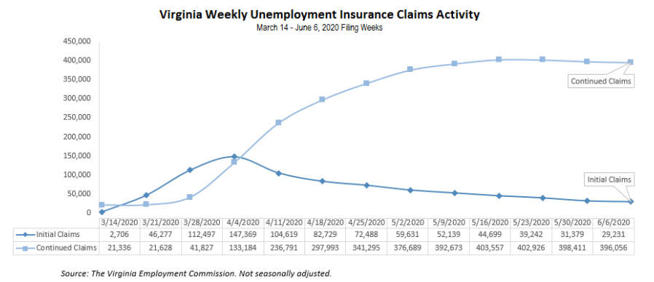
Nationwide, in the week ending June 6, the advance figure for seasonally adjusted initial claims was 1,542,000, a decrease of 355,000 from the previous week's revised level. The previous week's level was revised up by 20,000 from 1,877,000 to 1,897,000. The advance number of actual initial claims under state programs, unadjusted, totaled 1,537,122 in the week ending June 6, a decrease of 82,886 (or -5.1 percent) from the previous week.
https://www.vec.virginia.gov/UI-press-release
PDF of press release: https://www.vec.virginia.gov/sites/default/files/news-11972-Initial%20Claims%20Press%20Release%206%206%202020.pdf
For additional information on who is claiming unemployment insurance in Virginia, access the VEC’s U.I. claims data dashboard (https://www.vec.virginia.gov/ui-claims-dashboard) that is updated the following Monday after the weekly claims press release.
June 11 - 396K+ Virginians remain unemployed during pandemic; 44.5M Americans unemployed; initial claims continue drop
Nearly 400,000 Virginians are still unemployed following the economic fallout from the COVID-19 pandemic, though the number of initial jobless claims in the commonwealth continues to decrease.
https://www.virginiabusiness.com/article/44-5m-americans-remain-unemployed-during-pandemic/
June 8 - The Number Of People On Unemployment In Virginia Begins Slight Decline
For two straight weeks, fewer people have filed for weekly unemployment insurance benefits in Virginia than the week prior.
https://patch.com/virginia/across-va/number-people-unemployment-virginia-begins-slight-decline
Higher Education
June 10 - Governor Northam Announces $66.8 Million in Emergency Education Relief Funding
Governor Ralph Northam today announced that Virginia schools will receive $66.8 million through the federal Governor’s Emergency Education Relief (GEER) Fund to expand distance learning opportunities, fund services for students disproportionately impacted by loss of class time, and provide financial assistance to higher education students and institutions impacted by the COVID-19 pandemic.
News Release: https://www.governor.virginia.gov/newsroom/all-releases/2020/june/headline-857813-en.html
June 9 - Virginia’s Community Colleges Announce Intentions for Fall 2020 Classes
Virginia’s Community Colleges are open for business and ready to help individuals meet their educational needs as safely as possible. Here’s how we intend to move forward for fall 2020…
https://www.vccs.edu/virginias-community-colleges-announce-intentions-for-fall-2020-classes/
June 9 - Fall Comes Into View
College administrators continue to lay plans for the fall. Hybrid models, longer days and shortened semesters are among the popular planning options.
https://www.insidehighered.com/news/2020/06/09/colleges-continue-announcing-plans-fall-amid-pandemic

Virginia Economy
June 11 - Virginia Releases May 2020 Revenue Report
Governor Ralph Northam today announced that total General Fund revenue collections fell 20.6 percent in May, which is slightly better than expected. This is primarily due to delaying the individual tax due date to June 1, and the impacts of the COVID-19 pandemic on payroll withholding and retail sales.

News Release: https://www.governor.virginia.gov/newsroom/all-releases/2020/june/headline-857943-en.html

Full Revenue Report: https://www.finance.virginia.gov/media/governorvirginiagov/secretary-of-finance/pdf/master-revenue-reports/May--2020-Revenue-Letter-6-11-20.pdf

Other Resources
● Virginia State Resources: https://www.virginia.gov/coronavirus/support-for-businesses/#854620
●FAQs from Workers Regarding Covid-19:
English:https://www.governor.virginia.gov/media/governorvirginiagov/governor-of-virginia/pdf/Frequently-Asked-Questions-from-Workers-Regarding-COVID-19.pdf
Spanish:https://www.governor.virginia.gov/media/governorvirginiagov/governor-of-virginia/pdf/Las-Preguntas-Mas-Frecuentes-para-los-Empleados-Sobre-COVID-19.pdf
●Support for affected workers: https://www.virginia.gov/coronavirus/employment-and-financial-support/#855804
●F.A.Q. on Coronavirus Relief for Small Businesses, Freelancers https://www.nytimes.com/article/small-business-loans-stimulus-grants-freelancers-coronavirus.html
●The Paycheck Protection Program (PPP), a provision of the CARES Act, offers forgivable low-interest loans to small businesses facing uncertainty during the COVID-19 emergency, so businesses can retain workers, maintain payroll, and cover certain other existing overhead costs. https://www.sba.gov/funding-programs/loans/coronavirus-relief-options/paycheck-protection-program-ppp
●COVID 19 Testing Information and Locations: https://www.vdh.virginia.gov/coronavirus/covid-19-testing/

WARN Notices
Due to severe restrictions aimed at curbing the spread of coronavirus (COVID-19), some businesses are being forced to significantly reduce staff, and many will likely close altogether for at least some period of time.
The federal WARN Act requires covered employers to provide 60 days’ advance notice before terminating or laying off employees in connection with a plant closing or mass layoff. However, there are three exceptions to the 60 days’ notice requirement and two of these exceptions—for unforeseeable business circumstances and for faltering businesses—are likely to apply during the crisis that is unfolding from COVID-19.
**Businesses with fewer than 100 employees are not covered under the WARN Act and do not have to file WARN letters with the state. Therefore, this is not a comprehensive reflection of business closures in Virginia.
http://www.vec.virginia.gov/warn-notices
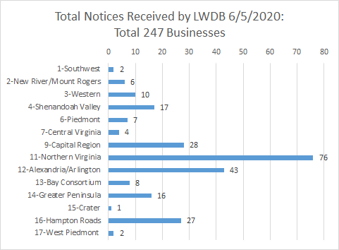
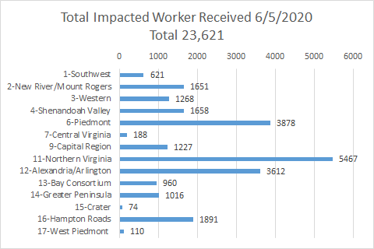
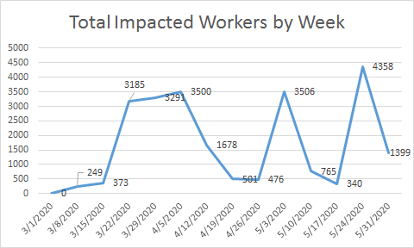
*The spike for the end of the week was caused by a single employer whose temporary furloughs resulted from the restrictions placed on non-essential medical procedures.
The above graphics do not represent all layoffs that have occurred in the Commonwealth of Virginia, only the businesses that have filed official notices with the Commonwealth or who have sought assistance from the workforce system.

Virginia news:
● Virginia Mercury: https://www.virginiamercury.com/
National news:
● Sign up for The New York Times Morning Briefing: https://www.nytimes.com/series/us-morning-briefing
● The Daily podcast: https://www.nytimes.com/column/the-daily

