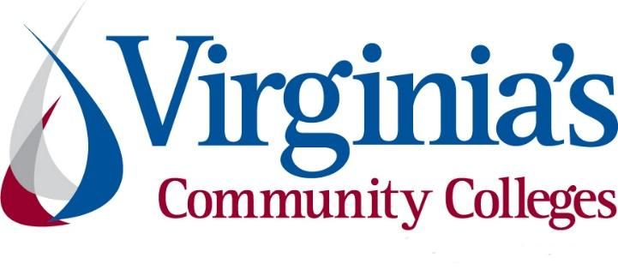
COVID-19 Update
Thursday, June 4, 2020
Virginia Daily Key Statistics - (please note that the VDH and VHHA numbers may vary slightly due to reporting times.)
Virginia’s Daily COVID-19 Statistics-Virginia Department of Health: http://www.vdh.virginia.gov/coronavirus/ (This page is updated daily before 10 AM. Numbers are preliminary and close out at 5 PM the day before posting. Case counts reflect what has been reported to VDH by healthcare providers and laboratories.)
People Tested (PCR): 351,354 (66,081 or 23.2% increase from last week)
Total Cases: 47,856 (6,455 or 15.6% increase from last week)
Total Hospitalizations: 4,957 (515 or 11.6% increase from last week)
Total Deaths: 1,445 (107 or 8% increase from last week)
COVID in Virginia’s Hospitals Dashboard: https://www.vhha.com/communications/virginia-hospital-covid-19-data-dashboard/
June 2 - Governor Northam Announces Phase Two Guidelines to Further Ease Public Health Restrictions
Governor Ralph Northam today signed Executive Order Sixty-Five and presented the second phase of the “Forward Virginia” plan to continue safely and gradually easing public health restrictions while containing the spread of COVID-19. The Governor also amended Executive Order Sixty-One directing Northern Virginia and the City of Richmond to remain in Phase One.
Most of Virginia is expected to enter Phase Two on Friday, June 5, as key statewide health metrics continue to show positive signs. Virginia’s hospital bed capacity remains stable, the percentage of people hospitalized with a positive or pending COVID-19 test is trending downward, no hospitals are reporting PPE shortages, and the percent of positive tests continues to trend downward as testing increases. The Governor and Virginia public health officials will continue to evaluate data based on the indicators laid out in April.
Excerpted from “Continued Restrictions” is the section on Higher Education.
Institutions of higher education are encouraged to continue remote learning where practical. However, such institutions may offer in-person classes and instruction, including labs and related practical training, provided they comply with all applicable requirements under the "Guidelines for All Business Sectors." No institutions of higher education shall hold or host gatherings of more than 50 individuals. Any postsecondary provider offering vocational training in a profession regulated by a Virginia state agency/board must also comply with any sector-specific guidelines relevant to that profession to the extent possible under the regulatory training requirements. Such professions may include, but are not necessarily limited to: aesthetician, barber, cosmetologist, massage therapist, nail technician, and practical nurse.
Phase Two guidelines for specific sectors, including “All Business Sectors”: https://www.governor.virginia.gov/media/governorvirginiagov/governor-of-virginia/pdf/Virginia-Forward-Phase-Two-Guidelines.pdf
Order of Public Health Emergency Six: https://www.governor.virginia.gov/media/governorvirginiagov/governor-of-virginia/pdf/eo/EO-65-Phase-Two.pdf
Executive Order Sixty-Five: https://www.governor.virginia.gov/media/governorvirginiagov/governor-of-virginia/pdf/eo/EO-65-Phase-Two.pdf
News Release: https://www.governor.virginia.gov/newsroom/all-releases/2020/june/headline-857141-en.html
June 3 - Virginia June 3 COVID-19 update: 666 new cases, 21 deaths reported; second lowest case increase since early May, lowest ICU figures to date
Virginia reported 666 new cases of COVID-19 statewide on Wednesday, the second lowest one day increase since early May, as daily cases numbers continue to trend down along with the percent of positive tests and current hospitalizations.

Governor Ralph Northam highlighted those trends when he announced Tuesday that most of Virginia will enter phase 2 on Friday, June 5.

https://www.wavy.com/news/virginia/virginia-june-3-covid-19-update-666-new-cases-21-deaths-reported-second-lowest-case-increase-since-early-may-lowest-icu-figures-to-date/

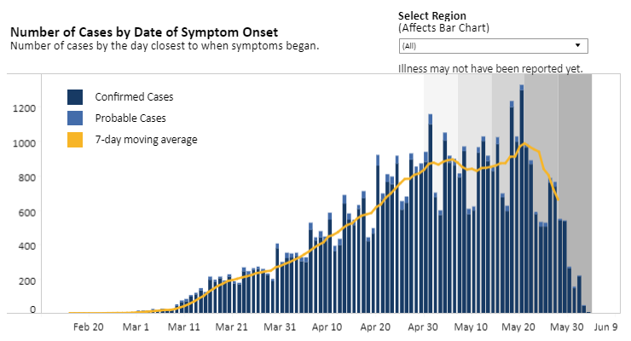
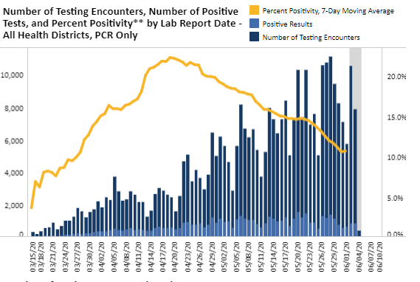
Graphs obtained from Virginia Department of Health: https://www.vdh.virginia.gov/coronavirus/

June 3 - Virginia to launch COVID-19 antibody study
The Virginia Department of Health launched a study this week to gauge how many adults in the state have so far contracted COVID-19, including those who never showed symptoms.
https://www.richmond.com/special-report/coronavirus/virginia-to-launch-covid-19-antibody-study/article_741776f9-7877-521f-9d44-4ee963992952.html
June 1 - A VCU researcher is harnessing supercomputers to unpack the coronavirus’ ‘spike’ protein
Michael H. Peters, Ph.D., a professor in VCU’s Department of Chemical and Life Science Engineering, is using powerful supercomputers at NASA’s Ames Research Center in California to investigate the “spike” protein of the novel coronavirus that causes COVID-19.
https://news.vcu.edu/article/A_VCU_researcher_is_harnessing_supercomputers_to_unpack_the_coronavirus

COVID 19 Testing in Virginia
June 1 - Hospital testing sheds some light on extent of asymptomatic COVID-19 in Virginia
In the weeks since Virginia’s hospitals have reopened for non-life-threatening procedures, many have implemented wider COVID-19 testing protocols to protect patients and staff from the virus.
In some cases, the results have been illuminating. In a Thursday call with the Virginia Nurses Association, Melody Dickerson, the senior vice president and chief nursing officer for Virginia Hospital System in Arlington, said her facility had been testing all admitted patients for the last three to four weeks.
https://www.virginiamercury.com/2020/06/01/hospital-data-reveals-extent-of-asymptomatic-covid-19-in-virginia/

Unemployment Data
June 4 - Virginia’s Unemployment Insurance Weekly Claims for Week Ending May 30th
For the filing week ending May 30, the figure for seasonally unadjusted initial claims in Virginia was 31,379. The latest claims figure was a decrease of 7,863 claimants from the previous week. The weekly total was the lowest since before the initial spike in unemployment insurance claims during the March 21 filing week.
For the most recent filing week, continued weeks claimed totaled 398,411, down 4,515 from the previous week but 379,958 higher than the 18,453 continued claims from the comparable week last year. The continued claims total is mainly comprised of those recent initial claimants who continued to file for unemployment insurance benefits during the COVID-19 pandemic. Continued claims during the May 30 filing week equaled 50% of all initial claims filed during the pandemic to this point. This percentage has trended downward in recent weeks.
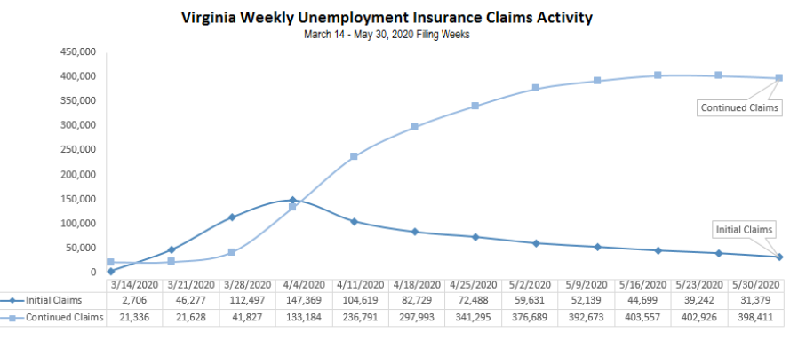
https://www.vec.virginia.gov/UI-press-release
Nationwide, In the week ending May 30, the advance figure for seasonally adjusted initial claims was 1,877,000, a decrease of 249,000 from the previous week's revised level. The previous week's level was revised up by 3,000 from 2,123,000 to 2,126,000. The advance number of actual initial claims under state programs, unadjusted, totaled 1,603,000 in the week ending May 30, a decrease of 314,604 (or -16.4 percent) from the previous week.
PDF of press release: https://www.vec.virginia.gov/sites/default/files/news-11952-Initial%20Claims%20Press%20Release%205%2030%202020.pdf
For additional information on who is claiming unemployment insurance in Virginia, access the VEC’s U.I. claims data dashboard (https://www.vec.virginia.gov/ui-claims-dashboard) that is updated the following Monday after the weekly claims press release.
June 4 - 1.9 million more Americans filed for unemployment, bringing pandemic total to over 42 million
Another 1.9 million Americans filed for unemployment insurance last week, the Department of Labor said Thursday.
The coronavirus pandemic has pushed unemployment in the U.S. to its highest rate since the Great Depression. Approximately 42 million U.S. workers have filed jobless claims since mid-March.
New jobless claims have leveled off slightly after peaking at nearly 7 million in the last week of March. This is the first time in 10 weeks that new claims have dropped below 2 million.
https://abcnews.go.com/Business/19-million-americans-filed-unemployment-bringing-pandemic-total/story?id=71063691

Higher Education
May 28 - Virginia College Students Shed Light on Challenges Related to COVID-19
Nearly three in four Virginia college students are combating anxiety, worry or other challenges to their mental health because of COVID-19, according to SCHEV’s survey of more than 1,000 Virginian college students. The survey, conducted from April 20 to May 4, 2020, revealed that 80 percent of students are struggling with academics, while another 45 percent are dealing with employment difficulties.
https://schev.edu/index/reports/insights/insights/2020/05/28/virginia-college-students-shed-light-on-challenges-related-to-covid-19

Other Resources
● Virginia State Resources: https://www.virginia.gov/coronavirus/support-for-businesses/#854620
●FAQs from Workers Regarding Covid-19:
English:https://www.governor.virginia.gov/media/governorvirginiagov/governor-of-virginia/pdf/Frequently-Asked-Questions-from-Workers-Regarding-COVID-19.pdf
Spanish:https://www.governor.virginia.gov/media/governorvirginiagov/governor-of-virginia/pdf/Las-Preguntas-Mas-Frecuentes-para-los-Empleados-Sobre-COVID-19.pdf
●Support for affected workers: https://www.virginia.gov/coronavirus/employment-and-financial-support/#855804
●F.A.Q. on Coronavirus Relief for Small Businesses, Freelancers https://www.nytimes.com/article/small-business-loans-stimulus-grants-freelancers-coronavirus.html
●The Paycheck Protection Program (PPP), a provision of the CARES Act, offers forgivable low-interest loans to small businesses facing uncertainty during the COVID-19 emergency, so businesses can retain workers, maintain payroll, and cover certain other existing overhead costs. https://www.sba.gov/funding-programs/loans/coronavirus-relief-options/paycheck-protection-program-ppp
●COVID 19 Testing Information and Locations: https://www.vdh.virginia.gov/coronavirus/covid-19-testing/

WARN Notices
Due to severe restrictions aimed at curbing the spread of coronavirus (COVID-19), some businesses are being forced to significantly reduce staff, and many will likely close altogether for at least some period of time.
The federal WARN Act requires covered employers to provide 60 days’ advance notice before terminating or laying off employees in connection with a plant closing or mass layoff. However, there are three exceptions to the 60 days’ notice requirement and two of these exceptions—for unforeseeable business circumstances and for faltering businesses—are likely to apply during the crisis that is unfolding from COVID-19.
**Businesses with fewer than 100 employees are not covered under the WARN Act and do not have to file WARN letters with the state. Therefore, this is not a comprehensive reflection of business closures in Virginia.
http://www.vec.virginia.gov/warn-notices
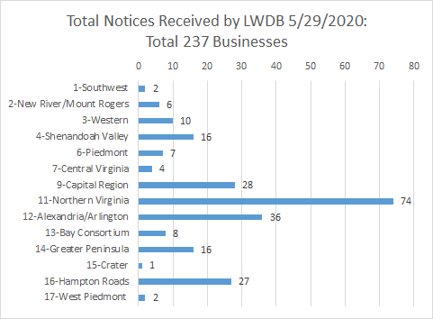
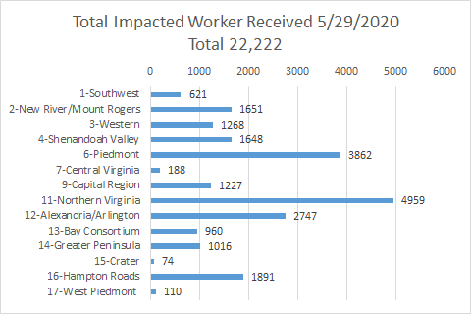
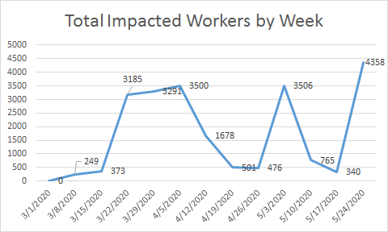
*The spike for the end of the week was caused by a single employer whose temporary furloughs resulted from the restrictions placed on non-essential medical procedures.
The above graphics do not represent all layoffs that have occurred in the Commonwealth of Virginia, only the businesses that have filed official notices with the Commonwealth or who have sought assistance from the workforce system.

Virginia news:
● Virginia Mercury: https://www.virginiamercury.com/
National news:
● Sign up for The New York Times Morning Briefing: https://www.nytimes.com/series/us-morning-briefing
● The Daily podcast: https://www.nytimes.com/column/the-daily

