COVID-19 Update
Thursday, May 7, 2020
Virginia Daily Key Statistics - (please note that the VDH and VHHA numbers may vary slightly due to reporting times.)
Virginia’s Daily COVID-19 Statistics-Virginia Department of Health: http://www.vdh.virginia.gov/coronavirus/ (This page is updated daily before 10 AM. Numbers are preliminary and close out at 5 PM the day before posting. Case counts reflect what has been reported to VDH by healthcare providers and laboratories.)
Number of People Tested: 136,558 (45,715 or 50.3% increase from last week)
Total Cases: 21,570 (5,724 or 36.1% increase from last week)
Total Hospitalizations: 2,955 (633 or 27.3% increase from last week)
Total Deaths: 769 (217 or 39.3% increase from last week)
COVID in Virginia’s Hospitals Dashboard: https://www.vhha.com/communications/virginia-hospital-covid-19-data-dashboard/
Governor Outlines Phased Plan to Safely, Gradually Ease Restrictions
May 4 - Governor Ralph Northam outlined a three-phase plan to ease restrictions on businesses and gatherings, when health data supports doing so.
Governor Northam said he will extend key provisions of Executive Order 53, which places restrictions on businesses and gatherings of more than 10 people, at least through next Thursday, May 14, at midnight. The Northam administration will continue to monitor health data to ensure that trends of positive cases are going downward, that hospital capacity remains steady, that testing is increased, and that hospitals and medical facilities have necessary supplies of PPE. For more information on key metrics, see the Governor’s Data Briefing.
Forward Virginia Blueprint: https://www.governor.virginia.gov//media/governorvirginiagov/governor-of-virginia/pdf/Forward-Virginia-Presentation-5.4.pdf
Article:https://www.governor.virginia.gov/

COVID 19 Testing in Virginia

May 1 - Virginia now has enough supplies to test anyone with coronavirus symptoms, Northam says

“We’re moving forward aggressively” with testing, the Democratic governor said Friday. The state signed contracts Friday with two private labs in Virginia and one in North Carolina to process at least 3,000 new tests per day, and with the help of other private labs, hospitals, universities and state labs, Northam said “tremendous progress” had been made in increasing the testing capacity.

http://www.pilotonline.com/news/health/vp-nw-new-coronavirus-cases-20200501-7mssckhumzbhzcbgfibtbgxxym-story.html
April 30 - Virginia National Guard helping fight COVID-19
More than 530 members of the Virginia National Guard are supporting COVID-19 response efforts, including testing for the coronavirus, demonstrating how to use personal protective equipment (PPE) and distributing food and medical supplies.
https://www.nationalguard.mil/News/Article/2170646/virginia-national-guard-helping-fight-covid-19/
May 6 - VDH working to increase testing capacity, accessibility
As we move through the first week of May, the Virginia Department of Health held a tele-press conference Wednesday morning to provide an update on testing for COVID-19 in the commonwealth.
State health officials said Virginia is at a much better place in regards to testing capacity and active testing efforts.
https://www.wric.com/news/virginia-news/vdh-working-to-increase-testing-capacity-accessibility/

PPE in Virginia
May 2 - Governor Northam Announces Virginia to Receive Three Critical Care Decontamination Systems
Governor Ralph Northam today announced that the Federal Emergency Management Agency (FEMA) has approved Virginia to receive three Battelle Critical Care Decontamination System™ (CCDS) that can collectively sterilize up to 240,000 units of personal protective equipment (PPE) per day for reuse. The three systems will be operational in the Town of Blacksburg, the City of Newport News, and Chesterfield County within the next week.
https://www.governor.virginia.gov/newsroom/all-releases/2020/may/headline-856494-en.html

Support for Virginians

April 27 - Virginia receives $2 million grant to address behavioral health impacts of COVID-19
https://www.wtvr.com/news/coronavirus/virginia-receives-2-million-grant-to-address-behavioral-health-impacts-of-covid-19

Unemployment Data
May 7 - VEC Report: https://www.vec.virginia.gov/node/11901
For the filing week ending May 2, the figure for seasonally unadjusted initial claims in Virginia was 59,631. The latest claims figure was a decrease of 12,857 claimants from the previous week. Though the 17.7% decline indicates that the volume of initial claims has retreated from its recent peak, it may not return to pre-pandemic levels for some time.
For the most recent filing week, continued weeks claimed totaled 376,689 up over 10% from the previous week and 358,211 higher than the 18,478 continued claims from the comparable week last year. The continued claims total mainly comprised those recent initial claimants who continued to file for unemployment insurance benefits during the COVID-19 pandemic. That total is more than ten percent of March private sector payroll employment in the Commonwealth.
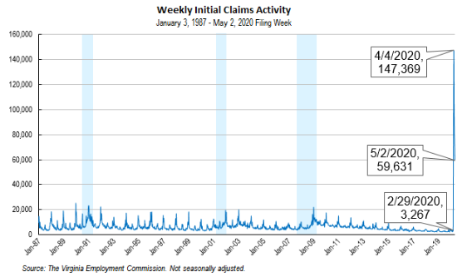
For additional information on who is claiming unemployment insurance in Virginia, access the VEC’s U.I. claims data dashboard (https://www.vec.virginia.gov/ui-claims-dashboard) that is updated the following Monday after the weekly claims press release.

Support for Higher Education

April 28 - Reopening Guidance for Cleaning and Disinfecting Public Spaces, Workplaces, Businesses, Schools, and Homes
Centers for Disease Control and Prevention (CDC): This guidance is intended for all Americans, whether you own a business, run a school, or want to ensure the cleanliness and safety of your home. This plan is part of the larger United States Government plan external icon and focuses on cleaning and disinfecting public spaces, workplaces, businesses, schools, and can also be applied to your home.

https://www.cdc.gov/coronavirus/2019-ncov/community/reopen-guidance.html

April 30 - How Is COVID-19 Impacting Americans’ Education Preferences?
In recent weeks, there has been no shortage of pundits and experts weighing in on the impacts of COVID-19. But new data from a nationally representative survey gives voice to the perspective of everyday Americans on how the pandemic is affecting their lives, especially in regards to work and education.
The Public Viewpoint: COVID-19 Work and Education Survey is produced by Strada Education Network, Emsi’s parent organization. It is updated weekly and currently reflects responses from over 5,000 U.S. adults.
The most recent results shed light on the ways in which COVID-19 is disrupting Americans’ pursuit of higher education. Some noticeable observations include:
Changes in where Americans plan to pursue education after COVID 19:
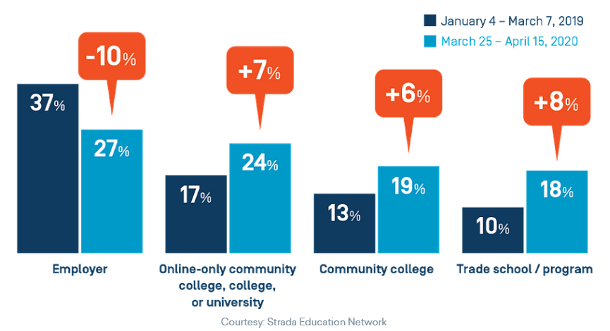
According to Strada’s survey, the majority of adults (59%) who are considering enrolling in the next six months would choose a certificate-type program or unbundled courses that offer specific skill training.
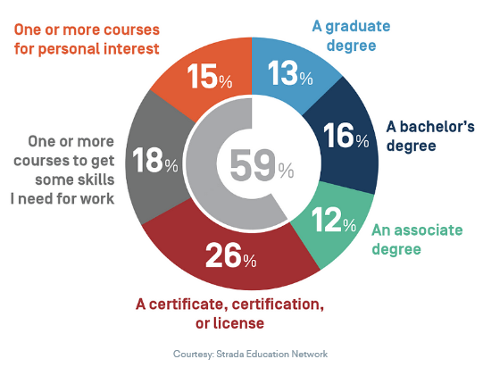

Of this same group (open to enrolling in the next six months), a combined 68% cited either upskilling in their current field or reskilling to make a career transition as their motivation.
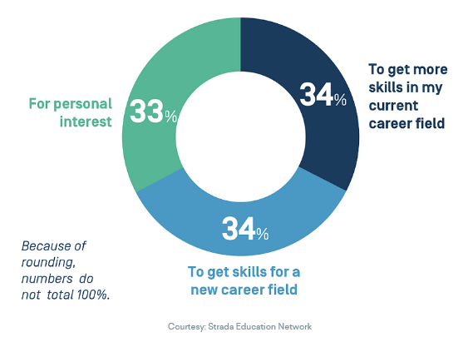
Virginia’s community colleges launch distance learning website

May 6 - Building on more than 25 years of experience in higher-education distance learning, Virginia’s Community Colleges are proud to announce the launch of CollegeAnywhereVA.org, an online portal enabling Virginians to find online courses that best meet their needs. In addition to connecting students with high-quality and affordable remote-learning courses, the site also connects current and prospective students with advisors, known as College Navigators, streamlining the application and course enrollment process.

Article: https://www.vccs.edu/virginias-community-colleges-launch-distance-learning-platform/

Support for Workers and Businesses

Nearly $12.7 billion in coronavirus relief loans have been approved for Virginia small businesses
Small businesses across Virginia have been approved for almost $12.7 billion in loans from the federal Paycheck Protection Program, according to federal data released this week.
In the first round of funding, which totaled about $349 billion nationwide, more than $8.72 billion was approved by the U.S. Small Business Administration for a total of 40,371 loans for Virginia businesses, the agency said.
https://www.richmond.com/business/watch-now-nearly-12-7-billion-in-coronavirus-relief-loans-have-been-approved-for-virginia/article_2640aff3-f445-550f-b7c5-840a446a6aae.html
Other Links
- Virginia State Resources: https://www.virginia.gov/coronavirus/support-for-businesses/#854620
- FAQs from Workers Regarding Covid-19:
English:https://www.governor.virginia.gov/media/governorvirginiagov/governor-of-virginia/pdf/Frequently-Asked-Questions-from-Workers-Regarding-COVID-19.pdf
Spanish:https://www.governor.virginia.gov/media/governorvirginiagov/governor-of-virginia/pdf/Las-Preguntas-Mas-Frecuentes-para-los-Empleados-Sobre-COVID-19.pdf
- Support for affected workers: https://www.virginia.gov/coronavirus/employment-and-financial-support/#855804
- F.A.Q. on Coronavirus Relief for Small Businesses, Freelancers https://www.nytimes.com/article/small-business-loans-stimulus-grants-freelancers-coronavirus.html
- The Paycheck Protection Program (PPP), a provision of the CARES Act, offers forgivable low-interest loans to small businesses facing uncertainty during the COVID-19 emergency, so businesses can retain workers, maintain payroll, and cover certain other existing overhead costs. https://www.sba.gov/funding-programs/loans/coronavirus-relief-options/paycheck-protection-program-ppp
WARN notices
Due to severe restrictions aimed at curbing the spread of coronavirus (COVID-19), some businesses are being forced to significantly reduce staff, and many will likely close altogether for at least some period of time.
The federal WARN Act requires covered employers to provide 60 days’ advanced notice before terminating or laying off employees in connection with a plant closing or mass layoff. However, there are three exceptions to the 60 days’ notice requirement and two of these exceptions—for unforeseeable business circumstances and for faltering businesses—are likely to apply during the crisis that is unfolding from COVID-19.
**Businesses with fewer than 100 employees are not covered under the WARN Act and do not have to file WARN letters with the state. Therefore, this is not a comprehensive reflection of business closures in Virginia.
http://www.vec.virginia.gov/warn-notices
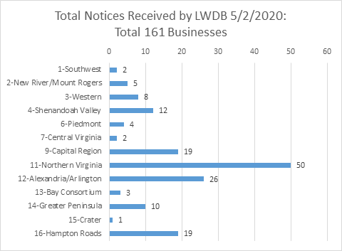
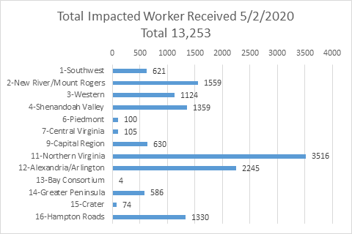
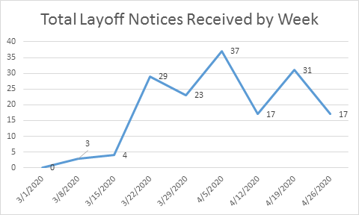
The above graphics do not represent all layoffs that have occurred in the Commonwealth of Virginia, only the businesses that have filed official notices with the Commonwealth or who have sought assistance from the workforce system.
Virginia news:
- Virginia Mercury: https://www.virginiamercury.com/
National news:
- Sign up for The New York Times Morning Briefing: https://www.nytimes.com/series/us-morning-briefing
- The Daily podcast: https://www.nytimes.com/column/the-daily

