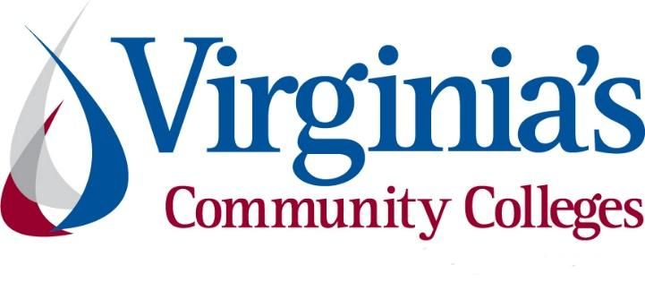
COVID-19 Update
Thursday, May 28, 2020
Virginia Daily Key Statistics - (please note that the VDH and VHHA numbers may vary slightly due to reporting times.)
Virginia’s Daily COVID-19 Statistics-Virginia Department of Health: http://www.vdh.virginia.gov/coronavirus/ (This page is updated daily before 10 AM. Numbers are preliminary and close out at 5 PM the day before posting. Case counts reflect what has been reported to VDH by healthcare providers and laboratories.)
People Tested (PCR): 285,273 (68,383 or 31.5% increase from last week)
Total Cases: 41,401 (7,264 or 21.3% increase from last week)
Total Hospitalizations: 4,442 (349 or 8.5% increase from last week)
Total Deaths: 1,338 (239 or 21.7% increase from last week)
COVID in Virginia’s Hospitals Dashboard: https://www.vhha.com/communications/virginia-hospital-covid-19-data-dashboard/
May 28 - Virginia COVID-19 cases rise by 1,152 as percent positivity continues trending down
As of Thursday, May 28, Virginia has had 41,401 total cases of COVID-19, including confirmed lab tests and clinical diagnoses, according to the Virginia Department of Health.

That's a rise of 1,152 cases since Wednesday, alongside 11,447 newly reported tests, which comes out to 10.1% of the newest tests coming back positive – a lower proportion than the current total state average.

https://www.whsv.com/content/news/Virginia-COVID-19-cases-rise-by-1152-as-percent-positivity-continues-trending-down-570829181.html

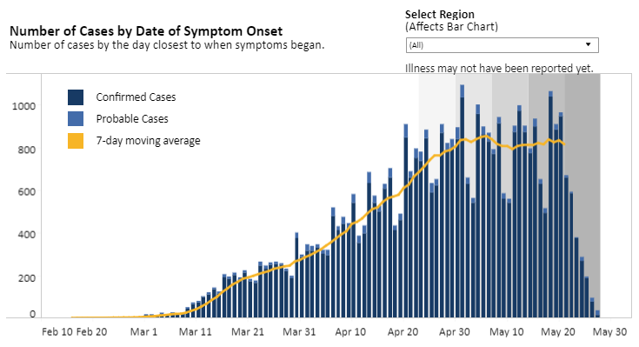
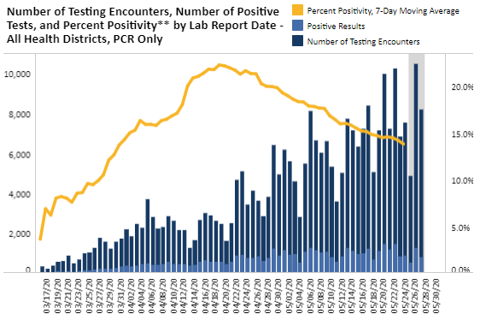
Graphs obtained from Virginia Department of Health: https://www.vdh.virginia.gov/coronavirus/

May 26 - Governor Northam Announces Face Covering Requirement and Workplace Safety Regulations
Governor Ralph Northam today signed Executive Order Sixty-Three, requiring Virginians to wear face coverings in public indoor settings to help contain the spread of the novel coronavirus. The Governor also directed the Department of Labor and Industry to develop emergency temporary standards to prevent workplace exposure to COVID-19.
Governor Northam also signed an amended Executive Order Fifty-One, extending Virginia’s state of emergency declaration.
News Release: https://www.governor.virginia.gov/newsroom/all-releases/2020/may/headline-857020-en.html
EO 63: https://www.governor.virginia.gov/media/governorvirginiagov/executive-actions/EO-63-and-Order-Of-Public-Health-Emergency-Five---Requirement-To-Wear-Face-Covering-While-Inside-Buildings.pdf

COVID 19 Testing in Virginia
May 28 - CVS opens 39 new drive-thru COVID-19 testing sites in Virginia
CVS Health will open 39 new drive-thru coronavirus testing sites Friday across Virginia.
According to the company, the self-swab tests are free — the tests are covered under a program funded by the Department of Health and Human Services. CVS will be accepting insurance at the drive-thru test sites.
https://www.wric.com/news/virginia-news/cvs-opens-39-drive-thru-covid-19-testing-sites-in-virginia/
May 22 - Commonwealth Deploys Artificial Intelligence-Powered Online Tool to Help Virginians Self-Screen for COVID-19
Governor Ralph Northam today announced that Virginians can now use COVIDCheck, a new online risk-assessment tool to check their symptoms and connect with the appropriate health care resource, including COVID-19 testing.
“If you are feeling sick or think you may have been exposed to someone with COVID-19, it is important that you take action right away,” said Governor Northam. “This online symptom-checking tool can help Virginians understand their personal risk for COVID-19 and get recommendations about what to do next from the safety of their homes. As we work to flatten the curve in our Commonwealth, telehealth services like this will be vital to relieving some of the strains on providers and health systems and making health care more convenient and accessible.”
News Release: https://www.governor.virginia.gov/newsroom/all-releases/2020/may/headline-856990-en.html
COVIDCheck: https://www.vdh.virginia.gov/coronavirus/covidcheck/

Contact Tracing
May 27 - Librarians, National Guard recruited for states’ new contact tracing armies
As states seek to loosen wide-ranging restrictions imposed to constrain the novel coronavirus, they’re also looking to deploy a huge new fleet of workers to keep cases under control.
https://www.virginiamercury.com/2020/05/27/librarians-national-guard-recruited-for-states-new-contact-tracing-armies/

Support for Virginians
May 28 - More federal aid for nursing homes in Virginia as testing push intensifies staffing challenge
Virginia nursing homes will receive almost $95 million in additional federal aid that they’ll likely need to pay for staffing and protective gear. The state is ramping up testing to identify residents and employees infected with COVID-19 to prevent the spread of the virus among its most vulnerable population.
https://www.richmond.com/news/virginia/more-federal-aid-for-nursing-homes-in-virginia-as-testing-push-intensifies-staffing-challenge/article_6d6d3a68-a636-5f24-b4b2-25428d482777.html
May 28 - Following months of workplace complaints, Northam proposes on-the-job safety rules for COVID-19
Gov. Ralph Northam has directed the state labor commissioner to develop emergency workplace regulations addressing on-the-job safety concerns that have prompted thousands of employee complaints since the COVID-19 pandemic began.

“These new workplace safety standards will apply to employers and should include use of personal protective equipment, sanitation, record keeping of incidents and hazard communication,” Northam said Tuesday.
https://www.virginiamercury.com/2020/05/28/following-months-of-workplace-complaints-northam-proposes-on-the-job-safety-rules-for-covid-19/
May 22 - Virginia Receives USDA Approval to Join SNAP Online Purchasing Pilot Program
Governor Ralph Northam today announced that for the first time, more than 740,000 Virginians who receive Supplemental Nutrition Assistance Program (SNAP) benefits will be able to pay for their groceries online and have them delivered, after the United States Department of Agriculture (USDA) approved Virginia to participate in an innovative online purchasing pilot program.
News Release: https://www.governor.virginia.gov/newsroom/all-releases/2020/may/headline-856993-en.html

Unemployment Data
May 28 - Virginia’s Unemployment Insurance Weekly Claims for Week Ending May 23rd
The Virginia Employment Commission (VEC) announced that the total number of initial claims filed in the ten weeks from mid-March through the May 23, 2020 filing week were over 100,000 more than were filed during the Great Recession that lasted from December 2007 to June 2009.
For the filing week ending May 23, the figure for seasonally unadjusted initial claims in Virginia was 39,242. The latest claims figure was a decrease of 5,457 claimants from the previous week. The weekly total was the lowest since before the initial spike in unemployment insurance claims during the March 21 filing week.
For the most recent filing week, continued weeks claimed totaled 402,926, down 631 from the previous week but 384,563 higher than the 18,363 continued claims from the comparable week last year. The continued claims total is mainly comprised of those recent initial claimants who continued to file for unemployment insurance benefits during the COVID-19 pandemic. Continued claims during the May 23 filing week equaled 53% of all initial claims filed during the pandemic to this point. This percentage has trended downward in recent weeks.
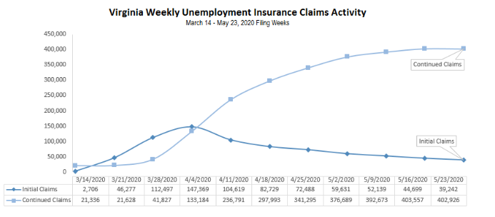
The following graph shows a shift in percent of claims among industries since March.
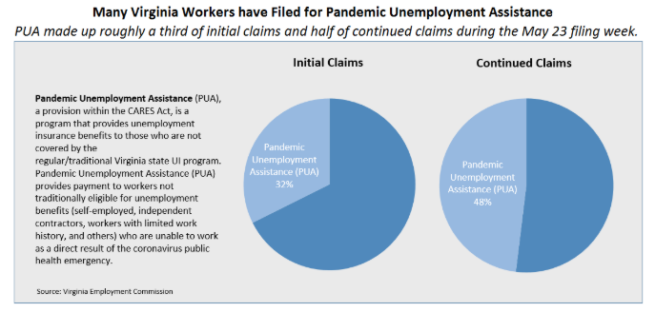
Press Release: https://www.vec.virginia.gov/node/11944
PDF of press release: https://www.vec.virginia.gov/sites/default/files/news-11944-Initial%20Claims%20Press%20Release%205%2023%202020.pdf
For additional information on who is claiming unemployment insurance in Virginia, access the VEC’s U.I. claims data dashboard (https://www.vec.virginia.gov/ui-claims-dashboard) that is updated the following Monday after the weekly claims press release.

May 28 - 2.1M Americans filed jobless claims last week
More than 2.1 million people in the United States filed initial claims for unemployment last week, according to U.S. Department of Labor statistics, bringing the total of unemployed Americans to more than 41.1 million in the wake of the economic crisis.
Last week’s U.S. claims were down by 323,000. In the week ending May 9, 33 states reported that 7.79 million people are claiming federal Pandemic Unemployment Assistance, which provides temporary benefits for people who are not eligible for regular or traditional unemployment insurance.
https://www.virginiabusiness.com/article/2-1m-americans-filed-jobless-claims-last-week/

Support for Businesses
May 28 - OPINION: Jeb Bush, Terry McAuliffe: Retraining, instead of layoffs, will speed economic recovery

Instead of laying off workers, we must train and retain them, to avoid the worst version of the recovery ahead.
https://www.usatoday.com/story/opinion/2020/05/28/jeb-bush-terry-mcauliffe-invest-workers-spur-economic-recovery-column/5259291002/
May 27 - Delta Dental of Virginia donates $3M to dentists
Through its nonprofit foundation, Delta Dental of Virginia will donate $3 million directly to 4,500 dentists in its network to cover expenses related to the coronavirus pandemic, the dental insurance provider announced Wednesday. Practices can use the funds for personal protective equipment (PPE) for their employees.
https://www.virginiabusiness.com/article/delta-dental-of-virginia-donates-3m-to-dentists/

Higher Education
May 28 - Governors Association Recommends Steps for States to Help Reopen Campuses
The nation’s governors should create a public health framework for colleges and universities to follow in order to reopen campuses, their national association said.

In a memo on Wednesday, the National Governors Association recommended a number of steps including following the lead of Connecticut Democratic Gov. Ned Lamont’s reopening advisory group, which laid out a framework recommending steps for colleges to take, including doing testing and contact tracing.
https://www.insidehighered.com/news/2020/05/28/live-updates-latest-news-coronavirus-and-higher-education
NGA Memo: http://www.nga.org/wp-content/uploads/2020/05/State-Higher-Ed-reopening-final.pdf
May 21 - State Board Holds the Line on Community College Tuition and Fees for Fall 2020
The State Board for Community Colleges, by a unanimous vote, elected to maintain the current in-state tuition and mandatory fees for Fall 2020. The Board’s decision means tuition will remain at today’s rate of $154 per credit hour – keeping community college tuition and mandatory fees at approximately one-third of the comparable costs of attending Virginia’s public four-year universities. This marks the second year in a row that the Board has voted to hold tuition and fees steady for the coming fall.
“We are doing everything we can to be an affordable, accessible resource for Virginians. Some people find themselves unexpectedly out of work. Others are looking for safer, convenient options to pursue their college aspirations. We want to be there for them,” said Glenn DuBois, chancellor of Virginia’s Community Colleges.
https://www.vccs.edu/state-board-holds-the-line-on-community-college-tuition-and-fees-for-fall-2020/
May 26 - College-bound students to miss out on billions in financial aid due to pandemic
This year, students may need extra help to make college a reality.
Because of the coronavirus crisis and sky-high unemployment rates, fewer than half of families feel confident in their ability to meet the costs of higher education, according to education lender Sallie Mae.
…
Yet fewer families have applied for financial aid.
https://www.cnbc.com/2020/05/26/amid-pandemic-college-bound-students-to-miss-out-on-billions-in-aid.html

Other Resources
● Virginia State Resources: https://www.virginia.gov/coronavirus/support-for-businesses/#854620
●FAQs from Workers Regarding Covid-19:
English:https://www.governor.virginia.gov/media/governorvirginiagov/governor-of-virginia/pdf/Frequently-Asked-Questions-from-Workers-Regarding-COVID-19.pdf
Spanish:https://www.governor.virginia.gov/media/governorvirginiagov/governor-of-virginia/pdf/Las-Preguntas-Mas-Frecuentes-para-los-Empleados-Sobre-COVID-19.pdf
●Support for affected workers: https://www.virginia.gov/coronavirus/employment-and-financial-support/#855804
●F.A.Q. on Coronavirus Relief for Small Businesses, Freelancers https://www.nytimes.com/article/small-business-loans-stimulus-grants-freelancers-coronavirus.html
●The Paycheck Protection Program (PPP), a provision of the CARES Act, offers forgivable low-interest loans to small businesses facing uncertainty during the COVID-19 emergency, so businesses can retain workers, maintain payroll, and cover certain other existing overhead costs. https://www.sba.gov/funding-programs/loans/coronavirus-relief-options/paycheck-protection-program-ppp
●COVID 19 Testing Information and Locations: https://www.vdh.virginia.gov/coronavirus/covid-19-testing/

WARN Notices
Due to severe restrictions aimed at curbing the spread of coronavirus (COVID-19), some businesses are being forced to significantly reduce staff, and many will likely close altogether for at least some period of time.
The federal WARN Act requires covered employers to provide 60 days’ advance notice before terminating or laying off employees in connection with a plant closing or mass layoff. However, there are three exceptions to the 60 days’ notice requirement and two of these exceptions—for unforeseeable business circumstances and for faltering businesses—are likely to apply during the crisis that is unfolding from COVID-19.
**Businesses with fewer than 100 employees are not covered under the WARN Act and do not have to file WARN letters with the state. Therefore, this is not a comprehensive reflection of business closures in Virginia.
http://www.vec.virginia.gov/warn-notices
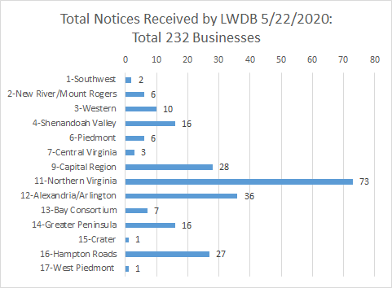
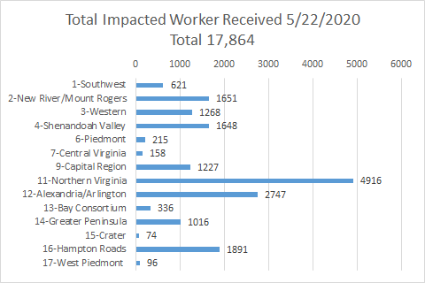
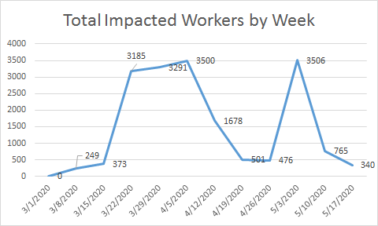

The above graphics do not represent all layoffs that have occurred in the Commonwealth of Virginia, only the businesses that have filed official notices with the Commonwealth or who have sought assistance from the workforce system.

Virginia news:
● Virginia Mercury: https://www.virginiamercury.com/
National news:
● Sign up for The New York Times Morning Briefing: https://www.nytimes.com/series/us-morning-briefing
● The Daily podcast: https://www.nytimes.com/column/the-daily

