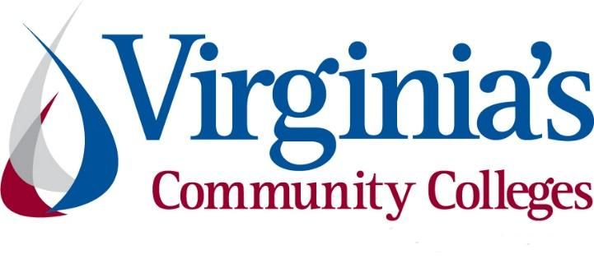
COVID-19 Update
Thursday, May 14, 2020
Virginia Daily Key Statistics - (please note that the VDH and VHHA numbers may vary slightly due to reporting times.)
Virginia’s Daily COVID-19 Statistics-Virginia Department of Health: http://www.vdh.virginia.gov/coronavirus/ (This page is updated daily before 10 AM. Numbers are preliminary and close out at 5 PM the day before posting. Case counts reflect what has been reported to VDH by healthcare providers and laboratories.)
Unique People Tested: 165,486 (43,367 or 35.5% increase from last week)
*Please note we switched to counting unique people this week based on new data and will do so going forward. For May 4, the number of unique tests given was 122,119.)
Total Cases: 27,813 (6,243 or 28.9% increase from last week)
Total Hospitalizations: 3,592 (637 or 21.6% increase from last week)
Total Deaths: 955 (186 or 24.2% increase from last week)
COVID in Virginia’s Hospitals Dashboard: https://www.vhha.com/communications/virginia-hospital-covid-19-data-dashboard/

Phase One of reopening to begin Friday for most of Virginia

May 13 - Phase One of reopening to begin Friday for most of Virginia

Gov. Ralph Northam Wednesday announced that Virginia will enter Phase One of the Forward Virginia plan Friday. The exception is Northern Virginia, which will remain in Phase Zero for at least an additional two weeks. Officials from Northern Virginia localities joined the briefing Wednesday to give updates on their plans to move forward.

https://www.newsleader.com/story/news/2020/05/13/phase-one-reopening-begin-friday/5183994002/

Governor Northam Announces Phase One Guidelines to Slowly Ease Public Health Restrictions
May 9 - Governor Ralph Northam signed Executive Order Sixty-One and presented a detailed framework for the first phase of the “Forward Virginia” plan to safely and gradually ease public health restrictions while containing the spread of COVID-19. The Phase One guidelines will be implemented when the data meets the public health criteria outlined by the Commonwealth. The new executive order modifies public health guidance in Executive Order Fifty-Three and Executive Order Fifty-Five and establishes guidelines for Phase One.
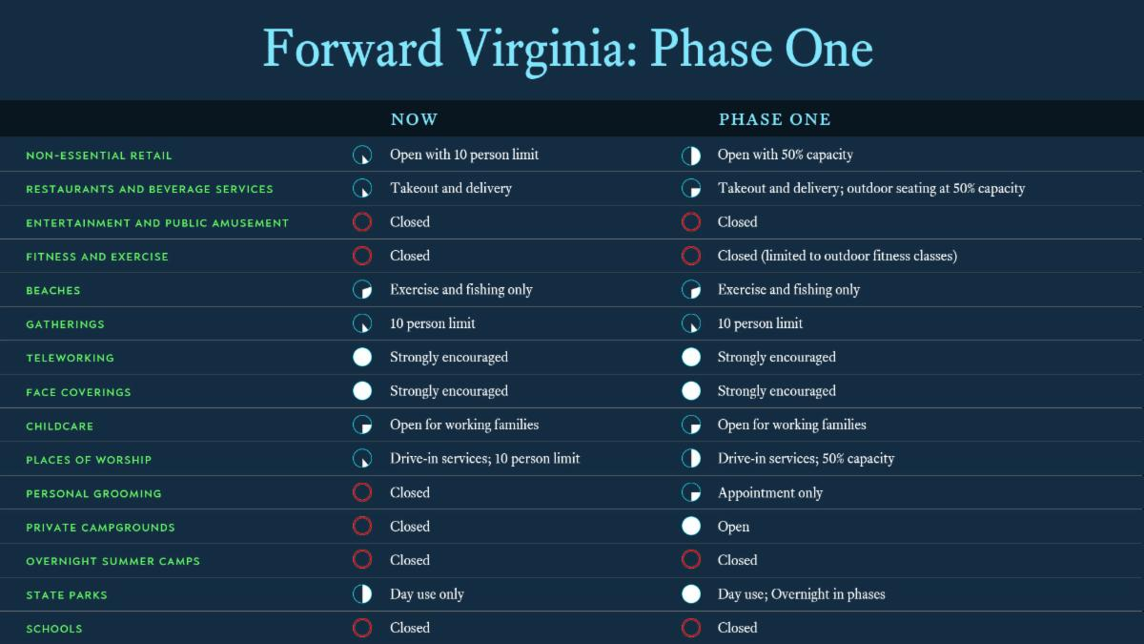
Phase One guidelines for specific sectors are available here or at virginia.gov/coronavirus/forwardvirginia.
View the graphs and slides from the Governor’s presentation here.
The full text of Executive Order Sixty-One and Order of Public Health Emergency Three is available here.
News Release: https://www.governor.virginia.gov/newsroom/all-releases/2020/may/headline-856681-en.html

May 12 - Governor Northam Delays Phase One for Northern Virginia Localities
Governor Ralph Northam today issued Executive Order Sixty-Two, allowing specific localities in Northern Virginia to delay entering Phase One of the “Forward Virginia” plan to ease restrictions on certain business operations that were put in place in response to the novel coronavirus, or COVID-19.

News Release: https://www.governor.virginia.gov/newsroom/all-releases/2020/may/headline-856741-en.html

May 14 - Governor Northam Delays Phase One for Accomack County and the City of Richmond

Governor Ralph Northam today announced that Accomack County and the City of Richmond would delay implementation of Phase One of the “Forward Virginia” plan to safely and gradually ease restrictions on certain business operations. Both the City of Richmond and Accomack County requested these extensions, and will enter Phase One no earlier than midnight on Thursday, May 28.

News Release: https://www.governor.virginia.gov/newsroom/all-releases/2020/may/headline-856796-en.html

May 14 - Virginia Releases April 2020 Revenue Report

Governor Ralph Northam today announced that April revenue collections fell 26.2 percent, primarily due to the extension of individual and corporate income tax deadlines until June 1 to provide relief to Virginians amid the ongoing COVID-19 pandemic.
“As anticipated, this is the first monthly revenue report to reflect the significant negative impacts of COVID-19 on the health of our Commonwealth’s finances,” said Governor Northam. “We are facing an unprecedented health and economic crisis, and we must combat this virus before we can begin to repair our economy. My top priorities continue to be protecting the health and safety of all Virginians.”
Press release: https://www.governor.virginia.gov/newsroom/all-releases/2020/may/headline-856786-en.html

May 14 - Governor Northam Calls for Increased COVID-19 Testing in Two Federally-Run Detention Facilities

Governor Ralph Northam today urged the federal government to implement additional screening and testing for COVID-19 in two federally-run detention centers in Virginia, the Farmville Detention Center and the Caroline County Detention Center, and offered state support to do so.
In a letter to Virginia’s congressional delegation, Governor Northam wrote that testing everyone in the facilities, including detainees, staff, and contractors, will help protect the health of those living in the facilities, as well as the surrounding communities.
News Release: https://www.governor.virginia.gov/newsroom/all-releases/2020/may/headline-856788-en.html

COVID 19 Testing in Virginia

May 13 - Virginia COVID-19 cases rise by 946 as testing continues upward trend.

So far in May, on an overall level, daily increases in COVID-19 cases confirmed in Virginia have dropped from highs of over 1,000 right around the start of the month.
That drop has happened even with a significant ramp-up in testing reflected on most days, so the moving 7-day average, which tracks the number of cases confirmed as a ratio of the amount of testing, has begun to fall, showing what appears to be the top of "the curve" behind us.
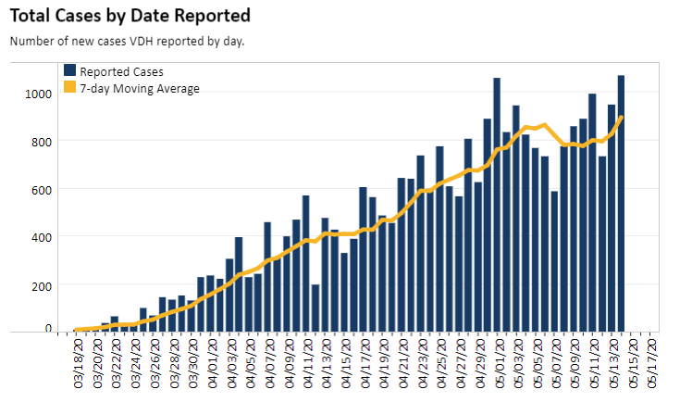

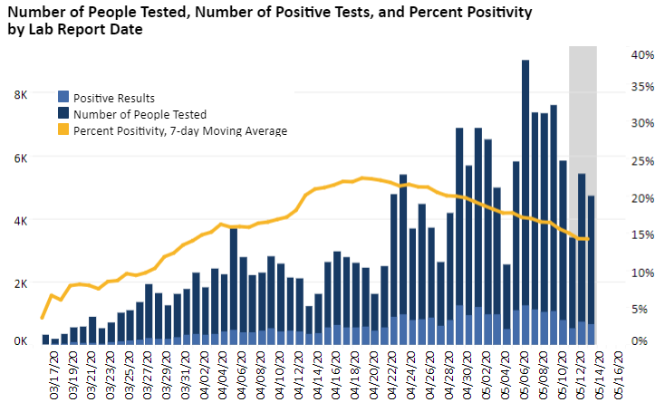
Graphs obtained from the Virginia Department of Health on May 14, 2020

PPE in Virginia
May 8 - More PPE - including 2.8 million masks - is on its way to Virginia
https://www.nbc12.com/2020/05/08/more-ppe-including-million-masks-is-its-way-virginia/
May 11 - Northam announces new program aimed to increase access to PPE in underserved communities
Governor Ralph Northam announced a pilot program with the City of Richmond to support the Commonwealth’s ongoing focus on health equity Monday, May 11.
The program aims to increase equitable access to personal protective equipment (PPE) in underserved communities that may be most impacted by COVID-19.

Contact Tracing
May 13 - Virginia Dept. of Health hiring 1,300 to help trace COVID-19
https://www.nbc12.com/2020/05/13/virginia-dept-health-hiring-help-trace-covid-/

Support for Virginians

May 11 - Virginia to send $650 million in U.S. aid to local governments, makes testing priority for state's share

Virginia plans to send $650 million in federal financial aid to local governments to pay the costs of responding to the coronavirus pandemic that has crippled the economy and collection of tax revenues essential to delivering public services.

https://www.richmond.com/news/virginia/virginia-to-send-650-million-in-u-s-aid-to-local-governments-makes-testing-priority/article_f6387502-7a94-5b58-bbfd-f4a92daf6f35.html

May 12 - Virginia says it accidentally overpaid 35,000 workers receiving unemployment insurance
https://www.virginiamercury.com/blog-va/virginia-says-it-accidentally-overpaid-35000-workers-receiving-unemployment-insurance/

Virginia SBDC Network Develops Business Recovery Resources for Small Business
As Virginia businesses and communities look forward to safely reopen, the Virginia SBDC network, and your local SBDC, have developed the Business Recovery webpage to help owners carefully plan for and execute their businesses’ new strategy.
https://www.virginiasbdc.org/recoveryresourcecenter/

May 13 - The Virginia Department of Motor Vehicles (DMV) will reopen 11 customer service centers statewide starting Monday, May 18.
The locations will be open for limited, appointment-only services. According to an update on the department’s website, “operational adjustments are being made for social distancing.”
https://www.nbc12.com/2020/05/13/dmv-open-locations-virginia-appointment-only-services/

Unemployment Data
May 14 - VEC Report: https://www.vec.virginia.gov/UI-press-release
For the filing week ending May 9, the figure for seasonally unadjusted initial claims in Virginia was 52,139. The latest claims figure was a decrease of 7,492 claimants from the previous week. Though the 12.6% weekly decline indicates that the volume of initial claims has retreated from its recent peak, it may not return to pre-pandemic levels for some time.
For the most recent filing week, continued weeks claimed totaled 392,673, up over 4% from the previous week and 374,869 higher than the 17,804 continued claims from the comparable week last year. The continued claims total is mainly comprised of those recent initial claimants who continued to file for unemployment insurance benefits during the COVID-19 pandemic. Thus far, about two thirds of workers who filed for initial claims during the pandemic continued to file during the May 9 filing week.
The following graph from VEC indicates that 680,455 initial claims were filed from the week ending March 14 to the week ending May 9. As of May 9, there are 392,673 continued claims.
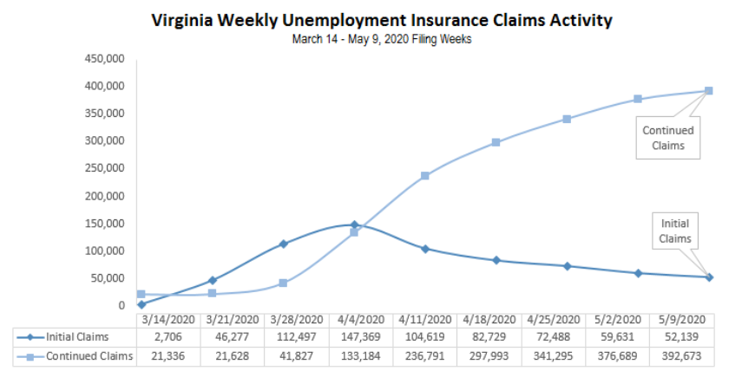

The following graph shows a shift in percent of claims among industries since March.
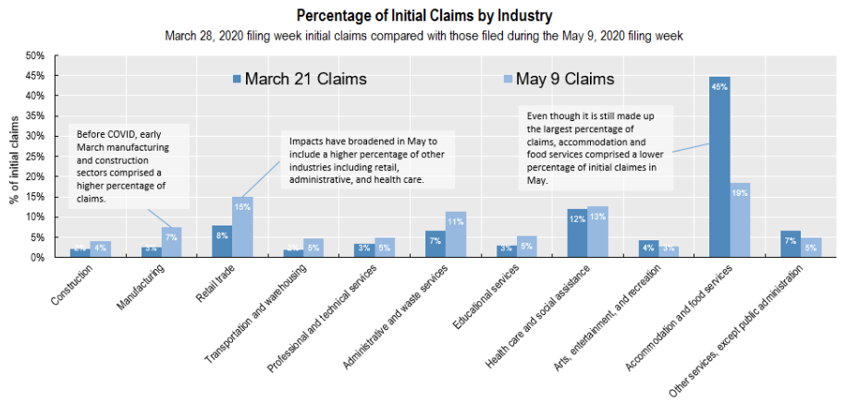
PDF of press release: https://www.vec.virginia.gov/sites/default/files/news-11916-Initial%20Claims%20Press%20Release%205%209%202020.pdf
For additional information on who is claiming unemployment insurance in Virginia, access the VEC’s U.I. claims data dashboard (https://www.vec.virginia.gov/ui-claims-dashboard) that is updated the following Monday after the weekly claims press release.
Note: VEC data is updated weekly on Thursday afternoon

Support for Higher Education
May 13 - Chancellor Appoints Task Force to Prepare Colleges for Post-Pandemic “New Normal”
Glenn DuBois, the chancellor of Virginia’s Community Colleges, named a new statewide task force today to examine and propose changes in how community colleges operate to meet the needs of Virginia students and businesses in a post-pandemic “new normal.” The task force has until May 15 to offer recommendations for the Fall 2020 semester and until August 15 to recommend longer-term changes.
https://www.vccs.edu/chancellor-appoints-task-force-to-prepare-colleges-for-post-pandemic-new-normal/
May 13 - House Democrats unveil massive new coronavirus relief bill ahead of Friday vote
House Speaker Nancy Pelosi unveiled Democrats' proposal for the next phase of coronavirus relief legislation on Tuesday, releasing a massive legislative package that Democrats hope to bring to a vote as early as Friday.
The text of the bill, which spans more than 1,800 pages, includes assistance to state and local governments, hazard pay for frontline health care workers, forgiveness of student debt and bolstering Medicaid and Medicare. The bill is known as the Health and Economic Recovery Omnibus Emergency Solutions Act, or HEROES Act.
Bill: https://docs.house.gov/billsthisweek/20200511/BILLS-116hr6800ih.pdf
Title by Title summary: https://appropriations.house.gov/sites/democrats.appropriations.house.gov/files/documents/Heroes%20Act%20Summary.pdf
Workforce: http://campaign.r20.constantcontact.com/render?m=1101293452633&ca=9dbab176-d051-4478-845a-6e58fd55ce60
Higher Education: https://www.forbes.com/sites/wesleywhistle/2020/05/12/pelosi-proposes-1200-stimulus-checks-10000-student-loan-forgiveness-and-money-for-colleges/#6684c34b78bd

May 7 - COVID-19 Work and Education Survey
More than 33 million workers have filed for unemployment since the COVID-19 crisis began, and the unemployment rate has climbed to 14.7 percent. We also know tens of millions more have kept their jobs or small businesses but have had hours, wages, and income reduced. This week, the "Strada Public Viewpoint: Work and Education Survey" explores early indicators of how affected workers are adapting—and the differences across different generations, education levels, racial and ethnic groups, and fields of work.
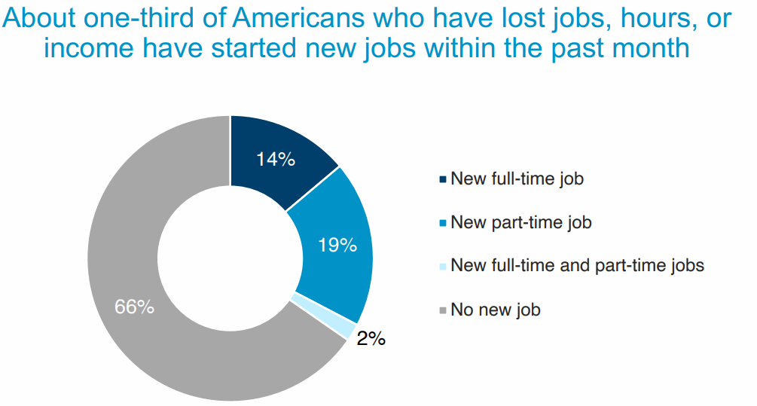
Report: https://www.stradaeducation.org/wp-content/uploads/2020/05/Public-Viewpoint-Report-Week-7.pdf
Slides: https://www.stradaeducation.org/wp-content/uploads/2020/05/Public-Viewpoint-Charts-Week-7.pdf

Support for Workers and Businesses
- Virginia State Resources: https://www.virginia.gov/coronavirus/support-for-businesses/#854620
- FAQs from Workers Regarding Covid-19:
English:https://www.governor.virginia.gov/media/governorvirginiagov/governor-of-virginia/pdf/Frequently-Asked-Questions-from-Workers-Regarding-COVID-19.pdf
Spanish:https://www.governor.virginia.gov/media/governorvirginiagov/governor-of-virginia/pdf/Las-Preguntas-Mas-Frecuentes-para-los-Empleados-Sobre-COVID-19.pdf
- Support for affected workers: https://www.virginia.gov/coronavirus/employment-and-financial-support/#855804
- F.A.Q. on Coronavirus Relief for Small Businesses, Freelancers https://www.nytimes.com/article/small-business-loans-stimulus-grants-freelancers-coronavirus.html
- The Paycheck Protection Program (PPP), a provision of the CARES Act, offers forgivable low-interest loans to small businesses facing uncertainty during the COVID-19 emergency, so businesses can retain workers, maintain payroll, and cover certain other existing overhead costs. https://www.sba.gov/funding-programs/loans/coronavirus-relief-options/paycheck-protection-program-ppp

WARN notices
Due to severe restrictions aimed at curbing the spread of coronavirus (COVID-19), some businesses are being forced to significantly reduce staff, and many will likely close altogether for at least some period of time.
The federal WARN Act requires covered employers to provide 60 days’ advanced notice before terminating or laying off employees in connection with a plant closing or mass layoff. However, there are three exceptions to the 60 days’ notice requirement and two of these exceptions—for unforeseeable business circumstances and for faltering businesses—are likely to apply during the crisis that is unfolding from COVID-19.
**Businesses with fewer than 100 employees are not covered under the WARN Act and do not have to file WARN letters with the state. Therefore, this is not a comprehensive reflection of business closures in Virginia.
http://www.vec.virginia.gov/warn-notices
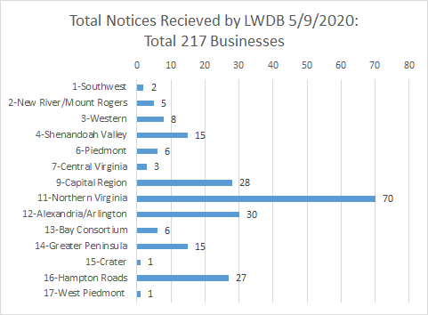
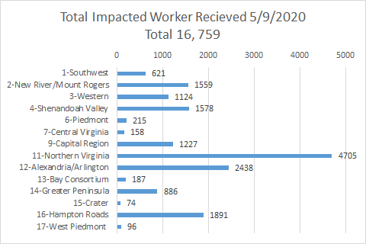
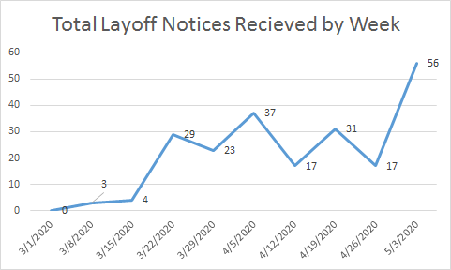
The above graphics do not represent all layoffs that have occurred in the Commonwealth of Virginia, only the businesses that have filed official notices with the Commonwealth or who have sought assistance from the workforce system.
Virginia news:
- Virginia Mercury: https://www.virginiamercury.com/
National news:
- Sign up for The New York Times Morning Briefing: https://www.nytimes.com/series/us-morning-briefing
- The Daily podcast: https://www.nytimes.com/column/the-daily

