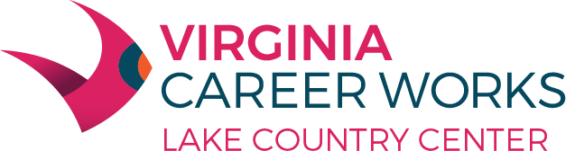

**Final Tuesdays Job Seeker Workshop**

November 28, 2023 1:00-2:00PM

**“Essential Computer Skills”**

**Please register at the reception desk!**

